Magpies’ WEEKLY SUGGESTED HOME LEARNING – WB 6.7.20
Hi Magpies! This week’s English involves magic. What would you paint if you had a magic brush? I would paint something linked to last week’s activity and looking after the environment. Try to think about something that would benefit others and not just yourself. Maybe you could paint your ideas as well as writing about them. Have fun and remember to keep in touch. We miss you! Love from Mrs Knott and Mrs Harris
ENGLISH | MATHS
Reading – Read every day for pleasure for 20 minutes.  Watch the video- The Magic paintbrush and complete the online activities  https://central.espresso.co.uk/espresso/primary_uk/subject/module/video/item727940/grade2/module719372/index.html  - Watch the video about expanded noun phrases and complete the activities.  https://www.bbc.co.uk/bitesize/topics/zwwp8mn/articles/z3nfw6f expanded noun phrases video and activities  - Write the story in your own words. Remember to use expanded noun phrases, similes and metaphors.  https://www.bbc.co.uk/bitesize/topics/zfkk7ty/articles/z9tkxfr Similes and metaphors video  - You could use the sequencing pictures to help  - If you had a magic paintbrush, what would you paint? Write a story about this.  Spellings – Year 3/4 Common Exception Words – learn the spellings below and put them into your own wordsearch. | 15 minutes on TT Rockstars each day  https://ttrockstars.com/  Contact school if you need a password reminder Year 4 -White Rose – Week – 11 – triangles  Use worksheets below and BBC Bitesize to support the white Rose videos  https://whiterosemaths.com/homelearning/year-4/  https://www.bbc.co.uk/bitesize  - Use the sheets below to support the videos  - Make a list of triangles you find in the environment?  - Can you make a picture using only triangles?
R.E. | OTHER
SPECIAL PLACES  RELATE.  On the map below (See sheet) are some places that were special to Jesus. It is possible today to visit many of these places in what Christians call the Holy Land. They can go there on a pilgrimage to find out more about what happened there and to experience that special place. Find out what you can about the places on the map and what happened in the life of Jesus in each special place. When you have done this, you can play the matching activity (see sheet below). These are the scripture references that you can look up to find stories about Jesus’ special places:  Luke 2: 11 (Bethlehem)  Matthew 2: 23 (Nazareth)  Luke 2: 41, 46 (Jerusalem)  Mark 1: 9 (Baptism in the Jordan)  Matthew 5: 1−2 (Sermon on the mount) | Science – Habitats –  https://central.espresso.co.uk/espresso/modules/s2_habitats/hedgerow/video1.html?source=search-all-all-all-all&source-keywords=hedgerow  Watch the above video and complete the online activities.  Geography - Compare the place that you researched last week to Ashton. Make a list of all the similarities and differences that you can think of.  – Time for music Y3/4 Lesson 9  https://www.stoswaldswigan.co.uk/classes/fun-learning-games/music  PSHEandC  It’s easy to forget about how far you have come this year. We have missed out on the times that we should have spent together but you shouldn’t forget how much you have still been learning and growing. Complete the sheet below to remind yourself about how special you really are.  Art- paint scenes from your story

Write about which event happened at what place on the map and say why that place is so special to Jesus. They could then relate that to special places for them (e.g. the River Jordan is special to Jesus as he was baptised there. St. Mary’s Church is special to me because this is where I was baptised).
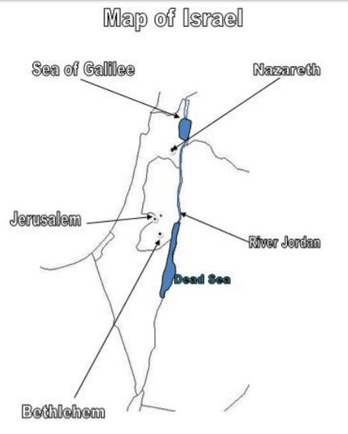
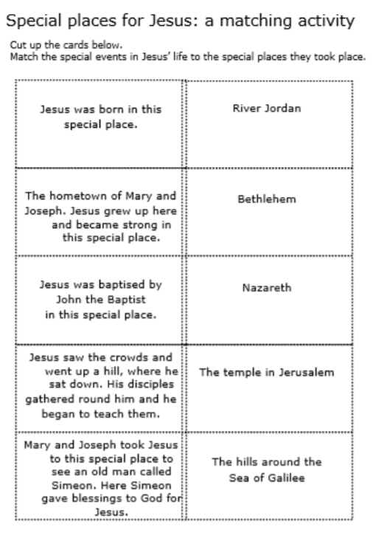

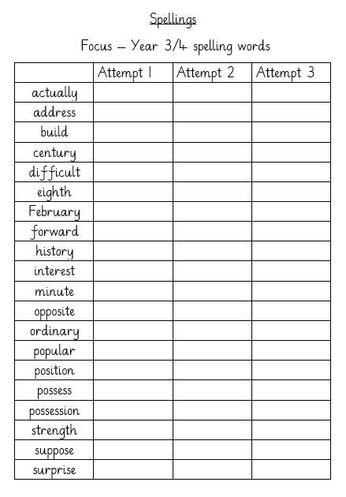
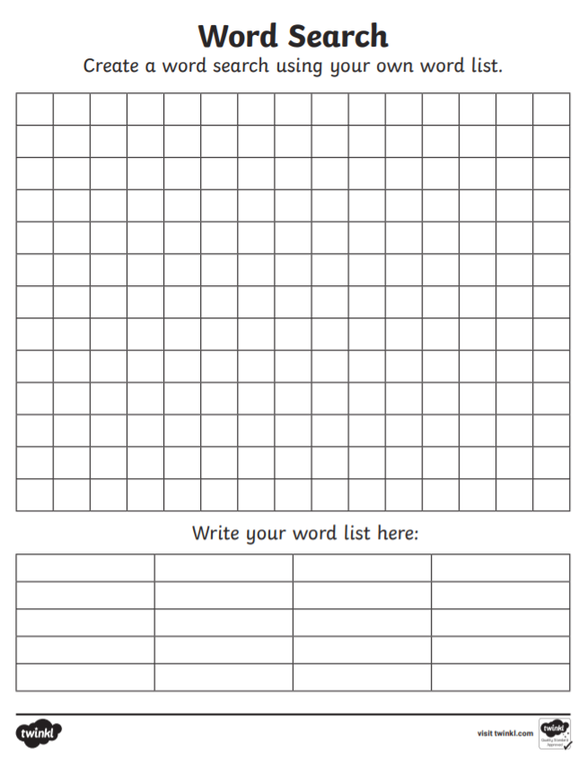

Monday
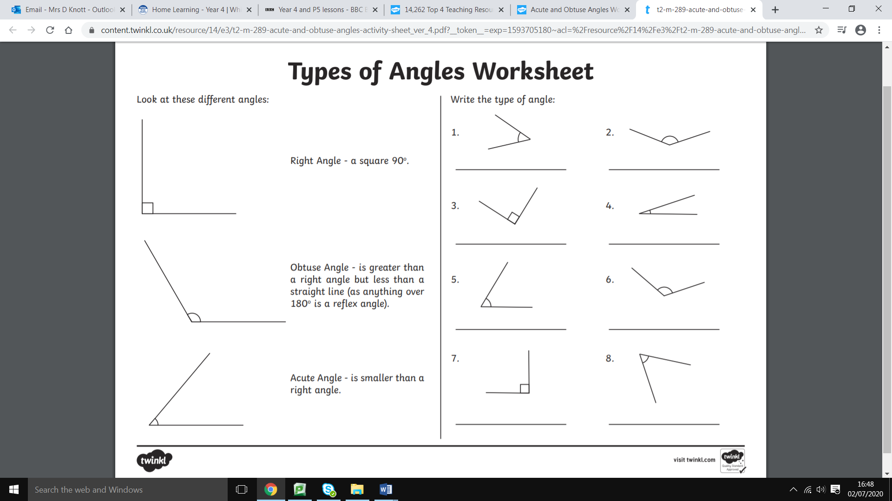
Tuesday

Wednesday
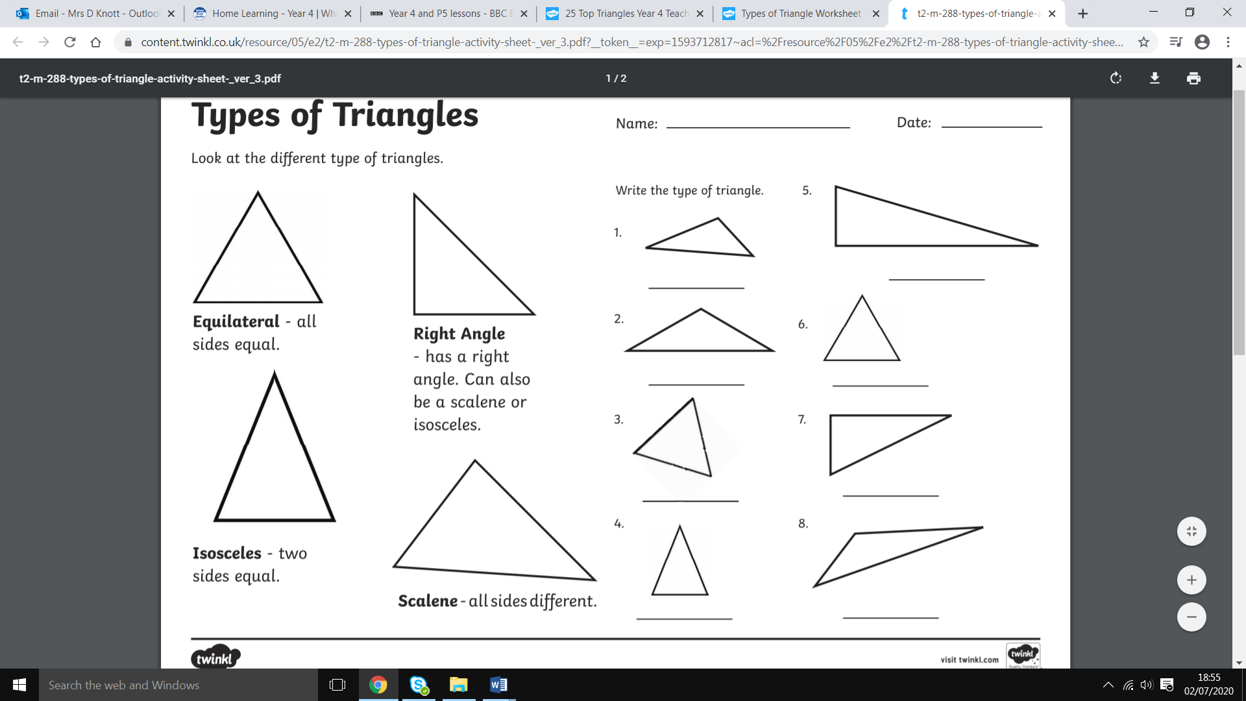

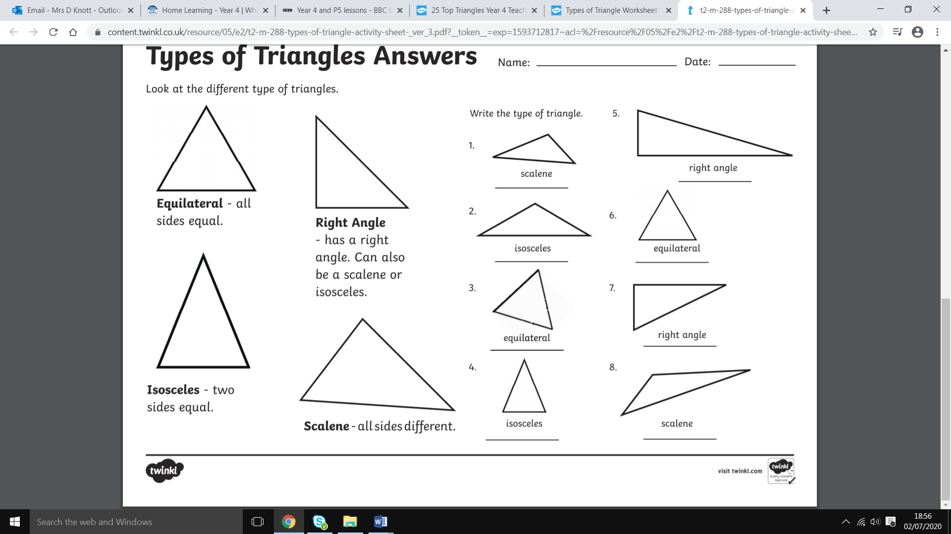

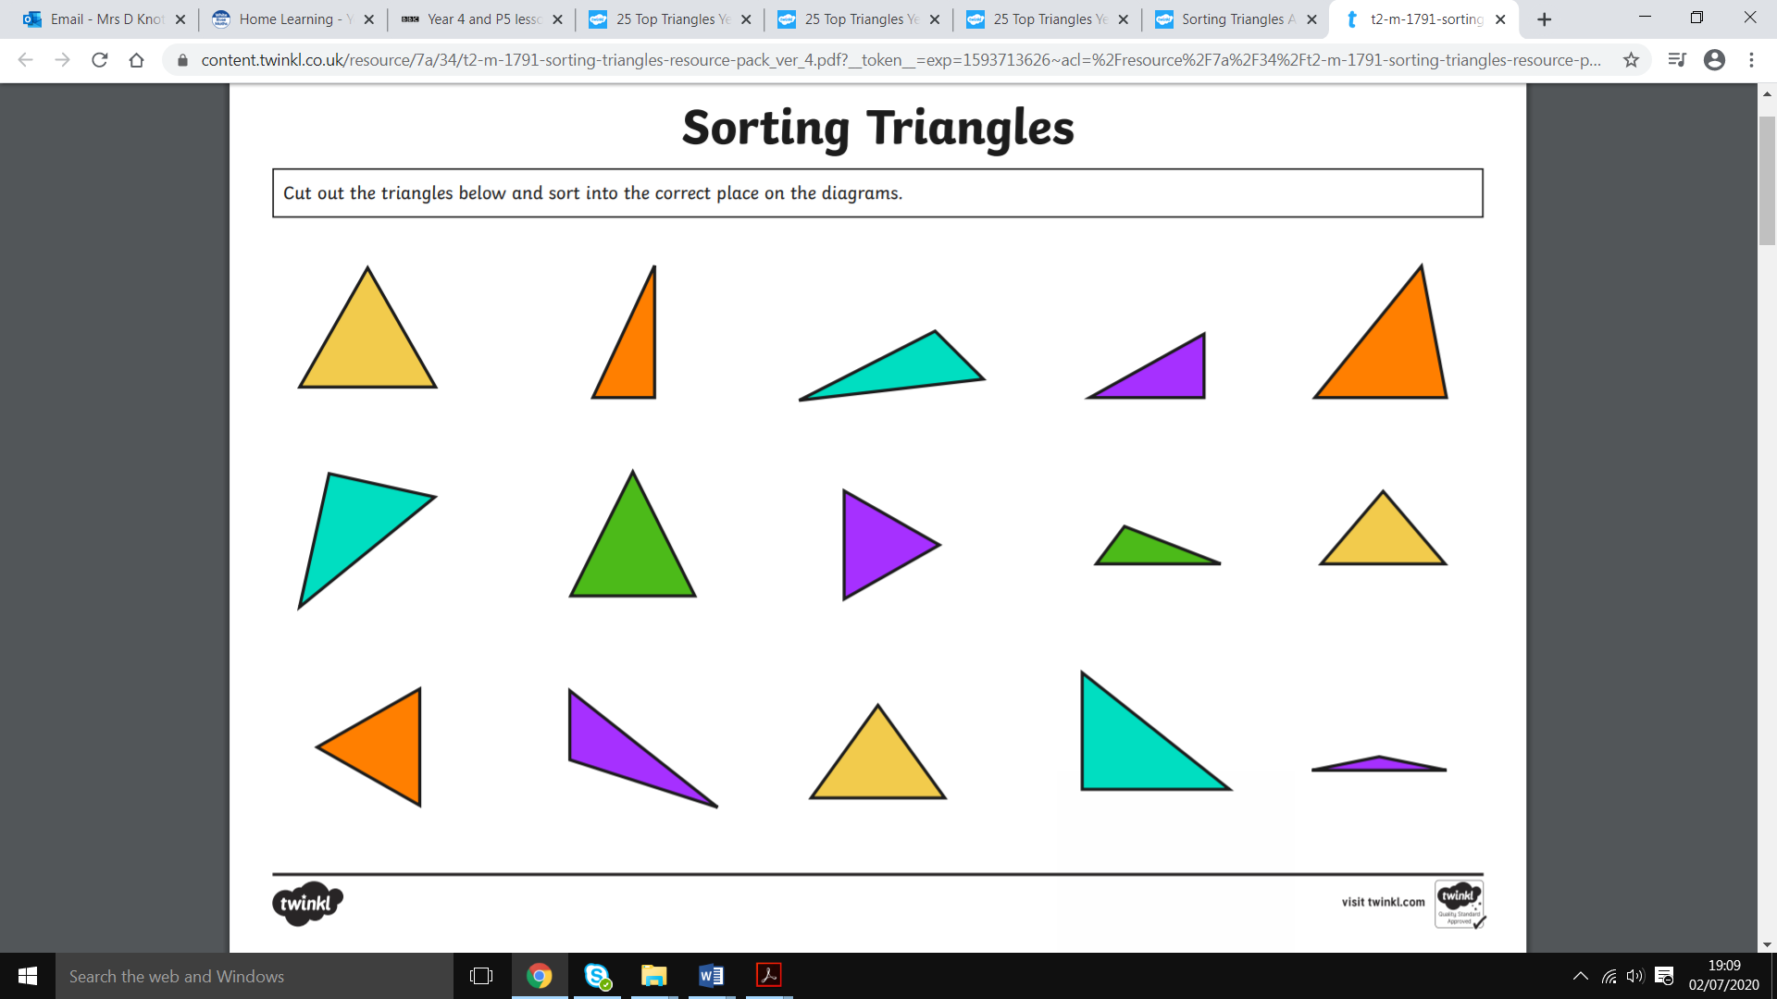

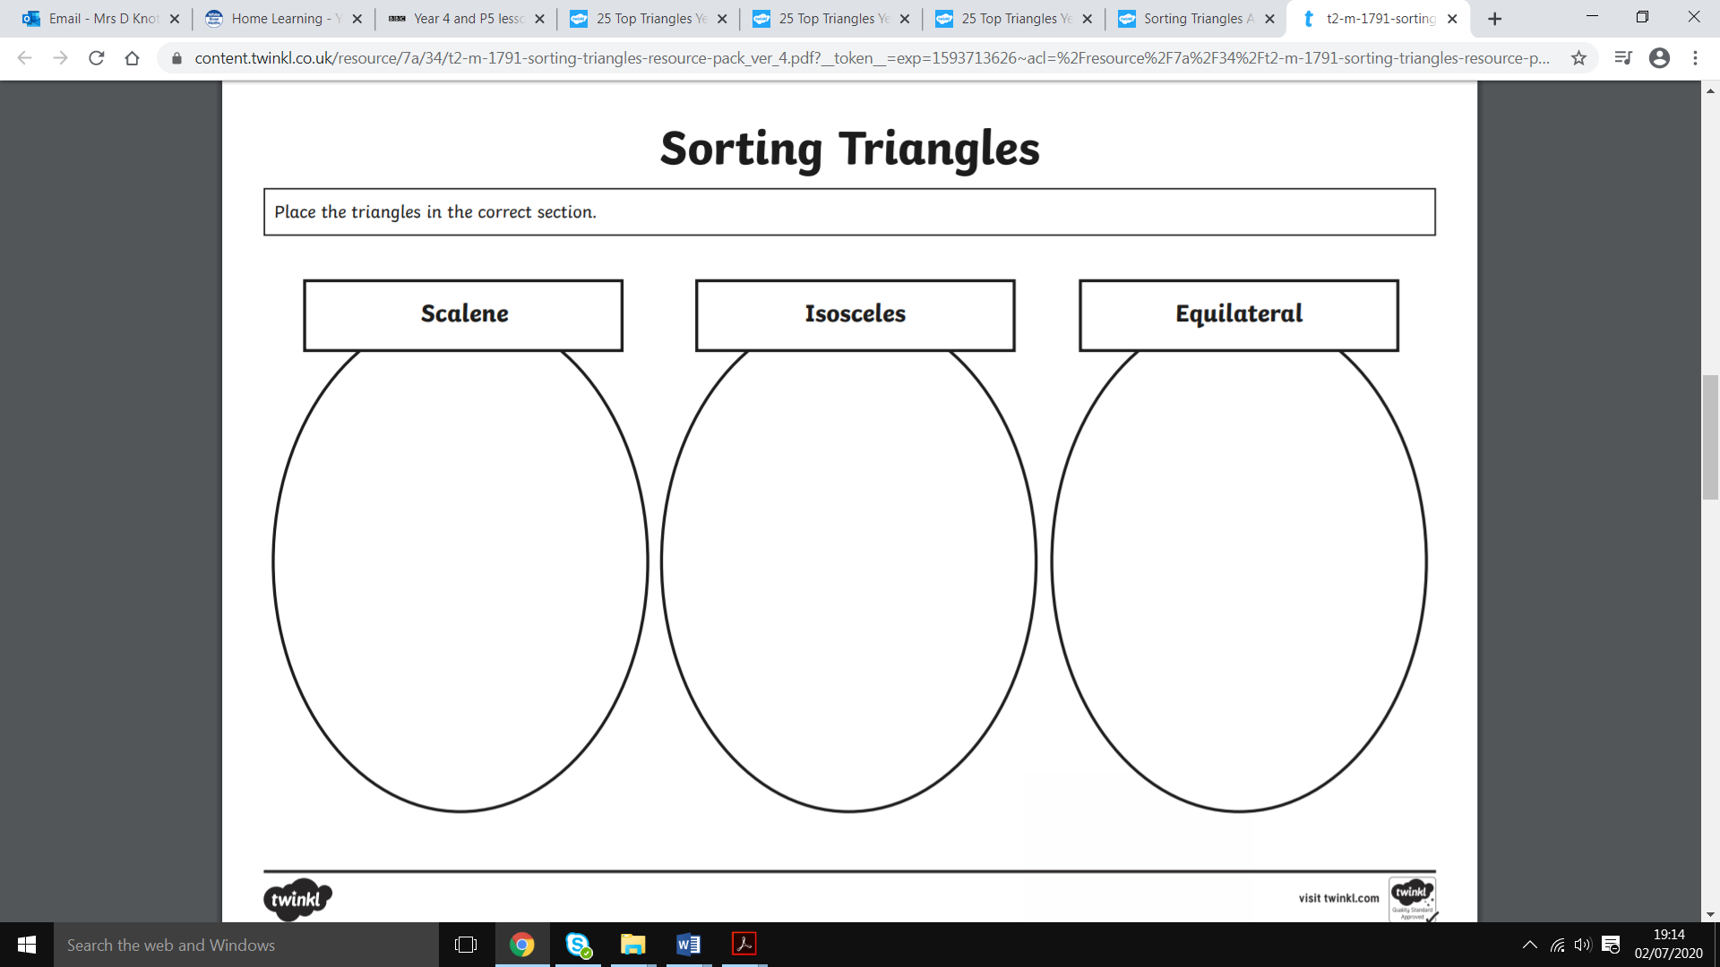
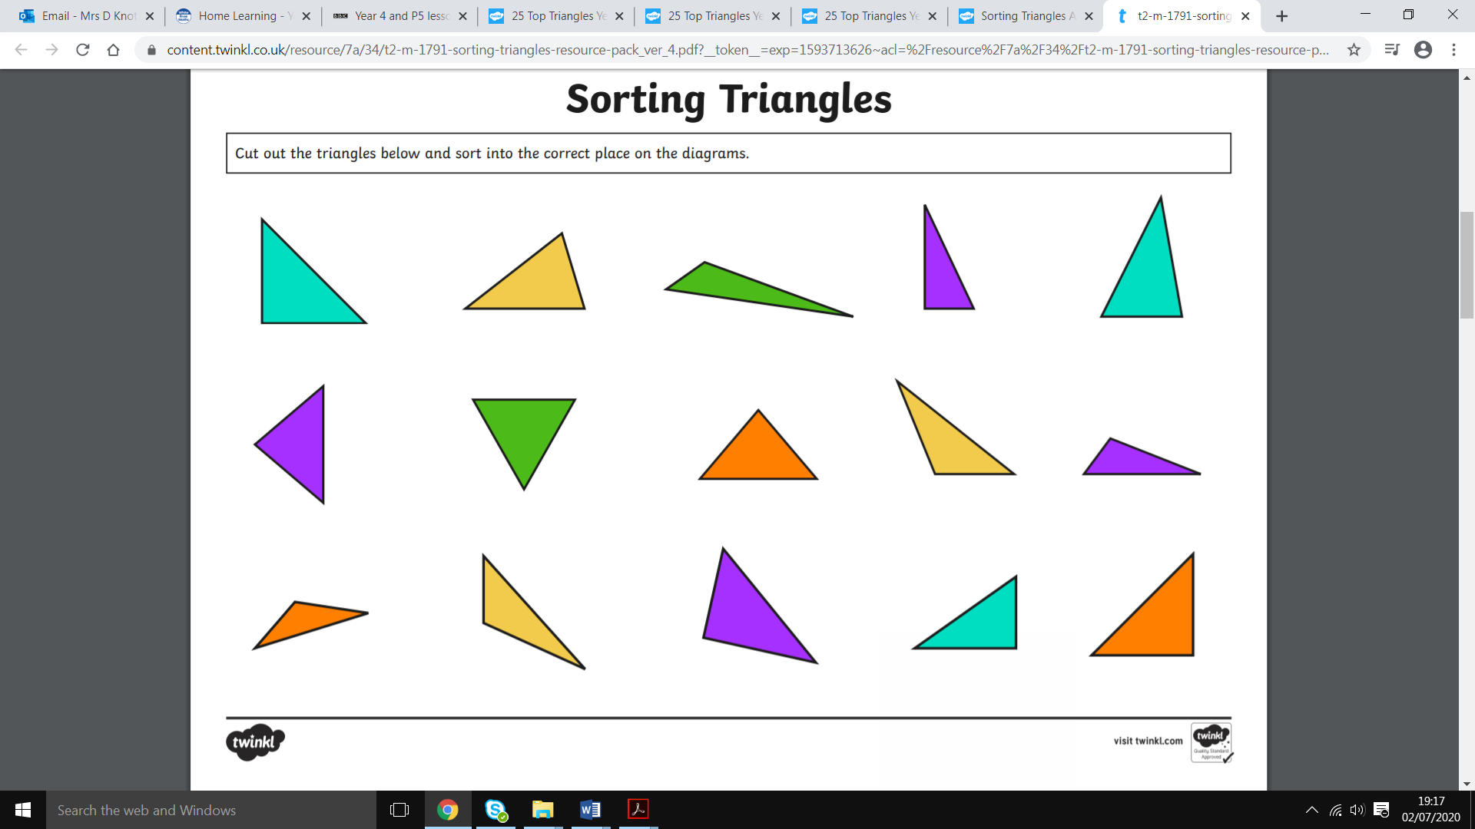

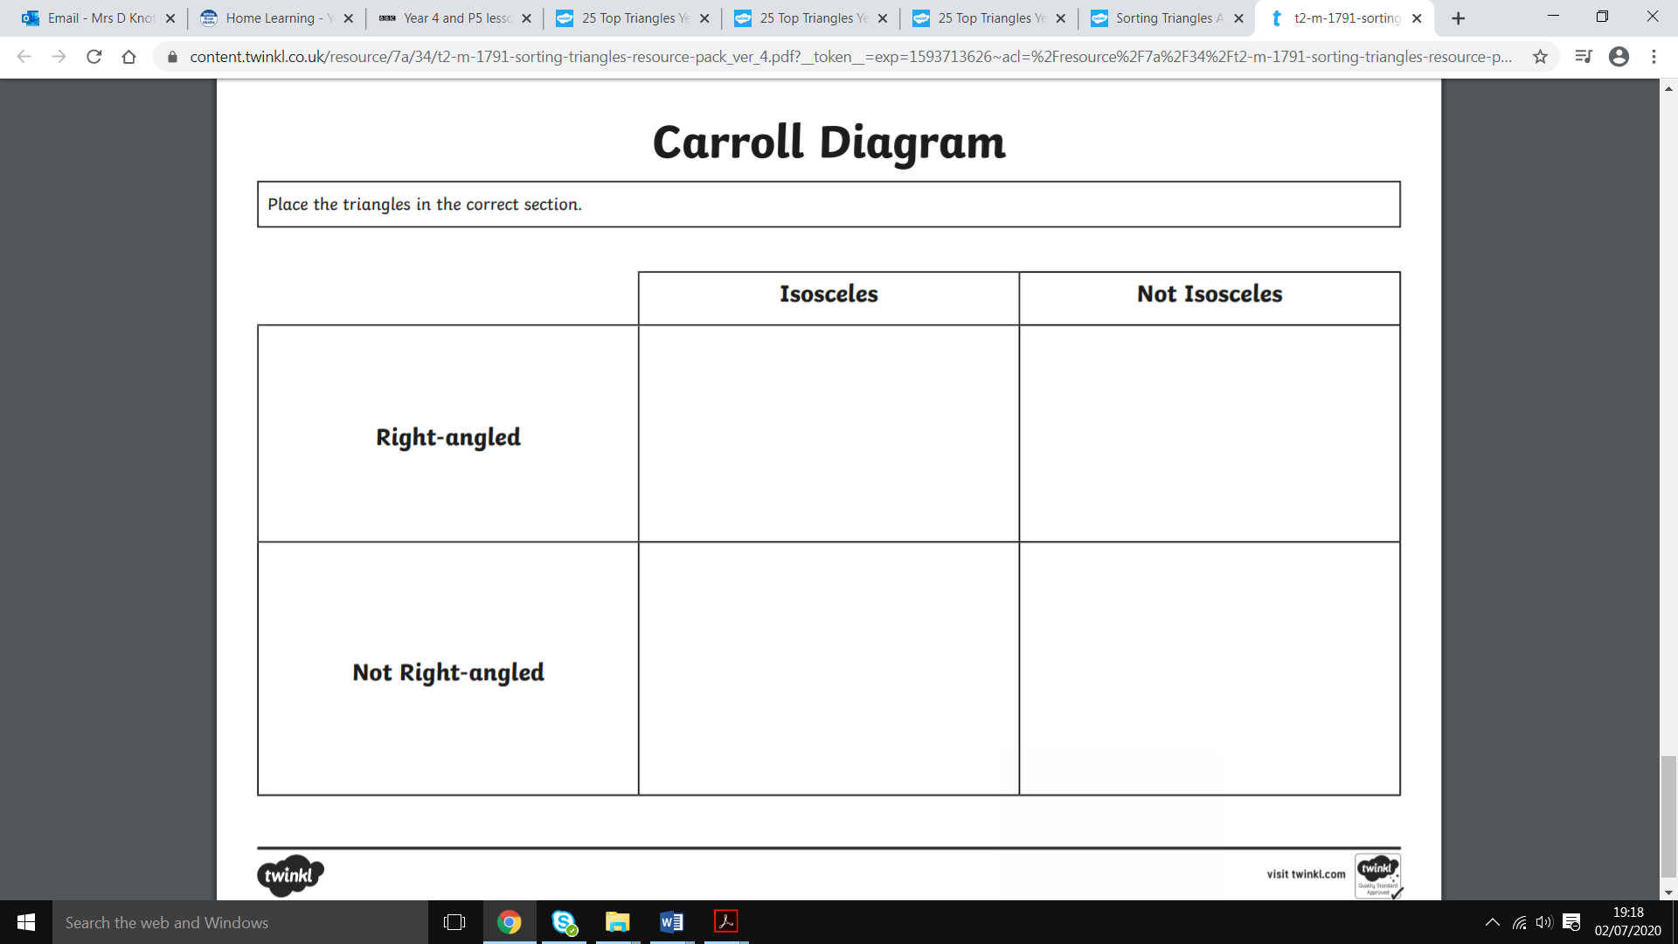

Answers

