OWLS’ WEEKLY SUGGESTED HOME LEARNING – WB 6.7.20
Hello Owls!
Thank you so much for all of your emails and Tweets last week and it was lovely to see Y6 on Zoom!
It’s our penultimate week of the school year which I can’t quite believe! I hope you enjoy your tasks this week and, as always, feel free to email me about anything.
Y6, it’s been great to see how much you’re enjoying the transition activities. We will be in touch with more plans this week!
Take care, Mrs Higgens and Mrs Smith xx
How to get in touch… enquiries@saintoswalds.wigan.sch.uk or you can Tweet @saintoswalds or @Mrs_higgens.

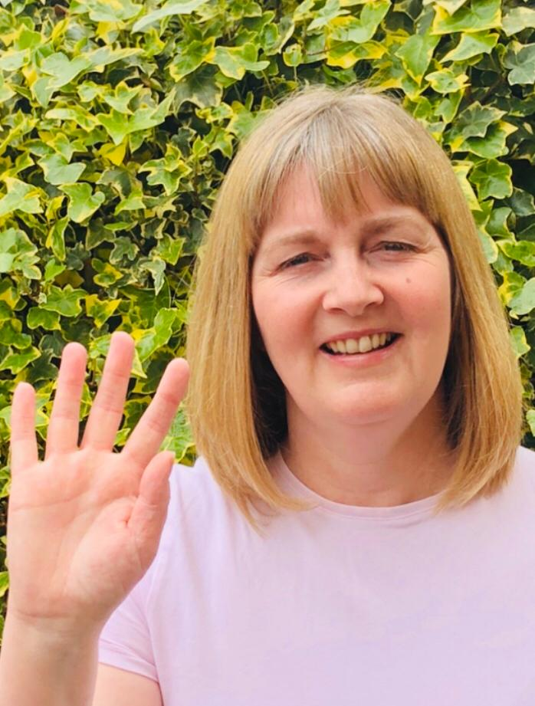
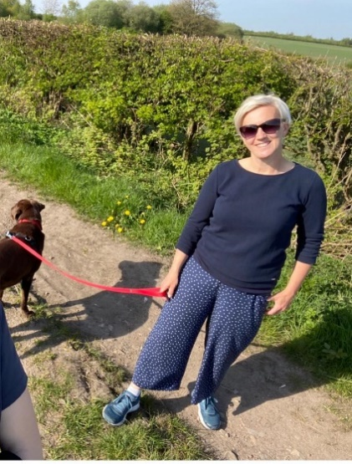

ENGLISH | MATHS
Year 6 Transition  We would like you to continue with the transition tasks on the Robinhood MAT website. The focus this week is about which qualities makes you unique and special. Follow the link below and then scroll down to Y6/7 transition learning projects. Week beginning 6th July  https://www.robinhoodmat.co.uk/Learning-projects/  This week most of our work has been chosen and adapted from RobinhoodMat Trust ‘Celebration Themed Week’ planning.  Spelling  - List a word that corresponds with the start of the following letters related to festivals. C E L E B R A T I O N S  - Create your own word search. The theme of this should be ‘Celebrations’. I’ve attached a blank word search.  Reading  - If you have newspapers or magazines in the house, have a read through and note any articles about celebrations. What are they celebrating and why? An alternative is to look online at a child-focused news site such Newsround.  - Read about celebrations across the world here on BBC Bitesize. List 5 new pieces of information you have learned.  - Don’t forget your reading for pleasure each day and also audio books are great too (there’s a free 30 day trial at Audible but you need ask parents’ permission).  Writing  - Write your very own superhero kid story. Use this Booktrust ‘Kid Normal’ resource to help. It includes a video and audio version of the Kid Normal book series.  - Create a newspaper report about the day you were born. Include weather on the day, stories in the news, etc. Could you interview any family members and include quotes in the article?  - Celebrate a local person. Research and create a list of local people who you feel are worth celebrating. Local may mean Wigan, Greater Manchester or even the North West. Then write an information report about the person. | Hamilton Maths Packs  Please use the home learning packs from Hamilton at Home.  https://www.hamilton-trust.org.uk/blog/learning-home-packs/  Click on this link and scroll down to go to either Y5 or Y6.  We are up to week 10 but feel free to go back if you feel like you need to. These have some PowerPoints to help and also come with answer sheets. The download includes a file for each day of work.  The structured daily lessons on BBC Bitesize are another good option https://www.bbc.co.uk/bitesize/dailylessons as is picking and choosing from Corbett Maths https://corbettmathsprimary.com/content/  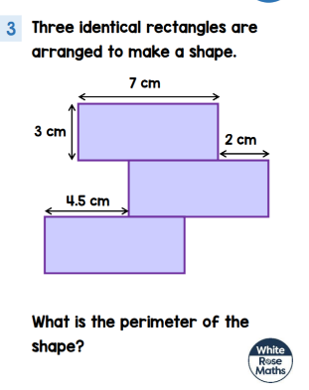  A daily problem from White Rose. More can be found here  Ongoing Times Table Rockstars- try for 15 minutes a day  https://ttrockstars.com/.  Great to see so many of you practising on here now!

R.E. | OTHER
This week we are continuing with The Universal Church topic- Our World. The resources have been attached again to allow you to continue with this on-going topic.  Why not explore Cafod’s website and find out more about where they work and how. This interactive map is a great way to explore our wider world.  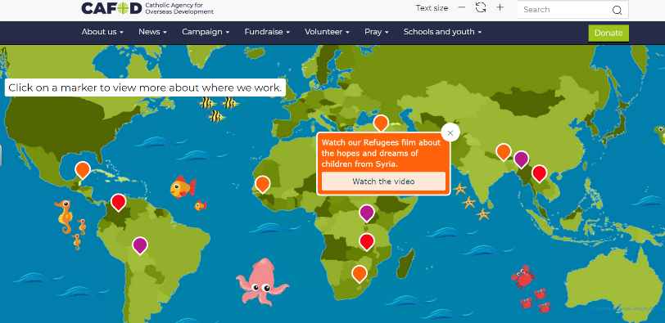  https://cafod.org.uk/Education/Kidz-Zone | Task 1- Planning a Celebration  It’s time to plan a celebration event of your choice. This could be a birthday party, a Christmas celebration, an Eid celebration, an end of term celebration, an Easter hunt or anything else you wish to plan. You have £150 to spend and 25 guests will be attending. What will the money be spent on? Plan the celebration considering the location of the event, how you will decorate the venue, what the guests will eat and drink and how the guests be entertained. Detail timings of the event and think about any timings for preparation.  Task 2- Time to Design  Imagine your perfect celebration outfit for an event. What would it look like? What would it be made from? How comfortable would it need to be? Design a costume for a celebration of your choice. Think about the patterns you would like to incorporate on your design and any cultural traditions.  Task 3- Birthdays around the World  Birthdays are celebrated differently in different countries. Write an information leaflet detailing how birthdays are celebrated in the following countries: China, England, Spain, Italy and Mexico. Which country would you like to celebrate your birthday in based on your findings? Why?  Science  Visit https://greatgrubclub.com/ where there are lots of activities and things to explore linking to healthy eating and cooking.  