ROBINS’ WEEKLY SUGGESTED HOME LEARNING – WB 6.7.20
Hi Robins, we hope that you and your families are safe and well. Hopefully this week will bring lots of sunshine for us to enjoy going outside without getting wet and needing our umbrellas. This week’s theme is Fairy Tales. I love reading fairy tales to children. Missing you all. Stay Safe!
Mrs Fox, Mrs Davies and Miss Lea xxx
We’d love to see your work, so please Tweet @saintoswalds or send an email to enquiries@saintoswalds.wigan.sch.uk FAO Miss Lea
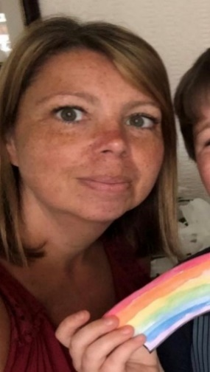

ENGLISH | MATHS
Reading for pleasure – 15mins per day  We are sure that you have lots of fairy tales at home to share together.  There are also lots of fairy tales with a twist for example:  Mr Wolf’s Pancakes  Revolting Rhymes by Roald Dahl  The True Story of the Three Little Pigs  The Three Little Superpigs  Mr Wolf and the Three Bears  DISCOVERY EDUCATION also have a link to videos and games linked to traditional tales.  In the search box type ‘Traditional Tales’  Reading Comprehension (see attached sheets)  Goldilocks and the Three Bears  Wanted  Troll’s Trouble  Find the Character  Writing Tasks  Book review of your favourite traditional tale or traditional tale with a twist  Character Description of the Troll from The Three Billy Goat’s Gruff  Write your own twist on a traditional tale  Change the ending to your traditional tale  Spelling Tasks (attached)  Fairy tales cross word  Apostrophes of possession  Phonics Tasks  Read the words and match to the pictures – I spy and Read (attached)  Alternative spelling for the or sound (sheets attached) | Basic Skills  Y1 – Quick recall of doubling and halving facts within 20  Top Marks Website has games to play linked to doubling and halving  Y2 – Rapid recall of 2’s, 3’s, 5’s, 10’s time tables – play TTrockstars and Top Marks to develop quick recall.  White Rose and BBC Bitesize  Year 1 – halves and quarters (sheets attached)  Year 2 – Time (sheets attached) o’clock, half past, quarter to and quarter past, 5 minute intervals  Time games online  Top Marks and Everyschool.co.uk  Attached sheets linked to fairy tales
RE | OTHER SUBJECTS
Neighbours  We have attached a sheet with a link for you to follow.  We would like you to think about what makes a good neighbour.  Challenge – make link people and draw all your neighbours linked together on the back of each person write what makes them a good neighbour.  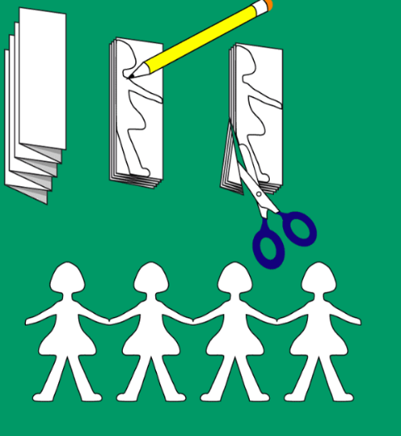 | Science https://www.science-sparks.com/fairy-tale-science-printables/  There are lots of different science tasks on the above website  We have attached 2 examples for you to have a go at.  Build a raft for the Three Billy Goats Gruff and Design and make a bridge for the Gingerbread Man.  Geography  We have attached a Fairy Tales Town Map  Write a set of directions to move through the town.  Use the language of forward, backwards, left, right, north, south, east, west in your directions.  Computing  Continue with the coding tasks on the Discover Education Coding website.  Type a letter from Goldilocks to the Three Bears saying sorry for going into their house and making mischief.  Music – continue to access the music tasks that you will find on our school website.  We have attached a song that you can your family can learn.  Mr Wolf Cooks Pancakes Song.  History – Robin Hood  Create a poster of Robin Hood – add interesting facts around your poster.  We have attached a Wanted poster template for you to complete.  BBC Bitesize have a video clip title – The Legend of Robin Hood.

