SPARROWS WEEKLY SUGGESTED HOME LEARNING – WB 6.7.20
Hello Sparrows! I hope you enjoyed the story all about Jack and the Beanstalk last week. This week your activities are all about Sports Day! Unfortunately, we weren’t able to have a Sports Day this year and it’s always a fun day so it would be shame to miss it out completely.
Please keep in contact as usual. You can email the office at enquiries@saintoswalds.wigan.sch.uk FAO Sparrows or tweet us @saintoswalds @mrs_wibberley @MrsOsborne73.
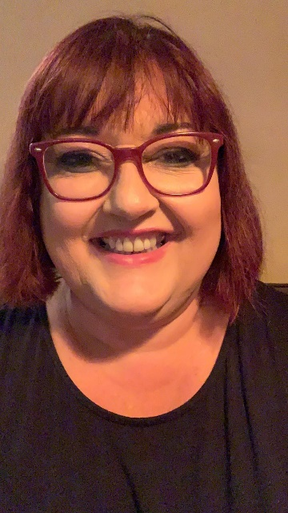
Stay safe and keep smiling
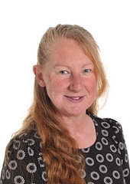
Mrs Wibberley, Mrs Osborne and Mrs Dean xx
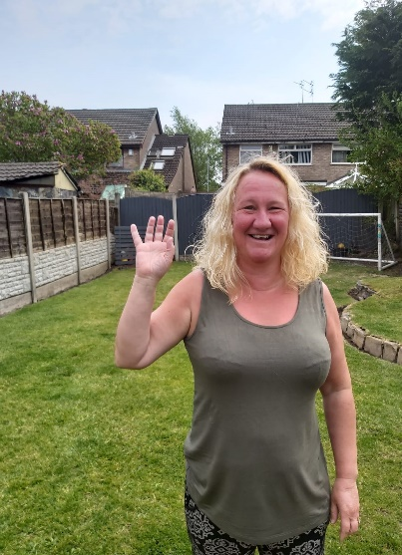
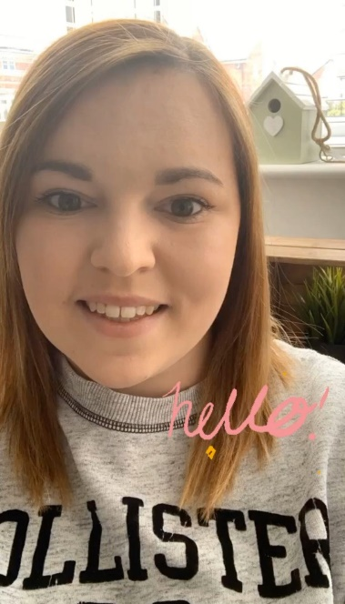

ENGLISH | MATHS
Reading – Read every day for pleasure for 10 minutes.  You can also listen to stories on www.vooks.com. This website is full of stories that come with videos and are a big hit in Sparrows as there are so many to choose from. Maybe your child can share their favourite story with you. You can get a free subscription for 1 month.  Comprehension –  - Find a fiction or non-fiction book all about a sport and share it with an adult.  - Complete the Sports Day comprehension below.  Writing –  - Write a set of instructions for the races you completed for your PE task.  - Write a speech for when you win a race.  - Complete the Sports writing frame below.  Phonics – Your child will be able to tell you which phonics group they are in. If they don’t know, please contact school so we can help you.  Mrs Osborne and Mrs Dean’s groups –  1. Go to https://www.phonicsbloom.com/ or https://new.phonicsplay.co.uk/ and play your favourite game to practise all the new sounds you have learnt over the past few weeks.  2. Find objects around the house that have the ‘ow’ (cow) sound in them. Write the words and draw pictures to match.  Mrs Wibberley’s group –  1. Go to https://www.phonicsbloom.com/ or https://new.phonicsplay.co.uk/ and play your favourite game to practise all the new sounds you have learnt over the past few weeks.  2. Find objects around the house that have the sound ‘i-e’ in them. Put these words into sentences and draw pictures to match.  Miss Lea and Mrs Davies’ groups –  1. Go to https://www.phonicsbloom.com/ or https://new.phonicsplay.co.uk/ and play your favourite game to practise all the new sounds you have learnt over the past few weeks.  2. Complete the Name the Alien task below. Use the sounds you have learnt to make up some nonsense alien names. | Basic skill – Sequence events in chronological order using language [for example, before and  after, next, first, today, yesterday, tomorrow, morning, afternoon and evening] (Reception Week 13 on the Hamilton Trust link below have some sequencing activities)  Recognise and use language relating to dates, including days of the week, weeks,  months and years  Unfortunately White Rose have started charging for their home learning tasks, however BBC Bitesize have partnered with White Rose and have some great daily tasks including maths for free. Follow this link for a daily maths task https://www.bbc.co.uk/bitesize/tags/zjpqqp3/year-1-and-p2-lessons/1  If your child finds this challenging, please follow this link https://www.hamilton-trust.org.uk/blog/learning-home-packs/ and use the previous year group’s tasks.
R.E. | OTHER
See below for the information and activities for this week’s RE task. | Art – Follow the instructions on this link to make your own American Football (or a different ball if you wish) This activity is great for fine motor control using the hole punch and threading. http://preschoolpowolpackets.blogspot.com/2014/05/football-preschool-craft.html  Design a sports kit – you can use the template below if you wish to.  PE – Make a balance beam and see how far you can get across without falling off – get your family involved and see who has the best balance (you can use a piece of string if you can’t make a beam).  Make your own races to complete in the garden with your family. Here are some ideas to get you started: egg and spoon race, dressing up race, bat and ball race, sack race (use pillow cases).  DT – Use materials from around your house to make a medal.  Science – Notice how your heart rate changes as you exercise and rest.  Complete the healthy eating activity below and learn what makes a balanced diet.  Geography – Find out about the national sport of different countries and locate the countries on a map.

