WAGTAILS’ WEEKLY SUGGESTED HOME LEARNING – WB 6.7.20
Hello Wagtails! Another week has zoomed by and one which was filled with lovely emails, tweets and seeing some of you in school. You never fail to amaze me with your resilience and hard work during this time in which we have all had to get used to a brand new way of working. Your work that I see is of great standard and the emails I receive are always so courteous and interesting. I love hearing about your week and how you are spending your time. Keep doing your best and keep up with those other activities that don’t involve school work or using a screen.
This week your tasks may make you hungry as they are all based around CHOCOLATE! On Tuesday 7th July, it is World Chocolate Day so of course I had to plan your activities around this!
Enjoy – keep safe – stay alert!
Miss Silver and Mrs Costello
xxx
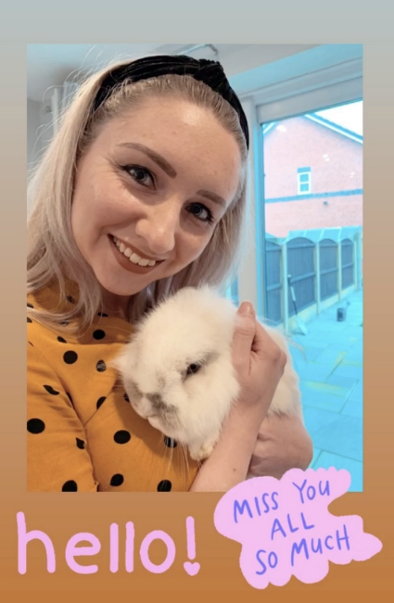

ENGLISH | MATHS
Reading – Read every day for pleasure for 15 minutes.  Do you have the book, Charlie and the Chocolate Factory by Roald Dahl? If you do, it might be nice to read it this week.  Comprehension tasks  - Read and complete the chocolicious focused reading skills sheets below (4 steps).  - Open this link and discuss the questions with your family: https://www.teachingideas.co.uk/sites/default/files/chocolateinspirations.pdf  Writing  - Write a list of all the chocolate bars you know. List them in alphabetical order. Challenge – Can you find a chocolate bar for each letter of the alphabet?  - I want you to hold a debate with your family. The topic is ‘Should chocolate be allowed as a snack at break time in school?’ You need to find out as much as you can about chocolate so you can argue whether or not it should be allowed in school. Use the for and against sheet below.  - Write an imaginative story about a land of chocolate. Read your story aloud to your family, developing a confident, audible voice in front of an audience.  - Find out as many facts as you can about chocolate. Use the facts you find to create a non-fiction piece of work. You could create an informative fact file, a spider diagram surrounded by interesting facts or a PowerPoint presentation informing others of chocolate facts. Use this link to get you started: https://www.teachingideas.co.uk/sites/default/files/chocolatefactcards_0.pdf  Spellings – words ending in –tion.  See spelling list below.  - Can you think of any other words that end in –tion?  - Create a glossary using –tion words. | Basic Skill – Statistics – Tally charts, block diagrams and pictograms  Work through the Espresso unit on statistics:  https://central.espresso.co.uk/espresso/primary_uk/subject/module/frontscreen/item883307/grade1/index.html  Watch the videos and complete the online activities (I have included the printable resources below). You will learn that data can be represented in different ways, and that summarising data in different ways can make it easier to answer questions and solve problems.  After learning about tally charts, block diagrams and pictograms, hold a survey based on chocolate. For example, what is the most popular chocolate? Use the planning sheet below and record your findings using the three different ways of representing data. (challenge yourself on the pictogram – make one picture represent 2 people)  If you wish to continue working through the Hamilton Trust’s home learning packs, click on the following link and download the Year 2 Week 9 pack.  https://www.hamilton-trust.org.uk/blog/learning-home-packs/
R.E. | OTHER
Theme: NEIGHBOURS – Everyone is our neighbour and loved by God  Read the story from Luke’s Gospel and act it out if you can (story below)  Samaritans were people who lived in Samaria and in those days, Jews and Samaritans would have nothing to do with one another. They did not get on because they couldn’t agree about what they believed, so they became enemies. This Samaritan was a good neighbour because he helped the man, kept him safe and made sure the injured man had what he needed till he was better. CAFOD works with our neighbours around the world, no matter who they are or what they believe, to make sure they have what they need.  - Talk about the pictures (fair or unfair) below and then produce a collage to represent the main areas of need (food, water, shelter, health, education) for our global neighbours and compare it to your own experiences.  - Talk about what makes someone a good neighbour and what we could do to help our global neighbours to make the world a fairer place.  - Record the story of The Good Samaritan in your own words and drawings, saying what he did and why he was a good neighbour. | Science – I want you create an investigation into whether chocolate can be changed from a solid to a liquid and back again. Use the investigation sheet below to help you.  Science - Prince Pondicherry (from Charlie and the Chocolate Factory) wanted a palace made of chocolate. Discuss why chocolate might not be a very good building material.  Science - If someone was given a lifetime supply of chocolate (like the children in Charlie and the Chocolate Factory), what might be the effect on their body?  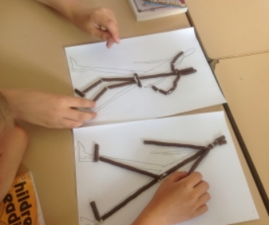  Art – Have a look at sculptures made by Giacometti. Can you create Giacometti figures made from chocolate matchmakers?  DT - Look at examples of different chocolate bars and sweets? Can you design your own chocolate bar and packaging? Think about:  - What shape your chocolate bar/wrapper will be.  - What ingredients your bar will be made from.  - What material you wrapper will be made from.  - The name and price of your chocolate bar.  - How you will advertise your new chocolate bar. Can you create a slogan?  Geography - Find out where the ingredients of a chocolate bar come from. Could you plot these on a map?  Geography - Research chocolate factories around the world.  History – Use this BBC Bitesize link to find out who brought chocolate to the UK and to gather a brief history of chocolate. https://www.bbc.co.uk/bitesize/articles/zngsqp3

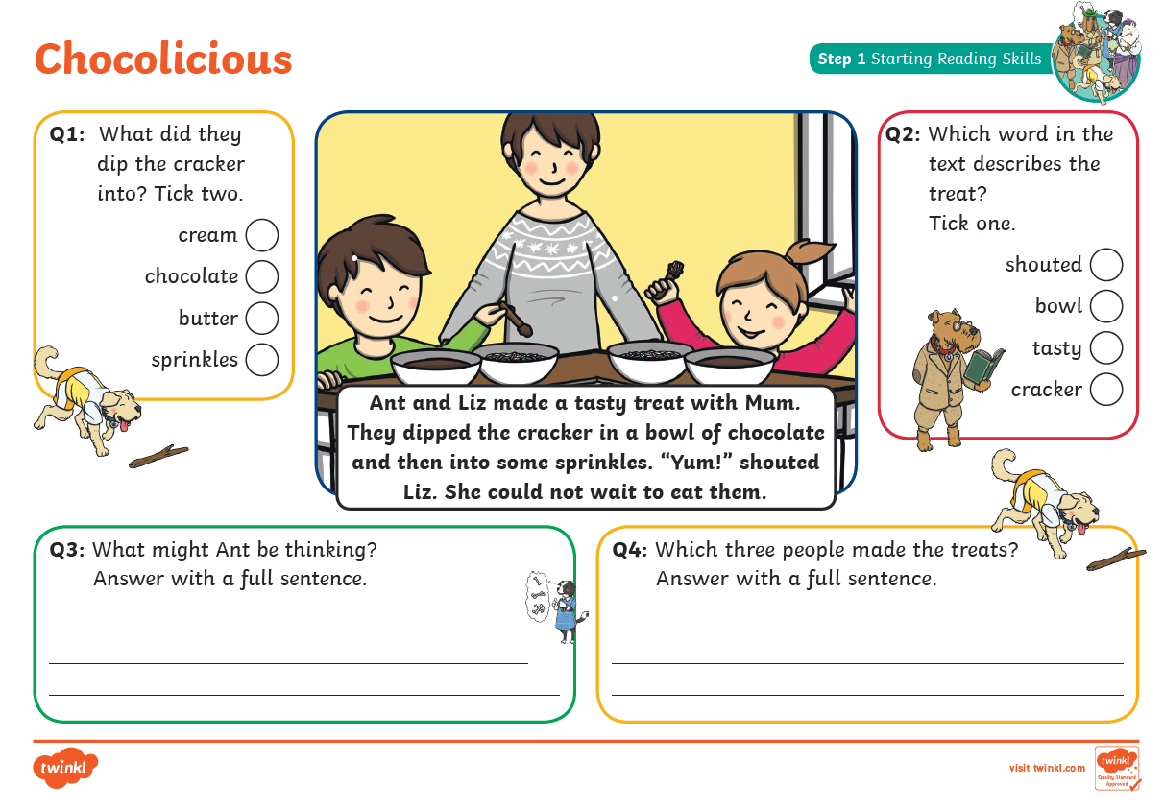
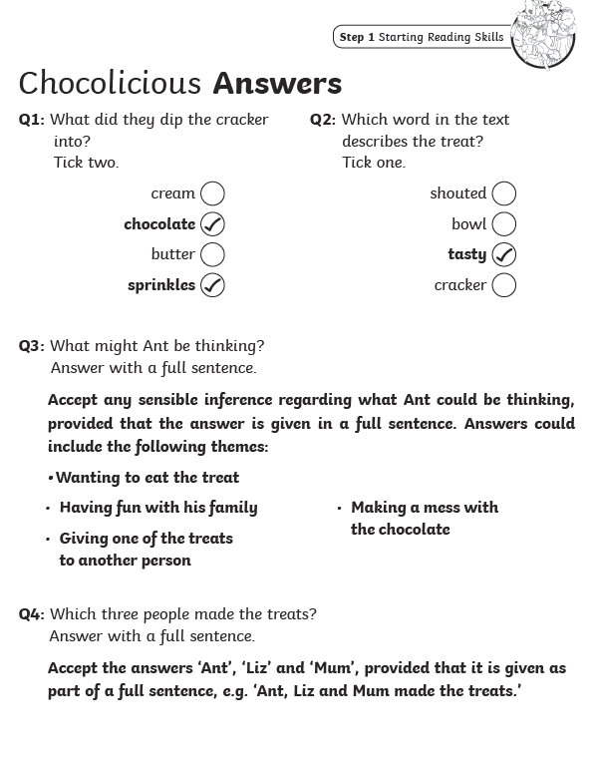

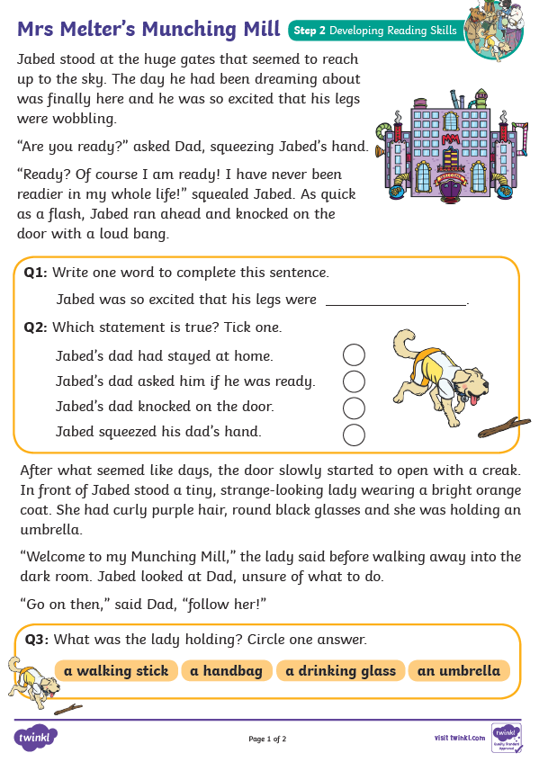
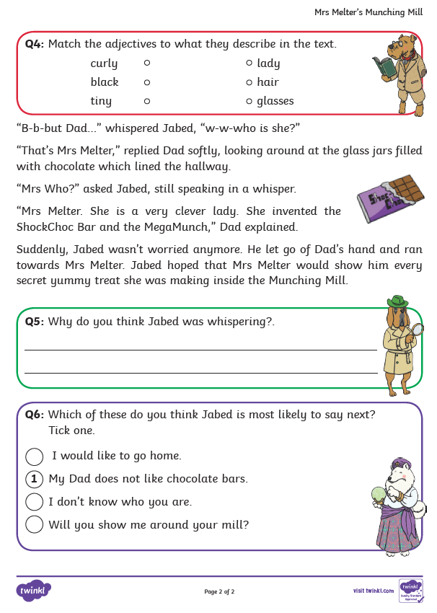
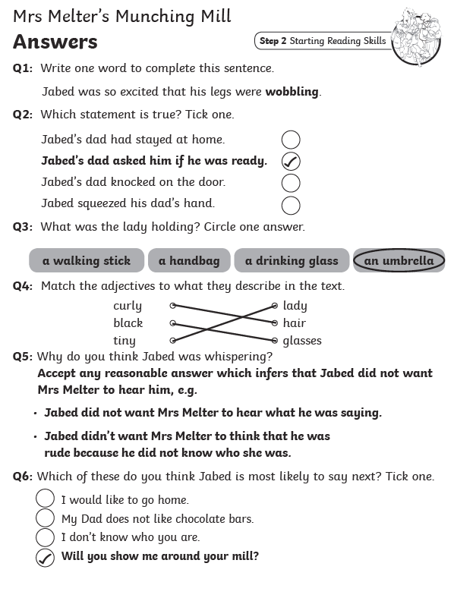
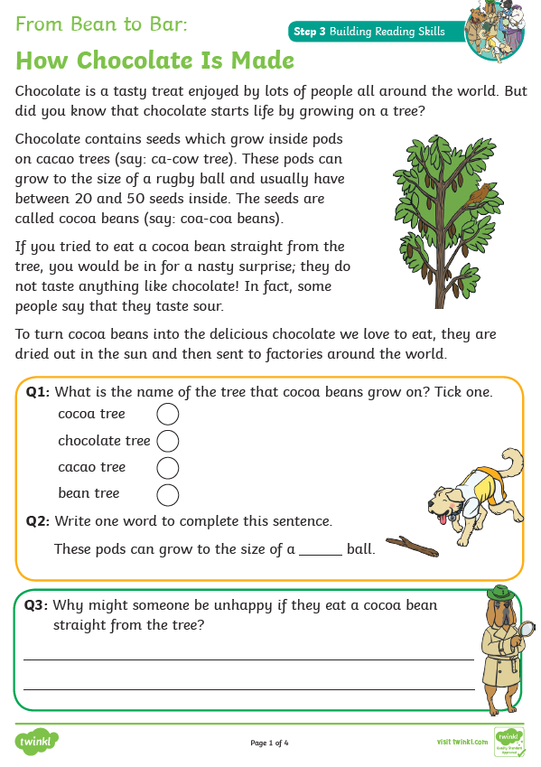
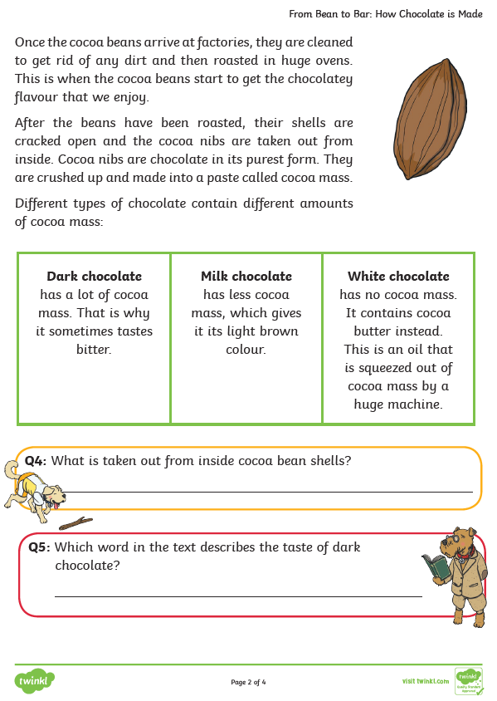
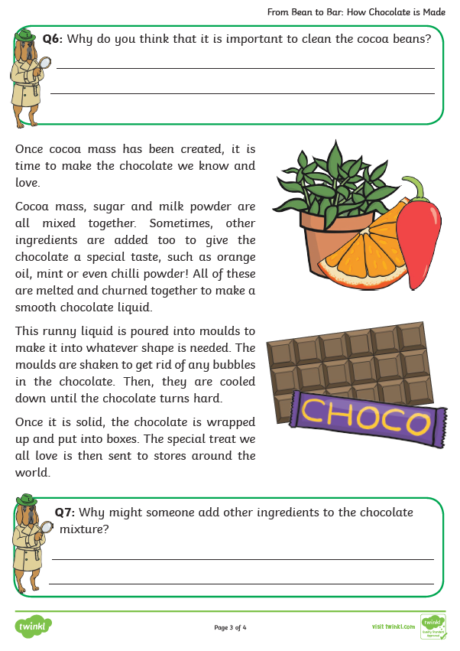
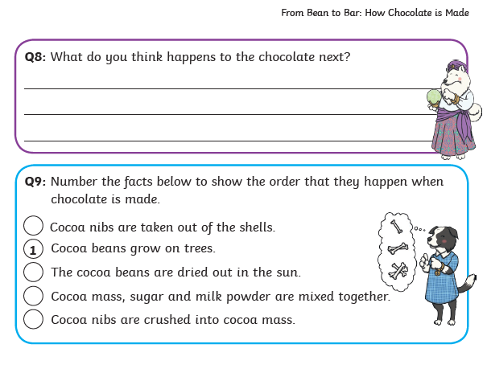

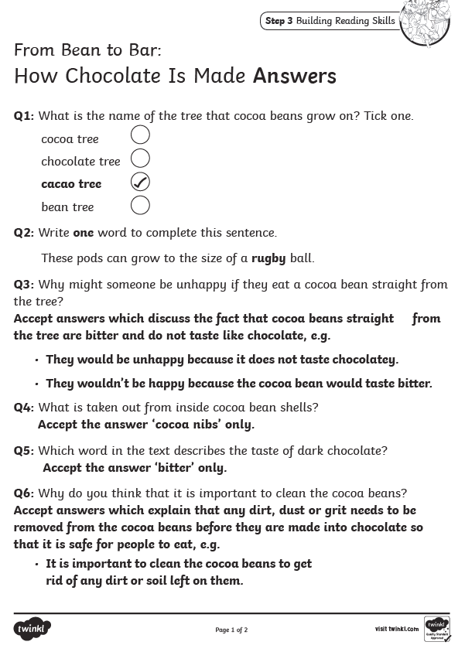
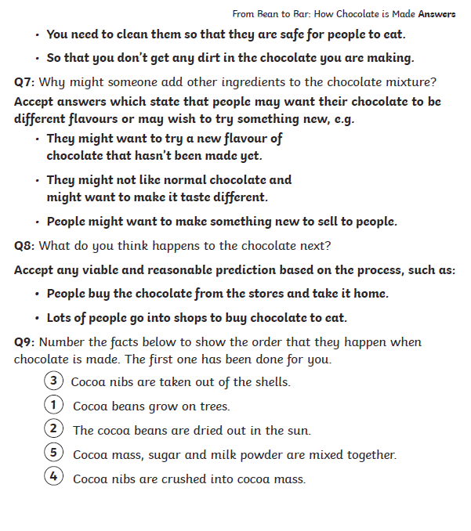

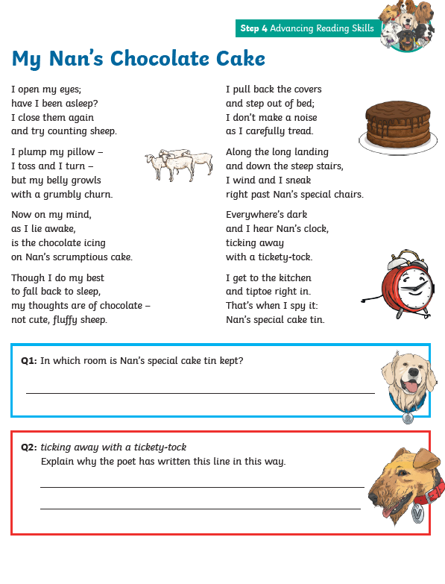
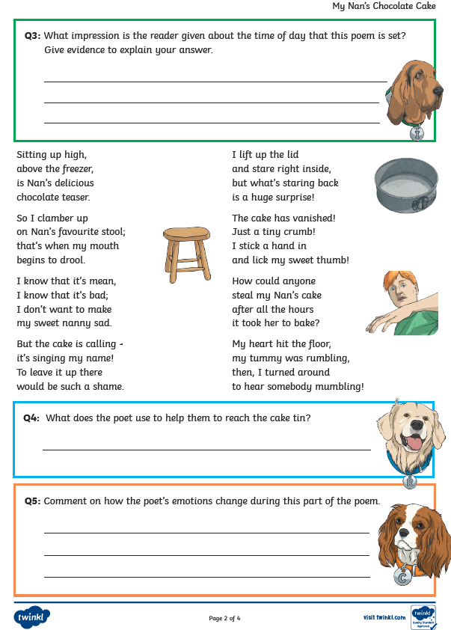
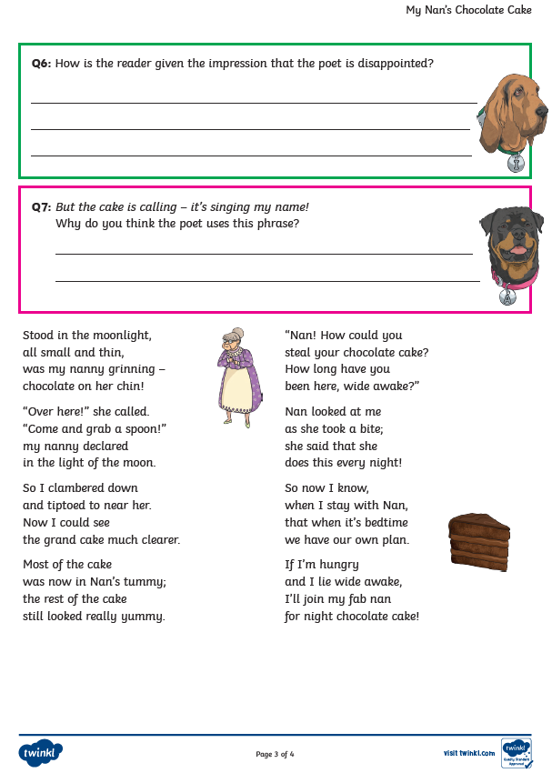
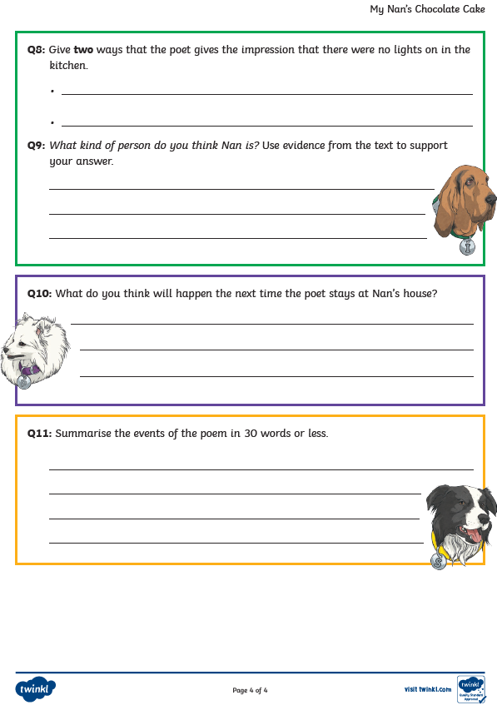
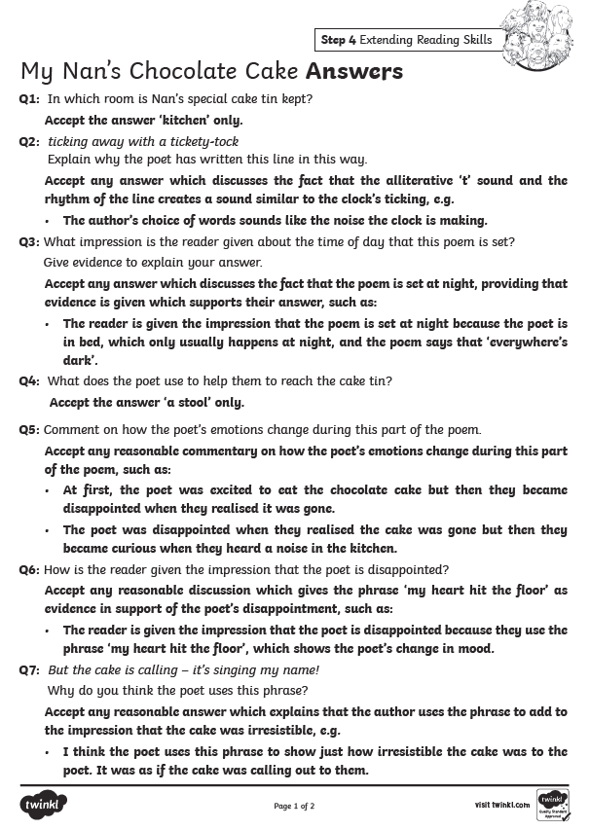
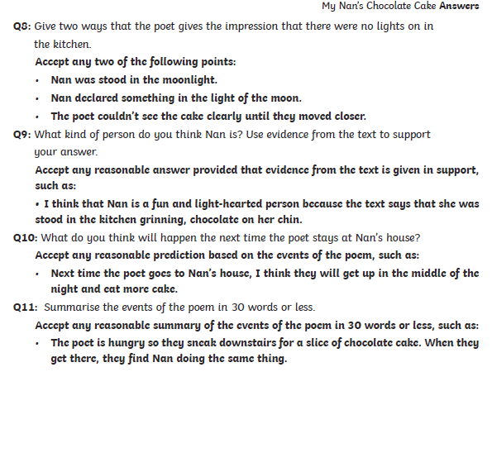

‘Should chocolate be allowed as a snack at break time in school?’
Reasons AGAINST
Chocolate should not be allowed
- _______________________________________________________________________________________________________________________________________________________________________________
- _______________________________________________________________________________________________________________________________________________________________________________
- _______________________________________________________________________________________________________________________________________________________________________________
- _______________________________________________________________________________________________________________________________________________________________________________

Reasons FOR
Chocolate should be allowed
- _______________________________________________________________________________________________________________________________________________________________________________
- _______________________________________________________________________________________________________________________________________________________________________________
- _______________________________________________________________________________________________________________________________________________________________________________
- _______________________________________________________________________________________________________________________________________________________________________________

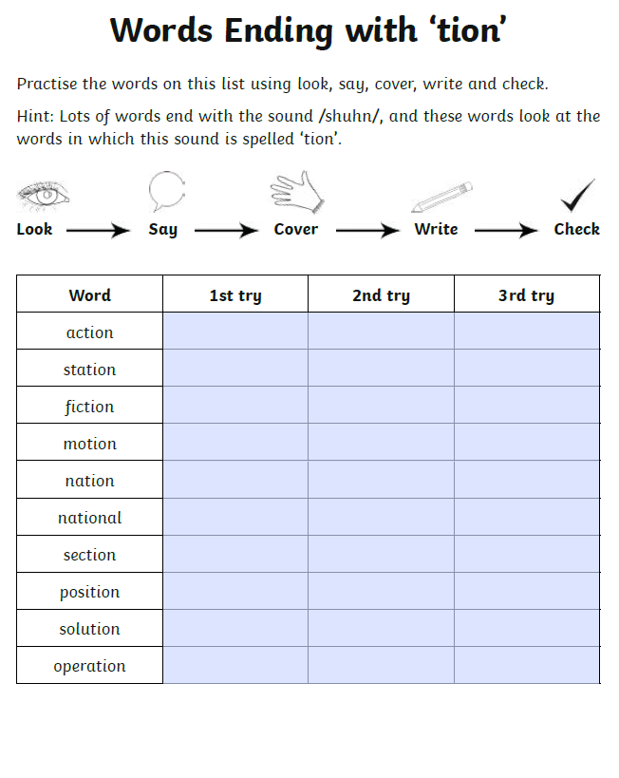

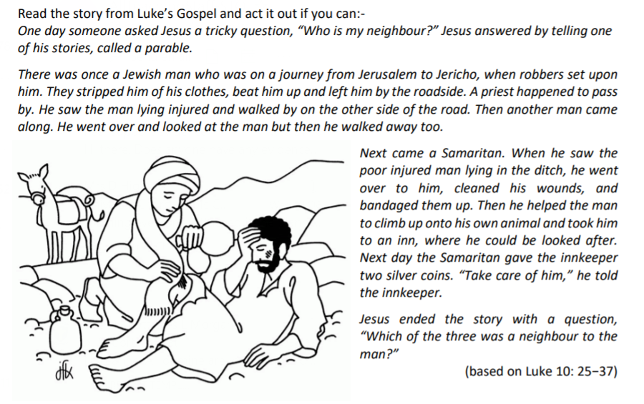
RE

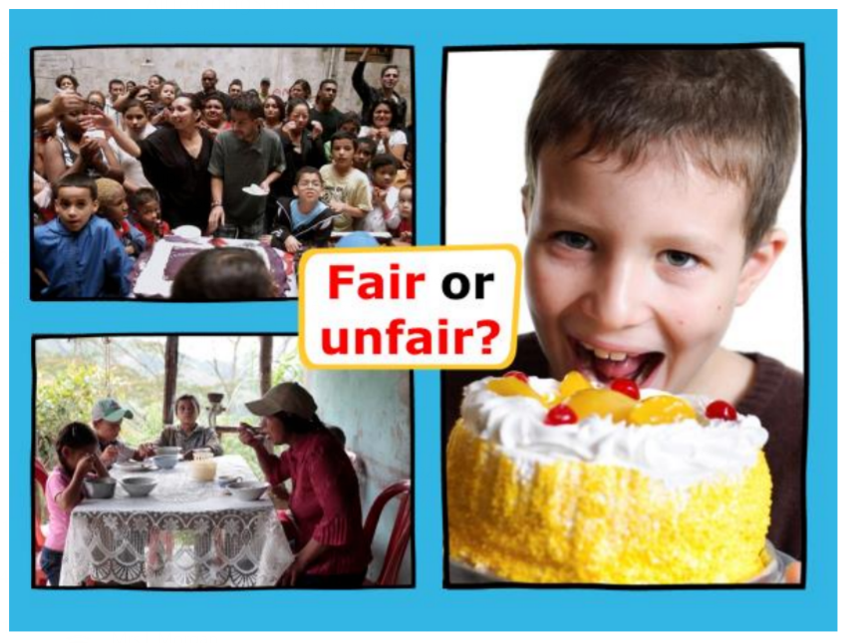
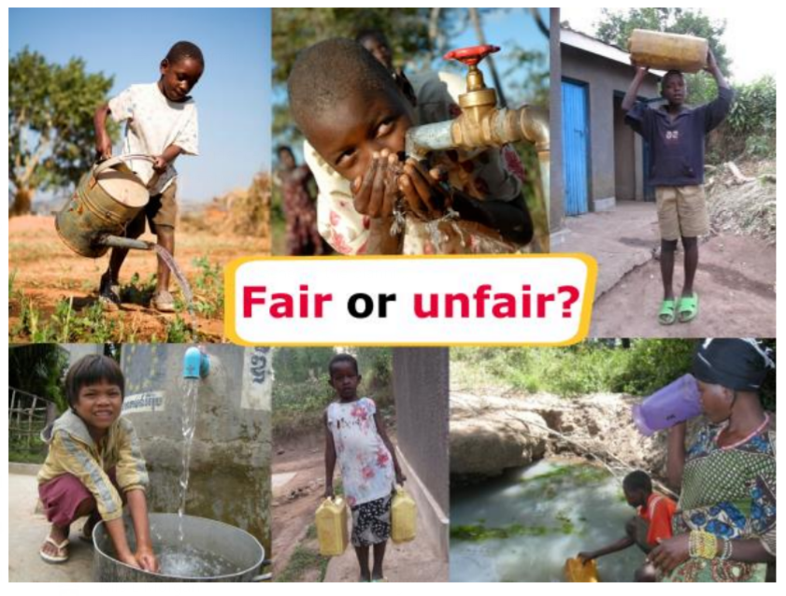
RE
