EAGLES’ WEEKLY SUGGESTED HOME LEARNING – WB 6.7.20
Good morning Eagles! How is it July already?! It has been lovely seeing and speaking to you all on Zoom over the last few weeks. We have some exciting things coming up in the last couple of weeks – we will be doing a Zoom worship and a leavers’ award ceremony! More details on these events soon. We also can’t wait to see you in the last week too. Remember to email us if you want to ask anything or let us know how you are doing. Well done to the children who are continuing to email work in! Have a great week.
Mrs Colothan, Mrs Hillam, Mrs Jones, Mrs Donlon and Miss Clegg XX
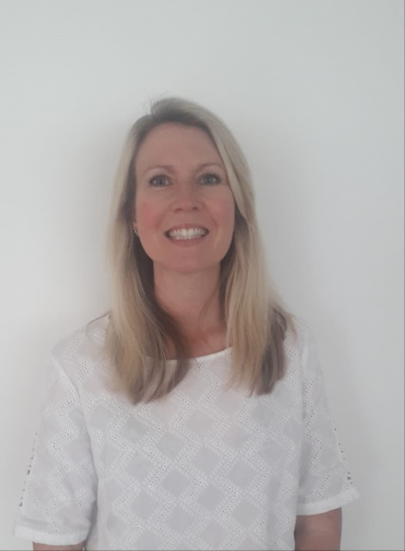
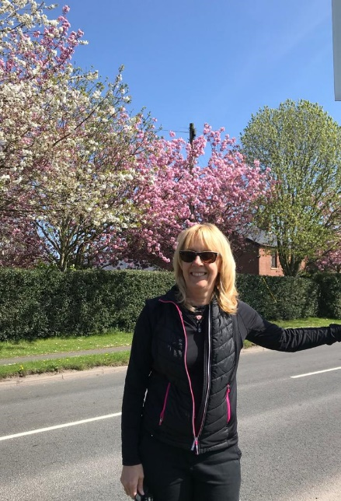

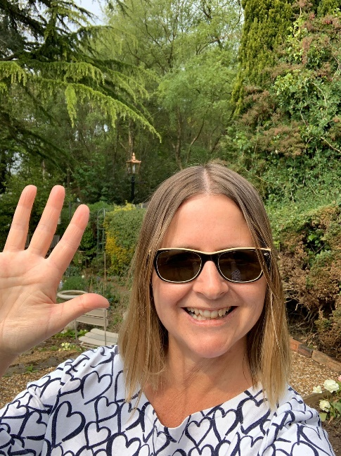
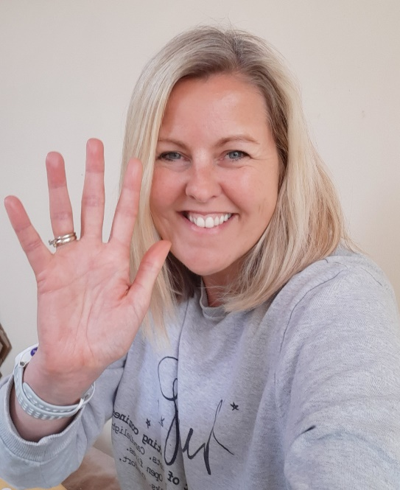

ENGLISH |  | MATHS
Reading – Read every day for pleasure for 30 minutes. You may like to use Epic. This is a great website where you read many online books for free for a month.  This week we will be focusing on writing a letter of complaint. Follow the link below and scroll down to ‘Letter of complaint’. There is a lesson for each day of the school week. Please follow these lessons in order.  https://classroom.thenational.academy/subjects-by-year/year-6/subjects/english  Grammar – Follow the link to refresh your understanding of using punctuation for parenthesis. Using punctuation for parenthesis is an important writing skill within a letter.  https://central.espresso.co.uk/espresso/primary_uk/subject/module/video/item361722/grade2/module305326/collection361842/section361748/index.html  Spellings – Use this link to access spelling activities on homophones and silent letters.  https://central.espresso.co.uk/espresso/primary_uk/subject/module/frontscreen/item709257/grade2/index.html?source=search-all-KS2-all-all&source-keywords=spelling%20y6 |  | 9 and 12 times table – Instant recall.  https://ttrockstars.com/  This week we will be using the nrich website. Normally in school, in the last few weeks of term, we would be completing a range of problem solving activities on a range of activities. Follow the links for the tasks below. There is one for each day. Some of the tasks are more challenging than others! Good luck!  https://nrich.maths.org/5632  https://nrich.maths.org/34  https://nrich.maths.org/8283  https://nrich.maths.org/2006  https://nrich.maths.org/12672  After each session, write a sentence or two to summarise what you have learned.
R.E. | OTHER
This week we are continuing with our unit of work based on the topic of The Universal Church- Our World. Please see resources which have been attached below. Continue to work through these.  Please feel free to access Cafod’s site for lots more engaging and free resources.  https://cafod.org.uk/Education/Primary-teaching-resources/Home-learning-primary  http://www.wednesdayword.org/ | Transition Tasks:  We are continuing with Robinhood Mat work.  Follow the link below and then scroll down to Y6/7 transition learning projects. Week beginning 6th July. The theme is about your individual qualities – recognising what you like, dislike and what you excel in.  https://www.robinhoodmat.co.uk/Learning-projects/  Science  Physical and Chemical Changes  You will have completed the lessons linked below last week.  This week you are to produce an information leaflet about physical and chemical changes (this was your English focused skill from last week). We are keeping your English skills ‘bubbling’!  https://classroom.thenational.academy/subjects-by-year/year-6/subjects/foundation  Music  This website includes a Ten Pieces film to watch and enjoy a linked creative activity that can be completed by you at home without any special materials or preparation!  A perfect, simple and easy way to keep listening, enjoying and creating music at this time.  https://www.bbc.co.uk/teach/ten-pieces/ten-pieces-at-home/zjy3382  ST. EDMUND ARROWSMITH TRANSITION TASKS  Try to complete three of these this week.  https://www.arrowsmith.wigan.sch.uk/parents/Y7-Intake

