BLACKBIRDS’ WEEKLY SUGGESTED HOME LEARNING – WB 1.6.20
Hi Blackbirds! Welcome back to home learning following half term. We hope you managed to get out and enjoy the beautiful weather we were blessed with. Here are this week’s home learning tasks. Please remember to tweet or email school, we really enjoy seeing what you are doing. Hope you enjoy the activities. #StaySafeStayHomeSaveLives
Miss Cartwright, Mrs Jackson and Mrs Harrison
ENGLISH | MATHS
Reading – Read every day for pleasure for 20 minutes.  Comprehension tasks – Ivan The Terrible  https://central.espresso.co.uk/espresso/modules/e2_comprehension_lks2/books/book_ivan_terrible.html Read the extract and answer the comprehension questions.  Writing –  1. Discover Education Poetry task- see the details below  2.Write a letter to a potential new child to describe our school. Include activities, lessons, rules etc.  3. Homophones activities  https://central.espresso.co.uk/espresso/primary_uk/subject/module/activity_index/item709251/grade2/index.html  Spellings – Homophones  Homophones worksheet from Twinkl- see below | Times tables – 2,3,4,5,6,8,10  https://ttrockstars.com/  4 times table  https://www.bbc.co.uk/teach/supermovers/ks1-maths-the-4-times-table-with-cyril-the-swan/zmsw382  8 times table  https://www.bbc.co.uk/teach/supermovers/ks2-maths-the-8-times-table-with-filbert-fox/z4mrhbk  White Rose Home Learning – Year 3 – Summer Term - Week 4 – multiplying and dividing  https://whiterosemaths.com/homelearning/year-3/  Watch the first half of lesson 3 then complete sheet 1 below.  Watch the second half of lesson 3 and complete sheet 2 below. You will need to have good recall of the 3,4,and 5 times tables to complete the partitioning activity. It might help the write out the times tables to help you.  Watch the first half of lesson 4 then have a go at sheet 3.  Watch the rest of lesson 4 before trying sheet 4.
R.E. | OTHER
The theme is: Serving and is linked to Pentecost.  Reconciliation – Inter-relating  CHOICES  Read the story below together and discuss the questions.  Design a table like this and record some choices you make this week. Record what choice you made, if it was good or wrong and what the consequences were for you and others.  Choice Good or Wrong Consequence | Science – Inner City Habitats  https://central.espresso.co.uk/espresso/modules/s2_habitats/video_pages/multivideo_city.html  Watch the videos and complete the online activities  Geography  Create a messy map of your local area – see example below  Music – Time for music Y3/4 Lesson 5  https://www.stoswaldswigan.co.uk/classes/fun-learning-games/music

L.I. Create your own homophone wordsearch

there
their
they’re
too
two
to
new
knew
knight
night
stare
stair
where
were
wear

Spellings –Homophones – Try the discovery activities- link above

Sheet 1 (Week 4 Lesson 3 QUESTIONS 1-4)
Dividing sharing base 10 equipment.
Tens | ones

69 ÷ 3 =

Tens | Ones
58 ÷ 4 =

65 ÷ 5 =
Tens | Ones

Sheet 2 (Week 4 Lesson 3 QUESTIONS 5-7)
Dividing by partitioning

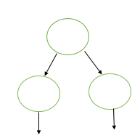
65 ÷ 5 =

54 ÷ 3 =

68 ÷ 4 =

Worksheet 3 ( Week 4 Lesson 4 Questions 1-3)
- There are 12 pencils and 3 rubbers.
How many more pencils than rubbers are there?

There are ______ times more pencils than rubbers.

- There are 15 flowers and 3 pots. How many more flowers than pots are there?

There are ______ times more flowers than pots.
- There are 16 cars and 4 buses.
How many more cars than buses are there?

There are ______ times more cars than buses.

Worksheet 4 ( Week 4 Lesson 4 Questions 4- 6)

- 21 is ______________times greater than 3.
_______ x 3 = 21

So the inverse is …
- is ______ x smaller than 21
21 ÷ 3 = ________

5. 20 is ______________times greater than 4.
_______ x 4 = 20

So the inverse is …
4 is ______ x smaller than 20
20 ÷ 4 = ________

. 6. 30 is ______________times greater than 5.
_______ x 5 = 30

So the inverse is …
5 is ______ x smaller than 30
30 ÷ 5 = ________
Discovery Education are looking for News Bites viewers to write haikus on the theme of Summer term 2020, please. That could mean a haiku simply on summer as a season or perhaps, for some of the older children, a haiku on what it feels like to return to school after weeks of lockdown, being reunited with friends and teachers (For those still at home, we are suggesting it could be a haiku that expresses thoughts on what home schooling is like for them).
They would like their News Bites item to feature several children reading their poems directly to camera, and to include shots of the poems written on the page as well, you will need to film your child, using iPhones (or similar!), holding the phone landscape not portrait. The children will need to be head and shoulders in shot like a news reporter and the poem on the page should be filmed separately (also landscape).
They hope you will find this a fun assignment. They will of course need parental consents signed, please see the form below.
They have resources on the site which give some guidance on haiku writing.
https://central.espresso.co.uk/espresso/primary_uk/servlet/file/store66/item1129206/doc.pdf

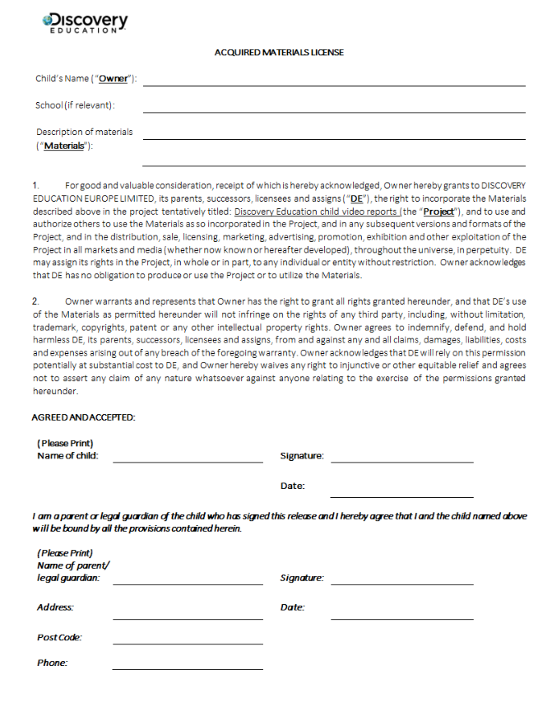

RE
Share this story:
It was holiday time, and lots of children were playing in the park. Tom and Andrew had met some of their friends and were looking forward to a good game of football. Just then, along came Paul. “Just look,” said Tom, “he’s got his sister with him!” And there she was. Jane was dressed in her shorts and was wearing new trainers. “What have you brought her for?” asked Andrew. “I had to choose,” said Paul. “Mum said I could come if I brought Jane, but if not, I would have to play with her at home.”

“It’s all right,” said Jane, “I can play football. I’ve been practising at home, and I’ve got my new trainers.” Tom liked Jane. He’d seen her kicking a football in the school playground and knew she wouldn’t spoil the game, but he felt a bit afraid of saying so. He thought Andrew wouldn’t be friends with him if he did.

“Hurry up,” shouted the rest of the gang. “Aren’t you going to play today?” It was now or never. “Come on Jane,” said Tom, “we’d better put our football boots on and show them.” Then he turned to Andrew, “Give her a chance,” he said. The game started before Andrew had a chance to answer. And they all enjoyed it. Tom, Paul and Andrew, and of course, Jane. None of them regretted that Paul had brought his sister with him.

SOME KEY QUESTIONS

- What do the words choice and consequence mean?
- What choices can you find in the story?
- What two choices did Mum give Paul?
- What do you think Paul said to his Mum?
- How do you think Jane felt when she heard what Tom said, and what Andrew said?
- How do you think Paul felt?
- What were the consequences of Paul’s choice?
- What choices have you had to make recently? How did you choose and what were the consequences? (Perhaps give some examples of class choices.)

Example of a Messy Map of local area

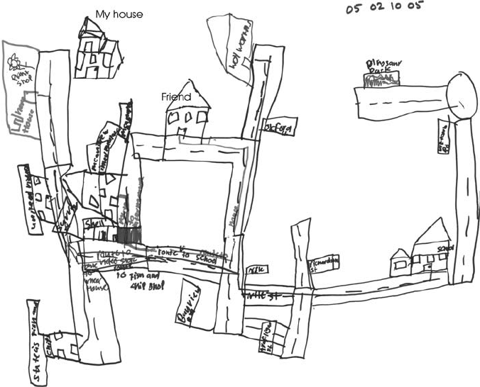

Information from Discovery Education
We are looking for News Bites viewers to write haikus on the theme of Summer term 2020, please. That could mean a haiku simply on summer as a season or perhaps, for some of the older children, a haiku on what it feels like to return to school after weeks of lockdown, being reunited with friends and teachers (For those still at home, we are suggesting it could be a haiku that expresses thoughts on what home schooling is like for them).

We would like our News Bites item to feature several children reading their poems directly to camera, and to include shots of the poems written on the page as well, so we will need teachers and parents to film the children, using iPhones (or similar!), holding the phone landscape not portrait. The children will need to be head and shoulders in shot like a news reporter and the poem on the page should be filmed separately (also landscape).

I hope some of your teachers and children will find this a fun assignment. We will of course need parental consents signed, please see attached.

We have resources on the site which give some guidance on haiku writing https://central.espresso.co.uk/espresso/primary_uk/servlet/file/store66/item1129206/doc.pdf

Please see the attached form below.

