BLACKBIRDS WEEKLY SUGGESTED HOME LEARNING – WB 13.7.20
Hi Blackbirds! This week is your final week in Blackbirds. I hope you enjoy this week’s activities which will lead us into the holidays. If you have any problems, please don’t hesitate to email or tweet school, I’m here to help!
Miss Cartwright, Mrs Jackson and Mrs Harrison XX
ENGLISH | MATHS
Reading – Read every day for pleasure for 20 minutes.  Last week we celebrated the 72nd birthday of the NHS. The NHS has been very important to everyone over the last few months so I thought we could celebrate the NHS ourselves this week.  Comprehension – Celebrating The NHS  Writing –  - Write an acrostic poem about someone in the NHS eg. doctor, nurse, paramedic, reflecting the job they do and how they help us.  - Complete the NHS wordsearch  - Research who Clement Attlee and Aneurin Bevan are. (There names are on the wordsearch) Write a paragraph about each man.  Spellings –Contractions revision–Think carefully about where the apostrophe is! Complete the activity below, learn the spellings and put them into sentences. | Times tables 2,3,4,5,6,8,10  https://ttrockstars.com/  https://www.bbc.co.uk/teach/supermovers/  White Rose Home Learning – Year 3 – Summer Term - Week 10 - shape and time  https://whiterosemaths.com/homelearning/year-3/  Use worksheets below and BBC Bitesize to support the videos
R.E. | OTHER
SPECIAL PLACES  Relate  Our world has been given to us by God, to enjoy, to share and to take care of so we should see it as a Special Place and take of it.  Think of as many ways as they can that enable us all to care for God’s world and to protect it as a special place. Make a promise to care for the world and write it on a heart shape.(See below) Illustrate your promise. | Have a go at the puzzle activities on the sheets below.  Music – Time for music Y3/4 Lesson 11  https://www.stoswaldswigan.co.uk/classes/fun-learning-games/music  Art- Create some summer landscape pictures. These could include the seaside, a summer garden, a summer woodland or the city you researched.
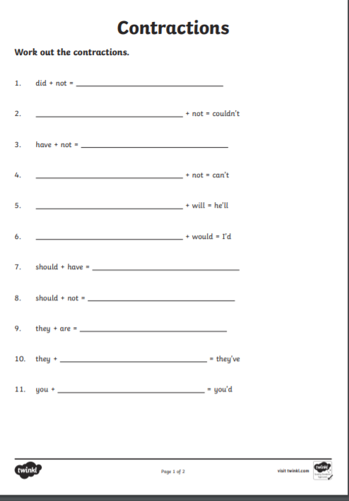

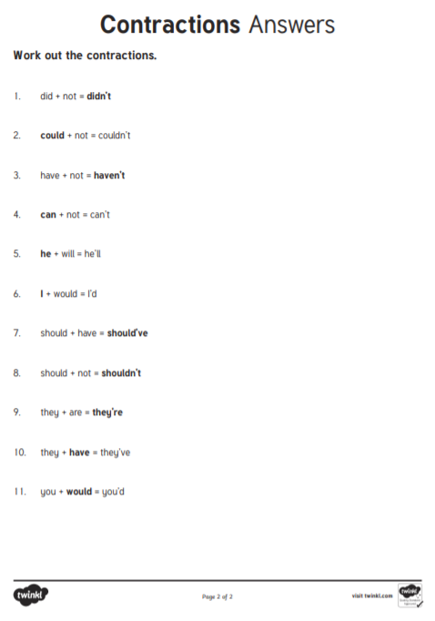
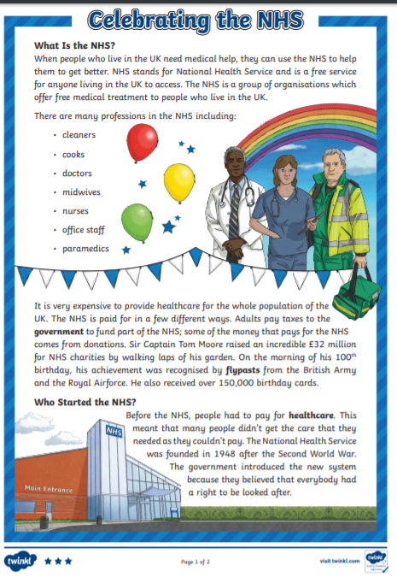
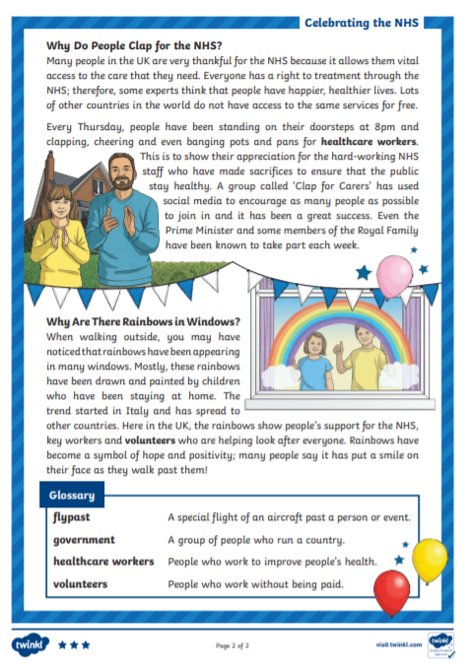

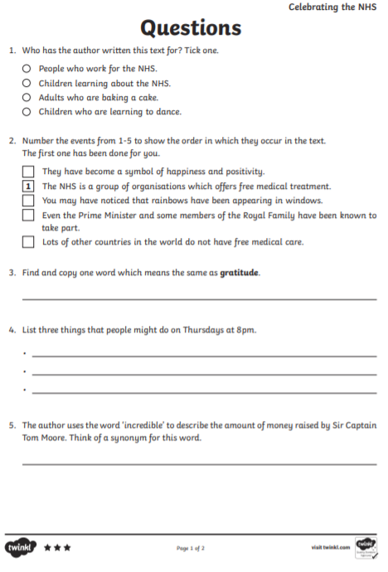
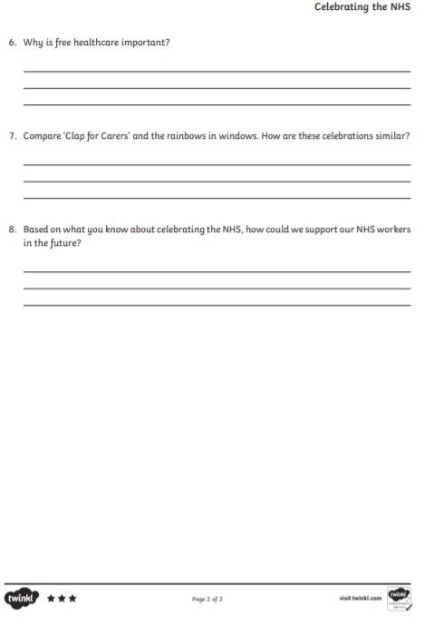

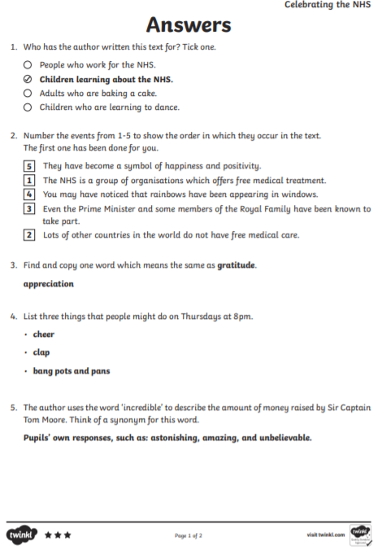

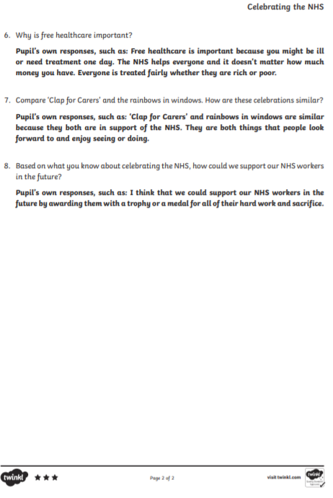
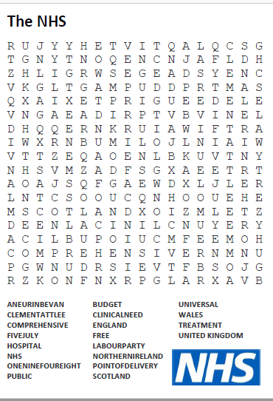

My Promise

