BLACKBIRDS WEEKLY SUGGESTED HOME LEARNING – WB 4.5.20
Hi Blackbirds! Hope you enjoyed last week’s activities. We have enjoyed seeing what you have been up to on Twitter and email. Keep sending these in FAO of Miss Cartwright to enquiries@saintoswalds.wigan.sch.uk. Here are some more activities for you to try this week. We hope that you really enjoy them. Take care - #StaySafeStayHomeSaveLives
Miss Cartwright, Mrs Jackson and Mrs Harrison XX

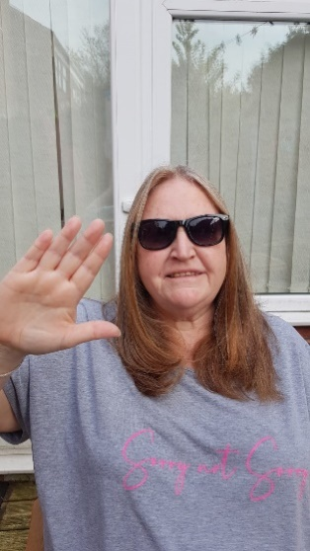
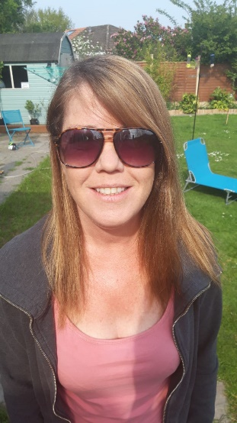
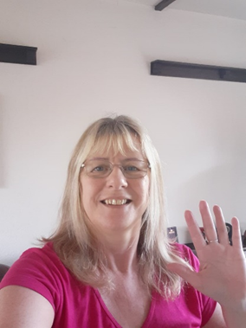

ENGLISH | MATHS
Reading – Read every day for pleasure for 20 minutes.  Comprehension tasks –Pet care of a dog (See below)  https://www.twinkl.co.uk/resource/t2-e-3760-lks2-reading-comprehensions-bumper-resource-pack  Writing – Write your own report for taking care of a pet (If you don’t have a pet you could write about an imaginary pet or write about how you would take care of a plant) (Use reading task as a template)  See also history activity.  Spellings – Y3 – adding the suffix ian (RWI Book 3 Unit 10) e.g. magician, mathematician, (See attached list) – choose the right word (See below)  Write sentences of your own with each of the words in. | 4 times table – instant recall  https://www.bbc.co.uk/teach/supermovers/ks1-maths-the-4-times-table-with-cyril-the-swan/zmsw382  White Rose Home Learning – Year 3 – Summer Term - Week 2 – 27/4/20 - Fractions  https://whiterosemaths.com/homelearning/year-3/  If this is a step to far, Week 1 and Week 2 just above the Summer Term links go back to basic fractions to support your child.  There is also the option to go to the year 2 Maths work too. Everything helps.  https://whiterosemaths.com/homelearning/year-2/
R.E. | OTHER
The theme is: Serving and is linked to Pentecost.  REVEAL  Read the extract from Acts 1: 6-11 (See below)  Draw a picture of Jesus at the ascension – add a speech bubble to show the promise Jesus made or write a paragraph to describe what happened.  Imagine you are one of the apostles after Jesus had returned to his Father. Having witnessed how Jesus served others, how will you continue his mission? In a method of your own choosing, record what actions you would take and give reasons for your choices | Science – What is a food chain? Watch the BBC bitesize clips below  https://www.bbc.co.uk/bitesize/topics/zx882hv/articles/z3c2xnb  https://www.bbc.co.uk/bitesize/topics/zbnnb9q/articles/zwbtxsg  Complete the worksheet (See below)  History – Ancient Egyptians – Start to create a scrap book all about the Ancient Egyptians – this week continue with your scrap book – what can you find out about the pyramids? Can you write a non-chronological report about them to add to your book? (Look at last week’s lessons for key features of a non-chronological report)  http://www.primaryhomeworkhelp.co.uk/egypt/pyramids.htm  https://www.bbc.co.uk/iplayer/episode/b00jzygg/horrible-histories-series-1-episode-2  https://www.bbc.co.uk/bitesize/topics/zg87xnb  Music – Time for music Y3/4 Lesson 2  https://www.stoswaldswigan.co.uk/classes/fun-learning-games/music

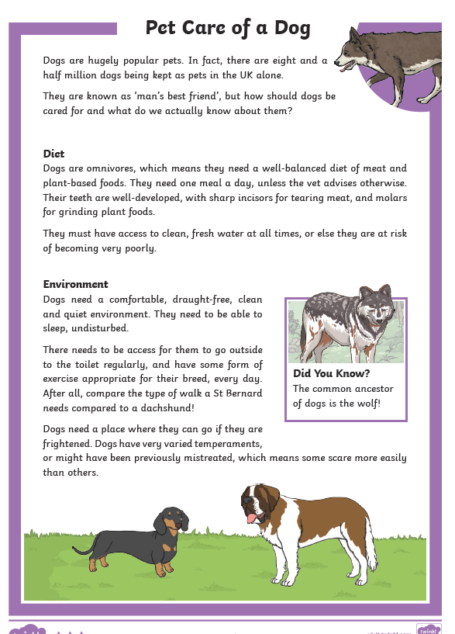

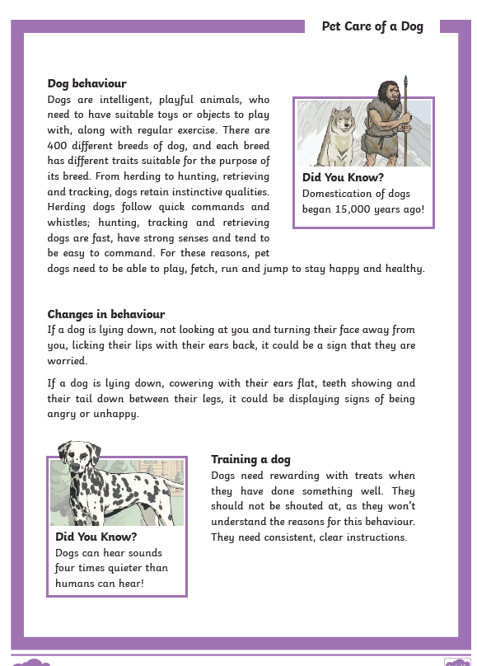
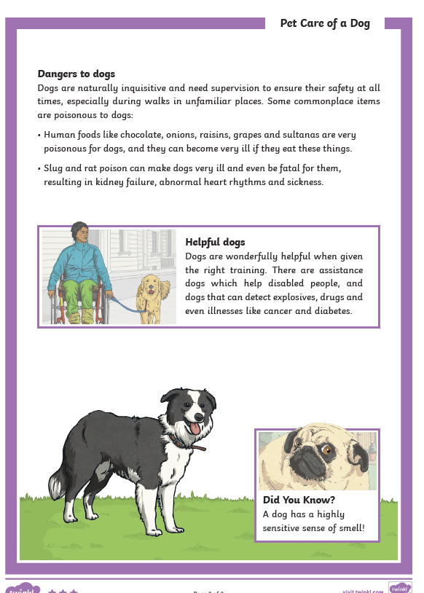
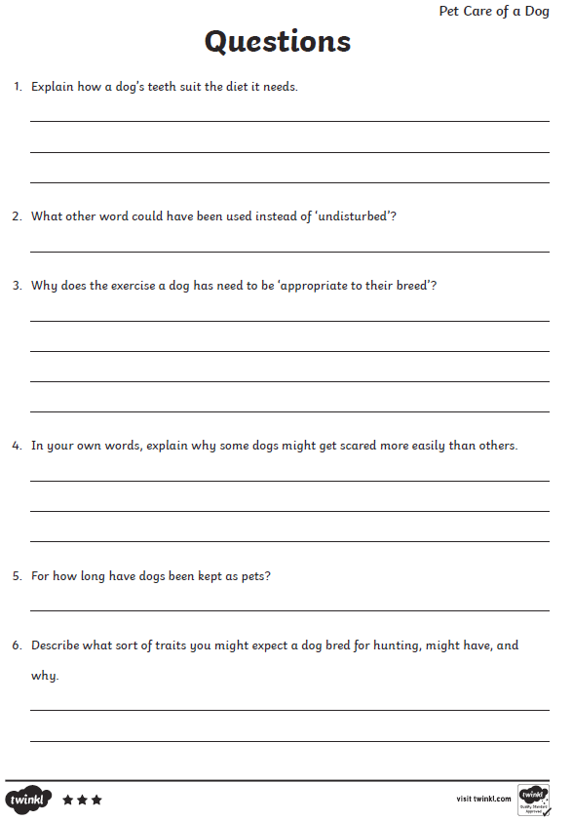
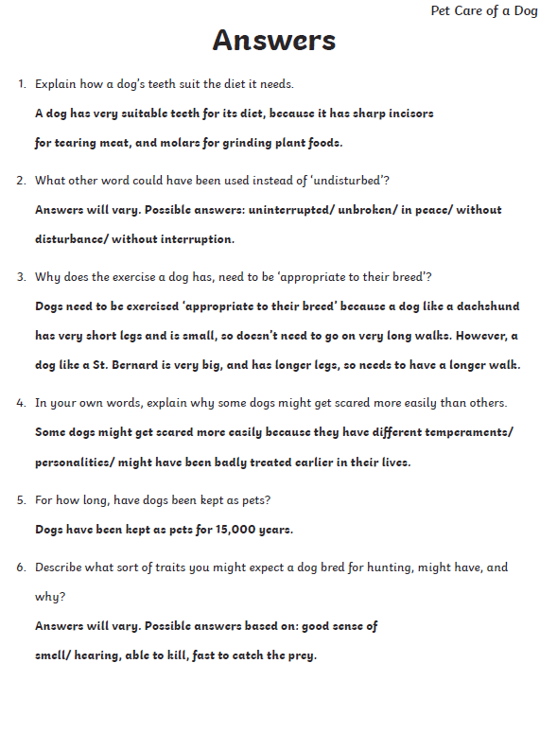

Choose the right word
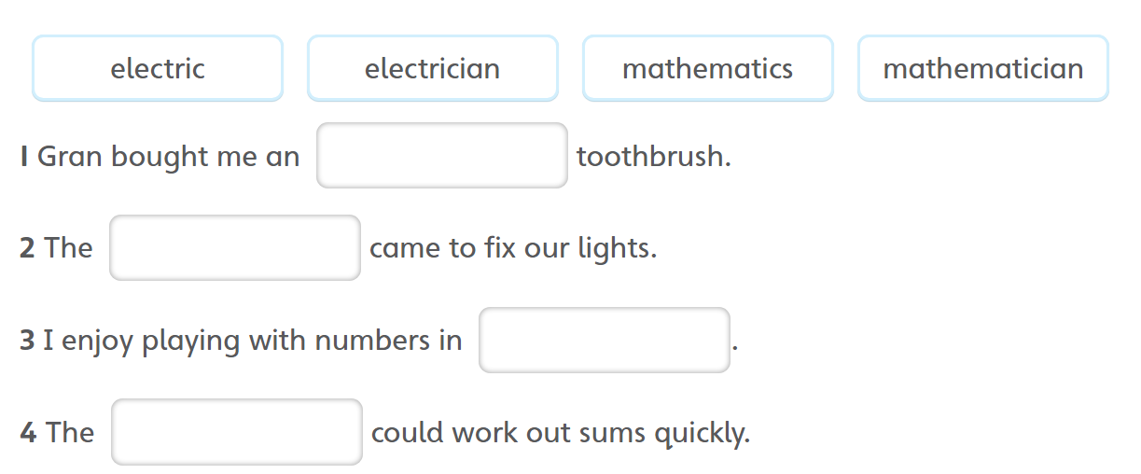

Spellings This week’s focus is adding the suffix –ian to words ending in c or cs.
music
musician
electric
electrician
optic
optician
magic
magician
politics
politician
mathematics
mathematician
Jumping Orange Words
difficult
grammar
guard
guide

RE
After Jesus had been raised to new life, he told his friends,
“You will receive the power of the Holy Spirit. You will be my witnesses here in Jerusalem and all over the world.”
As he said this, he disappeared from sight.
They realised that he had gone back to his Father as he had said he would.

Based on Acts 1: 6-11

.

The Church celebrates the Ascension forty days after Easter Sunday, the day of the Resurrection.
Teaching Point

A disciple is a follower of Jesus. An apostle is someone who is sent out to spread the Good News of Jesus to the whole world.

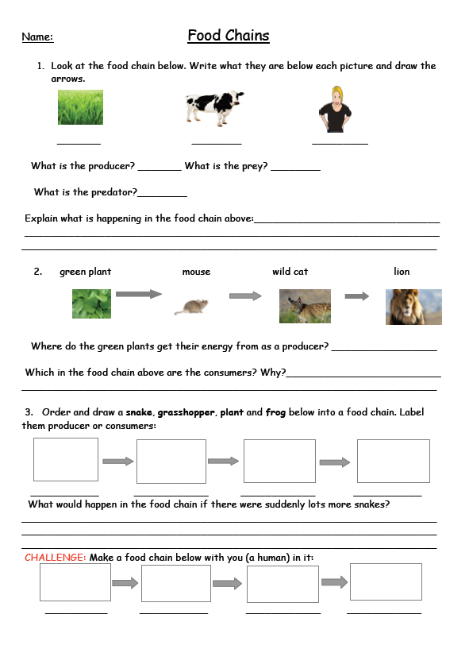

Food Chain Answers

