BLACKBIRDS’ WEEKLY SUGGESTED HOME LEARNING – WB 8.6.20
Hello Blackbirds! I hope you enjoyed last week’s tasks. Here are this week’s home learning activities. Please remember to tweet or email school, I really enjoy seeing what you are doing. Please also let us know if you are having any trouble with these, I’m here to help. #StaySafeStayHomeSaveLives
Miss Cartwright, Mrs Jackson and Mrs Harrison

ENGLISH |  | MATHS
Reading – Read every day for pleasure for 20 minutes.  Comprehension tasks –  https://central.espresso.co.uk/espresso/primary_uk/subject/module/video/item983189/grade2/module983185/index.html  Watch the video above and then complete The Heroes and Villains’ activity.  Writing –  - Create your own villain or hero using the sheet below.  - Describing characters activity  - Contrasting characters activity  Spellings – 1. words ending in ous spellings  2. Adding ous activity -sheet below  3. ous wordsearch- below |  | Times tables 2,3,4,5,6,8,10  https://ttrockstars.com/  https://www.bbc.co.uk/teach/supermovers/  White Rose Home Learning – Year 3 – Summer Term - Week 5–fractions  https://whiterosemaths.com/homelearning/year-3/  Watch lesson 1 then have a go at the first fractions sheet below. –  Watch lesson 2 then have a go at the second sheet.  Lessons 3 and 4 are revising work we did in class on tenths. You might recognise the worksheets but having another go is good practice.  Watch lesson 3 then have a go at the third sheet.  Watch lesson 4 then have a go at the forth sheet.
R.E. | OTHER
The theme is: Serving and is linked to Pentecost.  Reconciliation – Inter-relating  CHOICES  - Read the story below and then complete one of the following activities.  Imagine you were in the Temple the day Jesus told the story. Write a letter to a Christian community making links between what you heard and how that might help a Christian make choices.  Write/draw/act your own up-to-date story to illustrate choosing the good and the consequences. | Science – Habitats – create a bug house  https://www.rspb.org.uk/get-involved/activities/give-nature-a-home-in-your-garden/garden-activities/build-a-bug-hotel/#:~:text=Build%20a%20bug%20hotel%20Choose,other%20insects%20will%20love%20it.  Follow the instructions from the link above to create a bug hotel and perfect habitat for our smaller friends.  Geography - What has Ashton got to offer? If you had to persuade someone to visit Ashton and the surrounding area what would you say? Create a tourism leaflet for Ashton/ Wigan.  Include-leisure activities, housing, schools, places to visit, shops.  Use the template below or create your own. The link below gives a step by step guide to leaflet writing.  https://www.bbc.co.uk/bitesize/topics/zkgcwmn/articles/zrjqpg8  Music – Time for music Y3/4 Lesson 6  https://www.stoswaldswigan.co.uk/classes/fun-learning-games/music  Art- Before assembling your bug house create a piece of natural art and take a photograph of it.  Follow the link to see some examples of art by Andy Goldsworthy  https://www.bbc.co.uk/bitesize/clips/zh4wmp3

famous
serious
obvious
hideous
anxious
jealous
furious
glamourous
enormous
tremendous
hideous
curious
humorous
mountainous
outrageous

Can you think of any more examples?
Choose 5 of the above words and write a sentence for each.

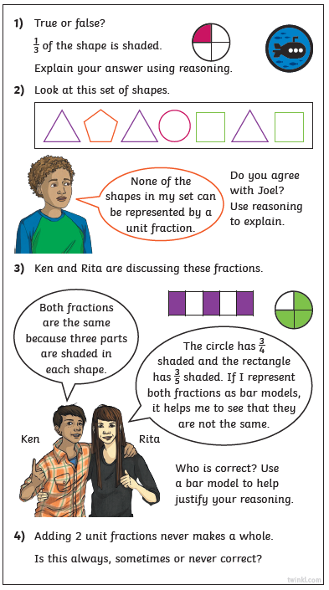
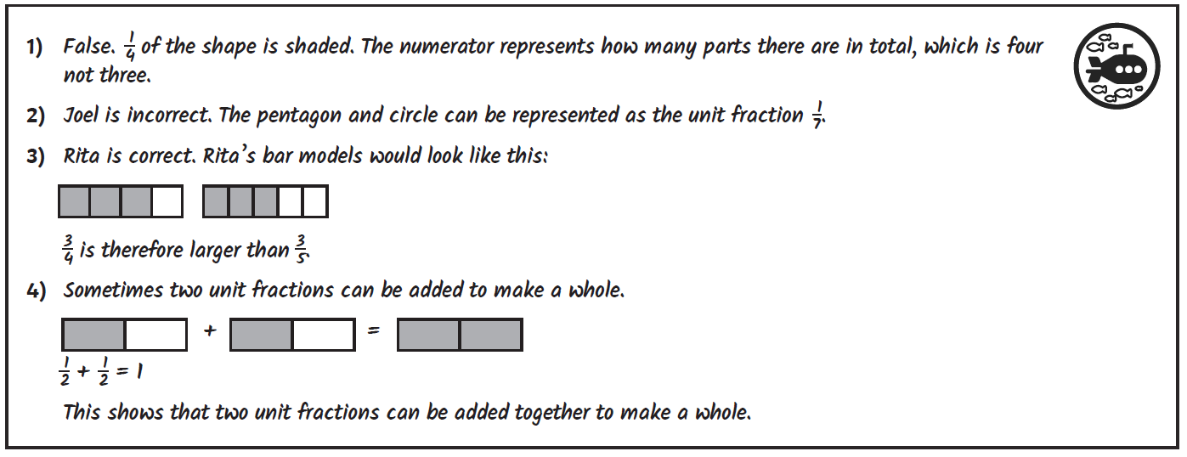

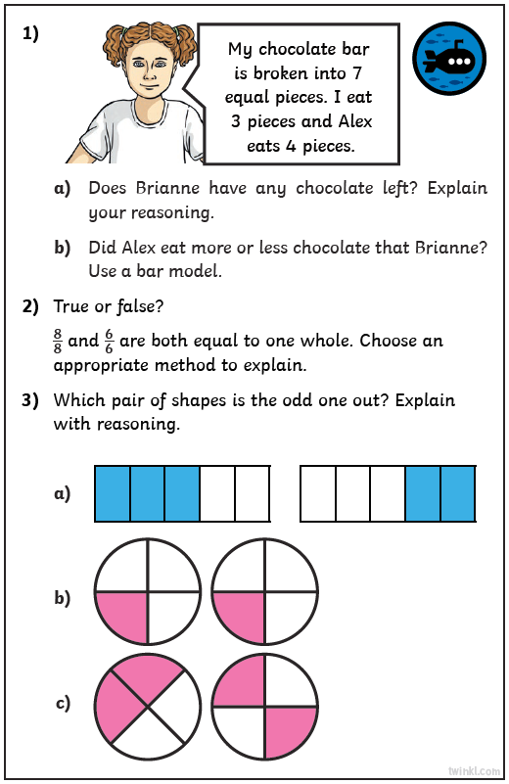
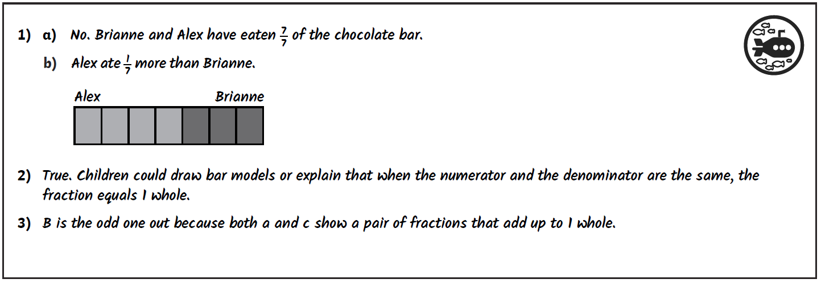

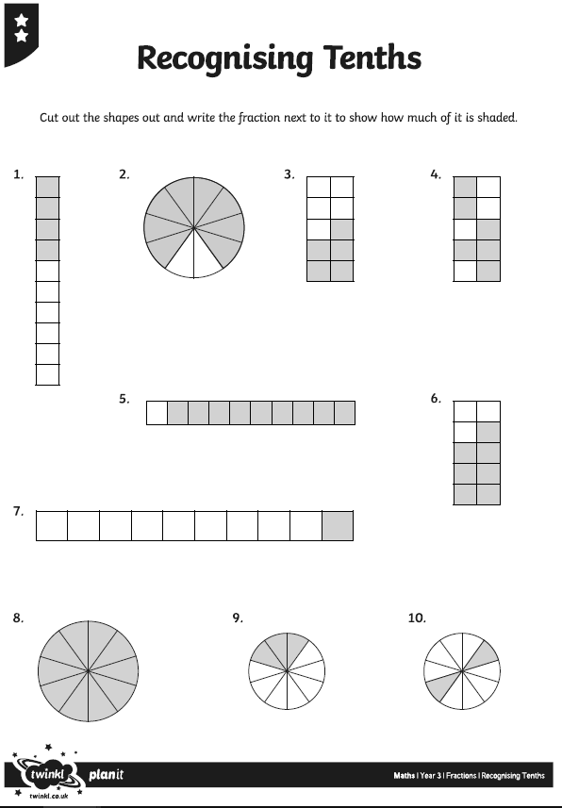
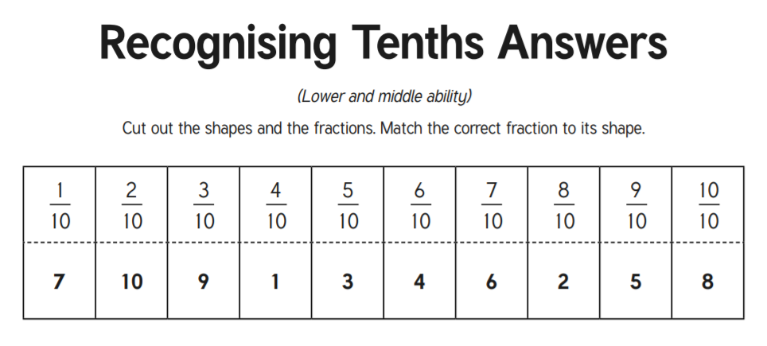
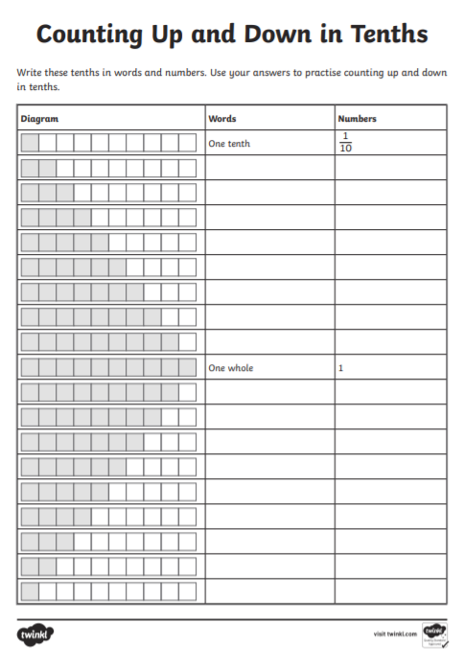

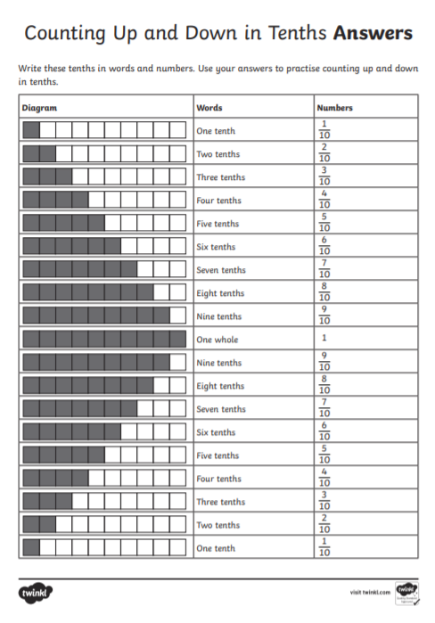

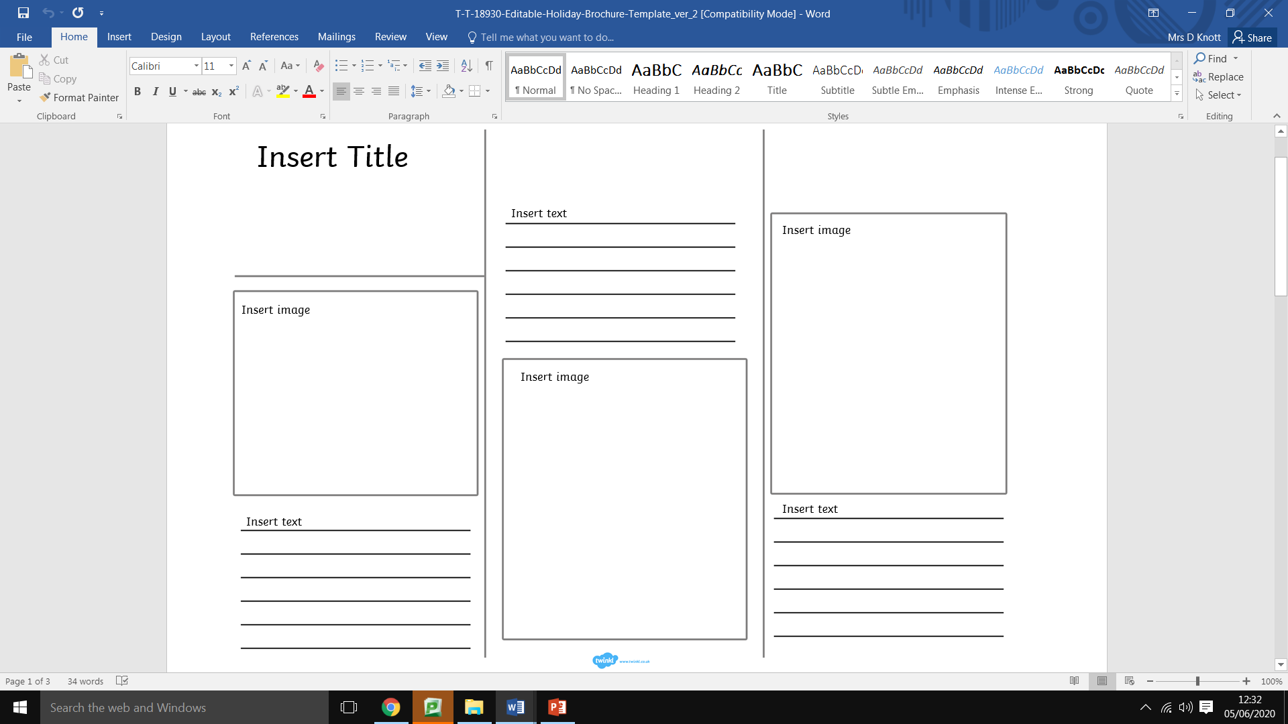

Information from Discovery Education
We are looking for News Bites viewers to write haikus on the theme of Summer term 2020, please. That could mean a haiku simply on summer as a season or perhaps, for some of the older children, a haiku on what it feels like to return to school after weeks of lockdown, being reunited with friends and teachers (For those still at home, we are suggesting it could be a haiku that expresses thoughts on what home schooling is like for them).

We would like our News Bites item to feature several children reading their poems directly to camera, and to include shots of the poems written on the page as well, so we will need teachers and parents to film the children, using iPhones (or similar!), holding the phone landscape not portrait. The children will need to be head and shoulders in shot like a news reporter and the poem on the page should be filmed separately (also landscape).

I hope some of your teachers and children will find this a fun assignment. We will of course need parental consents signed, please see attached.

We have resources on the site which give some guidance on haiku writing https://central.espresso.co.uk/espresso/primary_uk/servlet/file/store66/item1129206/doc.pdf

Please see the attached form below.

