St. Oswald’s Essential Safety Information Leaflet
WHAT ARE WE PUTTING IN PLACE TO STAY SAFE? | REALLY IMPORTANT POINTS TO KNOW | WHAT IF I CHOOSE TO KEEP MY CHILD AT HOME?
Hand gels, hand wash / soap and tissues will be available in all rooms and at the entrance of school. | 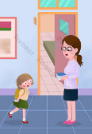  Children will be met at the gate by a member of staff. No parents or adults will be allowed onto the premises unless in an emergency. | You will not be fined for keeping your child at home and their attendance record will not be affected.
Deep clean prior to pupils returning and additional disinfecting of toilets and surfaces throughout the day. | All children MUST have their own water bottle which will be filled up by a member of staff throughout the day. | Children at home should continue to access their school work via the website.
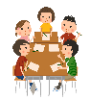  Pupils will stay in “bubbles,” which will not interact with other bubbles at all. Outdoor learning will be prioritised and the outdoor areas are zoned. | 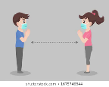  Staff will encourage social distancing where possible but this cannot be guaranteed at all times. | Y6 pupils will receive some online sessions with their class teachers. A timetable of these will be sent out.
Pupils will be regularly reminded to wash their hands effectively with frequent handwashing timetabled in throughout the day. This will be monitored by staff. | 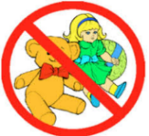  Packed lunch children must bring lunch in a plastic bag which can be disposed of and must not bring in any toys or anything else from home. | Home-learning will be continuing and this will be similar to work offered in school. Teachers in school will not be able to respond to Tweets / See Saw / Emails during the school day, but they will get back to you.
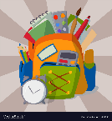  Every pupil will have their own equipment to use and will not share resources. No resources are to be brought in from home. | 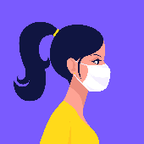  Staff may wear masks or gloves. If staff have to support pupils with major first aid issues, PPE will be worn. Pupils will not be required to wear masks and gloves. | If you have said that your child will not be returning and you change your mind, you must contact school and give us a week’s notice to prepare.
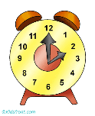  Pupils will have an allocated arrival and departure time to avoid large groups by the school gates. | Parents must not gather at the gates and must ensure they apply social distancing at the drop off and collection point. Only 1 parent/carer should drop off and pick up. | If you have said that your child will be returning and you change your mind, you must contact school and inform us straight away.
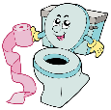  The school is zoned off so that each bubble has their own toilets and sinks and no child will leave their zone to go into other zones. | 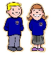  Pupils must wear their uniform and will need fresh clothing each day. Suitable alternatives are acceptable if children have outgrown their uniform or it’s an issue to provide fully clean clothing each day. | Communication of latest information available will continue via: Text, Email, SeeSaw (EYFS), the website, survey, Schudio and Twitter so please keep checking this regularly.
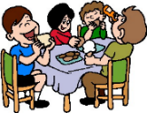  Pupils will be having staggered break times and lunch times and will be monitored by their designated teachers. They will have lunch in their zone and will be monitored by 1 different adult during lunch times who will be specifically assigned to that bubble. | 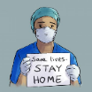  If a child / adult in your child’s bubble has symptoms, every child/teacher in the bubble will be asked to self-isolate for 14 days. Any symptoms must be reported immediately and a test must be arranged. Results must be reported to school. If your child has symptoms, they must not come to school and school must be informed. | Staff will endeavour to make additional contact with pupils who are not attending school to check on their wellbeing and/or learning.
All unnecessary resources have been removed from each zone in order to maximise space and support with thorough cleaning. | School hours will be different as they will be staggered to limit the number of pupils arriving at any given time. You will be informed of your time and must keep to this. | 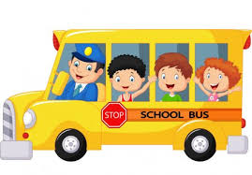  If you have to use public transport to travel to school, we would encourage you to stay at home.
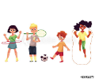  Limited outdoor equipment will be available and will be disinfected after each use. A member of staff is overseeing this and has prepared no/limited equipment activities. | School is only open from Monday to Thursday so that deep cleaning can take place. School will remain open for key worker children on Friday. | Feel free to contact school about any queries or concerns that you may have over the coming weeks.

