EAGLES’ WEEKLY SUGGESTED HOME LEARNING – WB 1.6.20
Good morning Eagles! We hope that you all had an amazing half term and you’ve been outside enjoying this beautiful weather. We didn’t hear too much from most of you before half term, so try this week to send us an email, even if it’s just to say hi. We’re putting together some transition work each week and we’re working hard to add in a few Zoom sessions in the coming weeks too. Unfortunately at this moment in time, we can’t have everyone back in school together but hopefully a virtual catch up will be the next best thing. We’re missing you all so much and we’re so sad that this has happened. We feel lucky that we had Robinwood together though – even in freezing cold February!
Take care - #StaySafeStayHomeSaveLives
Mrs Colothan, Mrs Hillam, Mrs Jones, Mrs Donlon and Miss Clegg XX
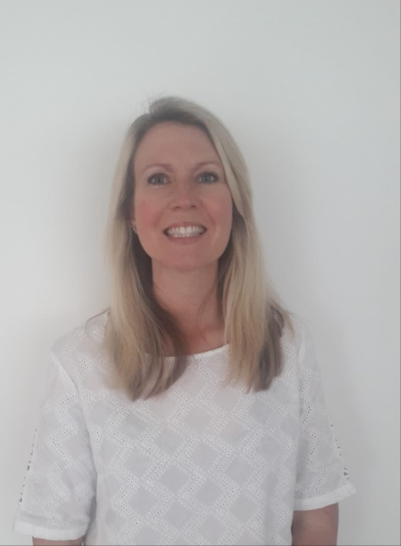
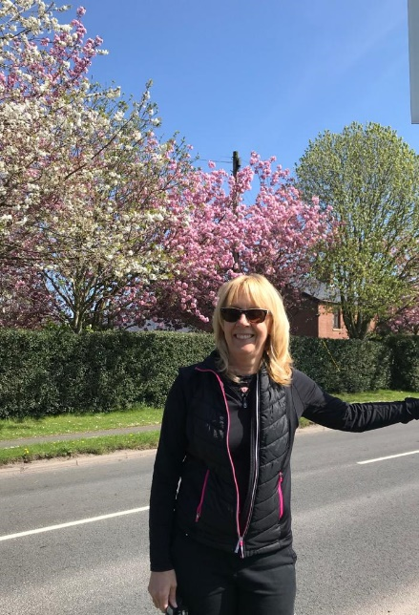

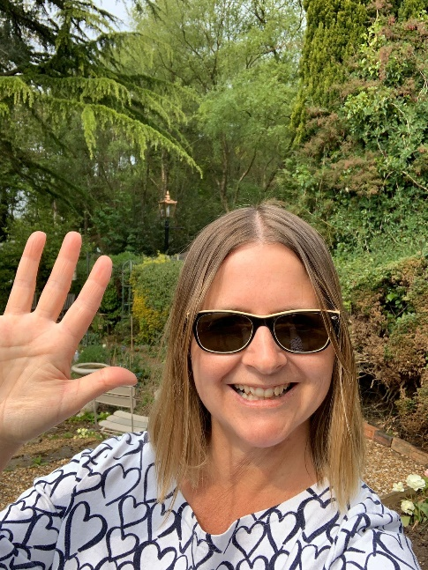
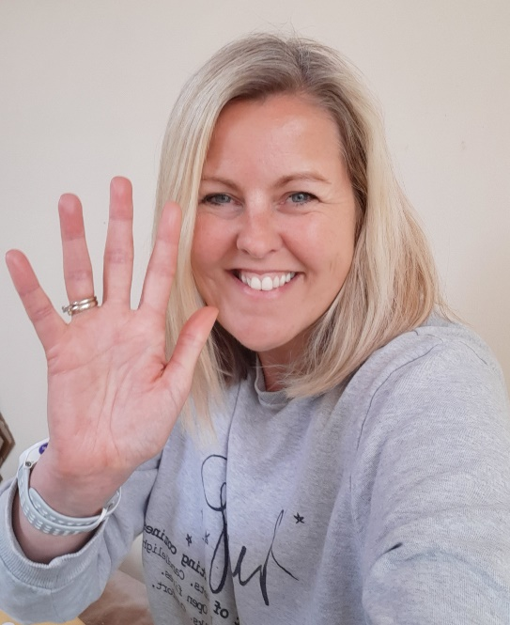

ENGLISH |  | MATHS
Reading – Read every day for pleasure for 30 minutes. You may like to use Epic. This is a great website where you read many online books for free for a month.  Transition Tasks:  The Robin Hood MAT has the most fantastic transition resources and all of the links. The focus this week is on feelings about transition to high school.  Follow the link below and then scroll down to Y6/7 transition learning projects. Week beginning 1st June:  https://www.robinhoodmat.co.uk/Learning-projects/  We’d really love to have a look at all of the work completed but especially the letter which is Thursday’s task. Really try to give as much information about you as possible, and don’t forget to include the punctuation and paragraphs. Show off your brilliant writing skills.  Poetry Writing  Discovery Education have asked us to enter a competition based on writing and performing a Haiku – a type of Japanese poem. Please read the information below and have any entries in by June 16th. It would be great if yours got chosen.  Spellings – Go back to the Y5/Y6 list and group them into ones you’re really secure with and ones that you need to learn better. Create a spelling game or some flashcards or even a poster to help you to remember these words. Here’s a link to the Y5/Y6 focus words. |  | 6 and 7 times table – Instant recall.  https://ttrockstars.com/  How many patterns can you spot in the 6 and 7 times tables?  White Rose - Home Learning – Year 6 – Summer Term - Week 5 – 18/5/20 – Multiplying and dividing  Please have a look at resources on BBC Bitesize and Oak Academy as they have some useful activities. The sheets on White Rose are no longer available but you can still access the videos.  https://whiterosemaths.com/homelearning/year-6/  Corbett Maths also has some brilliant videos to help to explain some of the tricky areas and also some good activities to help you. The 5 a day section offers you some quick fire tasks.  https://corbettmathsprimary.com/
R.E. | OTHER
Reconciliation- Freedom and Responsibility- Rules.  Think about how and when we have freedom, it is important to take some responsibility and keep to some rules/guidelines.  Task: as countries around the world try to begin releasing their lockdowns slowly and carefully, write a set of rules that you feel that people should keep. What rules have you liked during lockdown, such as all members of society washing their hands regularly. | Computing  https://central.espresso.co.uk/espresso/coding/lessons.html#/coding/units  Continue with coding. Also, the Discovery Education Haiku task involves making a film.  We are looking for News Bites viewers to write haikus on the theme of Summer term 2020, please. That could mean a haiku simply on summer as a season. It could be about home schooling and how this summer has been different to previous summers.  We would like our News Bites item to feature several children reading their poems directly to camera, and to include shots of the poems written on the page as well, so we will need teachers and parents to film the children, using iPhones (or similar!), holding the phone landscape not portrait. The children will need to be head and shoulders in shot like a news reporter and the poem on the page should be filmed separately (also landscape). Parents will need to complete the form below too.  History – We would have been looking at local British history this term and we’d have been looking at the history of the railway. What can you find out about Bryn or Garswood station this week? How long has it been there? Where could you get to in previous years and where can you get to now? When did the first railways appear in Britain? Below is a link to start you off. Present your findings on a Powerpoint or as a leaflet or do a news report. Email them in to us.  https://www.funkidslive.com/learn/railways/discover-early-history-britains-railways-first-railway-railways-uk-take-off/#  Wellbeing – Find below some little challenges to do from the Young Minds website.  https://youngminds.org.uk/resources/school-resources/wellbeing-activity-calendar-and-games/

