EAGLES’ WEEKLY SUGGESTED HOME LEARNING – WB 11.5.20
Good morning Eagles! Well, we should be doing SATs this week so this morning you should be getting ready for the SPAG test. Every year we send a letter out on the previous Friday listing all of the skills and qualities that SATs don’t measure, for example: art, music, kindness, baking, sport etc. This year, we’ve been able to see so many different skills that you’ve got and we’ve been able to celebrate those with you. Well done. We hope that you enjoy this week’s tasks. Keep sending us messages / pictures on Twitter or email as we love to see them and we check regularly and respond! Take care - #StaySafeStayHomeSaveLives
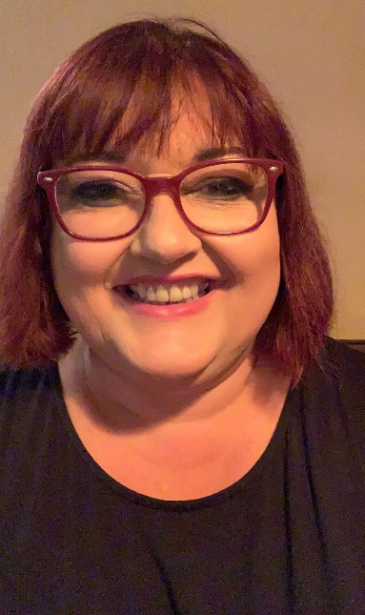
Mrs Colothan, Mrs Hillam, Mrs Jones, Mrs Donlon and Miss Clegg XX
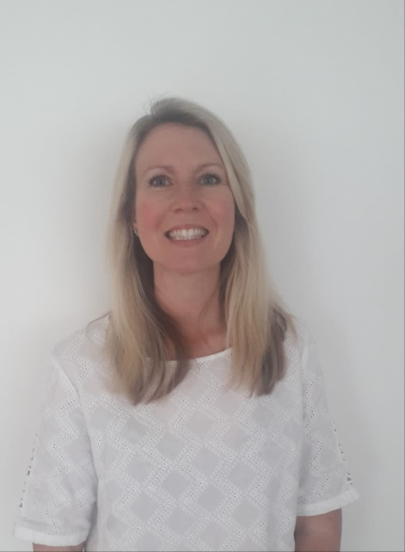
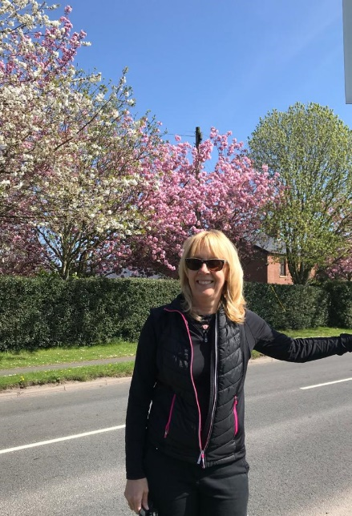

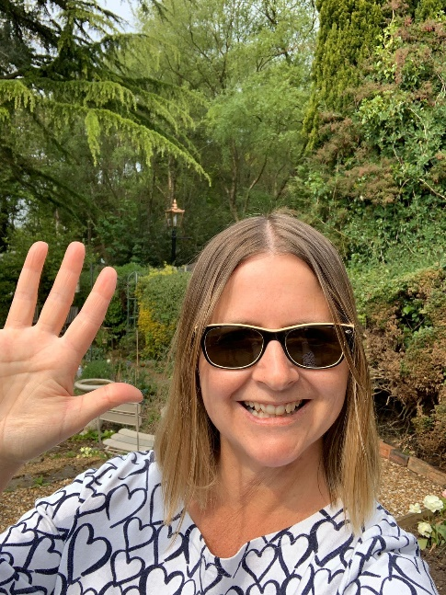
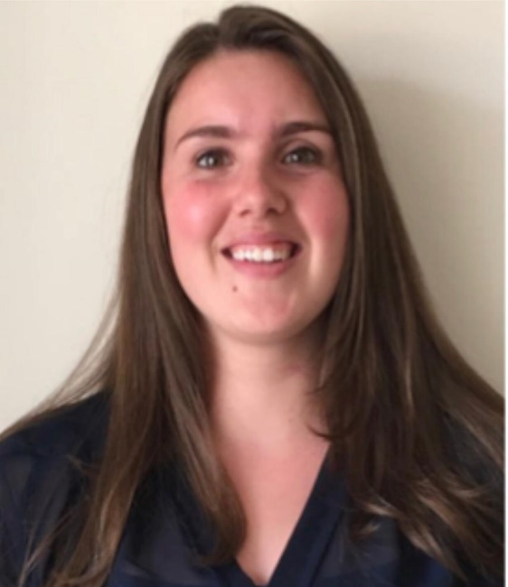
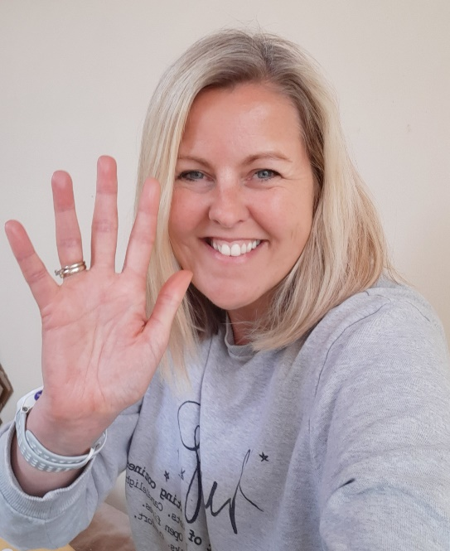

ENGLISH | MATHS
Reading – Read every day for pleasure for 30 minutes. You may like to use Epic. This is a great website where you read many online books for free for a month.  Comprehension tasks  Discovery Education – Reading – Upper KS2 – Private Peaceful – Complete the online questions and the extra questions. You don’t need to print them out.  https://central.espresso.co.uk/espresso/modules/e2_comprehension_uks2/books/book_private_peaceful.html?source=search-all-all-all-all&source-keywords=private%20peaceful  Poetry for the Great Fire Comprehension found below.  An online comprehension from Education Quizzes  https://www.educationquizzes.com/ks2/english/comprehension-01/  2019 reading SAT link – just if you fancy it!  https://www.sats-papers.co.uk/sats-2019/  Writing and Grammar  Grammar quiz – formal and informal sentences on Discovery Education  https://central.espresso.co.uk/espresso/primary_uk/subject/module/video/item361710/grade2/module305322/collection361830/section361768/index.html  2019 SPAG test if you fancy it. The link is above below the reading link.  Write a description of a person on a new planet. This links with our science. You could use what you’ve found out about other planets from your research. Use the, “Man on the Moon,” example below to help you with some ideas. Really try to describe so that your reader knows exactly what it’s like to be on the planet. Use expanded noun phrases, exciting vocabulary and don’t forget accurate punctuation. You could even draw it first to get some ideas. We can’t wait to visit lots of exciting places in the galaxy!  Spellings – The focus for this week is spelling plurals accurately. There’s so many rules to follow and so many times where the rules are broken! Research some other examples.  There are some sheets below. Complete a poster to share the rules and ask a grown up to test you on a few examples at the end of the week. | 12 times table – Instant recall.  https://ttrockstars.com/  How many patterns can you spot in the 12x tables?  https://www.bbc.co.uk/teach/supermovers/ks2-maths-the-12-times-table-with-chirpy-cockerel/z7v7rj6  White Rose - Home Learning – Year 6 – Summer Term - Week 3 – 4/5/20 -  https://whiterosemaths.com/homelearning/year-6/  Remember, if this is a bit tricky, you can have a look at the work in Y5 or you can continue working through your SATs books.  Corbett Maths also has some brilliant videos to help to explain some of the tricky areas and also some good activities to help you. The 5 a day section offers you some quick fire tasks.  https://corbettmathsprimary.com/
R.E. | OTHER
Father John has asked the parishioners to pray the rosary throughout May. Below is a guide to praying the rosary. What can you find out about praying the rosary? Try to set a little bit of time aside each day to pray the rosary.  Read the scripture passage below. Design a story board to show what happened on the road to Emmaus. Annotate the images to show you understand how the disciples knew it was Jesus when they reflected on their experiences.  Please read this week’s Wednesday Word together with your family, using the link below.  http://www.wednesdayword.org/ | Computing  https://central.espresso.co.uk/espresso/coding/lessons.html#/coding/units  Some coding for you to have a go at. Start at the 5A lesson but if this is too easy/difficult please go up or down the year groups.  Geography – Adopt a European country – A couple of weeks ago, we asked you to adopt a European Country. Please continue with your research about your country and find out about its cities, rivers, mountains, climate, culture. Create a 1 minute presentation to perform to somebody at home.  Music  https://www.stoswaldswigan.co.uk/classes/fun-learning-games/music  Time for music – Y5/Y6 – Stomp and body percussion.  PE – Please keep up with your walking / running / cycling and log your miles with school so that we can see how far as a school we can get! Good luck.

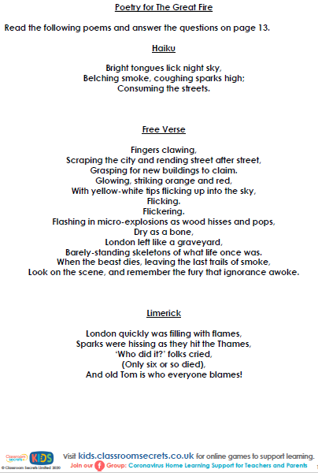

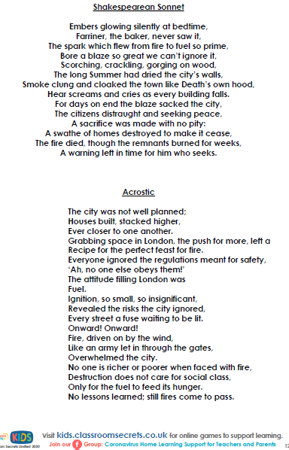

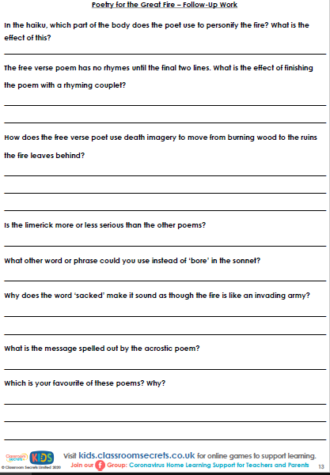

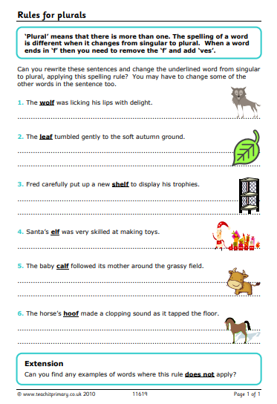

Making plurals

Singular: one
Plural: more than one

NEVER ADD APOSTROPHES WHEN MAKING PLURALS

MAKING A SINGULAR NOUN INTO A PLURAL DOES NOT REQUIRE AN APOSTROPHE

Most nouns are made into plurals by adding –s
Make the following into plurals:

Cat
school
ruler
piano
game
trainer
spoon
rope
chair
tune

Some nouns ending in –o are made into plurals by adding –es
Make the following into plurals:

Cargo
Echo
Hero
Potato
Tomato
Most nouns ending in hissing, shushing or buzzing sounds end in -es.
Make the following into plurals:

Sandwich
Brush
Box
Catch
Glass
Watch
Quiz
Bench
Match

Most nouns ending in -f or-fe change to -ves in the plural.
Make the following into plurals:

Half
Leaf
Loaf
Shelf
Wolf
Y words
For words ending in a vowel and then –y, just add -s
For words ending in a consonant and then –y, change -y to -i and add -es.
(Vowels are: a,e,i,o,u)

Look carefully at each word before you make it a plural. Is there a consonant just before the –y or is it a vowel? Take your time!

Army
Toy
Turkey
Ray
Boy
Journey
Fairy
Story
Donkey
Trolley
Jelly
Abbey
Chimney
Display
Family
Daisy
Day
Pony
Enemy
Some nouns keep the same spelling for singular and plural forms
Learn these:
Deer
Fish
Salmon
Sheep

Some nouns have no singular form, just plural
Learn these:
Trousers
Scissors
Tweezers

Some nouns change to plurals in an unusual way. Do you know the plurals for these nouns?

Man
Mouse
Tooth
Ox
Child
Louse

The Literacy Club

