EAGLES’ WEEKLY SUGGESTED HOME LEARNING – WB 13.7.20
Good morning Eagles! It’s your last week as official members of St. Oswald’s, but the class of 2020 will certainly hold a special place in our hearts forever. We’re so excited about seeing you this week too (if you’ve chosen to come back) and we’ve managed to make sure that you’re all with your friends who you asked to be with. We’ve set some tasks to still keep you going and even if this week, you just focus on transition tasks for Eddie’s and from Robin Hood Trust, you may wish to come back to some of the other tasks just before you start the next stage in your educational journey at St. Edmund Arrowsmith. The tasks will be staying on the website so you can always go back to some of the ones you may have missed once you’ve had a well-deserved rest with your families. Well done everyone. Our Zoom Leavers’ Collective worship is on Thursday at 10:30 a.m. and we’ll send the details out on Wednesday. Have a great week.
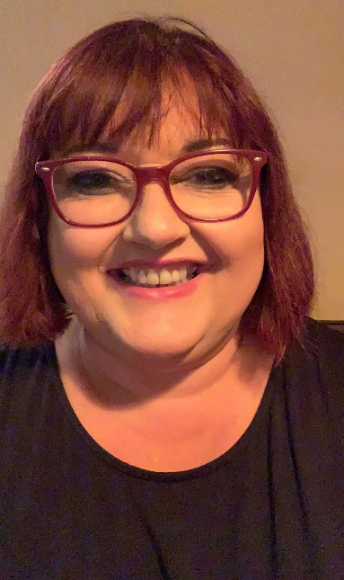
Mrs Colothan, Mrs Hillam, Mrs Jones, Mrs Donlon and Miss Clegg XX
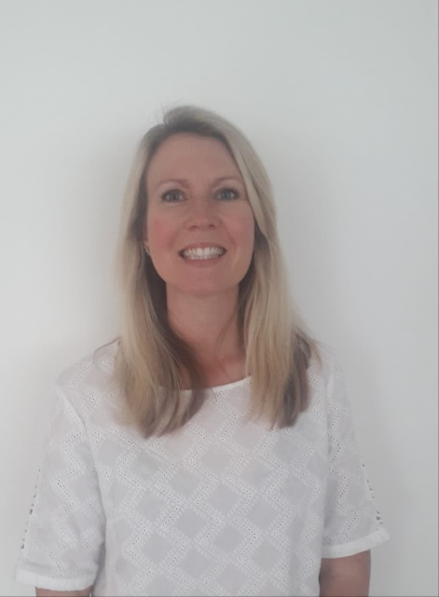
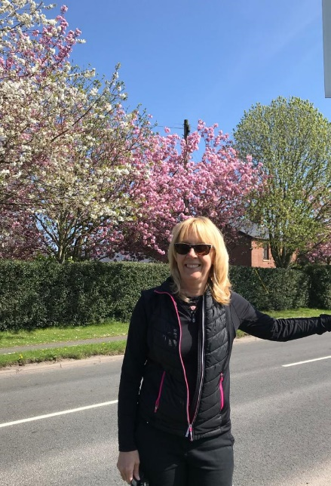

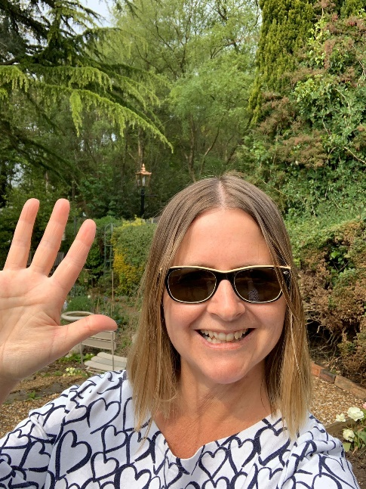
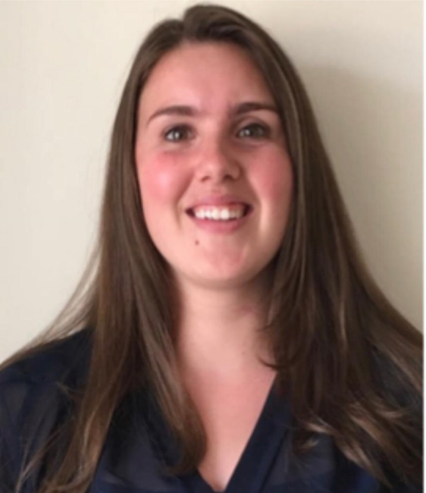
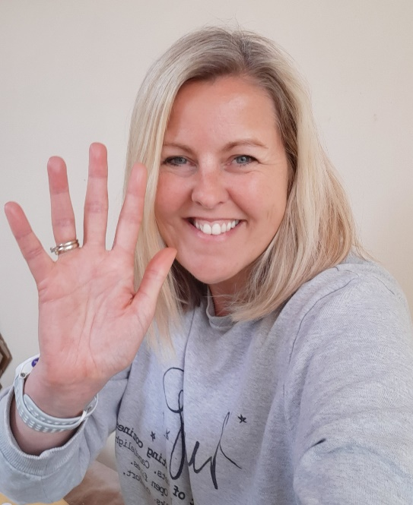

ENGLISH |  | MATHS
Reading – Read every day for pleasure for 30 minutes. You may like to use Epic. This is a great website where you read many online books for free for a month.  POETRY:  Follow the link below and scroll down to the poetry section. There are 5 lessons based on poetry and we’d like you to have a go at learning a poem off by heart this week. Could you write a poem about leaving primary school. We’d love to see what you come up with.  https://classroom.thenational.academy/subjects-by-year/year-6/subjects/english  Here’s a link to a punctuation quiz too on Discovery Education  https://central.espresso.co.uk/espresso/modules/e2_grammar/activities/index.html#tab4  Spellings – Use this link to access a spelling game to test you on your tricky words.  http://www.ictgames.com/mobilePage/lcwc/index.html |  | 6 and 8 times table – Instant recall.  https://ttrockstars.com/  Create your own useful Maths posters on an area of maths that you find tricky. Use your revision books to help you to find out more about this area. It could be angles, line graphs, area and perimeter, volume, ratio and proportion or fractions. Spend a bit of time this week researching that tricky area.  Corbett Maths is really helpful too as they have explanations. You could even create your own Maths Museum to show your understanding.
R.E. | OTHER
This week we are continuing with our unit of work based on the topic of The Universal Church- Our World. Please see resources which have been attached below. Continue to work through these.  Please feel free to access Cafod’s site for lots more engaging and free resources.  https://cafod.org.uk/Education/Primary-teaching-resources/Home-learning-primary  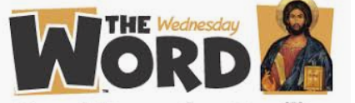  http://www.wednesdayword.org/ | Transition Tasks:  We are continuing with Robinhood Mat work.  Follow the link below and then scroll down to Y6/7 transition learning projects. Week beginning 13th July. The theme is about your successes so far. It’s a week of celebration.  https://www.robinhoodmat.co.uk/wp-content/uploads/2020/05/Year-6-Transition-Learning-Projects-W_C-13.07.2020-2.pdf  ST. EDMUND ARROWSMITH TRANSITION TASKS  Try to complete three of these this week.  https://www.arrowsmith.wigan.sch.uk/parents/Y7-Intake  MUSIC: We would have been doing lots of singing and performing this week. Here’s a unit about performing songs. Have a go at a few tasks  https://www.bbc.co.uk/bitesize/articles/zkx3bdm  ART:  Follow the link to help you to understand landscapes and perspective. Could you draw your favourite view. Some of us aren’t going on holiday this year, but you may have a favourite view. Find a photo and have a go at drawing it. It will help you to remember your holiday even if you might not get there this summer.  https://www.bbc.co.uk/bitesize/topics/ztjqtfr/resources/1

