EAGLES’ WEEKLY SUGGESTED HOME LEARNING – WB 18.5.20
Good morning Eagles! Have you all had a lovely weekend? We are very proud of the great work that you have been doing and we have also enjoyed seeing you being creative in other ways! Keep sending us messages / pictures on Twitter or email as we love to see them and we check regularly and respond! The staff really miss you so please keep in contact with us!
Take care - #StaySafeStayHomeSaveLives
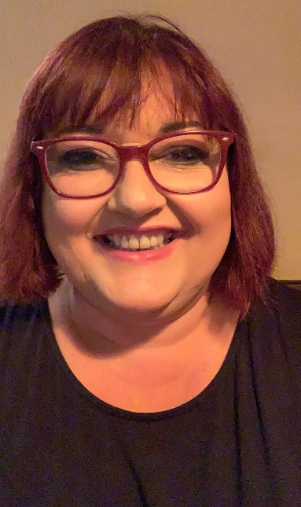
Mrs Colothan, Mrs Hillam, Mrs Jones, Mrs Donlon and Miss Clegg XX
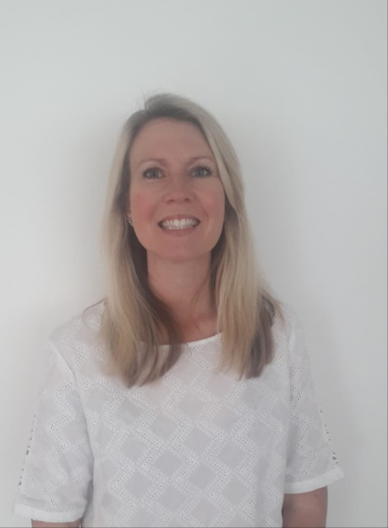
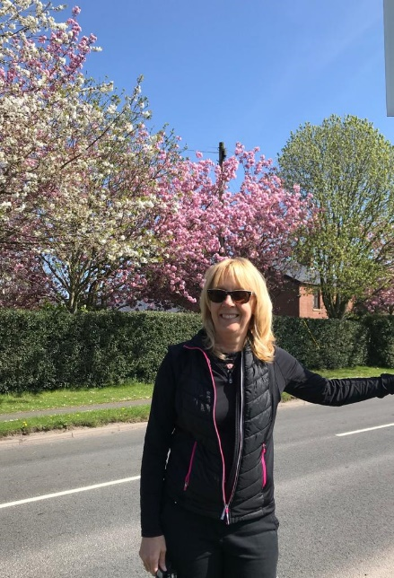

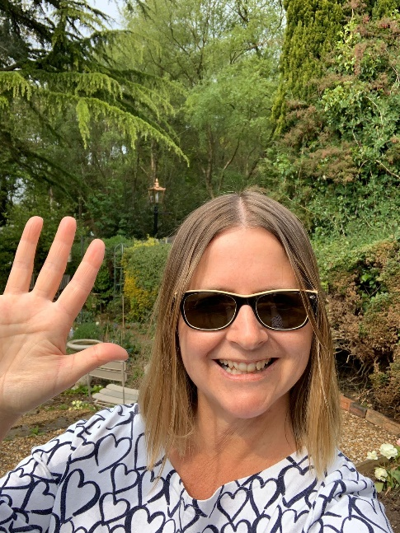
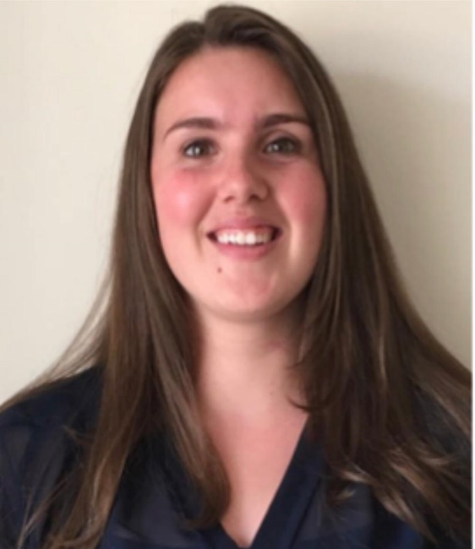
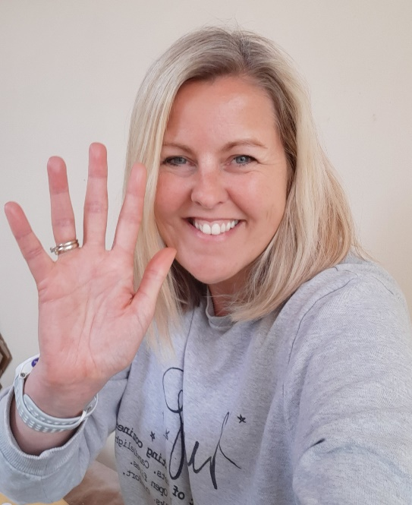

ENGLISH | MATHS
Reading – Read every day for pleasure for 30 minutes. You may like to use Epic. This is a great website where you read many online books for free for a month.  The English tasks this week combine both reading and writing skills. We will be focusing on making inferences based on short video clips and writing character profiles.  This week we have picked out some animations for you to watch. For each animation there will be a short writing task for you to complete.  - The first animation is called ‘WING’ and can be found using this link: https://www.youtube.com/watch?v=CkHrcePAW40 It is about a solitary, one winged creature called Wing who is harassed by a group of oppressive crows due to being weak and different from them. He decides that he wants to overcome his disability and escape from the forest. Watch the animation then write a short character description (no more the 200 words) of WING and one of the crows.  Use this link to help you with your writing: https://www.youtube.com/watch?v=brM5GlSLpdk  Remember to use DAD when writing character profiles – DESCRIPTION, ACTION, DIALOGUE (there is no dialogue in these video clips!)  - The second animation is called ‘The Ridge’ and can be found using this link: https://www.youtube.com/watch?v=xQ_IQS3VKjA  Write a character profile for the cyclist.  Try to use adventurous vocabulary in all of these profiles by using the online thesaurus  https://www.thesaurus.com/browse/kid  Grammar  Focus on synonyms. See Kangaroo sheet below! Email your answers to us and what other Kangaroo words can you think of?  Spellings – Slight change for this week – focus on playing games to support and develop spelling, using your knowledge of spelling patterns and sounds to help play the games below. Play with a family member – can you beat them? | 4 and 8 times table – Instant recall.  https://ttrockstars.com/  How many patterns can you spot in the 4 and 8 tables?  White Rose - Home Learning – Year 6 – Summer Term - Week 4 – 11/5/20 – Fractions  Please have a look at resources on BBC Bitesize and Oak Academy as they have some useful activities. The sheets on White Rose are no longer available but you can still access the videos.  https://whiterosemaths.com/homelearning/year-6/  Corbett Maths also has some brilliant videos to help to explain some of the tricky areas and also some good activities to help you. The 5 a day section offers you some quick fire tasks.  https://corbettmathsprimary.com/
R.E. | OTHER
Continue with praying the rosary. Information from last week - Father John has asked the parishioners to pray the rosary throughout May. Below is a guide to praying the rosary. What can you find out about praying the rosary? Try to set a little bit of time aside each day to pray the rosary. See sheets from last week.  Research the gifts of the Holy Spirit and create a poster. Think about how the gifts can help you in your everyday life.  Please read this week’s Wednesday Word together with your family, using the link below.  http://www.wednesdayword.org/ | Computing  https://central.espresso.co.uk/espresso/coding/lessons.html#/coding/units  Continue with coding.  Science – Earth, Sun and Moon. What achievements have we made in space travel. Where have we travelled to? Where do we want to travel to? Why? How do scientists predict that space travel will help us? Produce a factfile.  PSHE  Make a wish jar. In the jar write down everything you and your family would like to do when lockdown has ended.  Art/Mindfulness  https://www.youtube.com/watch?v=J6CYwBeQMvM  Add colour to your drawing.  This week is Mental Health Awareness week. Please complete some of the activities on the Time to Change website. BBC also has some good resources as does Young Minds.  PE – Continue with the school mile challenge. Keep completing the Joe Wicks PE lessons each day.

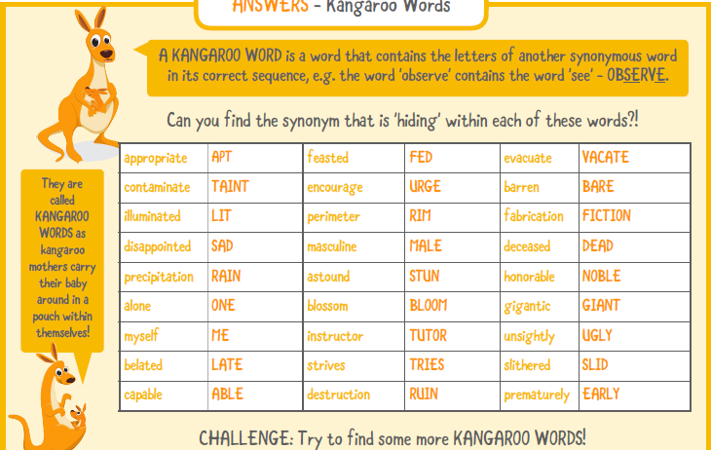
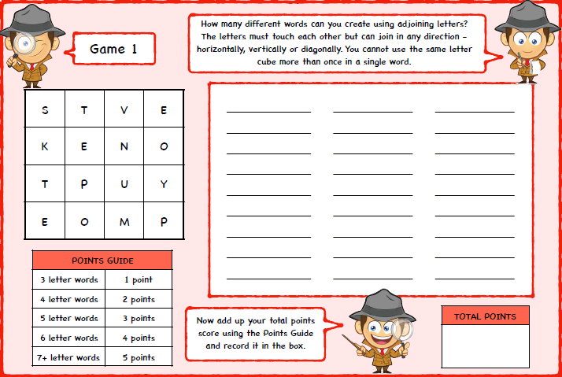
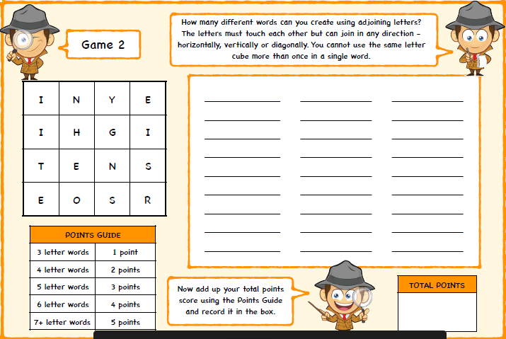
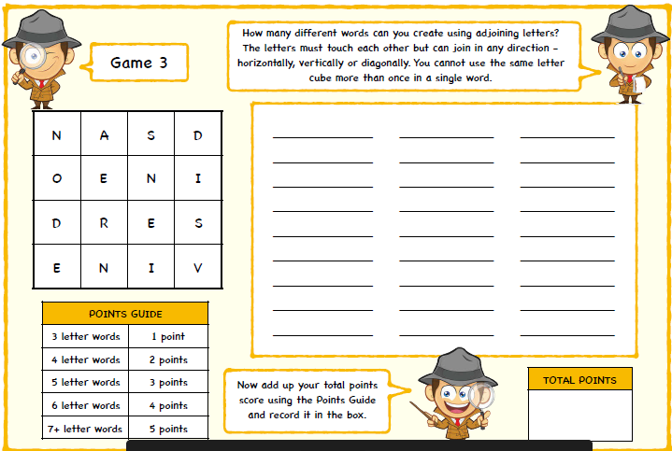

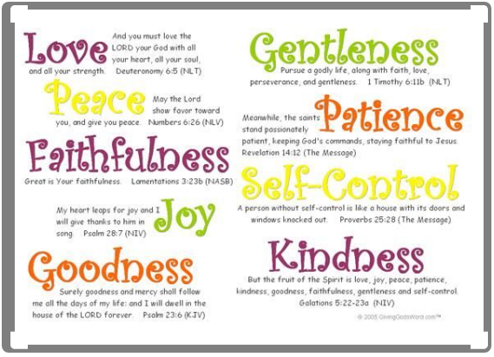
Fruits of the Holy Spirit

