EAGLES’ WEEKLY SUGGESTED HOME LEARNING – WB 27.4.20
Hi everyone. We hope that you are all doing well and not missing us too much. We’re definitely missing you all. Teaching isn’t any fun without children in front of us, answering our endless questions and making us laugh. We’ve sorted some tasks below for you to have a go at, but we’ve seen some of the other brilliant things that you’ve been doing too and it’s essential that you keep those going – especially the baking and the exercise! Keep sending us messages / pictures on Twitter as we love to see them and we check regularly and respond! You can also email your work in to us at enquiries@saintoswalds.wigan.sch.uk FAO Mrs Colothan and Mrs Hillam. Take care - #StaySafeStayHomeSaveLives
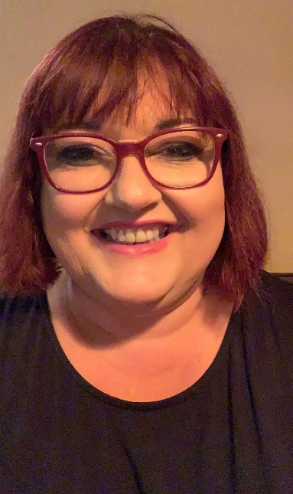
Mrs Colothan, Mrs Hillam, Mrs Jones, Mrs Donlon and Miss Clegg XX
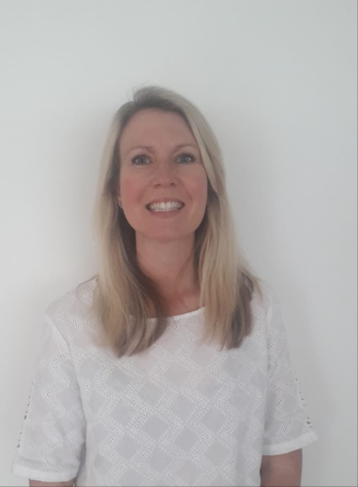
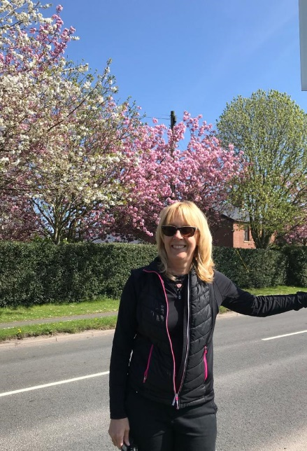

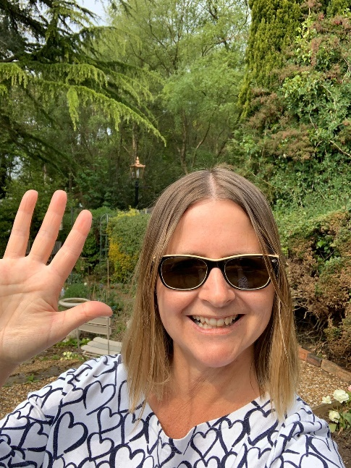
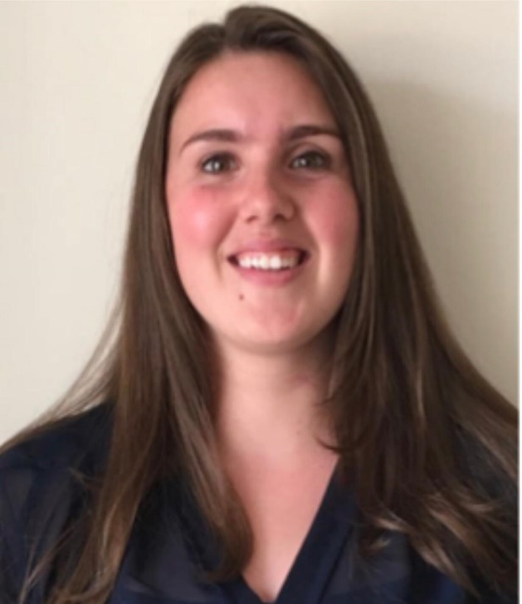
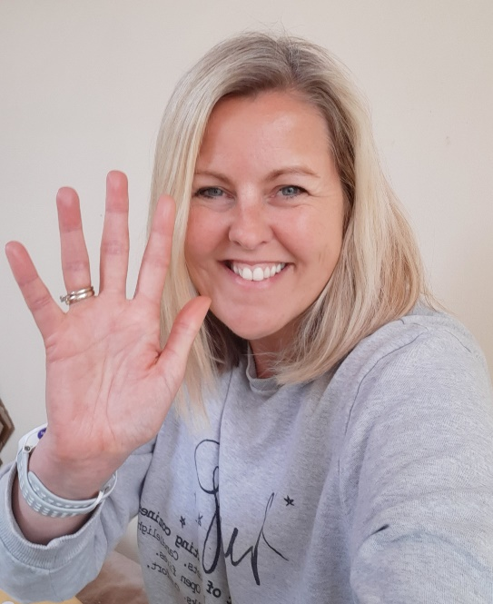

ENGLISH | MATHS
Reading – Read every day for pleasure for 30 minutes.  Comprehension tasks – London –  https://www.vocabularyninja.co.uk/quick-comprehension.html  David Attenborough biography – Please see below. (The answers are underneath so no cheating!)  Y6 Home Learning Pack – Week 2 – Howard Carter Comprehension  https://classroomsecrets.co.uk/free-home-learning-packs/  Writing – Biography – Write a biography about somebody of interest to you – sportsperson, musician, artist, author. Make it formal and interesting for your reader. There are some resources below to help you to plan your biography from Twinkl.  Spellings – Words ending in –cious, -tious, -cial and –tial Create a poster with examples on; Use your RWI spelling book for some examples to help you. Create a wordsearch; write a paragraph using as many words as possible.  https://www.bbc.co.uk/bitesize/topics/zt62mnb/articles/zp7dk7h | 7 times table – Instant recall;  https://ttrockstars.com/  https://www.bbc.co.uk/teach/supermovers/ks2-maths-the-7-times-table-with-moonbeam/zjp8y9q  White Rose - Home Learning – Year 6 – Summer Term - Week 1 – 20.4.20 - Calculating Angles and Maths Challenge.  https://whiterosemaths.com/homelearning/year-6/
R.E. | OTHER
The theme is: Transformation and is linked to Pentecost.  Research a form of energy: wind, water, solar power for example. What are the pros and cons? What do you feel about it? How does it help?  Create a poster / powerpoint / film report to share your findings.  https://www.bbc.co.uk/bitesize/topics/zp22pv4/articles/ztxwqty  How can you use your energy for the well-being of others – at home, in school, in the community? Draw images and write captions. Especially important at the moment – let us know what great ways you’ve been using your energy to make people in your homes smile. | Science - Earth and the solar system  https://www.bbc.co.uk/bitesize/topics/zkbbkqt start researching by watching some of the clips and perhaps making some notes.  We will be using our research to make our own games next week.  Geography – Adopt a European Country – What are the natural landmarks? What are the manmade features? Start to create a travel brochure to encourage others to visit the country.  https://www.natgeokids.com/uk/  Extra Challenge!  We’d love to make a slide show with a photograph taken by you (no parents allowed!). We would like this to be a photo of something in our world which makes you smile and feel happy. Some ideas might include a view that you have seen whilst out doing your daily exercise, a flower or tree, some art work or a drawing. Just email over one photograph please. Looking forward to seeing what you choose ☺

Sir David Attenborough – Naturalist and Presenter

As the world's most famous naturalist, Sir David Attenborough has brought amazing wildlife to television screens for over 50 years. From series such as Life on Earth to Frozen Planet, his documentaries have inspired generations to learn more about the natural world.

Early Years
Born in 1926, David Frederick Attenborough into a well-off family with two brothers, John and Richard. During World War II, his parents took in two Jewish girls who had fled the Nazis and they were treated like family. His brother Richard went on to great success as an actor and film-maker, starring in Hollywood blockbuster films such as Jurassic Park.

David became fascinated by natural history in his early childhood. In fact, by the age of seven he had already created his very own "museum" of bird eggs, old stamps and ancient fossils.

University and Early Career
After school, David studied natural sciences at Cambridge, but was reluctant to become an academic, disliking the idea of being stuck in labs and lecture theatres all his life. On finishing his studies, David joined the Royal Navy hoping to see the world, but didn't get very far; he was posted to North Wales and Scotland.

Family
In 1950 Attenborough married Jane Elizabeth Ebsworth Oriel; she died in 1997. The couple had two children, Robert and Susan. Robert is a senior lecturer in bioanthropology for the School of Archaeology and Anthropology at the Australian National University in Canberra.

Joining the BBC
David joined the BBC in 1952. His boss at the BBC initially told Attenborough he shouldn't actually work in front of the cameras as his "teeth were too big" but he had always wanted to present wildlife documentaries and after several years he started to make a name for himself, making the successful Zoo Quest series. By 1965 he was elevated to the post of Controller of BBC2, where he oversaw the introduction of colour TV to Britain, and only a few years later was made Director of Programmes for BBC1 and BBC2.

Wild World
David returned to his first love of making natural history documentaries in 1973. Several successful years of making wildlife programmes peaked with his series Life on Earth in the late nineteen seventies, at the time the most ambitious series the BBC had ever produced.

The Working Process
David begins any series with a general outline of the questions he wants to ask and answer, followed by a dialogue over many months with the prospective programme's researchers and producers. Once a massive file of notes has been accumulated, only then does David begin his travels.

What is David like to work with?
David writes all his own scripts and has won literary prizes for his books. The great presenter is no Prima Donna, always travelling economy class with his film crew, only accepting offers for airline upgrades if it extends to his crew as well. A modest David has been quoted as saying, "People assume I do all the work. I keep having to tell them, it was the cameraman, not me".

Quite apart from the extensive travel to often dangerous regions, David is willing take risks for his shows. He let himself be attacked by military ants in Africa, abseiled down a rainforest tree his late 60s and is the oldest person to set foot on the North Pole! In fact the plucky presenter has only two aversions: rats, and anywhere (like dark caves) where there might be rats.

A National Treasure
David Attenborough was named as the most trusted celebrity in Britain in a 2006. He has also been named among the 100 Greatest Britons alongside Winston Churchill, Princess Diana and Charles Darwin. At the age of 88, he is still producing natural history and films and has no intention of stopping. He said,, “I just wish the world was twice as big and half of it was still unexplored”

* bioanthropology the study of how humans evolved

Questions
1. When was David Attenborough born? [1]

_____________

2. How many siblings did he have? [1]

______

3. What did his brother Richard do when he grew up that made him famous? [2]

4. What kind of family did David grow up in? [2]

5. In fact, by the age of seven he had already created his very own "museum" of bird eggs, old stamps and ancient fossils.

- What does this tell us about David as a boy? [1]

________________________________________________

- Why is the word museum in inverted commas? [1]

6. What did David Study at University? [1]
__________________________________________
7. Explain why David did not want to work in a university [1]
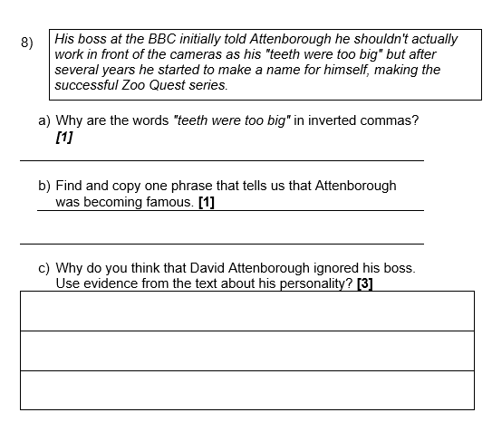

9) Why was David’s career in the Navy disappointing to him?[2]

10) Why is the word bioanthropy written in bold letters? [1]

____________________________________________________

11) What does the text tell you about televisions before 1965. Why was this important to Attenborough’s career? [2]

12) What else does David do, other than presenting, to contribute to his TV programmes? [2]

___________________________________________________

13)
The great presenter is no prima donna, always travelling economy class with his film crew, only accepting offers for airline upgrades if it extends to his crew as well. A modest David has been quoted as saying, "People assume I do all the work. I keep having to tell them, it was the cameraman, not me".

Why does the author include this information about David Attenborough? [2]

14) What is David afraid of? [2]

15) How do we know that David is courageous? [3]

16) Using information from the text explain what you would like and dislike about being a TV naturalist. Give reasons for your choices. [4]

Like | Dislike

17) Why do you think the author tells us about the other people included in the 100 Greatest Britons list? [2]

18) What two sentences tell us that David still wishes to carry on exploring, travelling and making his programmes? [2]

1. When was David Attenborough born? [1]
1926
2. How many siblings did he have? [1]

2 [brothers]

3. What did his brother Richard do when he grew up that made him famous? [2]
Actor [1] Film maker [1]

4. What kind of family did David grow up in? [2]

Well off [1]
Caring/Principled/Brave any reference to looking after the refugees [1]

5. In fact, by the age of seven he had already created his very own "museum" of bird eggs, old stamps and ancient fossils.

- What does this tell us about David as a boy? [1]

He was interested in wildlife/collecting things

- Why is the word museum in inverted commas? [1]
Because it was not actually a museum/ he called it museum but it was not – just a boy’s collection in his own home.

6. What did David Study at University? [1]
natural sciences/science
7. Explain why David did not want to work in a university [1]

He didn’t want to spend his time in lecture theatres [1] or
He didn’t want to spend his time in labs [1] or
He wanted to get out and travel/see the world/study animals in wild [1]
8)
His boss at the BBC initially told Attenborough he shouldn't actually work in front of the cameras as his "teeth were too big" but after several years he started to make a name for himself, making the successful Zoo Quest series.
- Why are the words "teeth were too big" in inverted commas? [1]
Because it is what someone actually said/quotation

- Find and copy one phrase that tells us that Attenborough was becoming famous. [1]
Started to make a name for himself
- Why do you think that David Attenborough ignored his boss. Use evidence from the text about his personality? [3]
He had always wanted to make wildlife documentaries. He had always been determined – even as a young boy. He is committed to documentary making. He believes in treating people fairly. [up to 3]

9) Why was David’s career in the Navy disappointing to him?[2]

He had wanted to travel the world[1]
He had only been sent to North Wales and Scotland/ Had not travelled very far [1]

10) Why is the word bioanthropy written in bold letters? [1]

because it is explained at the bottom of the page/in the glossary.

11) What does the text tell you about televisions before 1965. Why was this important to Attenborough’s career? [2]

Before 1965 TV was only in black and white/not in colour. [1]
Wildlife documentaries are better in colour or it led him to be controller of programmes. [1]

12) What else does David do, other than presenting, to contribute to his TV programmes? [2]
Writes scripts/discusses programmes with researchers and or producers/ makes notes [up to 2 marks]

13)
The great presenter is no prima donna, always travelling economy class with his film crew, only accepting offers for airline upgrades if it extends to his crew as well. A modest David has been quoted as saying, "People assume I do all the work. I keep having to tell them, it was the cameraman, not me".

Why does the author include this information about David Attenborough? [2]

To tell us what kind of person he is /that he treats people well// kindly is unassuming/humble/not full of himself/ he is one of the team not just the boss/ team player [upto 2 marks]

14) What is David afraid of? [2]

Rats [1]
Places where rats might be like caves – do not accept caves on its own[1]

15) How do we know that David is courageous? [3]

He abseils (in rainforests) [1]
Visited the North Pole (at aged 60) [1]
Allowed himself to be attacked by ants [1]
Visits dangerous places does dangerous things [1 – if not accompanied by examples]

16) Using information from the text explain what you would like and dislike about being a TV naturalist. Give reasons for your choices. [4]

Like | Dislike
Any plausible choice from the text  eg.  travelling/working with animals/writing books [1] if accompanied by a reason eg because I like to visit new places/ find animals interesting etc [2] | Any plausible choice from the text  eg.  Being away from home/doing dangerous things [1] if accompanied by a reason eg because I would miss my family/would be scared etc [2]

17) Why do you think the author tells us about the other people included in the 100 Greatest Britons list? [2]
Because they are very famous people who have done great things/everyone would have heard of [1] and so the reader can compare Attenborough to people they know/these people [1]

18) What two sentences tell us that David still wishes to carry on exploring, travelling and making his programmes? [2]

At the age of 88, he is still producing natural history and films and has no intention of stopping.

He says, “I just wish the world was twice as big and half of it was still unexplored”

