EAGLES’ WEEKLY SUGGESTED HOME LEARNING – WB 4.5.20
Good morning Eagles! We hope that you are all well and have had a lovely weekend. Thank you to all the children who have been emailing us their work - we have thoroughly enjoyed seeing your tasks and hearing your news! The weather is forecast as sunny and warm which is fantastic as the sunshine will help you to take part in our school walking challenge. May is National Walking Month so log your miles and send them into school – the staff have been trying hard to add to the school mileage! Our inspiration and theme for your work this week is Colonel Tom Moore and VE Day, which is celebrated on May 8th. Keep sending us messages / pictures on Twitter as we love to see them and we check regularly and respond! Take care - #StaySafeStayHomeSaveLives
Mrs Colothan, Mrs Hillam, Mrs Jones, Mrs Donlon and Miss Clegg XX
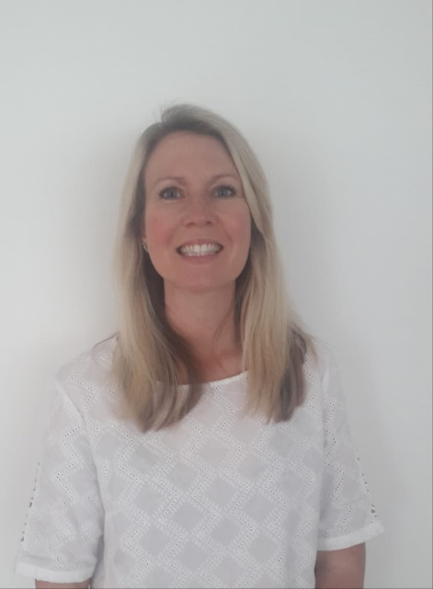
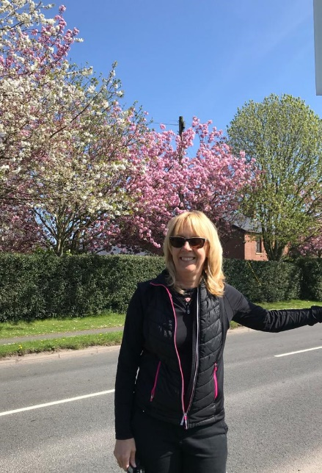

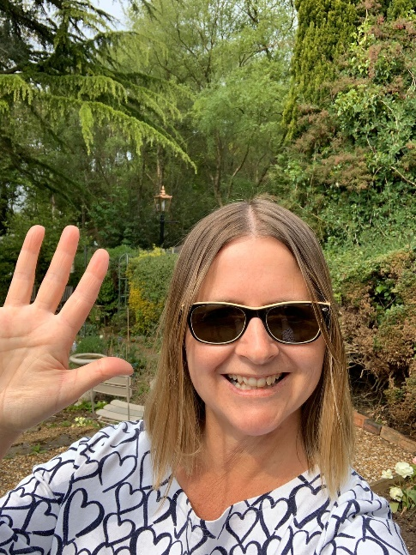

ENGLISH | MATHS
Reading – Read every day for pleasure for 30 minutes. You may like to use Epic. This is a great website where you read many online books for free for a month.  Comprehension tasks  https://central.espresso.co.uk/espresso/modules/e2_comprehension_uks2/index.html?source=search-all-KS2-all-all&source-keywords=comprehension  Try these comprehension tasks online. There is a quiz to take at the end of the text. How many can you get correct?  Writing – Poetry – Ambitions.  https://plprimarystars.com/resources/premier-league-writing-stars-poetry-challenge  This week, we are going to look at some poetry and the theme of ‘Ambitions’. Colonel Tom Moore, at the age of 99, had an ambition. He achieved and excelled in his ambition. What are your ambitions?  Watch the video of Karl Nova reading out his poem, ‘Beautiful Ambition’. You can also download a PDF of his poem. What is good about his performance? Make a list of 5 things. You could practise a performance of a poem for parents or siblings! This can be the Karl Nova poem or another poem that you find. Practise for at least 15 minute before your performance! Let us know how you get on.  Watch Karl Nova’s ‘Top Tips’. Watch the children talk about their ambitions. What are your ambitions? Make a mind map of words and phrases you could use in your own ‘Beautiful Ambitions’ poem.  Can you write a poem in a similar style? Don’t be afraid to ‘steal’ parts of Karl Nova’s poem to help you.  Spellings – Words containing the letter string ‘ough’. Research words and separate them into different sounds. How many sounds does the letter string ‘ough’ make? Complete this as a poster or mindmap.  Perhaps make a chatterbox with these words.  https://aychessekaye.wordpress.com/2014/03/18/make-chatterbox-free-printable-templates/ | 9 times table – Instant recall.  https://ttrockstars.com/  How many patterns can you spot in the 9x tables?  White Rose - Home Learning – Year 6 – Summer Term - Week 2 – 27/4/20 - Calculating Angles in quadrilaterals and polygons and Maths Challenge.  https://whiterosemaths.com/homelearning/year-6/  Remember, if this is a bit tricky, you can have a look at the work in Y5 or you can continue working through your SATs books.  Corbett Maths also has some brilliant videos to help to explain some of the tricky areas and also some good activities to help you. The 5 a day section offers you some quick fire tasks.  https://corbettmathsprimary.com/
R.E. | OTHER
May – Month of Mary  May is the month dedicated to ‘Our Blessed Lady’.  Use your own knowledge and any research you have carried out to write a biography of Mary. Use the biography skills that you developed last week. Further information on writing biographies is shown below.  Father John has asked the parishioners to pray the rosary throughout May. Below is a guide to praying the rosary. What can you find out about praying the rosary? Try to set a little bit of time aside each day to pray the rosary. | Science - Earth and the solar system  https://www.bbc.co.uk/bitesize/topics/zkbbkqt Using the research you completed last week, can you make our own science game linked to the solar system? This could be a board game, card game etc. Make sure you are clear on what the rules are and how the game is to be won!  History – Can you develop your understanding of VE Day On 8th May 1945? This was when Britain celebrated the end of World War Two. To understand why VE Day was so important, you need to understand WW2. Visit these sites to help in your research: Primary Homework Help - WW2 A Brief Overview of World War II – Video BBC Teach - VE Day What Is VE Day?  Can you create a timeline of important events leading up to VE Day? You could also produce an information poster about VE Day.  There is an activity sheet below with some additional links on.  Eagles seem to be doing lots of baking during lockdown. Why not try some wartime recipes? With one rationed egg and a packet of powdered milk in the larder, World War II’s home cooks had to be creative. Find out what families were eating over 75 years ago. Can you create any wartime foods? The BBC website has many wartime recipes for you to try. We would really like to see any pictures of food that you have created. Mrs Colothan’s favourite is Bread Pudding!  Extra Challenge!  Through his fundraising, Colonel Tom Moore has shown what a kind and thoughtful person he is. What acts of kindness can you do this week? Who can you help?

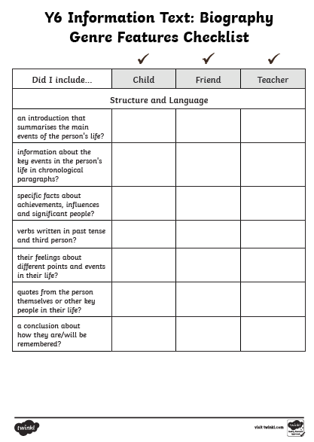

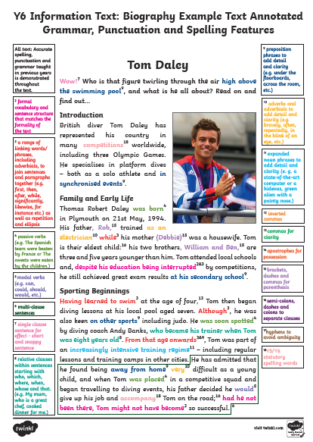

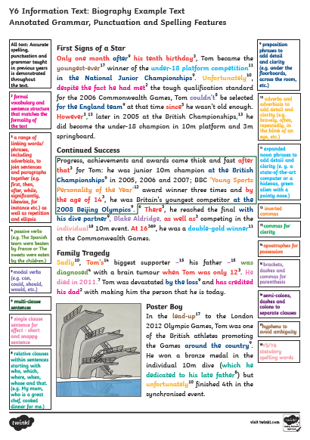

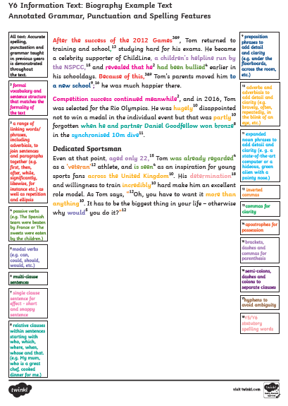

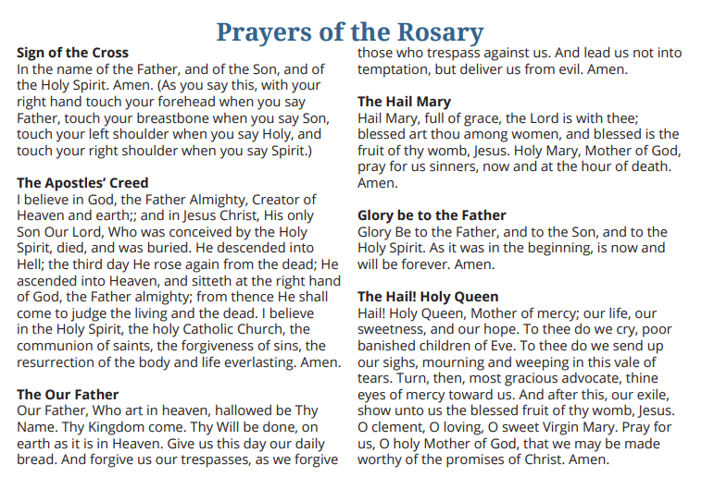

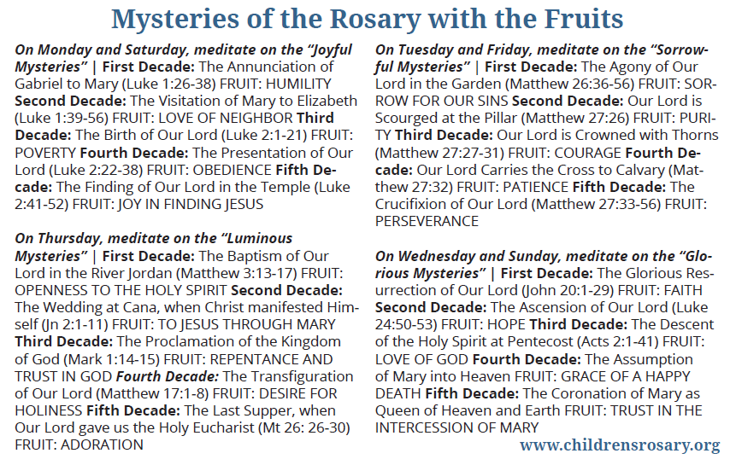

VE DAY
The project this week aims to provide opportunities for you to learn more about VE Day.
Choose one or more activity a day to explore. Be creative about how you present your work.
‘Stay At Home’ Street Party  Read this article on Newsround and look closely at the photographs. How did people celebrate in 1945? Plan your own ‘stay at home’ street party.  What games could be played? What decorations would be put up? What food would be eaten? Who would be there? Is there anyone in your family who went to a VE Day party you could speak to?  For something more simple, you could design your own VE Day party invitation or create your own Union Jack flag bunting or make a Union Jack flag out of Lego! | Understanding World War Two/VE Day  On 8th May 1945, Britain celebrated the end of World War Two. To understand why VE Day was so important, you need to understand WW2. Visit these sites to help in your research:  Primary Homework Help - WW2  A Brief Overview of World War II – Video  BBC Teach - VE Day  What Is VE Day?  Can you create a timeline of important events leading up to  VE Day? | Wartime Recipes  With one rationed egg and a packet of powdered milk in the larder, World War II’s home cooks had to be creative. Find out what families were eating over 75 years ago.  Create some delicious meals using the recipe booklets below. You could serve them at your ‘Stay at Home Street Party!’  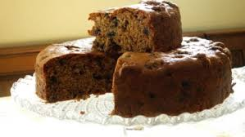  Wartime Recipe Booklet  Wartime Ration Recipes  WW2 Cake  Wartime Scones  Jam Tarts
Crack The Codes  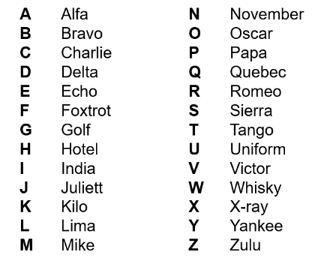  Phonetic Alphabet  The phonetic alphabet that was used in RAF ransmissions during the war. Learn to spell your name using the phonetic alphabet e.g.  Ted = Tango Echo Delta  Morse Code  Morse code is a communication system that represents the alphabet and numbers with a series of dots, dashes or a combination of both as shown here. Watch this video to find out more about Morse Code.  Can you write a secret coded message for your family to crack? | VE Day Songs  Try and learn the Horrible Histories VE Day song and perform it to your family.  Create your own motivational song. Listen to some of the following clips for inspiration. Click here to listen to some more traditional war time songs as well as the links below.  Wartime song lyrics  Run, rabbit, run!  Long way to Tipperary/ Pack up your troubles  We’ll meet again  The White Cliffs of Dover  Learn step-by-step how to Swing dance (The Lindy Hop) which originated in the late 1920s and early 1930s in Harlem, New York City. | 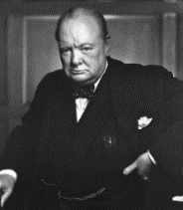  Winston Churchill  Who was Winston Churchill? Why do we remember him today? Produce a fact file/ poster displaying your information.  Create a mind map or list of facts about Winston Churchill.  What was his job?  Why was he so important during WW2?  What was one of his famous phrases?  Can you describe his characteristics?  Why he was important?  You can read more about Churchill using these links from Twinkl and Ducksters. You may present this information in any way you choose or use this template.  CHALLENGE: Can you learn Winston Churchill’s Victory speech and record yourself presenting it?
Make, Do and Mend  During WW2, there was a shortage of materials to make clothes. People were urged to "Make, do and mend".  Do you have any clothes or accessories that you could ‘upcycle’ into new clothing or something completely different to give it another purpose and a new lease of life? | Europe during the Second World War  Colour in the countries on the map (here) according to whether they were Allies, Axis, Axis controlled or Neutral.  You could print the map from Twinkl (code UKTWINKLHELPS) or create a list.  NatGeo Kids - WW2 History | Spitfire Science  Design and make your own Spitfire. You could make it out of paper, wood, recycled materials, etc. Test out your design. How far does it glide?  Does the material used for a paper plane affect the distance it travels? Try using newspaper, card, tinfoil, etc and carry out a test. Remember, only change ONE thing to make it a fair test.

