EAGLES’ WEEKLY SUGGESTED HOME LEARNING – WB 8.6.20
Good morning Eagles! Thank you for the work that you have been sending in. We have really enjoyed reading your transition work and letters to St. Edmund Arrowsmith. We will be completing more transition work in the weeks to come. Dates for the Zoom sessions are now in place and we are so looking forward to seeing all your faces once again! Hopefully the weather is going to improve this week so you can enjoy that sunshine once again!
Take care - #StaySafeStayHomeSaveLives
Mrs Colothan, Mrs Hillam, Mrs Jones, Mrs Donlon and Miss Clegg XX
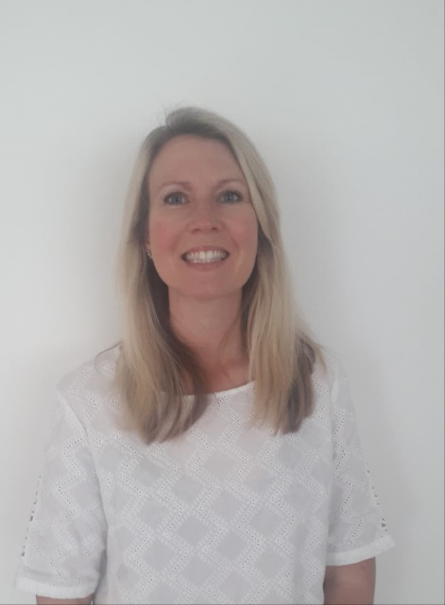
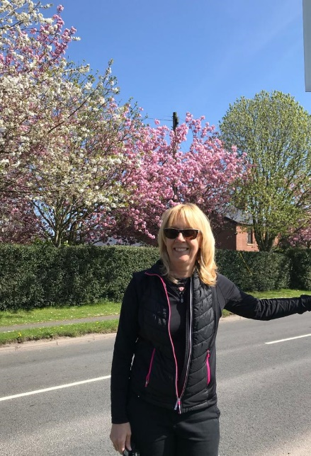

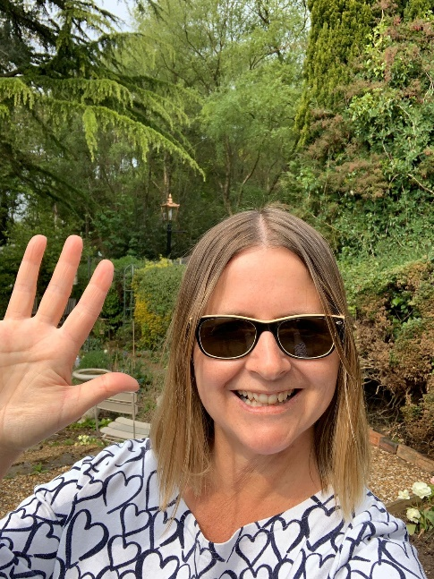
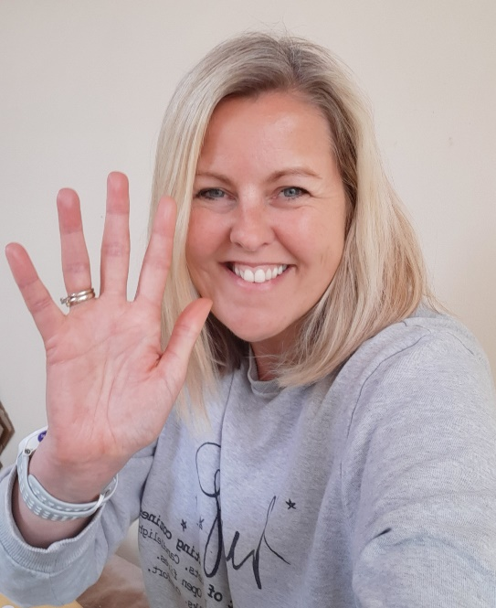

ENGLISH |  | MATHS
Reading – Read every day for pleasure for 30 minutes. You may like to use Epic. This is a great website where you read many online books for free for a month.  This week we are having a weekly focus on the genre of newspapers.  https://www.thenational.academy/online-classroom/year-6/english#subjects  Follow this web link and work through the five lessons on newspapers. These five lessons contain all the reading and writing work for the week.  There is so much happening worldwide during this time which you can use as material to write your newspaper article at the end of the week. Please ensure that the content of your work, including spelling, punctuation and grammar is your very best!  Spellings – Choose some of the words the Y5/Y6 list that you needed to learn better from last week (or choose any words that you struggle spelling) and complete the ‘Roll and Spell’ task below. |  | 4 and 6 times table – Instant recall.  https://ttrockstars.com/  How many patterns can you spot in the 4 and 6 times tables? What patterns can you spot? What is similar about the 4 and 6 times tables?  https://www.thenational.academy/online-classroom/year-6/maths#subjects  Use this web link and scroll down to the coordinates and shapes section. Begin to work through the first 5 lessons on this section.
R.E. | OTHER
Our new theme is based on Reconciliation.  We would like you to think about care and compassion. Think about the following questions and create a poster or booklet.  - What makes you feel better if you feel unwell?  - How do you care for others who may be sick?  - How can you show care and compassion for others who may have people in their family who have been poorly?  http://www.wednesdayword.org/ | Transition Tasks:  You completed some fantastic work using the Robin Hood MAT last week. We will continue with this.  Follow the link below and then scroll down to Y6/7 transition learning projects. Week beginning 8th June. The theme is about organising yourself!  https://www.robinhoodmat.co.uk/Learning-projects/  Art - Drawing Around Objects  This is a great activity to show of your creativity. The idea is to take an everyday object and to draw around it to make it look like something else. Have fun and we can’t wait to see your creations. See below for some examples.  Wellbeing – Get snapping  We are living through extraordinary times and although our freedom of movement is currently limited, our freedom of expression isn’t. With this in mind, we want you to share an image inspired by the current lockdown and self-isolation.  We would like you to take a photograph using your phone or digital camera to provide a window into your world during the 'Lockdown'. We are looking for fun or emotional or inspiring pictures that show how you and your family and even your pets are getting through these strange times. You can take pictures in your home or garden or things you can see from where you live. Or why not take pictures on your daily walk/exercise? Be as creative as you want, but please also be safe.  Once you have decided on your image email it to us!

