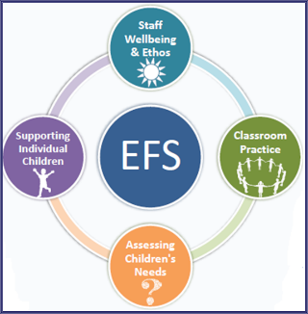
At St. Oswald’s Catholic Primary School, the mental and emotional health of our pupils and staff are key priorities. For this reason, we are proud to be part of the Emotionally Friendly Schools (EFS) programme supported by Wigan Educational Psychology Service, Wigan Targeted Educational Support Services (TESS) and CAMHS.
The EFS programme is a flexible, whole-school approach to improving children’s mental health and wellbeing for schools. It provides schools with evidenced-based methods, tools and support to help nurture happy, successful children by effectively identifying and responding to their broad emotional needs.
The aims of the programme are to improve: 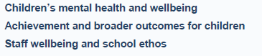
As part of our mission to achieve these aims, we are currently working towards a ‘Bronze Accreditation’ for the work we are doing around EFS in school. We are hoping to be one of the first schools in the borough to achieve this award.
Our work in this area includes weekly ‘Mindful Monday’ sessions for pupils to work on developing areas of Social, Emotional and Mental Health such as: Confidence & Self-Esteem, Managing Emotions including worry, frustration and anger; Friendship and Social Skills. If you would like your child to take part or if you have any concerns about your child’s social, emotional or mental health, please speak to their class teacher or Mrs. Barton - Emotionally Friendly Schools Champion
These materials are from the EFS Manual:
The importance of children’s emotional wellbeing

Learning and achievement
Good emotional wellbeing is key to academic learning.

Emotionally healthy children arrive at school ready to learn and are more likely to achieve academic success. They are more motivated learners, have fewer behavioural problems and show greater commitment to their school work. However, between 75 – 97% of children who experience poor emotional wellbeing achieve below expected grade levels and face school failure. This is easy to understand when we consider that it is hard for children to concentrate on their school work if they are tired, anxious or angry. We can all remember a time when we’ve felt negative emotions and know how our work has suffered. For us, this was transient; for our children, this can be permanent. Equally, the child that does not believe they can achieve, simply won’t. In their world, every time they try, they fail – so why try? Children with low self-esteem frequently underachieve in all areas of their lives.

‘Feel good, learn good’

Simply put, learning and wellbeing are two sides to the same coin. The bottom line for most schools is enabling children to achieve all they are capable of achieving. If children have poor wellbeing, they will not achieve. Alternatively, if we improve our children’s emotional wellbeing, this will lead to:
- pupils who are more engaged in the learning process.
- pupils who can concentrate and learn better.
- improved literacy and numeracy levels.
- improved academic achievement more widely, including performance on national tests.

What is Emotional Wellbeing?
At it’s core, children’s emotional wellbeing can be seen through positive coping abilities; high self-esteem; a sense of security and attachment; and feelings of social connectedness. Good emotional wellbing helps children to cope with, and bounce back from, the full array of events and emotions that will arise through their lives.

You will recognise a child with high levels of emotional wellbeing as:
- being an effective and successful learner
- being able to easily make and sustain friendships
- dealing with and resolving conflict effectively
- being able to solve problems with others
- managing strong feelings such as frustration, anger and anxiety
- recovering from setbacks and persisting in the face of difficulties
- working and playing cooperatively
- recognising and standing up for their rights and the rights of others

Approximately 1 in 5 of the children in your school will be experiencing some form of mental health difficulty, with 1 in 10 displaying sufficiently severe needs to meet clinically significant criteria. Unfortunately, mental health difficulties in children and young people are increasing.

