St. Oswald’s Catholic Primary School
English Policy
2025/26
Written by: Mrs Latham, Miss Bake and Miss Lea



St. Oswald’s Catholic Primary School
English Policy – September 2025 – Subject Leaders: Mrs Latham, Miss Bake and Miss Lea
Love Jesus, Love Learning, Love Each Other
As a school we ensure that all children and staff are treated fairly and equally. All children have equal rights to access all areas of the curriculum, regardless of race, gender and disability. Within this subject area, the SLT and all staff endeavour to provide the appropriate provision for this to occur. This policy follows the guidelines and practices that are stated and outlined in St. Oswald’s Equality Scheme.
INTENT
At St. Oswald’s Catholic Primary School, we value the importance of cross-curricular teaching, and learning opportunities that develop children’s creativity to the full. We feel that English teaching is at the heart of this process and our creative curriculum framework is rich with purposeful reading, writing and speaking and listening opportunities. English is one of the most important tools that children will ever need; it is a vital way of communicating in school and in public life, therefore at St. Oswald’s, it is our intent to make children competent in a key number of English skills and give them the opportunity, support and disposition to use them in a diverse curriculum.
At St Oswald’s our intentions are:
- To encourage children to read and write with confidence, fluency and understanding.
- To enjoy word play and poetry.
- Be able to orchestrate a full range of reading cues to monitor their reading and correct their own mistakes.
- Understand the sound and spelling system and use this to read and spell accurately.
- Listen attentively and with understanding.
- Have fluent and legible handwriting.
- Have an interest in words and their meanings and a growing vocabulary.
- Know and understand and be able to write in a range of genres in fiction and poetry, and understand and be familiar with some of the ways in which narratives are structured through basic literary ideas of setting, character and plot.
- Understand, use and be able to write a range of non-fiction texts.
- Be able to plan, draft, revise and edit their own writing and have a suitable technical vocabulary through which to understand and discuss their reading and writing.
- Be interested in books, read with enjoyment and evaluate and justify their preferences through reading and writing, develop their powers of imagination, creativity, inventiveness and critical awareness.
IMPLEMENTATION
How we implement English at St. Oswald’s

Reading and Writing
St. Oswald’s are following The Literary Curriculum from the Literacy Tree. It is a complete, thematic approach to the teaching of primary English that places children’s literature at its core. We use a whole-school approach, where children explore 115 literary texts and experience at least 90 unique significant authors as they move through the school.
The Literary Curriculum provides complete coverage of all National Curriculum expectations for writing composition, reading comprehension, grammar, punctuation and vocabulary, as well as coverage of spelling and phonics. All plans lead to purposeful application within a wide variety of written outcomes. The diagram below shows how the ‘text approach’ to teaching English is implemented.
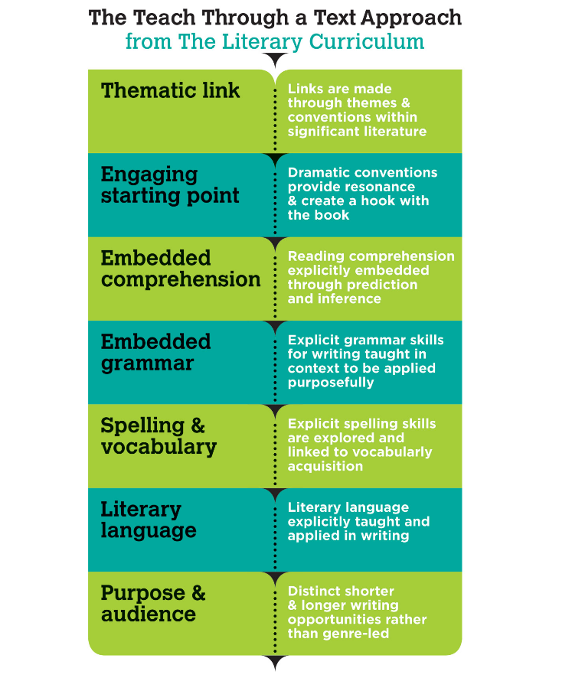
Teachers use engaging starting points to generate interest, engage and activate inference. These link to the books’ themes and employ elements of dramatic conventions, which are maintained and addressed across the sequence. Teaching includes explicit grammar objectives so that the grammar skills for writing are seen in context and can be applied within writing. These can be taught ‘discretely’ yet creatively, and still embedded firmly within the context of the book.
In addition, within the lessons, spelling investigations and activities are integrated, so that patterns and rules can be explored, discovered and then used purposefully within writing. Pupils have access to a variety of shorter and longer writing opportunities that are purposeful and pertinent to particular points of text. Children are encouraged to write in role, with bias and for a distinct audience, rather than writing in one fixed genre for the whole planning sequence. Collectively, our teaching helps children build a literary repertoire; develop a knowledge of significant authors and prepares them for the subject content of critical reading at Key stage 3.
Texts are always selected for their quality and significance. There is a wide variety including classics, award-winning texts, celebrated and significant authors such as children’s laureates and poet laureates. Children have access to novels, novellas, picture books, wordless texts, narrative poems, playscripts, historical narrative, mystery, adventure, fantasy and narrative non-fiction.
Each teaching session will include significant periods of AFL, including self & peer assessment, where pupils will be reviewing writing against success criteria and improving identified vocabulary/sentences/paragraphs.
Phonics, Spelling and Handwriting
Phonics is the cornerstone of learning to read. As such, pupils in KS1 have a daily diet of Monster Phonics before progressing onto the Grammarsaurus spelling objectives. If required, additional phonics support is given, when needed, in KS2 through Monster Phonic interventions and delivered by trained teaching assistants. The Spelling with Grammarsaurus scheme is designed to enhance children’s spelling skills after or alongside phonics by focusing on morphology, etymology, and orthography. Through this approach, children develop a deep understanding of how words are built, how their structures relate to meaning, and how spelling patterns are influenced by word origins. Throughout the scheme, pupils explore the building blocks of words, uncovering the relationships between meaning and spelling. This knowledge empowers them to spell more accurately, recognise patterns across words, and apply their understanding to both familiar and unfamiliar vocabulary. This is in line with the new ‘Writing Framework’ guidance, published by the DfE. In addition, handwriting is taught explicitly through English lessons as well as discrete handwriting lessons four times per week which follows the programme, Letterjoin, which is explained in our Handwriting Policy. Children in the Foundation Stage experience English through speaking and listening in both formal and informal situations and for different purposes. They experience reading through a range of simple texts and books and are encouraged to write for a variety of purposes through play/free choices activities. Phonics and handwriting skills are also taught formally at this stage through activities planned in line with the Early Years Foundation Stage Profile. In addition, children at every stage are given the opportunity to hear adults read aloud from a range of literature as part of story time/class novel. Children are grouped for Phonics across EYFS and Key Stage One.
Assessment
The following methods for assessment, recording and reporting are used at St. Oswald’s:
- Baseline assessments are carried out during the autumn term for the Foundation Year, and again at the end of the year.
- The Foundation Stage profile is completed and inputted onto Target Tracker. It is analysed by the Early Year’s Leader and English Subject Leader.
- Targets are set, monitored and assessed for reading, writing and spelling.
- Ongoing monitoring of sounds and English high frequency words in reading and spelling takes place until no longer needed.
- Regular spelling tests are administered, alongside opportunities for spelling application using dictation, cloze sentences, definition work and independent application. Progress within these areas are monitored on a termly basis by the subject leaders.
- From Subject Leader Analysis children are identified if they have failed to achieve targets or make progress from the previous year and their English work is monitored carefully. These children receive interventions where necessary.
- SATs at the end of Key Stage 1 and SATs at the end of Key Stage 2 are undertaken.
- Informal day to day assessments take place to ensure that planning and teaching effectively meet the needs of the children.
- Throughout the year, results are inputted onto Target Tracker, and overall school analysis is conducted and reported back on.
- Effort and achievement in English is formally reported to parents three times a year. This includes a summative report given to parents in the summer term which outlines the child’s achievements and sets future targets, and 2 interim reports with gradings on, provided for parents in the Autumn and Spring Terms.
- There are also three parent evenings, where targets and achievements are discussed. These are attended by pupils from Y2 –Y6.
- Monitoring and Evaluation is an important way of maintaining quality and standards. The close scrutiny of planning, children’s work and pupil interviews ,along with detailed termly analysis procedures, is an effective means of monitoring and accessing good practice within the school.
- Children are also encouraged to evaluate their own work and set appropriate individual targets, using greens pens in their books .St. Oswald’s makes use of the Raiseonline, FFT and Keypass data, identifying key areas that were particular strengths and areas for future development from the Key Stage 2 SATs. This information is reported to all staff, so that they are aware of key areas in need of development that can be addressed through their teaching.
- Evaluation of Key Stage 1 SATs and Key Stage 2 SATs results allow for whole school target setting.
- Whole-school staff meetings, Subject leader and year group teacher moderation meetings ,as well as Cluster moderation meetings, all ensure that our judgements of writing are sound.

IMPACT

- Children achieve very high standards in reading, writing and spelling;
- Children can apply their reading and writing skills across a variety of subjects.
- The vast majority of children achieve their year group expectations;
- The vast majority of children make 6 steps of progress each year;
- Children develop a genuine love of reading and writing.
- Children can apply their reading and writing skills across a variety of subjects – cross-curricular skills;
- There is a rising trend of greater depth achievers at the end of KS1 and KS2.

ENGLISH FROM SEPTEMBER 2020 IN RESPONSE TO COVID-19

Intent:
- to use resources from the DFE and Literary Curriculum to plan an effective catch up sequence for all of our pupils;
- to use pre-learning grammar and reading activities to ensure planning is matched to where individuals are at;
- to build the confidence, resilience and competence with reading and writing post lockdown;
- to ensure all pupils access a wide range of high quality texts to deepen understanding;
- to ensure language opportunities are maximised in every lesson to enhance pupil confidence further;
- to identify gaps from 2019-2021 and plan catch up opportunities to fill these gaps;
- to use an additional afternoon sessions to close gaps in spelling, reading and writing and plan for many opportunities to apply reading and writing skills consistently across all areas of the curriculum;
- to ensure all of our pupils fulfil the expectations of the National Curriculum 2014.
- to use Seesaw to maintain the learning journey if the class goes into isolation or a 2nd national lockdown is put in place and to set more supportive homework activities.
- Monitor closely the progress and development of the vulnerable groups throughout the school.
- To develop confident early communicators in EYFS, where the environment enables pupils to succeed and practise language and communication skills daily.
- Identify individuals early who need additional intervention and support to continue to develop in their learning.
- Form greater links between home and school through Seesaw so that parents develop a greater awareness of how they can support their child.

Implementation:
- Teachers will use the Literary Curriculum, Monster Phonics and Oak National Academy resources to support them with their teaching. These contain consistent vocabulary, a variety of texts and questions. The plans also take into account the previous year’s learning which pupils must have to build on their understanding.
- Pupils will complete regular spelling, reading and writing tasks to assess pupils’ basic skills;
- Teachers will use daily quizzes and starters to keep areas of spelling and grammar bubbling.
- 4 daily English lessons a week which are 1 hour and 15 mins long and 3 additional afternoon catch up slots will be made available to pupils.
- Termly assessments will be completed and reviewed across all year groups.
- Baseline assessments will continue in EYFS in English and findings from this will support with curriculum delivery and opportunities in the continuous provision.
- Ongoing CPD for staff will ensure staff are consistent in their approach to expectations of basic skills which will be addressed in feedback and marking.
- CPD for staff on the effective use of Seesaw and how this can be used in the best way.

Impact:
- Children by the end of the year will have shown sufficient progress – it is difficult to define, “sufficient,” as the pandemic is ever-changing;
- The vast majority of pupils will be performing mostly within age-related expectations;
- Children will report that they enjoy English and understand the benefit of reading and writing alongside speaking and listening;
- Spelling scores, termly reading and SPAG assessments and regular writing moderation in school indicate good progress has been made;
- Seesaw illustrates the confidence pupils have to recall their learning at home.
- Pupils have a strong sense of the value of literacy and can make links across all areas of the curriculum applying their skills with thought and care. They can articulate their strengths in Literacy and their areas for development.

