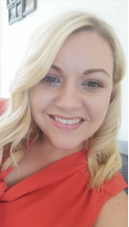
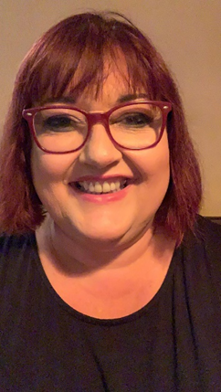
OWLETS AND EAGLETS - WEEKLY SUGGESTED HOME LEARNING –
WB 1.06.2020

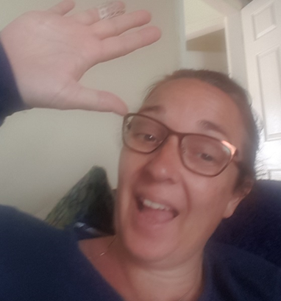

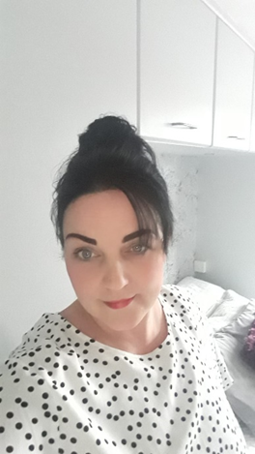
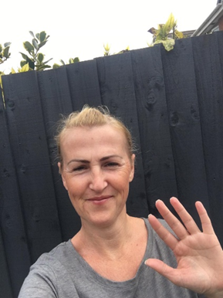
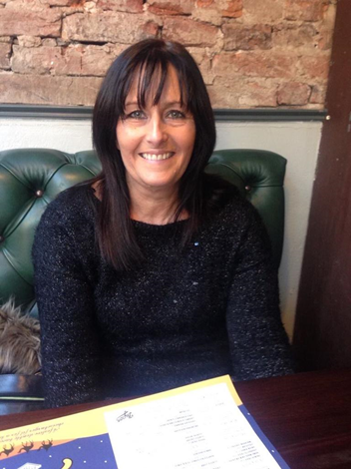

Hello Owlets and Eaglets, we hope you are all well and looking after yourselves. We hope that you have enjoyed your half term. These are our suggested activities for you this week. We hope that you enjoy them. We would love to find out how you get on with them. Please email or tweet pictures to school so that we can upload them onto your see-saw account. It is lovely to see what you have been up to. If you complete different activities that is fine, still send these as we can share these with the other parents too. Thank you for your ongoing support, enjoy you’re your week of learning. School email – enquiries@saintoswalds.wigan.sch.uk Tweet - @saintoswalds

ENGLISH | MATHS
Reading – Read a variety of books at home. Favourite books can be repeated as it supports the children with their language development as they will hear the patterns of language in the story.  With your child, look in magazines, newspapers and books for the tricky words they are currently learning. They could use a highlighter to highlight in magazines and newspapers.  Look at this link on Oxford Owls - Helping children read at home  Use Oxford Owl to access books that are related to phase 2 and 3 phonics. Where possible children to read to parents daily.  When you go on click on all ages and click on age 4-5. Then go into levels and click on letters and sounds and choose either phase 2 or 3.(phase 2 will be a little easier and phase 3 more challenging) If you find that these are still not challenging for them then choose age 5-6, go into levels, letters and sounds and click on phase 4. This will then bring books up for you to access with your child.  After reading the book ask the questions on the back cover of the book and complete the play activities linked to the book.  Register here for free access to Oxford owl or you can use our class login  My class name – owlets and eaglets  My Class Password – reception.  Just go to the Oxford Owl login page and click on the My Class login button and use the above details.  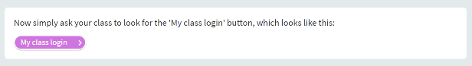  Look at the story “The Rainbow Fish.” If you don’t have this story at home. Here is a link to the story  The Rainbow Fish.  What is your favourite part of the story?  Who are the characters?  What happened at the beginning of the story?  What happened in the middle of the story?  What happened at the end of the story  Writing task – To write a list of the characters in the story.  Remind the children how to set out their list writing each character one under the other. Remember to use a phase 2 and 3 sound mat to help your child with the sounds in the words.  Writing task 2:  Practice name writing. Can they write their first name? Middle name? Surname?  Writing task 3:  Ask your child to write out the tricky words they are working on at the moment on pieces of paper and turn them into a pairs game. Ask your child to put these words into sentences and write them down. Think about the spaces between their words and remember to add a full stop at the end of their sentence.  Inference activity  Look at the picture at the end of the planning. Talk about the picture and then answer the questions on the picture underneath it.  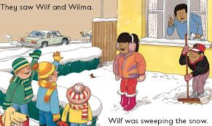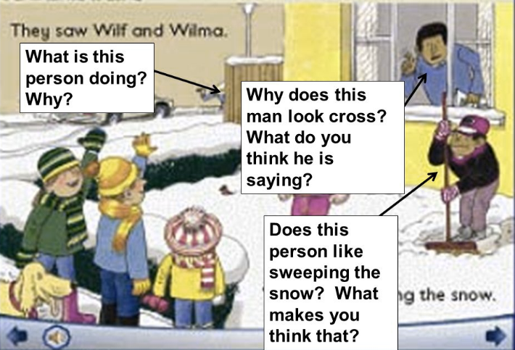  Phonics (Reading and writing)  As we have now introduced the children to all the sounds in phase 2 and 3, take some time this week to assess the children on which sounds that they can read and write independently. Reading – show the children a sound ask them to tell you what it is. Make a record of which sounds your child is unsure of. Writing – say each sound from phase 2 and 3 letters and sounds and ask your child to write it. Make a record of which ones they are unable to write on their own. Complete also for reading phase 2 and 3 keywords. Once you have found which sounds your child is struggling with use the phonics play games that can be found in resources tab on phonics play to work with your child on these sounds and words. There are some tick sheets available at the bottom of the planning for you to use if you wish.  Please remember to use the free log in -  Use the Username – march20 and the password – home  If you wish to complete a spelling test use a mixture of the key words you have looked at with the children from phase 2 and 3. Only look at up to 8 words choose from these words – the, I no, go, to, into, he, we, me, be, she, they, was, my, all, you, her, are. | Mathematics  Watch number blocks clip each day with your child at  Numberblocks BBCiplayer or Numberblocks Cbeebies  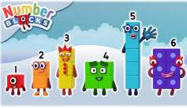  Activity – Practice number formation with you children. Here are the rhymes that we use in the classroom to help your child remember how to write the numbers.  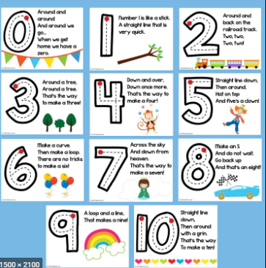  Follow the White Rose Week 5 using the story - Superworm. Maths focuses – positional language, comparing number order (forwards and backwards), counting reliably, adding, length and ordering different lengths.  You may also want to look on Oak National Academy Reception Click on the link below to access 5 lessons on Time  5 lessons on numbers within 20  Start with lesson 6 and work through to lesson 10. Complete one lesson each day. Lessons focus on finding one less than a given number, exploring one more and one less, investigating number combinations within 20, patterns and ordinal numbers.  Practise counting up to 20. This can be done through playing hide and seek, singing number songs, chanting, board games etc. Remember to also practise counting back from 20 to 0.  Don’t forget that you have your Numbots username and password that was sent to you on your child’s see-saw learning journal. Look in the parent information file on the app to find it again if you have forgotten it.  If you wish you may also like to recap some of the shape names with the children. Look at 2D and 3D shapes around your home.  Children are expected to know – 2D shapes - circle, triangle, rectangle, square but we found the children were ok with these and introduced them to oval, semi-cirlce and pentagon. 3D shapes – cone, sphere, cube, cuboid, pyramid, cylinder.  They are also expected to be able to describe these shapes using related vocabulary.  2D – sides and vertices (corners)  3D – faces, vertices (corners), vertex (point on the top), edges (straight or curved)  i.e. A cube has square faces, straight edges and has vertices. It can slide. To challenge your child you could ask them to count the faces, edges and vertices.  You can find resources for shape on discovery education espresso. A link for this is on our school website. If you have forgotten the password, you can contact school to find out what it is.  Click on Foundation on the top bar  Then click on the maths subject.  Then click on shape.  Here you will be able to access videos related to flat (2D) and solid (3D) shapes.
R.E. | OTHER
The theme is: Good News  RE – ‘The Miracle of the five loaves and two fishes.’ Please listen to the story about the little boy who teaches us that ‘friends share with others.’ Talk about how Jesus performs a miracle! Indeed Jesus fed the 5000! You can find this story on The little boy shares. You may wish to explore other miracles performed by Jesus.  We would have been starting our new topic Friends. To start our topic we listen to some stories linked to the topic.  The Selfish Crocodile.  The pain and the great one.  Then we talk to the children about who their friends are and why they think they are a good friend.  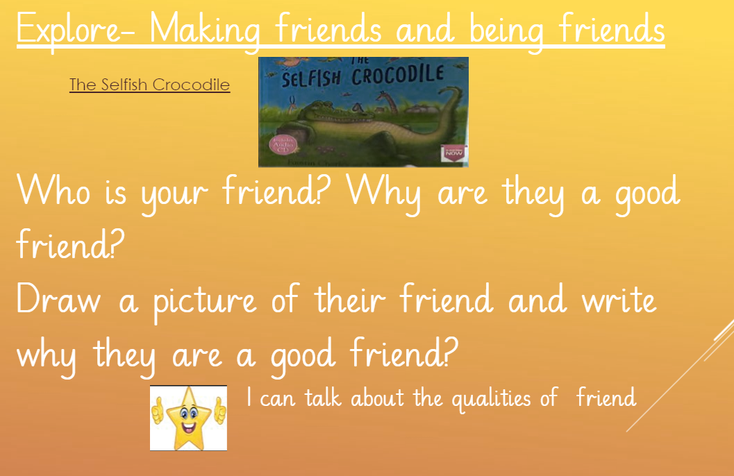  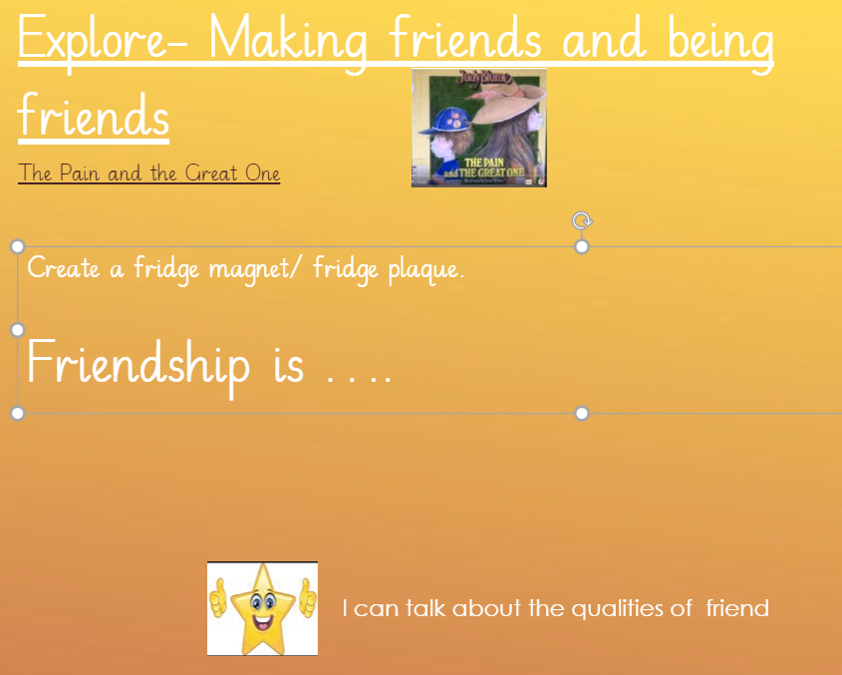  Activity - Create a plaque or fridge magnet with the slogan Friendship is … and place in the house.  Pentecost is on Sunday 31st May. | PE –Physical activities for kids follow the link and copy the exercises from the video.  Or try cosmic kids yoga Click on the link and choose from one of the videos.  You could also try some ‘Funky Fingers’ activities such as playdough, threading, cutting and sticking activities. You can try out the ‘Finger aerobics’ on ‘You Tube’ and ‘Funky finger playdough’ and 'handwriting finger warm-ups' activities. Your child may need a small piece of playdough or pencil or some coins to complete some of these activities. This is to develop fine motor control, pencil grip and coordination when writing.  Understanding the world – looking after our environment. Take your child for a litter pick around your front and back garden. Create a poster to remind people to put rubbish in the bin.  Recycling/ Exploring Materials- ○ Provide your child with a selection of packaging to sort into groups to recycle. Can they identify plastic, paper, card, metal.  Rainmakers - Provide your child with either a plastic container, bottle or other junk modelling item. Pour in a spoon or two of rice or lentils and secure with a bottle lid or sellotape. Decorate with stickers, glitter and sequins if you have them available. Have fun exploring making rain sounds.  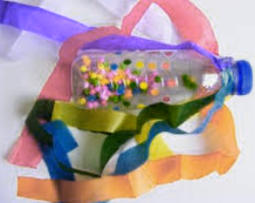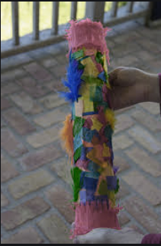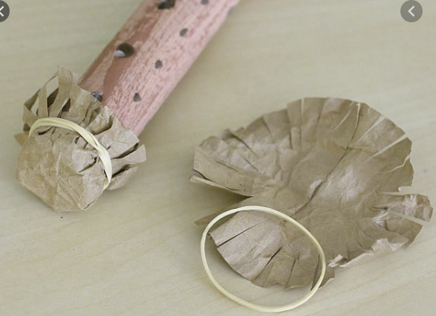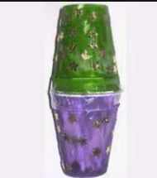

Your own number rhyme sheet.

Picture to be used for the inference activitiy.

Phonics
When revisiting the sounds with the children sing the song.
i.e when revisiting a sound.
An (insert the sound here) together make one sound.
What is it?
An (insert the sound here) together make one sound.
What is it?
It’s in (insert 4 words with the sound in here)
An (insert the sound here) together make one sound.
What is it?

If you need support with the song when recapping sounds with your child, please do not hesitate to get in contact with Mrs Gill via see-saw.

After singing the song ask the children which sound did we hear in each of the words. Repeat the words slowly if you need to. Then repeat the song again but where we sing what is it? The children say the sound the letters make together.

Resources for Phonics
