OWLETS AND EAGLETS - WEEKLY SUGGESTED HOME LEARNING – WB 11.05.2020

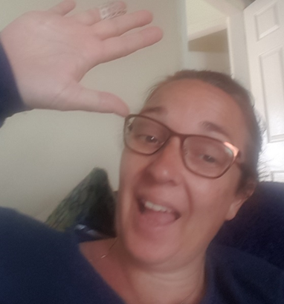

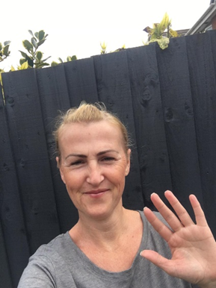
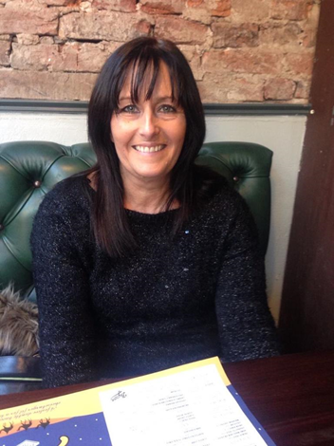

Hello Owlets and Eaglets. We hope that you have had a nice week and you have enjoyed doing the tasks. We hope that you had fun celebrating on Friday too. Send us any pictures of you having your parties at home. Keep us posted with how you get on this week and we can add your work onto Seesaw. Have a good week,
Mrs Gill, Mrs Davies, Mrs Ridings, Mrs Hanway and Miss Woolley xx

ENGLISH | MATHS
Reading – Read a variety of books at home. Favourite books can be repeated as it supports the children with their language development as they will hear the patterns of language in the story.  Look at this link on Oxford Owls - Helping children read at home  Use Oxford Owl to access books that are related to phase 2 and 3 phonics. Where possible children to read to parents daily.  When you go on click on all ages and click on age 4-5. Then go into levels and click on letters and sounds and choose either phase 2 or 3.(phase 2 will be a little easier and phase 3 more challenging) If you find that these are still not challenging for them then choose age 5-6, go into levels, letters and sounds and click on phase 4. This will then bring books up for you to access with your child.  After reading the book ask the questions on the back cover of the book and complete the play activities linked to the book.  Register here for free access to Oxford owl or you can use our class login  My class name – owlets and eaglets  My Class Password – reception.  Just go to the Oxford Owl login page and click on the My Class login button and use the above details.  Re- cap the story “Giraffes Can’t Dance.” If you don’t have this story at home. Here is a link to the story https://www.youtube.com/watch?v=vZjsLK5vwNU  What happened at the beginning of the story?  What happened in the middle of the story?  What happened at the end of the story  Writing task – To write the story  We would like your child to write to write 3 sentences about the story.  Ask your child to write a sentence for the beginning, middle and end of the story.  You may wish to use a phase 2 and 3 sound mat to help your child. We sent these home with the children on the back of their name cards.  Comprehension task  What is happening in the picture?  Why do you think this?  How do you think they are feeling?  Phonics (spelling)  Phoncis play phase 3 letters and sounds planning see below.  Go to week 8, use this planning over two weeks. In school, we usually introduce the children to 2 sounds per week. When introducing a new sound we sing a song before we introduce the sound. We hold up the sound and sing the song. The songs are at the end of the planning sheet along with some of the resources that you will need within the sessions.  Please remember to use the free games on Phonics Play also.  Use the Username – march20 and the password – home  to access the free games.  If you wish to complete a spelling test use a mixture of the words you have looked at over the week and any key words that they have worked with. Only look at up to 8 words. | Mathematics  Watch number blocks clip each day with your child at  Numberblocks BBCiplayer or Numberblocks Cbeebies  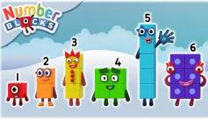  Activity – Practice number formation with your children. Here are the rhymes that we use in the classroom to help your child remember how to write the numbers.  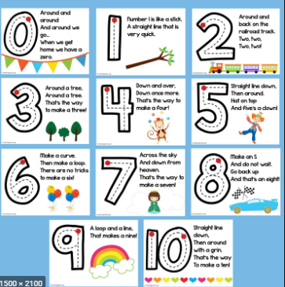  .  In addition, if you wish you may want to use week 3 White Rose maths planning. The link is below.  https://whiterosemaths.com/homelearning/early-years/  Work on the week 3 planning link includes size, shape, length, doubling and sharing, simple addition, days of the week, counting, making patterns. This work uses the book The Hungry caterpillar however you do not need the book to cover the activities. If you don’t have the book you may wish to listen to the story. Follow this link which will take you to the story. https://www.youtube.com/watch?v=75NQK-Sm1YY&t=337s  You may also want to look on Oak National Academy Reception Click on the link below to access 5 lessons on Grouping and Sharing.  5 lessons on Calendar and Time  Start with lesson one and complete one lesson each day.
R.E. | OTHER
The theme is: Good News  RE – Good news  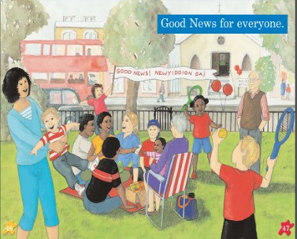  Ask your child the following questions-  What do you see in the picture?  Why are they celebrating?  How are the people celebrating?  How would you celebrate the good news of Jesus?  Celebrate with your child by singing – If your happy and you know it clap your hands.  Tell your child the story of Pentecost  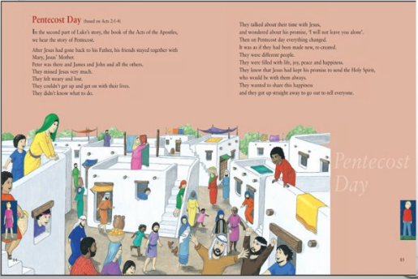  - Make streamers with the words  ‘Share the good news of Jesus with everyone’. And create a celebration dance with them.  May is the Month of Mary.  Father John has asked the parishioners to pray the rosary throughout May. Try to set a little bit of time aside each day to pray the rosary, encourage the children to learn the Hail Mary and join in with this bit of the rosary. Follow the link below for a video to help the children learn the prayer.  The Hail Mary | Play animal charades- Take it in turns to act as different animals. Add in noises as a clue…  Learn the song, ‘The animal fair’ https://www.bbc.co.uk/teach/school-radio/nursery-rhymes-the-animal-fair/z766wty  Looking after your pet - If you have a pet at home encourage your child to take part in their daily care. They could help feed, groom and clean up after your pet. Caring for pets.  Have a go at the camouflage-jigsaw-game. You will need to use a free twinkle account to access.  https://www.twinkl.co.uk/resource/tg-ga-150-camouflage-jigsaw-game  Create an animal den- Provide your child with blankets and sheets to make an animal den.  Can you create a 3D picture?  We would like you to make a 3D jungle with your child. You can use a shoes box for this activity. Decorate the box like a jungle. You can use different materials. Make trees and animals from different materials. To go in the box. They should not be stuck the sides but try to get them to stand at different levels in the box.  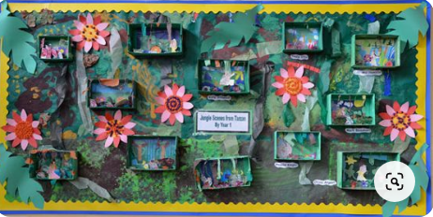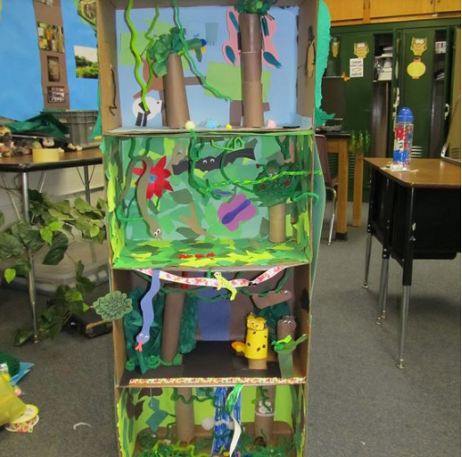  PE – We would like your child to take part in yoga.  https://www.youtube.com/results?search_query=cosmic+kids+yoga+ There are lots of videos please choose one that your child would like.  Personal and Social development - Being a kind friend Find out about how to be a kind friend through the story of My friend bear on Oak National Academy.

Picture for the comprehension task.

Your own number rhyme sheet.
Story to be read during our RE task.

3D Jungle picture

Phonics
When introducing a new sound to the children I usually introduce the sound through a song.
i.e when introducing ear.
An e, a, r together makes one sound.
What is it?
An e, a, r together makes one sound.
What is it?
It’s in fear and hear and near and tear
An e, a, r together makes one sound.
What is it?

i.e when introducing air.
An a, i, r together makes one sound.
What is it?
An a, i, r together makes one sound.
What is it?
It’s in air and stairs and fair and hair
An a, i, r together makes one sound.
What is it?

i.e when introducing ure.
An u, r, e together makes one sound.
What is it?
An u, r, e together makes one sound.
What is it?
It’s in sure and pure and cure and manure
An u, r, e together makes one sound.
What is it?

After singing the song ask the children which sound did we hear in each of the words. Repeat the words slowly if you need to. Then repeat the song again but where we sing what is it? The children say the sound the letters make together i.e. ear, air, ure.

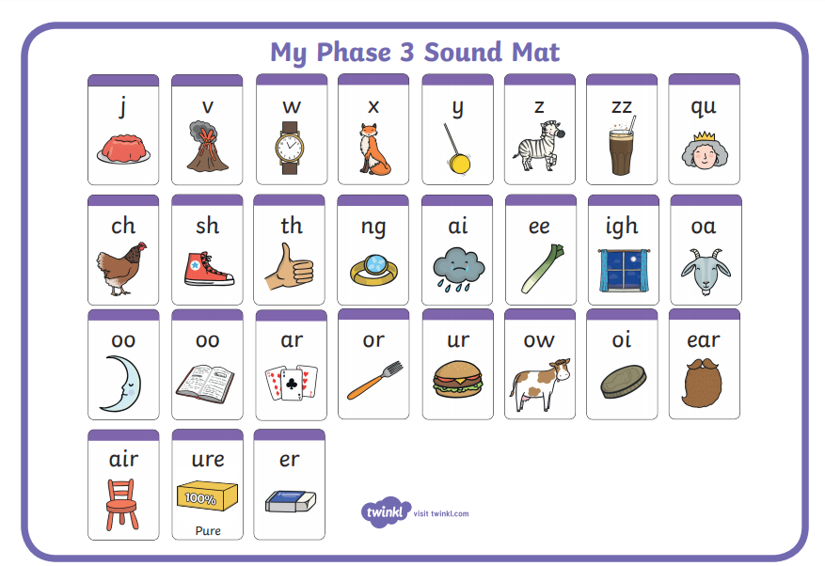

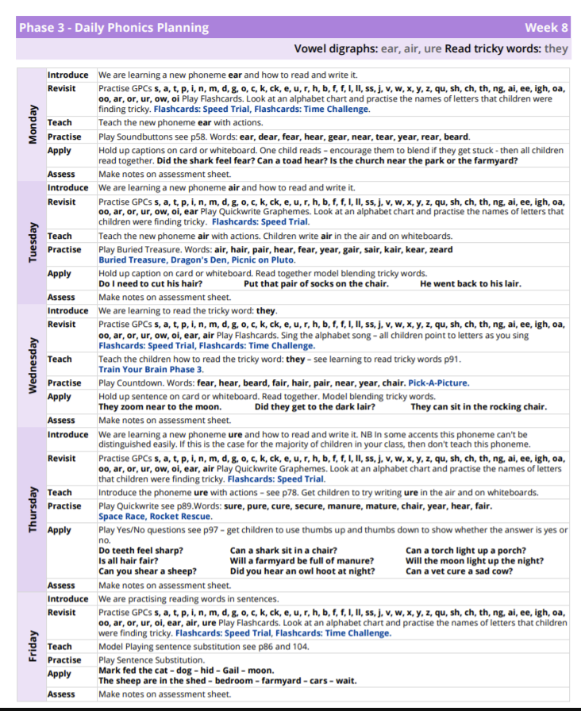

Monday Resource in the Apply Section.
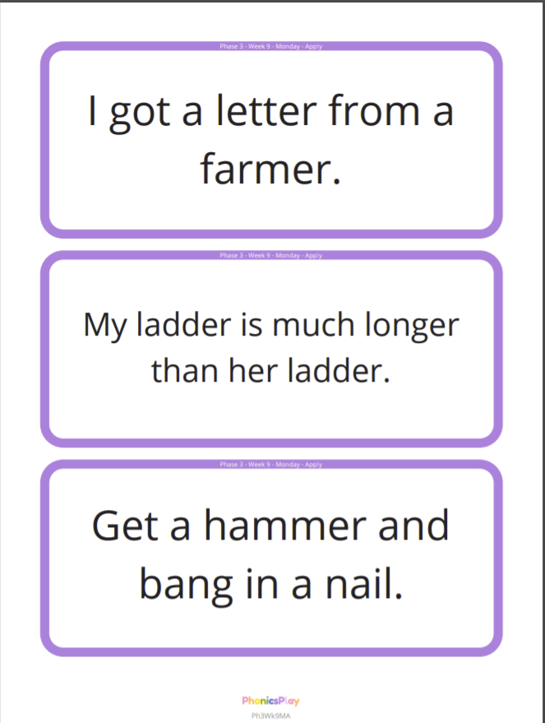

Tuesday – Resource for the Practise and Apply sections.
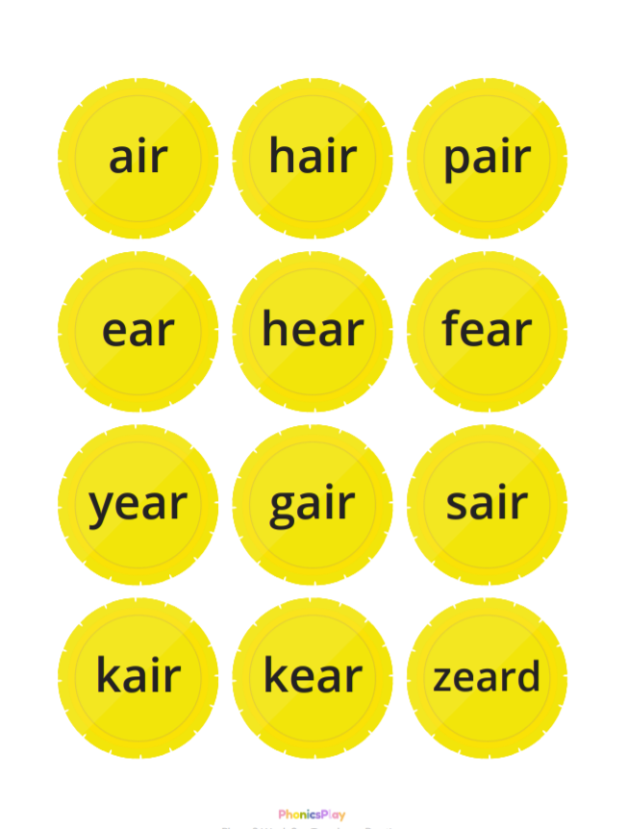

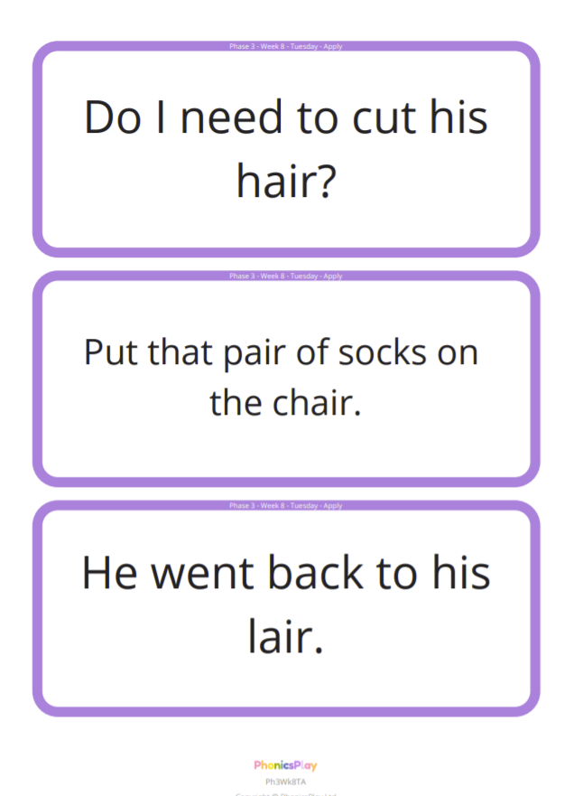

Wednesday – resource for the Apply section.
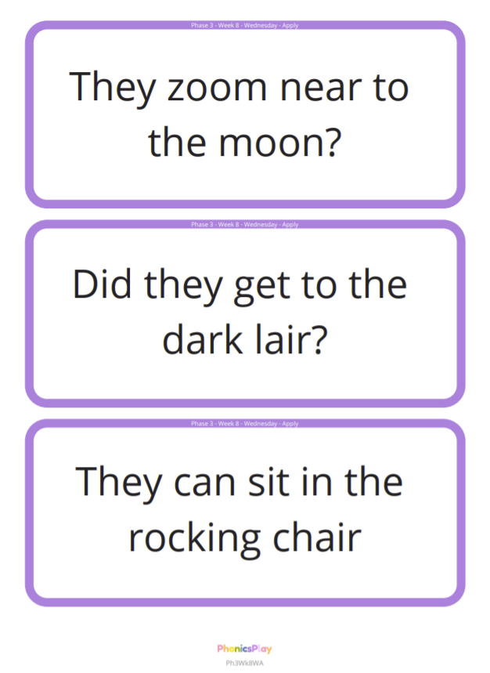

Thursday – Resource for the Apply section.
