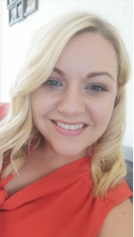
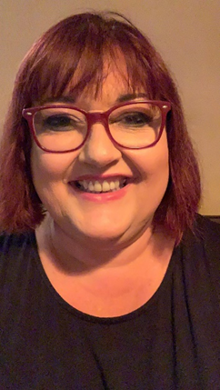
OWLETS AND EAGLETS - WEEKLY SUGGESTED HOME LEARNING –
WB 13.07.2020

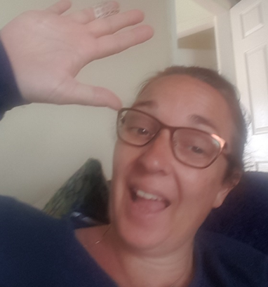

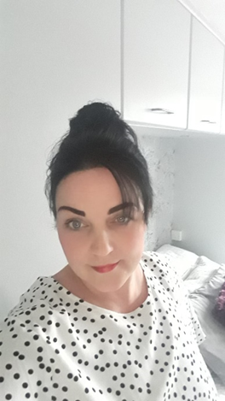
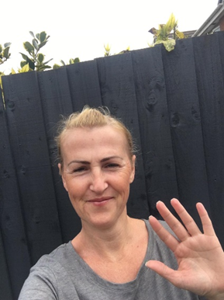
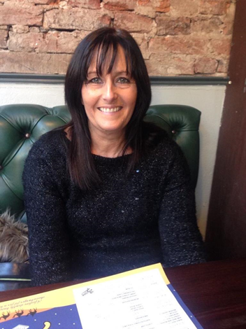

Hello again Owlets and Eaglets, we hope you are all well and still looking after yourselves. These are our suggested activities for you this week. We hope that you enjoy them. This week we have 2 focuses. One focus is on Music giving your child the opportunities to learn more about music. The second focus is on transition giving the children the opportunity to reflect on their time in their current class, discuss their favourite memories and achievements whilst also considering their hopes and dreams for the next academic year. Please remember to share some pictures on See-Saw. It is lovely to see what you have been up to, thank you for keeping in contact with us, we miss you so much and it’s lovely to see your happy faces, showing us what you have been up to. Thank you for your ongoing support, enjoy your week of learning. School email – enquiries@saintoswalds.wigan.sch.uk Tweet - @saintoswalds

ENGLISH | MATHS
Reading – Read a variety of books at home. Favourite books can be repeated as it supports the children with their language development as they will hear the patterns of language in the story.  Use Oxford Owl to access books that are related to phase 2 and 3 phonics. Where possible children to read to parents daily.  When you go on click on all ages and click on age 4-5. Then go into levels and click on letters and sounds and choose either phase 2 or 3.(phase 2 will be a little easier and phase 3 more challenging) If you find that these are still not challenging for them then choose age 5-6, go into levels, letters and sounds and click on phase 4. This will then bring books up for you to access with your child.  After reading the book ask the questions on the back cover of the book and complete the play activities linked to the book.  Register here for free access to Oxford owl or you can use our class login  My class name – owlets and eaglets  My Class Password – reception.  Just go to the Oxford Owl login page and click on the My Class login button and use the above details.  Some extra literacy activities this week are taken from Robin Hood Multi Academy Trust. Focus this week is on Music.  Story sound effects- Read a story together and add in your own musical sound effects e.g. make swishy swashy sounds with fabric to go with ‘We’re Going on a Bear Hunt’. You can repeat this with as many stories as you like!  Read together the story of Mr Big. Discuss with your child how Mr Big felt when the other animals didn’t want to be around him.  Read and sing a variety of nursery rhymes with your child. Which one is their favourite? Do any of the rhymes have the same rhythm?  Have a look at and explore musical notes. Talk about how people read the different notes to play different musical instruments. Talk about the different instruments people can play. Which instrument would you like to be able to play?  Writing task 1 –  Ask your child to think about how some musical instruments are played, for example bang a drum, tap a tambourine, shake the maracas. Write out the words and encourage your child to trace them.  Writing task 2-  Your child can draw a picture of the events from their favourite Nursery rhyme. CHALLENGE: Ask your child to write out the words to a part of the song or the song title.  Writing task 3 –  Ask your child to sing their favourite nursery rhyme. As they sing each line of the song, they can draw small pictures to help them remember the song.  Writing task 4 –  Listen to a piece of classical music of your choice. Ask your child to draw/ paint along to the music. How does the music make them feel? CHALLENGE: Can they write onto their picture how it made them feel?  Inference activity  See end of planning for larger pictures for this activity. Can I infer what is happening in the pictures?  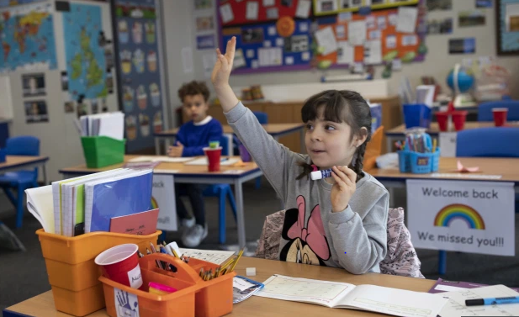  What can you see in the picture?  What is the little girl doing?  How is she feeling? Why do you think this?  What can you see in the picture?  Who is holding the little girls hands?  Do you think she is happy or sad? Why?  Phonics (Reading and writing)  Phase 4 phonics –  Please remember to use the free log in - Use the Username – march20 and the password – home If you wish to complete a spelling test use a mixture of the key words you have looked at with the children from phase 2, 3 and 4. Only look at up to 8 words choose from these words – the, I no, go, to, into, he, we, me, be, she, they, was, my, all, you, her, are, . Or use the words covered in this weeks phase 4 planning. Phase 4 phonics – Start your phonics session by playing the flashcard games on phonics play for key words and sounds for either phase 2 or phase 3. Help your children to read the following words think, thank, street, spring, plink, thand, spreet, sprick.. Once they have practised reading them, can they have a go at writing them? Segment the words slowly so that the children can hear each sound.  We would like you to go over reading the tricky words again. Display a word card. Say a sentence using the word. Repeat with each word card. Start again with the first word card and repeat the process more quickly but without giving a sentence. Work through all cards. Go through cards a final time with children saying the word without sounding them out. Words: said, so, do, have, like, some, come, were, there, little, one, when, out, what.  Play the yes/no game with these questions (enlarged at the bottom of the plan). Ask your child to read the sentence then decide whether the answer is yes or no.  When you drink milk, will you hear it crunch? Will an igloo melt in spring? Will a pink shrimp punch a green crab? Can string think? Do you think mud will scrunch? Do cars sleep? Will a plump toad burst? Do skunks stink? Do fish blink? Do clocks get cross? Can crabs clap hands? Are you fond of plums? Did a shark ever jump up a tree? Do trains run on tracks? Will a truck go up steep stairs? Can we see the stars on a clear night? When you get wet, will you shrink? Will trash jump from a dustbin? | Mathematics  Watch number blocks clip each day with your child at  Numberblocks BBCiplayer or Numberblocks Cbeebies  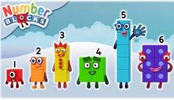  Activity – Practice number formation with you children. Here are the rhymes that we use in the classroom to help your child remember how to write the numbers.  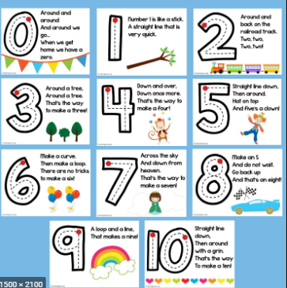  Follow the White Rose Week 10 using the story The Dinosaur that pooped a planet –spatial awareness, 2D and 3D shapes, patterns, change- adding more, doubling, halving and sharing and measure.  You may also want to look on Oak National Academy. The 5 lessons this week are on depth of numbers within 20. Reception Click on the link below to access 5 lessons on numbers within 20. This includes addition and subtraction within 20 part 1, 2 and 3 and depth of numbers within 20 part 1 and 2 on Oak National Academy Depth of numbers within 20s. Please scroll down to the bottom of the link to find the 5 lessons.  Practise counting up to 20. This can be done through playing hide and seek, singing number songs, chanting, board games etc. Remember to also practise counting back from 20 to 0.  If you wish to do some more activities taken from Robin Hood Multi academy trust learning projects. These are on shape.  Take your child on a shape hunt. Look around the house and garden for different objects that have: 2D shapes – circle, square, triangle, rectangle (oblong) 3D shapes – sphere, cube, cuboid, cylinder, pyramid.  Sing these shape songs together: 2D shape song and the 3D shape song. Then play the Turtle Diary online game.  Can your child draw around objects to create 2D shapes? Ask your child to name the shapes they have drawn. Can they cut the shapes out to make a 2D shape picture i.e. a house, rocket, robot?  Make a clap beat for your child, can they repeat the clapping sequence? Can they make their own for you to follow?  Find and talk about recycled 3D shape objects e.g. boxes, bottles, tubes, Do they roll? Can you build the shapes on top of each other to make a tower? Can you see any 2D shapes?
R.E. | OTHER
The theme is: Universal Church – Our World  This is the final week on the Our World topic. The activities are taken from the CAFOD website. This week it is a time for your child to praise God for our wonderful world and respond to what we love and wonder about our world;  Task 1- Share God’s Story 1, pages 6-7 God said, “ITake care of my world!” (Larger image at the bottom)  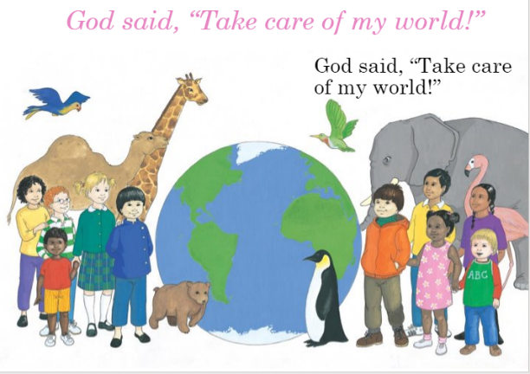  Then continue to read God’s Story 1 1  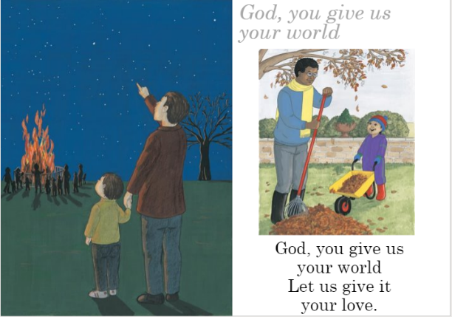  (larger image at the bottom)  Say the words;  Let’s sing to God  Let’s praise God together!  Task 2- Show picture of Azmera from Ethiopia collecting water with her mother  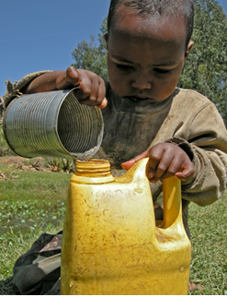  - What is Azmera doing?  - How is Azmera taking care of the world?  - How do we take care of the world?  - What does it mean to praise God?  - How can we work together to praise God’s wonderful world?  Explain that one of the wonderful things we praise God for is water. It is a precious gift from God and we need to use it well and not waste it.  - Why is water so precious?  - What can we do to help save water?  Task 3 – Talk with your child about how it’s good to use water to keep us healthy and clean but explain how we might waste water. How might we save water?  Task 4- Make a sign for home as a reminder not to waste water.  Task 5-  Remembering  Start the session with a moment of quiet reflection. Provide your child with the opportunity to engage with questions of meaning and purpose related to Our World.  Ask the children if there is anything they wonder about  - How wonderful is our world?  - How could we make God’s world even more wonderful?  - What would happen if we did not look after our world?  Task 6- Responding  You could ask your child to draw or write how they would look after God’s wonderful world (larger image at bottom of page)  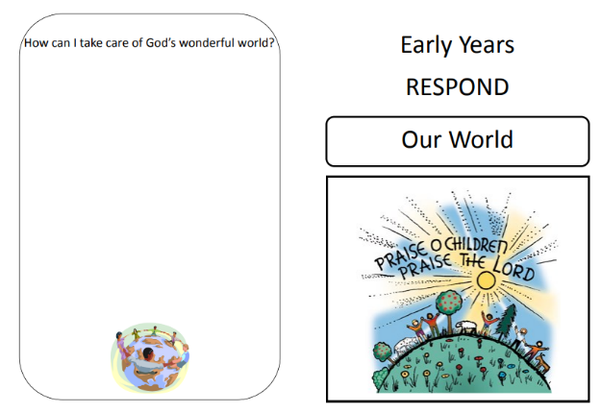  CAFOD also have Kidz-Zone area (click on the link). Here you will find more information about the work of CAFOD, online games, things to do and children’s prayers. Click on the link then scroll down below the world map. | These activities are related to transition allowing your child to reflect on the past year, their memories and achievements.  Memories-Over the last year, your child will have created many school memories that they will cherish forever. Capture these memories in a fun way by asking your child to create a drawing or painting that illustrates their favourite school memory. This could be of a memorable lesson, a school trip or a game they played with friends. If your child has more than one favourite memory, they could create multiple art pieces and put these together to create a collage.  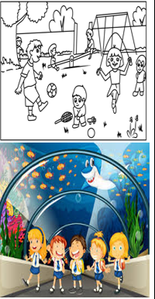  Achievements-Your child has achieved so much over the course of the year and now it is time to reflect on what makes them proud. Talk to your child about their proudest achievement this year. This could be learning to read some simple words, holding a pencil correctly or eating all of their school lunch every day. 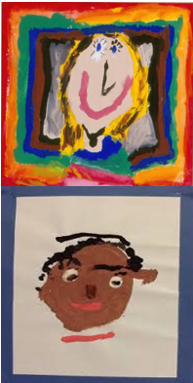  Individual Qualities-Ask your child to think about what makes them special. What makes them different to other people? Using an old shoe box, make a ‘Special About Me’ box. Your child could collect items from around the house that represent their personality such as a paintbrush, a storybook or a pair of dance shoes. Alternatively, your child could carefully cut out pictures from magazines or draw pictures to represent their individual qualities. Talk about the importance of being unique together .  After discussing your child’s accomplishments, ask them to choose one. Work together to create a portrait of your child which depicts their proudest achievement.  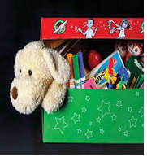  Goal setting- Read or listen to the story ‘Giraffes Can’t Dance’ here. Talk about how Gerald the giraffe showed determination when trying to achieve his goals. Ask your child what they are looking forward to most about their new class, what they would like to get better at and what they would like to learn about.  Then discuss all of the things that will help your child get ready for their new year group (see the list below). With your child, choose a few of the items from the list to practise over the next few weeks before September.  Getting ready for my new year group  - Taking turns when playing games  - Putting on my P.E kit independently  - Putting equipment away when I have finished using it  - Writing my first and last name  - Washing and drying my hands  - Using scissors safely  - Pouring water from a jug  Wellbeing - try cosmic kids yoga Click on the link and choose from one of the videos.  Take some time to be quiet and still, listen to some calming music and think about your week. What has gone well? What has not gone so well?  .

Your own number rhyme sheet.

RE

Task 1
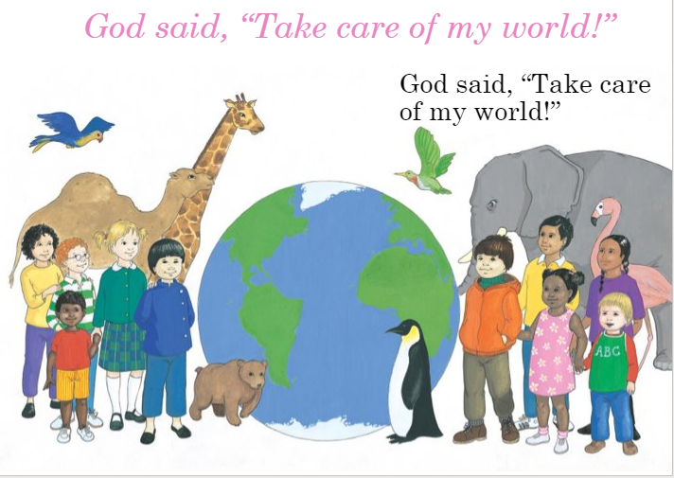

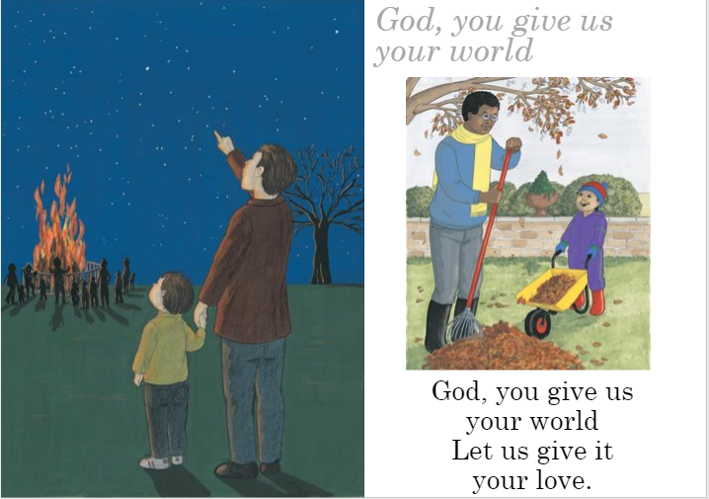

Task 2

Task 6
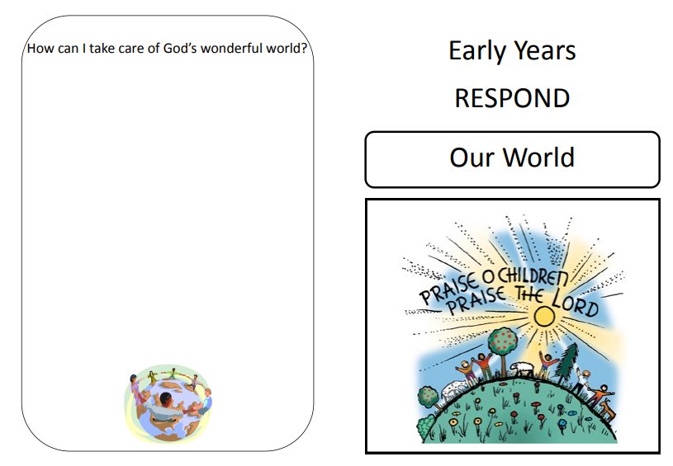

Inference Activity
What can you see in the picture?
What can you see in the picture?
What is the little girl doing?
How is she feeling? Why do you think this?
What can you see in the picture?
Who is holding the little girls hands?
Do you think she is happy or sad? Why?
Phonics
When revisiting the sounds with the children sing the song.
i.e when revisiting a sound.
An (insert the sound here) together make one sound.
What is it?
An (insert the sound here) together make one sound.
What is it?
It’s in (insert 4 words with the sound in here)
An (insert the sound here) together make one sound.
What is it?

If you need support with the song when recapping sounds with your child, please do not hesitate to get in contact with Mrs Gill via see-saw.

After singing the song ask the children which sound did we hear in each of the words. Repeat the words slowly if you need to. Then repeat the song again but where we sing what is it? The children say the sound the letters make together.

Resources for Phonics
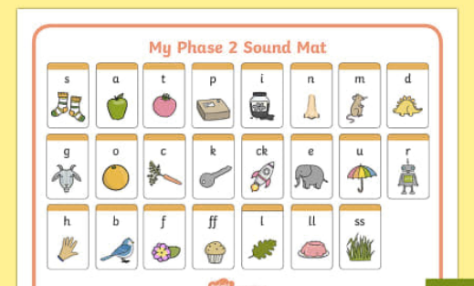
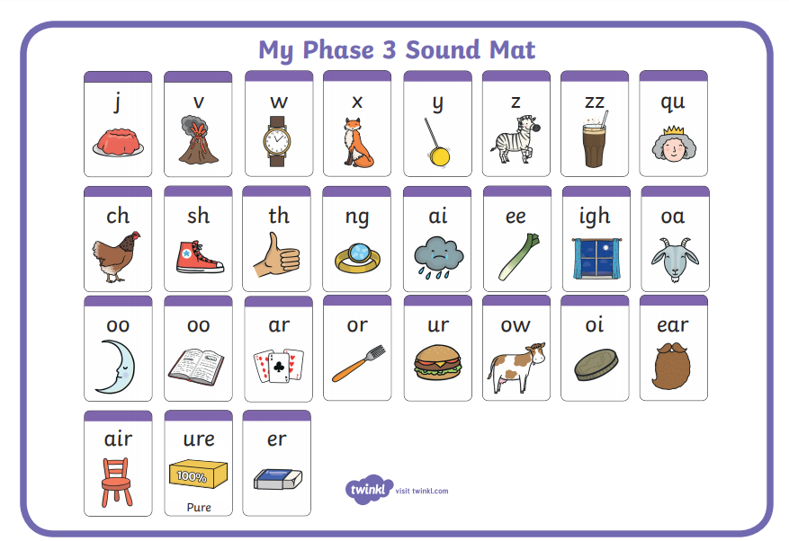

Phase 2, 3 and 4 tricky words for you to practise.
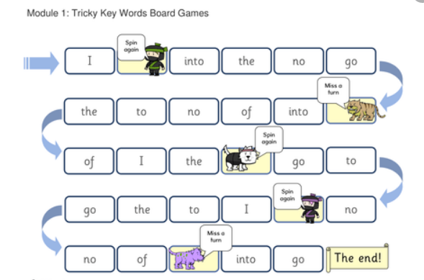

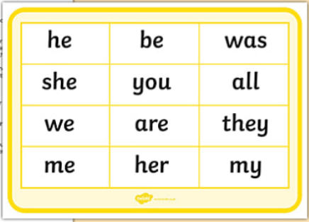
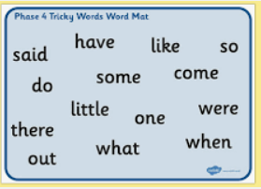
Phonics sentences

- Do clocks get cross?

- Can crabs clap hands?

- Are you fond of plums?

- Did a shark ever jump up a tree?

- Do trains run on tracks?

- Will a truck go up steep stairs?

- Can we see the stars on a clear night?

- When you get wet, will you shrink?

- Will trash jump from a dustbin?

