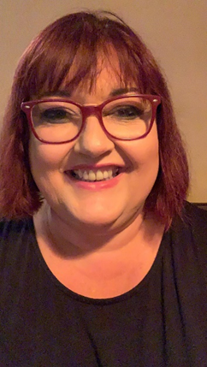
OWLETS AND EAGLETS - WEEKLY SUGGESTED HOME LEARNING – WB 18.05.2020

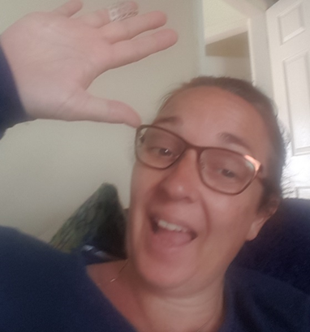

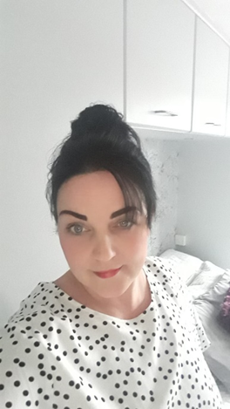
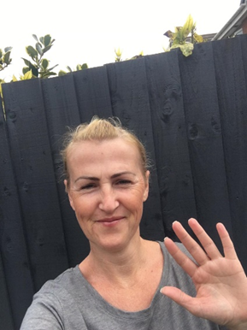
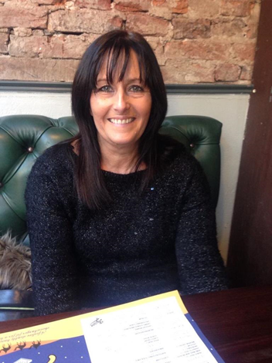

Hello Owlets and Eaglets, we hope you are all well and looking after yourselves. These are our suggested activities for you this week. We hope that you enjoy them. We would love to find out how you get on with them. Please email or tweet pictures to school so that we can upload them onto your See-saw account. It is lovely to see what you have been up to. If you complete different activities that is fine, still send these as we can share these with the other parents too. Thank you for your ongoing support, enjoy your week of learning.
School email – enquiries@saintoswalds.wigan.sch.uk Tweet - @saintoswalds

ENGLISH | MATHS
Reading – Read a variety of books at home. Favourite books can be repeated as it supports the children with their language development as they will hear the patterns of language in the story.  Look at this link on Oxford Owls - Helping children read at home  Use Oxford Owl to access books that are related to phase 2 and 3 phonics. Where possible children to read to parents daily.  When you go on click on all ages and click on age 4-5. Then go into levels and click on letters and sounds and choose either phase 2 or 3.(phase 2 will be a little easier and phase 3 more challenging) If you find that these are still not challenging for them then choose age 5-6, go into levels, letters and sounds and click on phase 4. This will then bring books up for you to access with your child.  After reading the book ask the questions on the back cover of the book and complete the play activities linked to the book.  Register here for free access to Oxford owl or you can use our class login  My class name – owlets and eaglets  My Class Password – reception.  Just go to the Oxford Owl login page and click on the My Class login button and use the above details.  Look at the story “walking through the jungle.” If you don’t have this story at home. Here is a link to the story  Walking through the jungle.  What is your favourite part of the story?  Who are the characters?  What happened at the beginning of the story?  What happened in the middle of the story?  What happened at the end of the story  Writing task – To write the story  Ask your child to draw their favourite animal from the story. Can they label the parts of the animal? They may wish to find out a fact about it and write it on their picture. Remember to use a phase 2 and 3 sound mat to help your child with the sounds in the words.  Visit .Our Zoo at Chester Zoo Follow the link to find out more about the different animals that they have there to help you find out lots of facts about your favourite animal.  Writing task 2:  Practice name writing. Can they write their first name? Middle name? Surname?  Comprehension activity  Follow the link to the story Ketchup on Your Cornflakes. This is on Discovery education. Once you have read the story if you click on activities. It will Bring up two activities a  Comprehension and a sequencing task please complete both. If you decide to do these on separate days remember to revisit the story for each one.  Phonics (Reading and writing)  Introduce the final phase 3 sound er. Hold up the sound and sing the song at the end of the planning. Phonics planning. Go to phase 3 week 8 And use some of the resources that you will need within the sessions on phonics play.  Please remember to use the free log in -  Use the Username – march20 and the password – home  to access the free games. Planning can be found in Teachers resources.  If you wish to complete a spelling test use a mixture of the words you have looked at over the week and any key words that they have worked with. Only look at up to 8 words choose from these words – her, farmer, longer, shorter, powder, letter, dinner, thicker, dapper, supper, better, summer. | Mathematics  Watch number blocks clip each day with your child at  Numberblocks BBCiplayer or Numberblocks Cbeebies  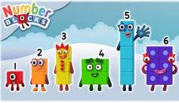  Activity – Practice number formation with you children. Here are the rhymes that we use in the classroom to help your child remember how to write the numbers.  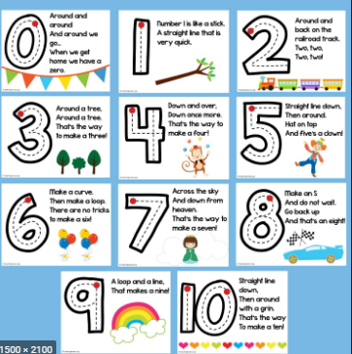  Follow the White Rose Week 4 using The very busy spider story. Maths focuses – patterns, counting, adding, subtracting, number recognition, doubling and halving, positional language.  You may also want to look on Oak National Academy Reception Click on the link below to access 5 lessons on Time  5 lessons on numbers within 20  Start with lesson one and complete one lesson each day. Focuses on counting objects to 20, making a number more and less using a number line, ordering numbers, developing a sense of 10, exploring place values, finding one more than to 20.  Practise counting up to 20. This can be done through playing hide and seek, singing number songs, chanting, board games etc.  Follow the White Rose Week 4 using The very busy spider story. Maths focuses – patterns, counting, adding, subtracting, number recognition, doubling,  Don’t forget that you have your Numbots username and password that was sent to you on your child’s see-saw learning journal. Look in the parent information file on the app to find it again if you have forgotten it.
R.E. | OTHER
The theme is: Good News  RE – Good news  Respond- Remembering, celebrating and responding to the story of Pentecost.​  Re-cap the story of Pentecost.  Ask your children the following questions  What is good news?  What happened on Pentecost day?  Who give us good news?  Who is the Holy Spirit?  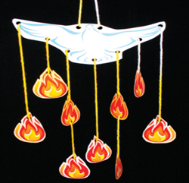  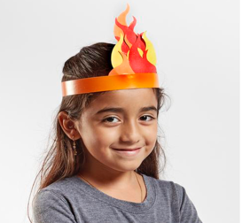  How do we receive good news?  Get your child to make a hat with flames on or a flame mobile to remember our work on Pentecost.  Pentecost is on Sunday 31st May.  Remember to keep helping your child to learn the Hail Mary to remember that May is the Month of Mary. | Looking after your pet - If you have a pet at home encourage your child to take part in their daily care. They could help feed, groom and clean up after your pet. If you do not have a pet at home, think about how you would look after a book character, ie, a Gruffalo or one of the animals in Room on the Broom or the Tiger in “The Tiger who came to tea.”  There are lots of activities on the RSPCA website including singing a song, colouring and a story.  https://education.rspca.org.uk/education/teachers/earlyyears/caringforourpets  PE –Physical activities for kids follow the link and copy the exercises from the video.  At this time we feel it is really important to help our young children to develop their own ways in which they look after their wellbeing.  Cbeebies have developed an app that is really useful.  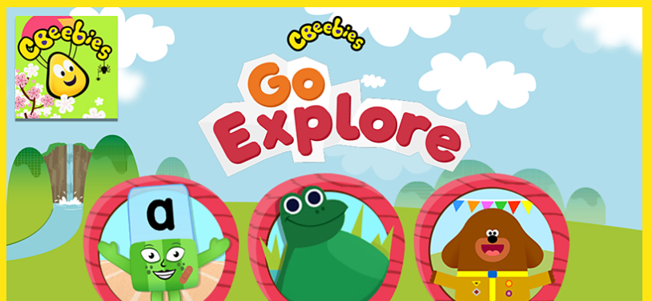  If you download the Go Explore app and go on the ‘Your Mindful Garden’ there are some games and activities that your child will enjoy.  Make an animal mask follow the link for instructions on how to make an animal task.  Talk to your children about what foods do they like. Can they sort them into healthy and unhealthy foods? You can do this by using the food that you have to hand or you can follow the link and do the activity online healthy and unhealthy food

Your own number rhyme sheet.

Story to be read during our RE task.
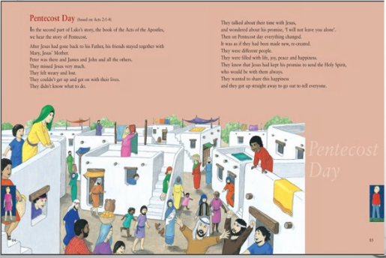
Phonics
When introducing the new sound to the children sing the song.
i.e when introducing er.
An e and r together make one sound.
What is it?
An e and r together make one sound.
What is it?
It’s in her and hammer and letter and farmer
An e and r together make one sound.
What is it?

After singing the song ask the children which sound did we hear in each of the words. Repeat the words slowly if you need to. Then repeat the song again but where we sing what is it? The children say the sound the letters make together i.e. er.

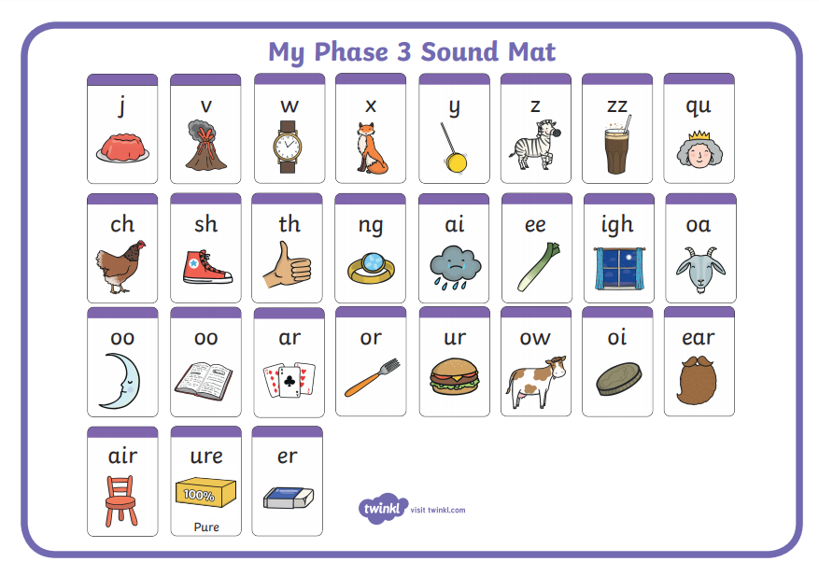

Resources for Phonics
