OWLETS AND EAGLETS WEEKLY SUGGESTED HOME LEARNING – WB 27.4.20
Hello reception, we hope that you are all well. We are missing you all so much, especially your happy, smiling faces. Parents you are all doing a fantastic job by caring and helping your child learn. We know this is a time of great anxiety so please don’t force the issue of learning, it is important that you listen to your children, answer their questions, reassure them that school will start again. Take this time to enjoy sharing books, baking, creating and making memories. Please share any work on Seesaw or by sending photos to the enquiries@saintoswalds.wigan.sch.uk email FAO of Mrs Gill or Miss Davies or direct tweet @saintoswalds. Wishing you all a great week and we look forward to hearing from you.
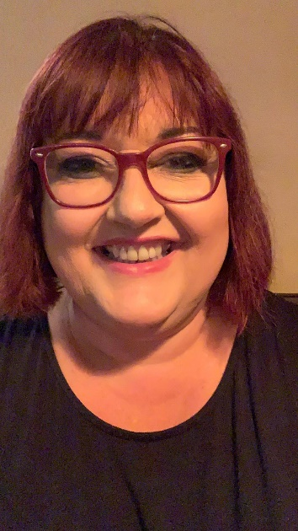
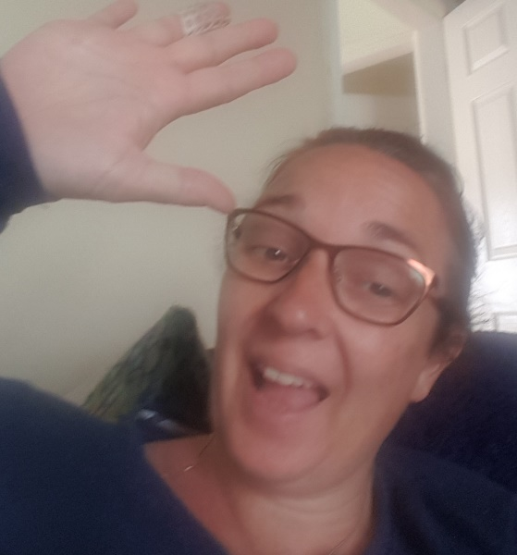
Mrs Gill, Mrs Davies, Mrs Hanway, Mrs Ridings and Miss Woolley XXXXX

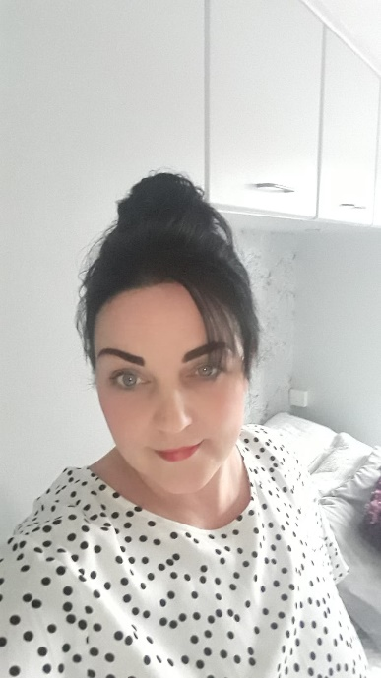
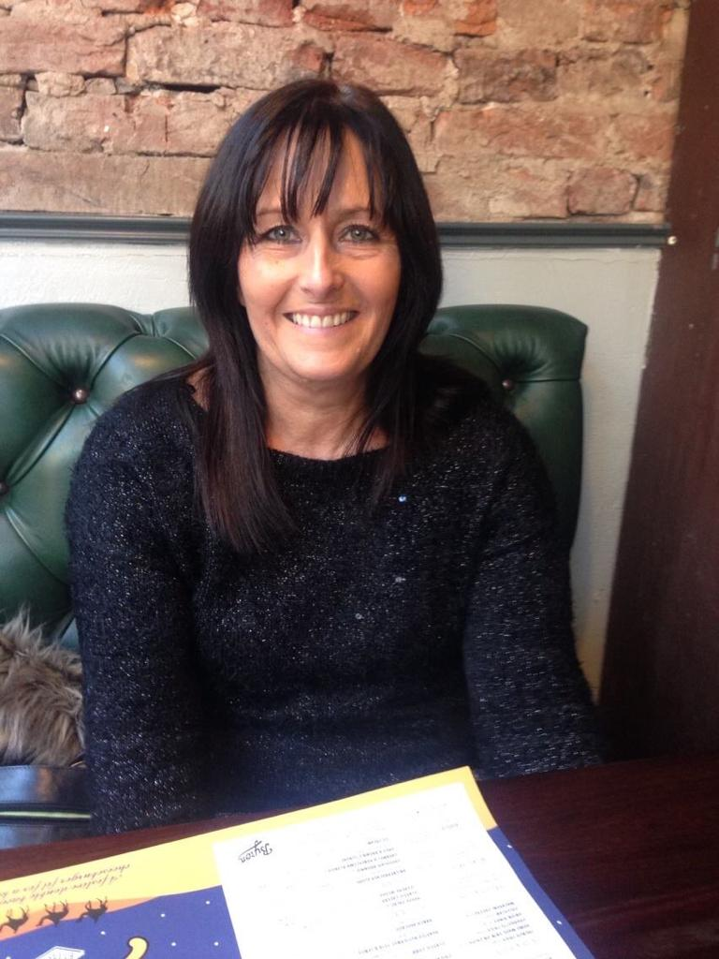
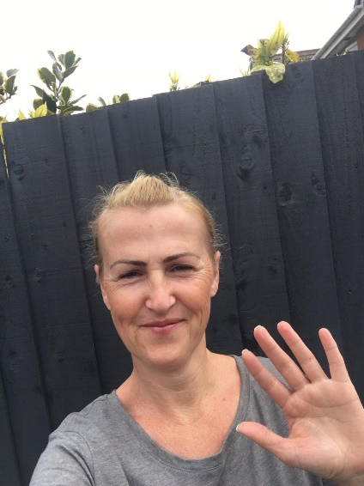

ENGLISH | MATHS
Please watch Bringing the Rain to Kapiti Plain by Verna Aardema with your children. Here is a link to the story https://www.youtube.com/watch?v=RLk5xWf9Xlg.  Discuss the story with the children. You can ask these questions:-  What is your favourite part of the story?  Where do you think the story is set?  Who are the characters?  Writing task- Writing a caption.  Look at the images below (choose 1). Talk to your child about what is happening in their chosen picture. Can they say a sentence about the picture? Ask your child to write the sentence that they have discussed with you. You can use a sound mat if your child needs help remembering what the sounds look like. There is an Sound Mat below.  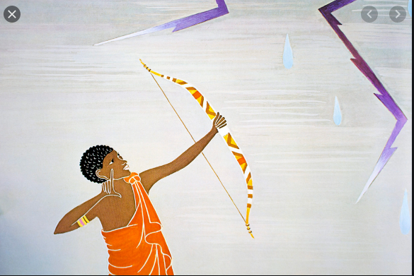  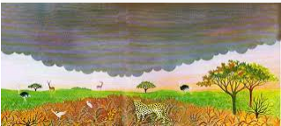  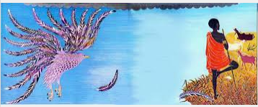  Compression task  1. Look at this picture and ask your child these questions.  Where do you think they are going and why?  What is happening?  How does the boy feel?  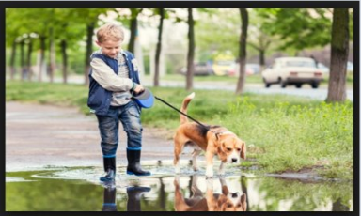  Phonics (spelling)  Ask your child to write phase 3 tricky words on square pieces of paper. You write the same word on a square piece of paper. Play pairs with the words asking your child to read the word each time one is turned.  For more phonics ideas please look at week7 letters and sounds planning that has been added to your child’s Seesaw file. | Mathematics  Watch number blocks with your child  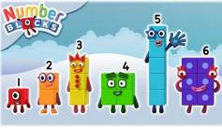  Activity – Ordering numbers from 1 to 20  Ask your children to order the numbers 1 – 20. They can write them on paper and then order them.  Extension activity – remove some of the numbers and ask your child to order the numbers when there are some missing.  Also, if you wish you may want to use week 2 White Rose maths planning. The link is below.  https://whiterosemaths.com/homelearning/early-years/  Work on this link includes pattern making, sorting, positional language, symmetry, counting and shape.
R.E. | OTHER
The theme is: Good News  RE – Good news  - Watch The Jolly Post Man and Other People’s Letters https://www.youtube.com/watch?v=gpeo_0yoD0k  Ask your child the following questions.  Who received the good news?​  How did they receive the good news?​  How did they feel?​  - Explore that everyone has good news to share. Collect items of good news i.e letters, cards, emails, photographs, certificates. Ask your child to write a piece of good news that they would like to share with their teacher. Talk about their ideas first, it may help to use a sound mat if needed.  - Design and make a Good News board to put up in a room in your house. The children can add good news messages, cards, invitations to virtual parties or gatherings as they receive them during the lockdown. Other family members can also add to this board. | Expressive Arts and PE –  Play some African music for the children to listen to. Here are a couple of links for some music. Only play for as long as you feel necessary. https://www.youtube.com/watch?v=4a7IHDXRG6k  Also look at  https://www.youtube.com/watch?v=9b81mWYIyTo  What did they enjoy or not enjoy about the music? Which one did they like the best? Why?  Now ask your child to move like different African animals (baboon, camel, cheetah, elephant giraffe, lion, monkey, zebra) here is a short video that looks at the different ways in which animals move.  https://central.espresso.co.uk/espresso/primary_uk/subject/module/video_index/item1149557/grade1/index.html  Children to practise their movements first and then put the music back on for them to add their movements to.  Video the children completing their dances. Show this back to them and ask them is there anything that they could improve?  Topic –Expressive Arts and Design  Look at different animal prints on the internet. Ask your child which animal they think that the animal print belongs to. Why do they think that?  Make animal print from an animal of your child’s choice. You can use any resources that you have to hand; paint, tissue paper, crayons, felt tips, materials etc.

