OWLETS AND EAGLETS - WEEKLY SUGGESTED HOME LEARNING – WB 04.05.2020
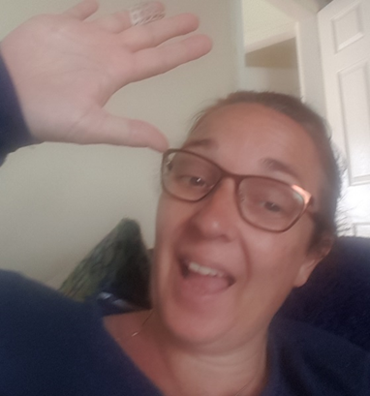

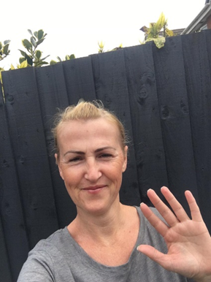
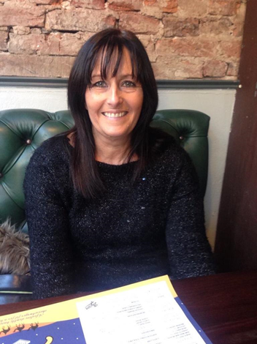

ENGLISH | MATHS
Reading – Read a variety of books at home. Favourite books can be repeated as it supports the children with their language development as they will hear the patterns of language in the story.  Look at this link on Oxford Owls - Helping children read at home  Use Oxford Owl to access books that are related to phase 2 and 3 phonics. Where possible children to read to parents daily.  When you go on click on all ages and click on age 4-5. Then go into levels and click on letters and sounds and choose either phase 2 or 3.(phase 2 will be a little easier and phase 3 more challenging) If you find that these are still not challenging for them then choose age 5-6, go into levels, letters and sounds and click on phase 4. This will then bring books up for you to access with your child.  After reading the book ask the questions on the back cover of the book and complete the play activities linked to the book.  Register here for free access to Oxford owl or you can use our class login  My class name – owlets and eaglets  My Class Password – reception.  Just go to the Oxford Owl login page and click on the My Class login button and use the above details.  This week we will look at the story, “Giraffes Can’t Dance.” If you don’t have this story at home. Here is a link to the story https://www.youtube.com/watch?v=vZjsLK5vwNU  Discuss the story with the children. You can ask these questions:-  What is your favourite part of the story?  Where do you think the story is set?  Who are the characters?  How did Gerald feel when the other animals laughed at him?  Was this a nice thing to do?  Writing task – To give clues  We would like your child to write clues to describe an animal  Example:- My animal has a long neck.  He eats shoots off the trees.  He has long legs.  Ask your child what animal they would like to write clues for. Discuss what the animal looks like, where it lives and how it acts. Ask your child to write the clues using their phonics knowledge. You may wish to use a phase 2 and 3 sound mat to help your child. We sent these home with the children on the back of their name cards.  Comprehension task  1. Look at this picture and ask your child these questions.  Who do you think the people in the picture are?  How do they feel? And why?  Where do you think they are?  Phonics (spelling)  Phoncis play phase 3 letters and sounds planning see below.  Go to week 8, use this planning over two weeks. In school, we usually introduce the children to 2 sounds per week. When introducing a new sound we sing a song before we introduce the sound. We hold up the sound and sing the song. The songs are at the end of the planning sheet along with some of the resources that you will need within the sessions.  Please remember to use the free games on Phonics Play also.  Use the Username – march20 and the password – home  to access the free games.  If you wish to complete a spelling test use a mixture of the words you have looked at over the week and any key words that they have worked with. Only look at up to 8 words. | Mathematics  Watch number blocks clip each day with your child at  Numberblocks BBCiplayer or Numberblocks Cbeebies  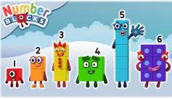  Activity – Practice number formation with you children. Here are the rhymes that we use in the classroom to help your child remember how to write the numbers.  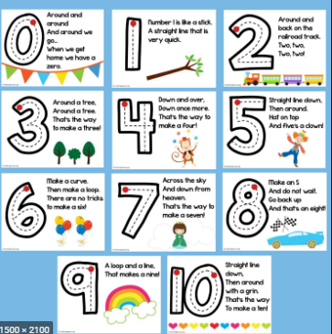  .  In addition, if you wish you may want to use week 1 White Rose maths planning. The link is below.  https://whiterosemaths.com/homelearning/early-years/  Work on the week 1 planning link includes size, shape, simple time, counting, making patterns. This work uses the book Supertato, however you do not need the book to cover the activities. If you don’t have the book you may wish to listen to the story. Follow this link which will take you to the story. Supertato story  You may also want to look on Oak National Academy Reception Click on the link below to access 5 lessons on Grouping and Sharing.  5 lessons on Grouping and Sharing s  Start with lesson one and complete one lesson each day.
R.E. | OTHER
The theme is: Good News  RE – Good news  Read this story of Pentecost below with your child and ask them following questions;  How did the friends of Jesus feel when he went back to his father?  Have you ever felt like that? When?  What did the friends of Jesus do?  What happened on Pentecost day?  How did the friends of Jesus feel?  What did the friends of Jesus do after the coming of the Holy Spirt?  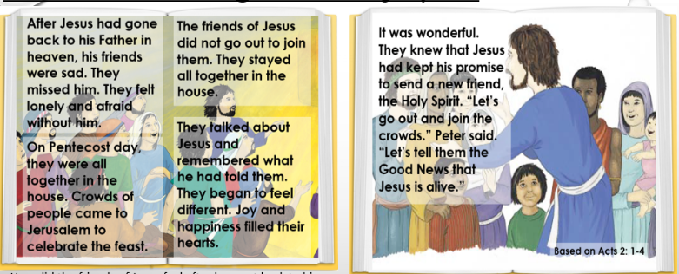  Tasks –  1.-Take photos of your child making different facial expressions, sad, lonely, afraid, happiness and joy.  2.- Sort the following words into groups - are they a good feeling or a bad feeling?  Delighted, happy, miserable, timid, frightened, pleased, lonely, sad, laughing, joyful, smiling, upset and afraid. | Play animal charades- Take it in turns to act as different animals. Add in noises as a clue…  Learn the song, ‘The Animals Went in Two by Two’ Ask your child to draw out two of each animal and practice writing the numerals 2, 3, 4, 5, 6, 7, 8,.9 and 10  The animals went in Two by Two  Looking after your pet - If you have a pet at home encourage your child to take part in their daily care. They could help feed, groom and clean up after your pet.  Big and small animals- Draw as many big animals as you can on one piece of paper and as many small animals as you can on another sheet of paper. Some children may be able to write a list as an alternative or label their animals in the picture.  Find all the books that have animals in them in your house - Ask your child to look through the books in your house and to find any with animals on the front cover. Ask them to sort the books into groups of their choice e.g. animals that can fly, swim, big, small, live on a farm/ at the zoo.  Create an animal den- Provide your child with blankets and sheets to make an animal den.  Can you create a pop-up jungle animal picture?  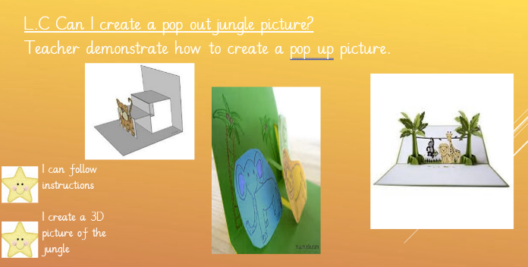  PE – Daily sessions with Joe Wickes the body coach.  Try doing the 5 a day big Jubilee dance  Big Jubilee dance Help to teach Gerald the Giraffe some new dance skills.  Dr Dog explains Coronavirus follow link and put in your free twinkl login on your account to download.  https://www.twinkl.co.uk/resource/dr-dog-ebook-eyfs-t-p-843  VE DAY – FRIDAY 8TH MAY  It’s also VE day on Friday 8th May. We would have been celebrating this in school by having a party and doing some work to commemorate the 75 year anniversary. Your child could make a party hat in the colours of the Union Flag for a pretend street party or they could make some VE day bunting. There is a colouring picture at the end also.

Picture for the comprehension task.

Your own number rhyme sheet.

Story to be read during our RE task.

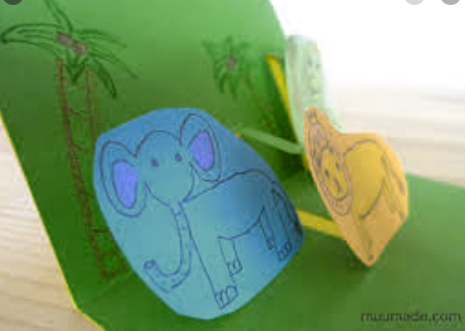
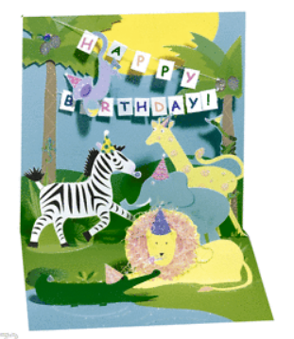
Pop up wild animal picture

When introducing a new sound to the children I usually introduce the sound through a song.
i.e when introducing ear.
An e, a, r together makes one sound.
What is it?
An e, a, r together makes one sound.
What is it?
It’s in fear and hear and near and tear
An e, a, r together makes one sound.
What is it?

i.e when introducing air.
An a, i, r together makes one sound.
What is it?
An a, i, r together makes one sound.
What is it?
It’s in air and stairs and fair and hair
An a, i, r together makes one sound.
What is it?

i.e when introducing ure.
An u, r, e together makes one sound.
What is it?
An u, r, e together makes one sound.
What is it?
It’s in sure and pure and cure and manure
An u, r, e together makes one sound.
What is it?

After singing the song ask the children which sound did we hear in each of the words. Repeat the words slowly if you need to. Then repeat the song again but where we sing what is it? The children say the sound the letters make together i.e. ear, air, ure.

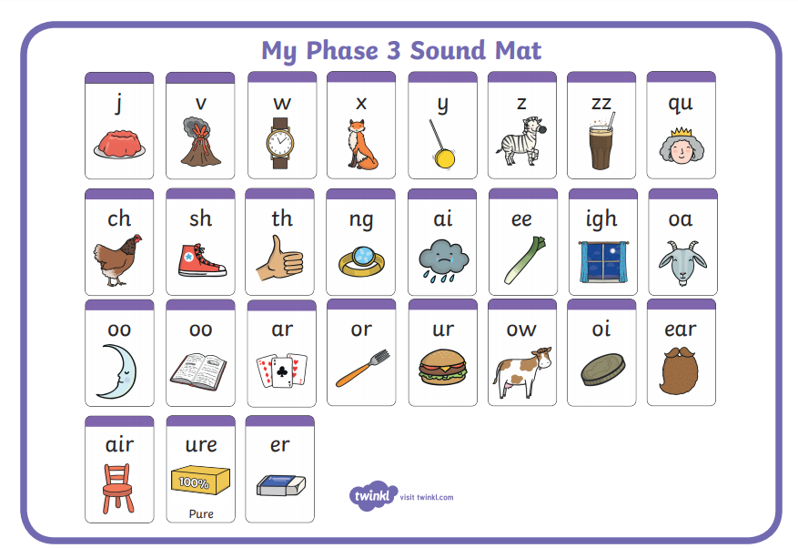

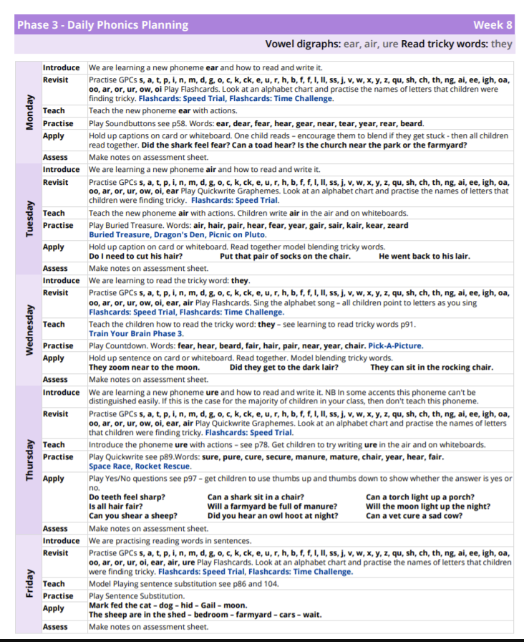

Monday Resource in the Apply Section.
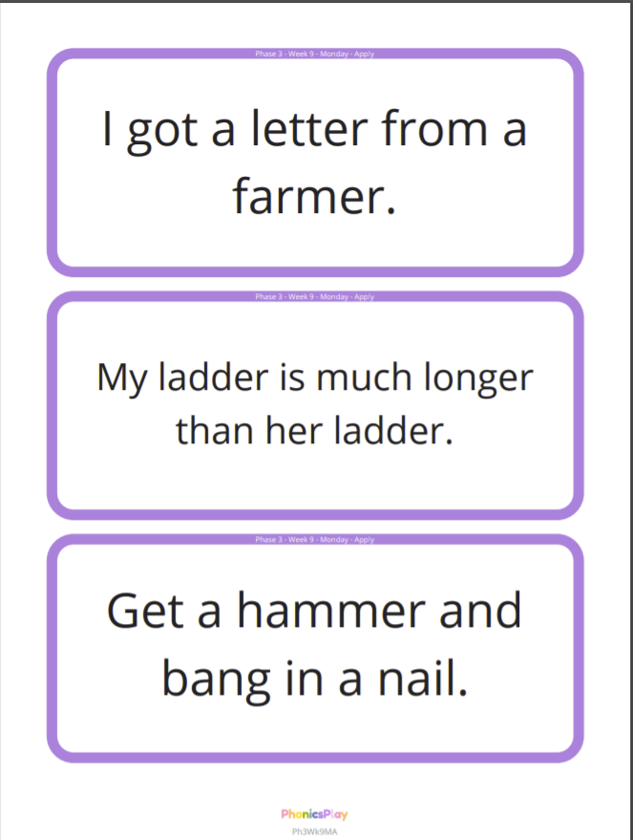

Tuesday – Resource for the Practise and Apply sections.
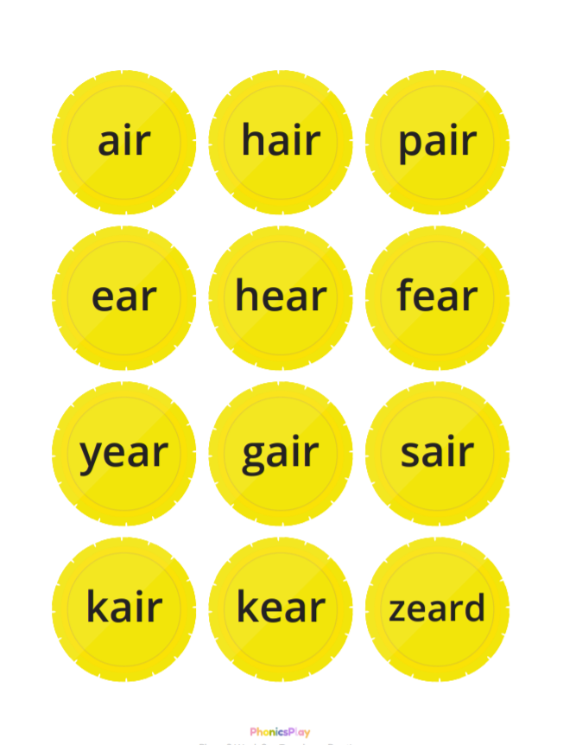

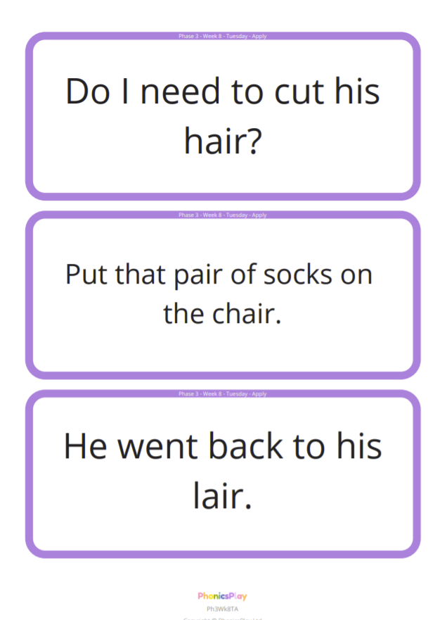

Wednesday – resource for the Apply section.
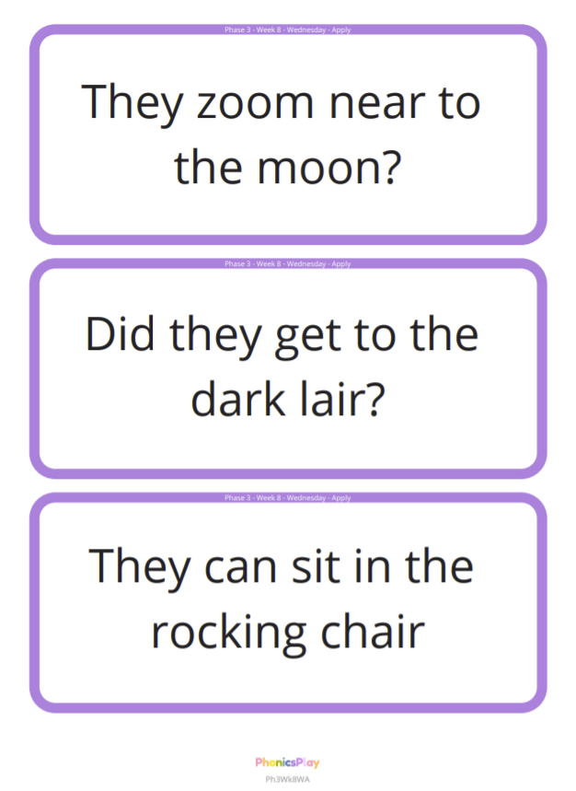

Thursday – Resource for the Apply section.
