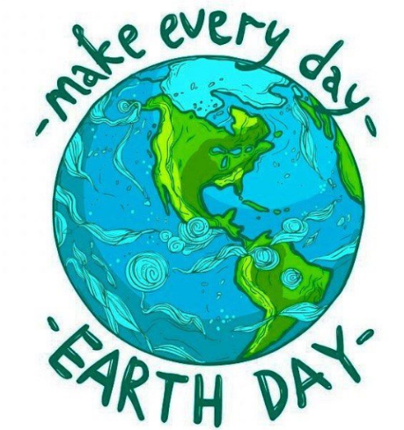
Earth Day 2020
Earth Day is an annual reminder to slow down and appreciate the bounty of the earth.
The following Earth Day activities will encourage children to create objects from natural and recycled materials and spend more time outdoors.

- Learn what a Carbon Footprint is. Create a poster or PowerPoint Presentation to inform others.
- Make a bug hotel. If you like digging in the garden looking for bugs, make a hotel to attract a variety of mini-beasts. There are lots of ideas online to help you. You could also create a container fairy garden.
- Plant seeds and create a ‘plant observation journal’.
- Make a pinecone and peanut butter bird feeder.
- Conduct a plastic audit in your home. Count how many plastic containers, wraps, bottles and bags you purchase for your kitchen and bathroom.
- Paint stones and sticks and create games to play with them.
- Make tin can drums and wind chimes.
- Watch an environmental documentary or animal show and research ways to protect your favourite animals.
- Do a recyclable sorting activity.
- Gather nature items from outside, like leaves and pinecones, and make an art project out of them. What animals can you create out of the things you find?
- Write a list of 5 ways you can help our Earth.
- Create an Earth Day acrostic poem.
- Find out the history of Earth Day.
- Create a solar system word search.
- Research new plant-based recipes or recreate your favourite family recipes with plant-based alternatives.
- Learn food preservation techniques such as canning, pickling, drying and freezing to enjoy fruits and vegetables year-round and minimise your food waste.
- Repurpose materials from around your house into new items; make jewellery, bags or plant holders!
- Draw or paint what you want a sustainable future to look like. Write a creative story about what that world is like.
- Attend a virtual teach-in on an environmental topic, including: biodiversity loss, plastic pollution, food waste, food security, air quality, insect population, water quality and local climate change impacts. After attending an online teach-in, discuss with your family actions you can take to make a difference!

