Hi Magpies! How are you? Hope you enjoyed last week’s activities. Remember to send us an email to enquiries@saintoswalds.wigan.sch.uk FAO Mrs Knott or Tweet @saintoswalds to let us know how you are doing. It would be lovely to see you as you are working on school work or other home activities. Here are some more activities for you to try this week. Take care - #StaySafeStayHomeSaveLives
Mrs Knott and Mrs Harris xx
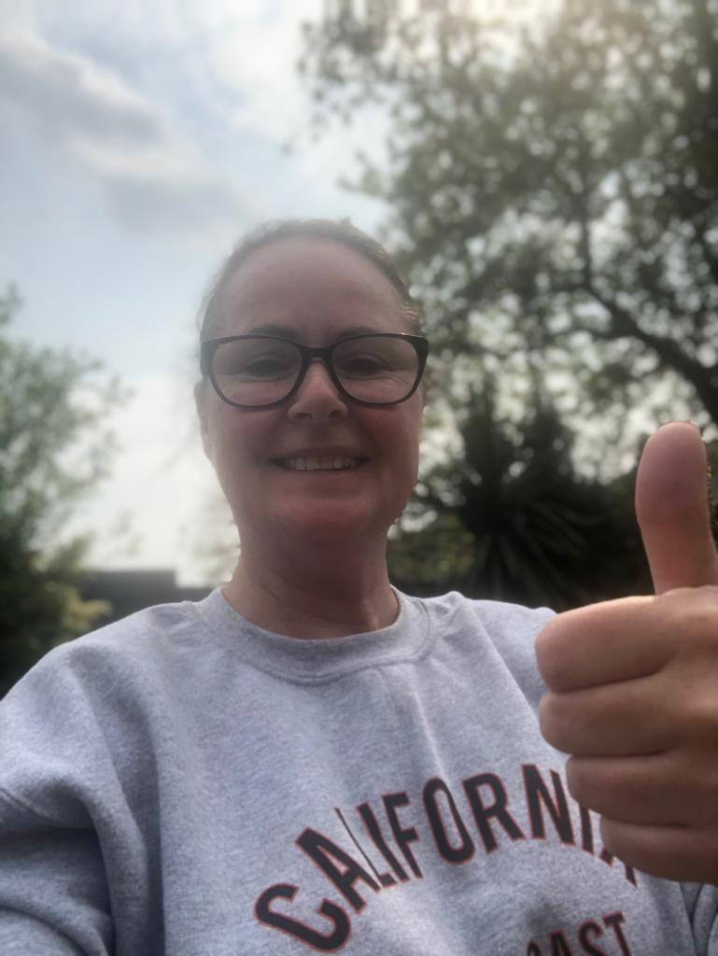

ENGLISH | MATHS
Reading – Read every day for pleasure for 20 minutes.  Comprehension tasks Activities Discovery Education.  1.The Butterfly Lion- read the extract and take the online quiz. There are also extra questions to print.  https://central.espresso.co.uk/espresso/modules/e2_comprehension_lks2/books/book_butterfly_lion.html?source=search-all-all-all-all&source-keywords=butterfly%20lion  2. Write a book review of your favourite book there is a template available on the link or create your own.  https://central.espresso.co.uk/espresso/primary_uk/servlet/file/store66/item981389/doc.pdf  https://central.espresso.co.uk/espresso/primary_uk/servlet/file/store66/item981390/doc.pdf  3. Complete the nouns and adjectives activity from Discovery  https://central.espresso.co.uk/espresso/modules/e2_grammar/further_resources/factfile_nouns_p1.html?source=search-all-all-all-all&source-keywords=nouns%20and%20adjectives  Writing – a. Book review see above  b. What do think happens next in the story? Write the next chapter and try to include expanded noun phrases.  c. Expanded noun phrases activity (Twinkl)- see below  d. What do you know about lions? Go to https://gowild.wwf.org.uk/regions/africa-fact-files/index.html  to find out more about lions and what the WWF are doing to help them. Create a Lion fact file  Spellings – Words ending in – ture and sure  Related activities-  https://central.espresso.co.uk/espresso/primary_ uk/subject/module/activity/item710375/grade2/ module709251/index.html  See list below | Basic Skill –9 times tables- instant recall and the corresponding division facts.  https://ttrockstars.com/  https://www.bbc.co.uk/teach/supermovers/ks2-maths-the-9-times-table-with-filbert-fox/z4mrhbk  White Rose Maths– Year 4 - Summer term – Week 3 – 4.5.20 and Maths challenge.  https://whiterosemaths.com/homelearning/year-4/  If this is proving to be too challenging, please go to the Y3 home learning to build your child’s confidence.
R.E. |  | OTHER
The theme is:  The theme is: Serving and is linked to Pentecost- Energy  REVEAL  - Use the image from God’s Story 3 page 133.See below. Imagine you are the follower of Jesus in blue addressing the crowd. Write your script in a big speech bubble, telling them how the power and energy of the Pentecost experience has changed you and the wonder and awe you experienced.  - A television company is going to broadcast ‘Question Time’ from your school. From your class, elect a panel of ‘apostles’ to speak. Prepare questions to ask them about how their beliefs and actions regarding how the energy and power they experienced at Pentecost enabled them to serve |  | Science – The digestive system- watch the video and read the information  https://central.espresso.co.uk/espresso/primary_uk/subject/module/video_index/item1070017/grade2/index.html  Then complete the labelling activity.  https://central.espresso.co.uk/espresso/primary_uk/subject/module/activity/item694489/grade2/module1070017/index.html  DT/Art Challenge! Can you make a model of the human digestive system?  History – Ancient Egyptians –https://www.bbc.co.uk/bitesize/topics/zg87xnb  Continue to create your scrap book all about the Ancient Egyptians –What can you find out about communication? What is Egyptian writing called? Solve the code activity- see below  Geography- Locate and label African countries- see activities below https://www.oddizzi.com/teachers/explore-the-world/places/  Music – Time for music Y3/4 Lesson 3 https://www.stoswaldswigan.co.uk/classes/fun-learning-games/music

Spellings This week’s focus is words ending in sure and ture
adventure
texture
furniture
pleasure
ensure
enclosure
closure
creature
pressure
treasure
Can you find any other examples? List them here
Jumping Orange Words
occasion
occasionally
ordinary
opposite
often

- Imagine you are the follower of Jesus in blue addressing the crowd. Write your script in a big speech bubble, telling them how the power and energy of the Pentecost experience has changed you and the wonder and awe you experienced.

Label Egypt on the map of Africa
Can you label any other countries?

