Magpies’ WEEKLY SUGGESTED HOME LEARNING – WB 13.7.20
Hi Magpies! We have reached our final week. I am so proud of the way you have continued to learn and you should be very proud of yourselves too. I am sad that I have not seen you for such a long time, I have thought about you all the time and missed you a lot. I have created a little souvenir of our year that I hope you will print and keep. I hope you enjoy this week’s activities. Please send me an email to let me know how you are.
Mrs Knott Mrs Harris
ENGLISH | MATHS
Reading – Read every day for pleasure for 20 minutes.  This week I’ve taken the English activities from a Twinkl summer activity pack.  I’ve included each sheet and the answers below. | 15 minutes on TT Rockstars each day  https://ttrockstars.com/  Contact school if you need a password reminder Year 4 -White Rose – Week 12 – Symmetry and co-ordinates  Use worksheets below and BBC Bitesize to support the white Rose videos  https://whiterosemaths.com/homelearning/year-4/  https://www.bbc.co.uk/bitesize  Use the sheets below to support the videos  If you would like more practise try the free resources from Classroom Secrets  https://classroomsecrets.co.uk/describe-position-year-4-position-and-direction-free-resource-pack/
R.E. | OTHER
SPECIAL PLACES  The World is a special place.  The earth is the Lord’s  and everything in it,  The world, and all who live in it  Psalm 24  Laudato Si' animation  Pope Francis has written a letter addressed to every person on the planet, asking us all to protect the earth. Will you play your part to protect our common home?  Watch the video  https://cafod.org.uk/Education/Primary-teaching-resources/Laudato-Si-animation  Complete the worksheet below to show how you will help to take care of God’s world. | Science – Habitats – create a spider diagram/mind map including everything that you have learned about animals and their habitats.  Art- Can you make a mobile to show how we can look after the world? With a parent follow the link below for ideas  https://www.pinterest.co.uk/pin/401664860492550728/

We have really missed you during lockdown and are sad that we have not been able to complete Year 4 with you.
We know that this has been a challenging time for everyone and we are very proud of you all.
Please remember all the happy times that we had together.
What will you remember?
Will it be some of the stories that we shared like The Ironman or The Selfish Giant?
Will it be the art work, guitar lessons or working with Wigan Athletic?
Will it be the times that you spent playing with your friends?
What about our Christmas performance? That seems so long ago now but we still remember how wonderful you all were, learning all your lines and songs.
We will remember how hard you worked, how keen you were to learn, how you made us laugh and your smiling faces that you greeted us with each day.
We hope that you have a lovely summer holiday and hope to see you very soon.
Lots of love from Mrs Knott and Mrs Harris.
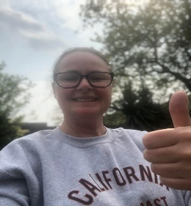

RE
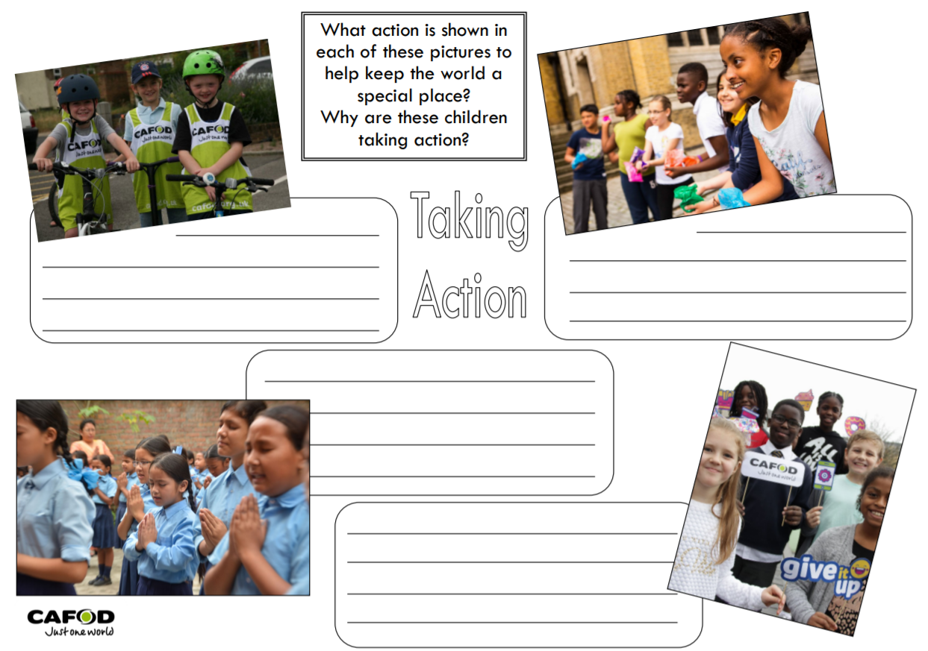
RE
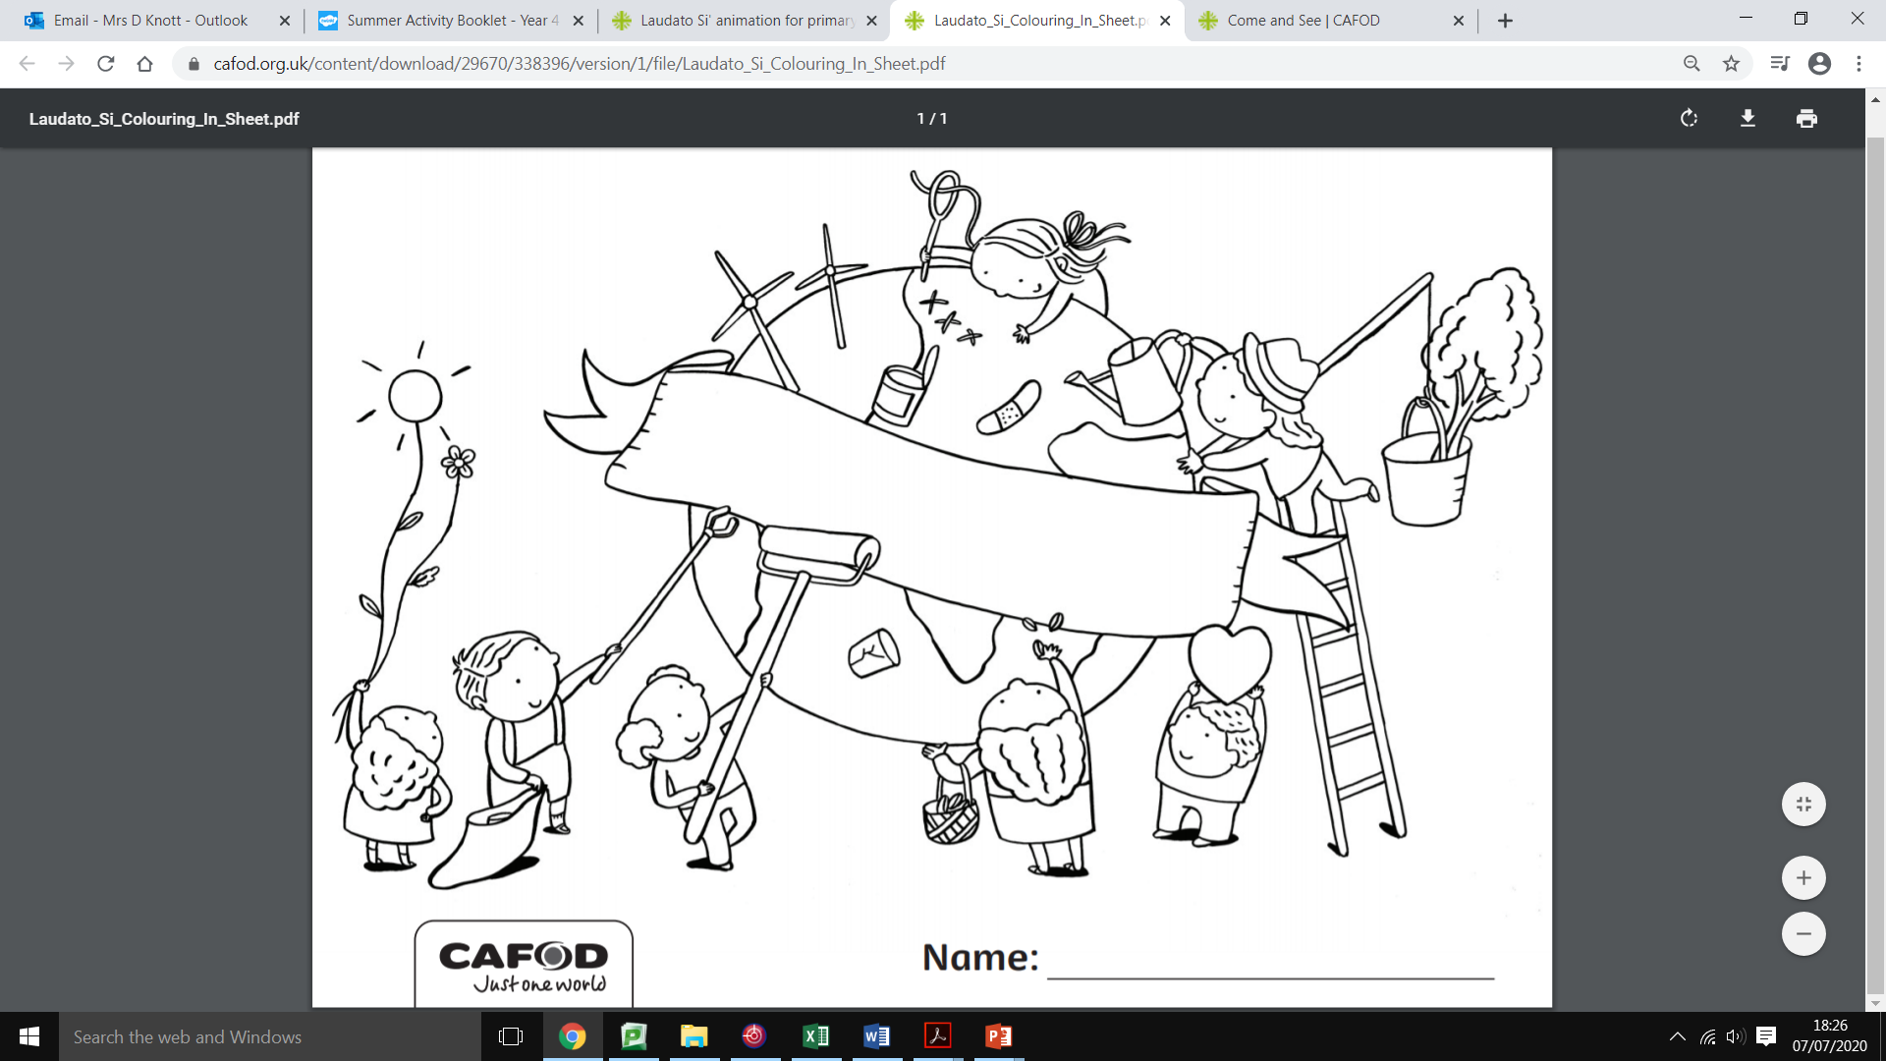

Monday

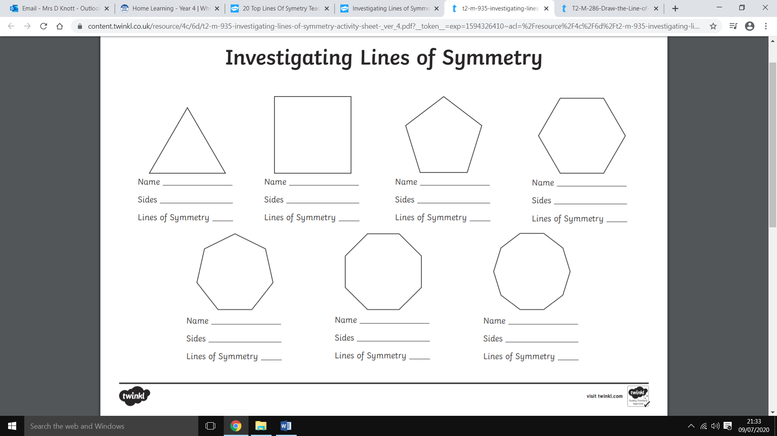

Tuesday

Wednesday

Thursday

