Magpies’ WEEKLY SUGGESTED HOME LEARNING – WB 18.5.20
Hi Magpies! Hope you enjoyed last week’s activities. We have enjoyed seeing what you have been up to on Twitter and email. Keep sending these in. Here are some more activities for you to try this week. Take care - #StaySafeStayHomeSaveLives
Mrs Knott and Mrs Harris
ENGLISH |  | MATHS
Reading – Read every day for pleasure for 20 minutes.  Comprehension tasks  The BFG read the extract and complete the online activities.  https://central.espresso.co.uk/espresso/modules/e2_comprehension_lks2/books/book_bfg.html  Writing – Write a character description of the BFG – use as many expanded noun phrases as you can. (refer to last week’s grammar task on nouns and adjectives) Don’t forget to think about his appearance, feelings and character. Refer to actions in the text to give examples eg He was very sneaky when he hid in the shadows.  - Complete the adjectives word search below  - Create an acrostic poem about the Giant (See below for an example of an acrostic poem about a Mammoth)  Spellings –  https://central.espresso.co.uk/espresso/primary_uk/subject/module/activity/item731648/grade2/module709251/index.html  Short ou sound as in young, touch |  | Times tables activities from Classroom Secrets focus on 4 and recap on7,8  https://ttrockstars.com/  https://kids.classroomsecrets.co.uk/home-learning-timetable/  Twinkl Fractions sheets (differentiation)- see below  Use White Rose fractions videos- home learning for week 5 and BBC Bitesize as support.  https://whiterosemaths.com/homelearning/year-4/  https://www.bbc.co.uk/bitesize/tags/z63tt39/year-4-and-p5-lessons/1
R.E. | OTHER
The theme is: Serving and is linked to Pentecost.  REVEAL  Read Corinthians 12: 4-8, 11 (See below)  - Record the skills you think God has given you and what you would like the Holy Spirit to give them the energy to do. (You can choose how to record this ie. Mind map, writing, pictures)  - Read The Holy Spirit Prayer (See below)  Write your own prayer thanking God for the Holy Spirit | Science – What are the types of teeth?  https://www.bbc.co.uk/bitesize/topics/z27kng8/articles/zsp76yc  See attached powerpoint.  Complete the worksheet below labelling the different teeth.  Can you design a poster to show the function of each of the types of teeth?  History, Art, DT  Continue finding out about the Egyptians for your scrap book. This week find out as much as you can about mummies. Can you make your own paper money following the instructions and using the templates shown below?  https://www.twinkl.co.uk/resource/t-t-16327-egyptian-mummy-paper-model-pack  Music – Time for music Y3/4 Lesson 4  https://www.stoswaldswigan.co.uk/classes/fun-learning-games/music

L.I. Find all the adjectives in the wordsearch?

a | b | o | f | u | s | q | u | e | a | k | y | w | c | r
n | f | r | a | l | i | p | z | a | t | j | s | a | g | u
s | r | a | o | s | h | r | i | l | l | x | l | c | e | s
u | e | r | y | k | p | i | c | r | a | z | y | k | u | t
o | s | e | d | r | e | k | w | d | a | o | m | y | h | y
r | h | y | a | s | t | n | j | e | x | l | v | i | s | a
e | o | h | z | o | b | e | a | u | t | i | f | u | l | t
g | s | r | z | f | c | e | n | o | h | h | q | u | r | e
n | e | w | l | t | r | s | n | e | i | c | u | a | h | r
a | q | u | i | e | t | e | a | t | c | r | t | g | y | r
d | t | v | n | d | c | c | s | r | k | o | u | e | e | i
w | e | a | g | l | o | o | m | y | f | o | x | p | e | b
s | h | r | l | n | e | o | z | j | r | k | e | u | u | l
l | m | u | e | l | p | l | i | i | f | e | y | k | l | e
a | d | u | g | l | y | a | r | e | d | d | o | m | b | b

crazy beautiful dazzling bent
wacky spiral sharp gloomy
broken rough terrible sly
ugly crooked dull squeaky
rusty shrill dangerous deep
wet blue quiet fresh
tall thick huge rare

Now use two of the adjectives you have found in sentences.
____________________________________________________________________________________________________________________________________________________________________________________________
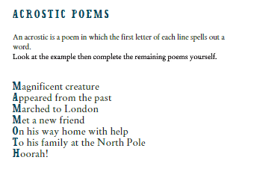

touch
young
country
enough
tough
double
trouble
toughest
roughest
youngest
Can you find any other examples? List them here
Spellings –short ou

Now try the discovery activity

L.C. Can you learn your 4 times table multiplication and division facts so you have instant recall?
4 x 10 = 40 ÷ 4 =
4 x 1 = ___ ÷ 4 = 1
4 x 7 = 28 ÷ 4 =
4 x ___= 8 8 ÷ 4 =
4 x 0= 0 ÷ 4 =
4 x 8 = ___ ÷ 4 =8
4 x 3 = 12 ÷ ___ = 3
4 x 4 = 16 ÷ 4 =
4 x ___ = 36 36 ÷ 4 =
4 x 11 = ____ ÷ 4 = 11
4 x 5 = 20 ÷ ___ =5
4 x 12 = _____ ÷ 4 = 12
4 x 6 = 24 ÷ 4 =

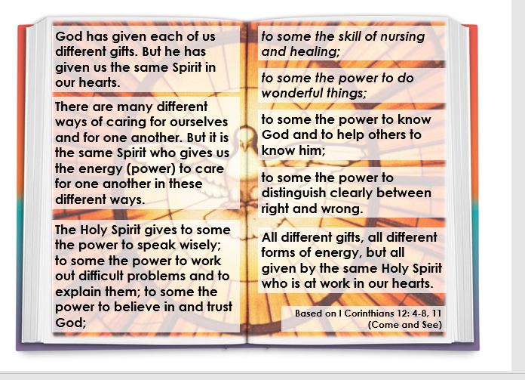

Come Holy Spirit, fill the hearts of your faithful and kindle in them the fire of your love. Send forth your Spirit, and they shall be created and you shall renew the face of the earth.

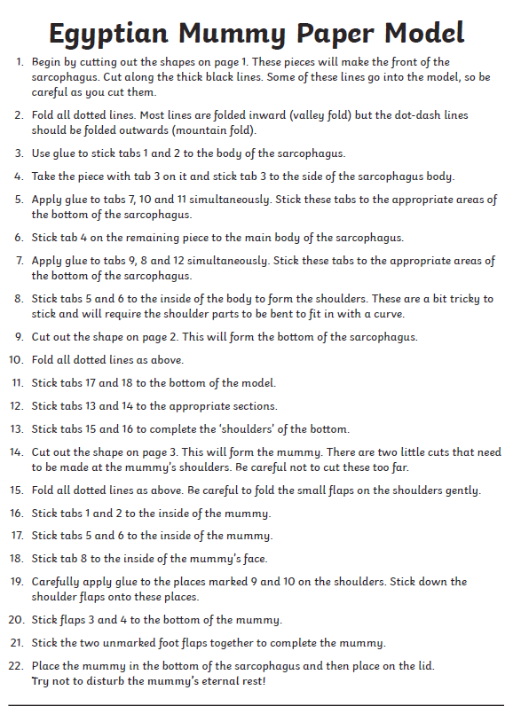
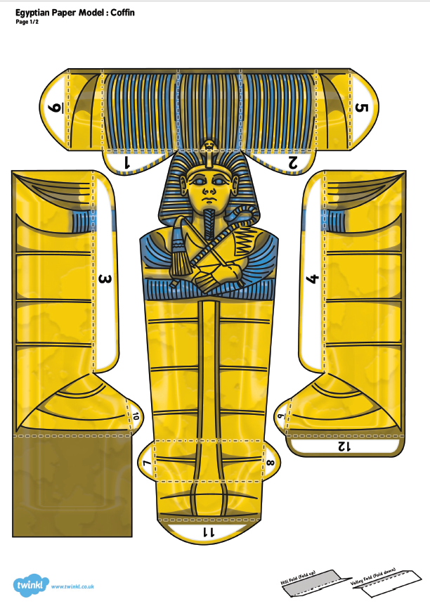
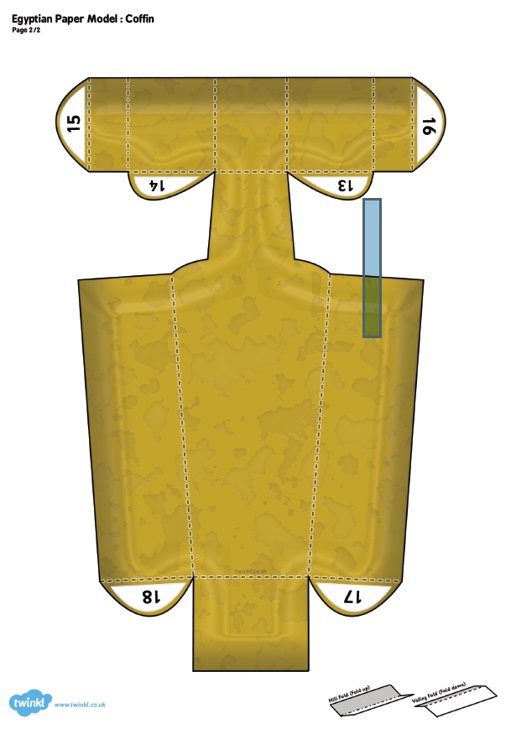
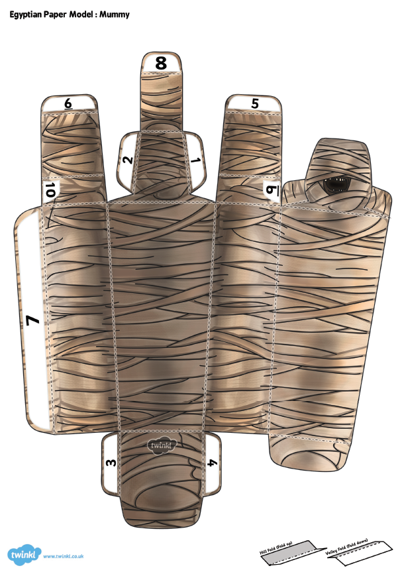

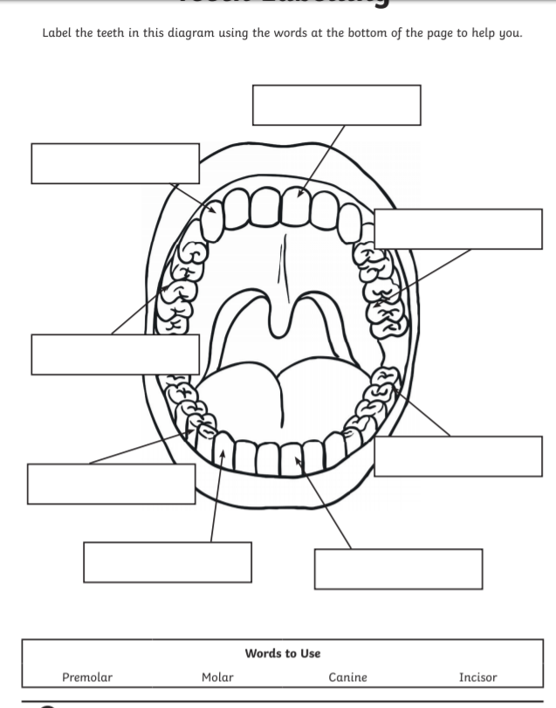

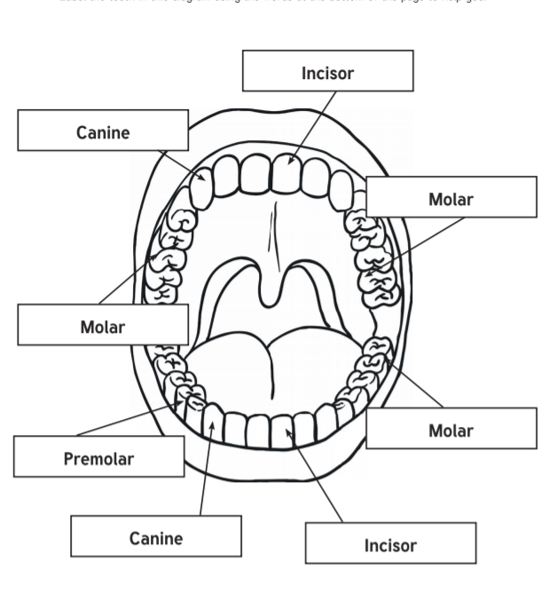

There are many possible answers to these.

