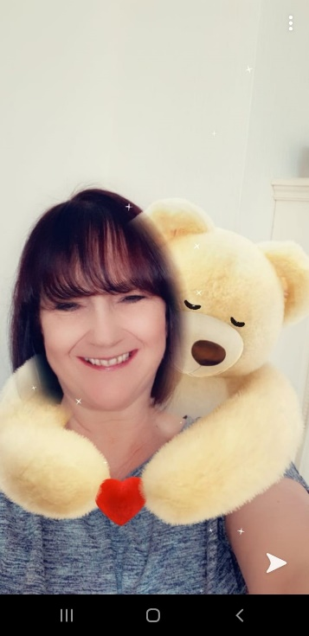
Hello Magpies. I hope that you are all well. I am really missing you and can’t wait until I see you again. I have sorted some tasks for you to have a go at, alongside the amazing things that you are already doing. Keep exercising and exploring nature and keep letting us know what you’re doing. I’d love to see how you’re getting on so please email to enquiries@saintoswalds.wigan.sch.uk FAO Mrs Knott or Tweet @saintoswalds .
Take care! Mrs Knott and Mrs Harris xx
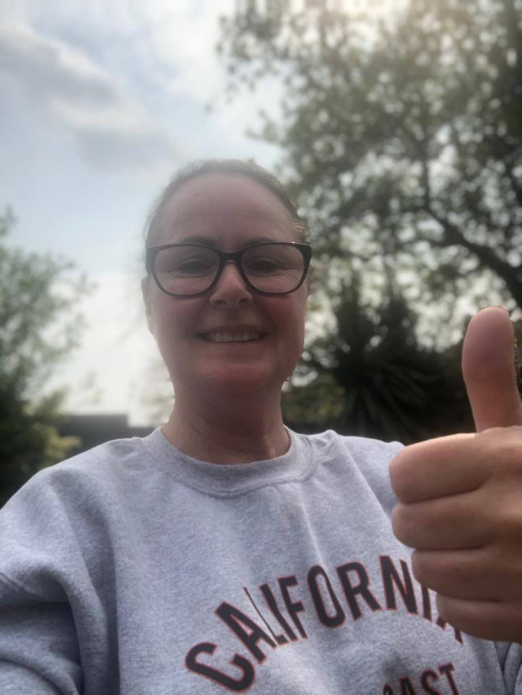

ENGLISH | MATHS
Reading – Read every day for pleasure for 20 minutes.  Comprehension tasks – Garden birds – This is below.  Writing – Write your own fact file about an animal of your choice – an example is below.  https://www.natgeokids.com/uk/  Spellings – adverbs ending in ly  Make a table to show the root word then the word with the suffix ly added to it e.g  quiet- quietly  silent- silently  Create your own wordsearch  Write a paragraph of your activities for the day using as many adverbs as possible.  Another example sheet is below. | Basic Skill – 6 times tables- instant recall  https://ttrockstars.com/  https://www.bbc.co.uk/teach/supermovers/ks2-maths-the-6-times-table-with-fred-the-red/zrq3xyc  White Rose Maths– Year 4 - Summer term – Week 1 – Decimals and Maths challenge.  https://whiterosemaths.com/homelearning/year-4/  If this is proving to be too challenging, please go to the Week 1 and week 2 activities which may be more appropriate, or go to the Y3 home learning to build your child’s confidence.
R.E. | OTHER
The theme is:  Energy  Discuss different types of energy  Discuss in more detail the energy we get from fire and wind.  What are the advantages and disadvantages of using fire as a source of energy?  Create a poster to highlight fire safety.  https://www.manchesterfire.gov.uk/staying-safe/  Can you use wind to move an object?  Try making a kite or power a car using a balloon. | Science – Habitats- use materials from around your home to create a bird house or bird feeder.  Geography – create a messy map of your local area. What are the key physical and human features?  https://www.bbc.co.uk/bitesize/clips/z8ngkqt  This is a KS1 but it gives you a good idea of what you could do.  Music – Listen to Spring by Vivaldi (available on You Tube)  https://www.youtube.com/watch?v=l-dYNttdgl0  Art – Draw or paint in response to the music- Spring by Vivaldi  DT – (linked to geography this week)

QUESTIONS ON THE FOLLOWING PAGES

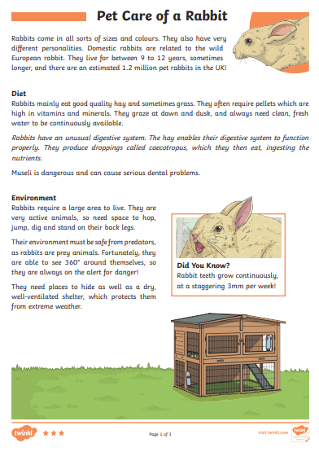
A Fact File Example from Twinkl

