Hi Magpies! Hope you enjoyed last week’s activities. Remember to send us an email to enquiries@saintoswalds.wigan.sch.uk FAO Mrs Knott or Tweet @saintoswalds to let us know how you are doing. It would be lovely to see you as you are working on school work or other home activities. Here are some more activities for you to try this week. Take care - #StaySafeStayHomeSaveLives
Mrs Knott and Mrs Harris xx
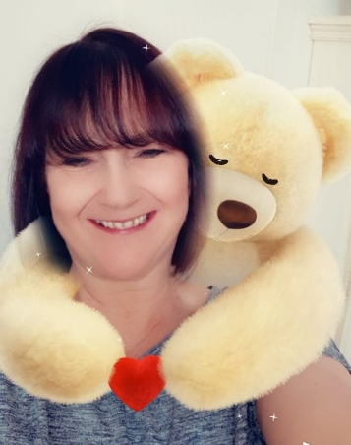
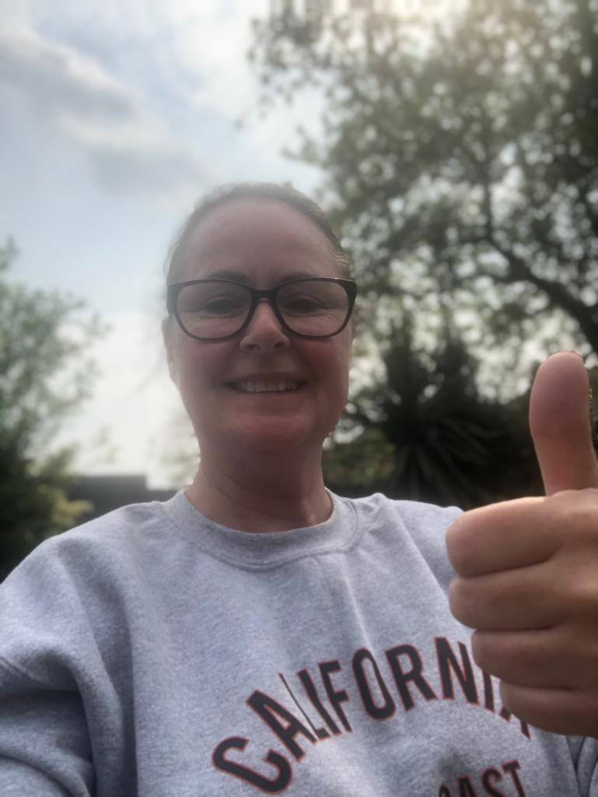

ENGLISH | MATHS
Reading – Read every day for pleasure for 20 minutes.  Comprehension tasks Activities from Twinkl –Pet care of a dog (See below)  https://www.twinkl.co.uk/resource/t2-e-3760-lks2-reading-comprehensions-bumper-resource-pack  Writing – Write your own report for taking care of a pet (If you don’t have a pet you could write about an imaginary pet or write about how you would take care of a plant)  Spellings – Words ending in - que - gue  See list below  Write sentences of your own with each of the words in. | Basic Skill – 8 times tables- instant recall and the corresponding division facts.  https://ttrockstars.com/  https://www.bbc.co.uk/teach/supermovers/ks2-maths-the-8-times-table-with-filbert-fox/z4mrhbk  White Rose Maths– Year 4 - Summer term – Week 3 and Maths challenge.  https://whiterosemaths.com/homelearning/year-4/  If this is proving to be too challenging, please go to the go to the Y3 home learning to build your child’s confidence.
R.E. | OTHER
The theme is:  The theme is: Serving and is linked to Pentecost- Energy  REVEAL  Read the extract from Acts 1: 6-11 (See below)  Draw a picture of Jesus at the ascension – add a speech bubble to show the promise Jesus made or write a paragraph to describe what happened.  Imagine you are one of the apostles after Jesus had returned to his Father. Having witnessed how Jesus served others, how will you continue his mission? In a method of your own choosing, record what actions you would take and give reasons for your choices  Methods could include:  A news report- This could be written or you could record yourself as a news reader  A cartoon strip/comic strip  A letter telling someone about Jesus’s work and how you will carry on his mission  A poster displaying key information | Science – What is a food chain? Watch the BBC bitesize clips below  https://www.bbc.co.uk/bitesize/topics/zx882hv/articles/z3c2xnb  https://www.bbc.co.uk/bitesize/topics/zbnnb9q/articles/zwbtxsg  Complete the worksheet (See below)  History – Ancient Egyptians – Start to create a scrap book all about the Ancient Egyptians – this week continue with your scrap book – what can you find out about the pyramids? Can you write a non-chronological report about them to add to your book?  http://www.primaryhomeworkhelp.co.uk/egypt/pyramids.htm  https://www.bbc.co.uk/iplayer/episode/b00jzygg/horrible-histories-series-1-episode-2  https://www.bbc.co.uk/bitesize/topics/zg87xnb  Music – Time for music Y3/4 Lesson 2  https://www.stoswaldswigan.co.uk/classes/fun-learning-games/music

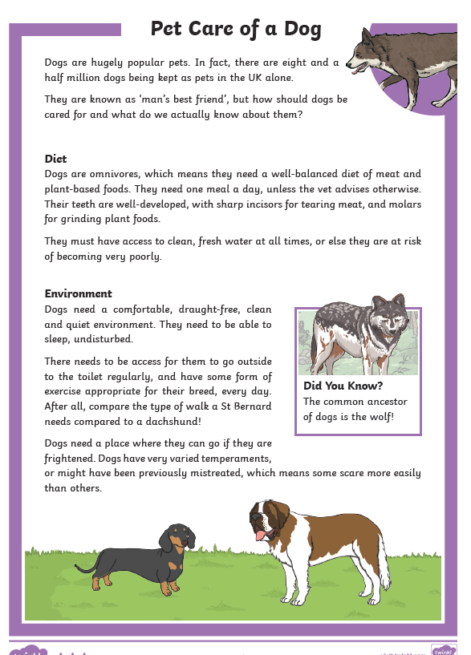

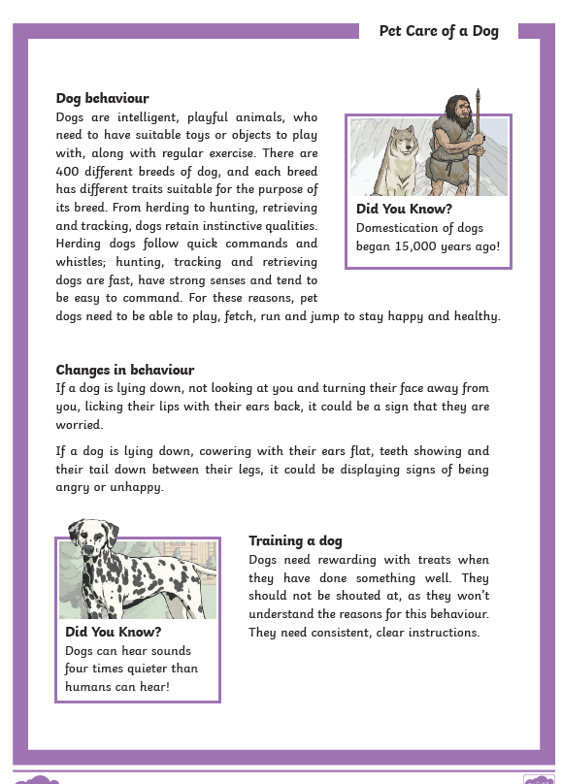A Taken from Twinkl

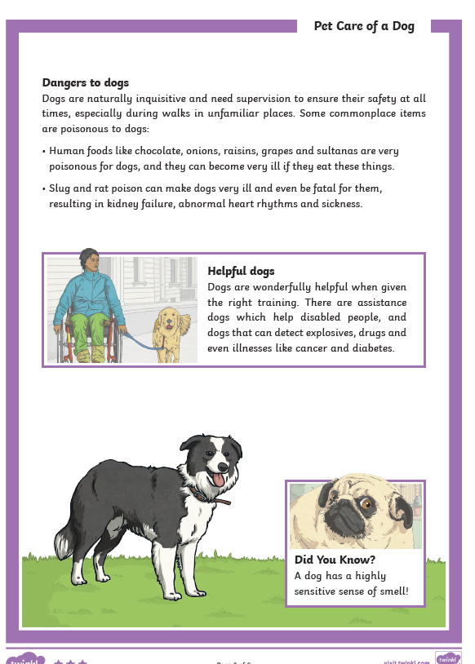

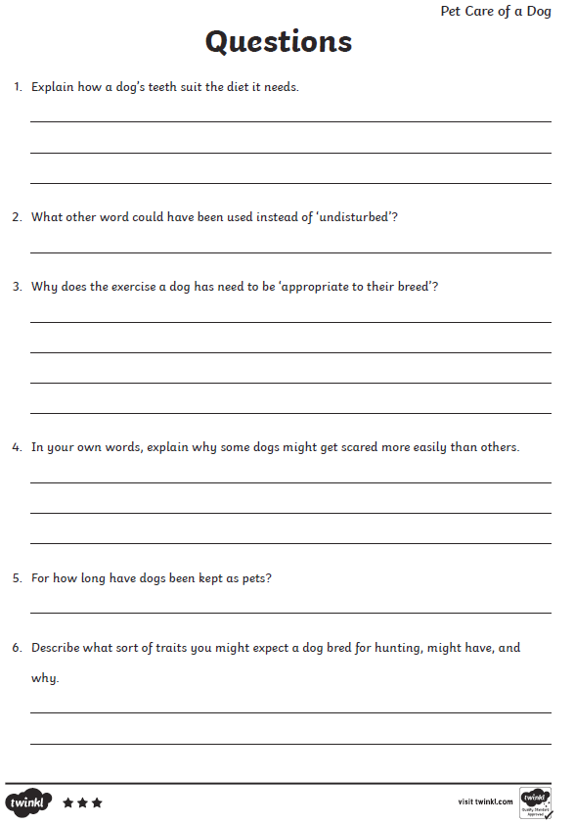

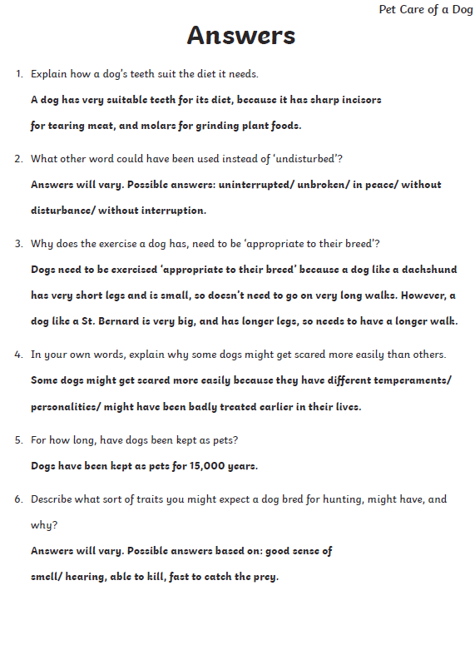

Spellings This week’s focus is words ending in que que
cheque
antique
unique
grotesque
catalogue
colleague
fatigue
league
tongue
Can you find any other examples? List them here
Jumping Orange Words
difficult
grammar
guard
guide

RE
After Jesus had been raised to new life, he told his friends,
“You will receive the power of the Holy Spirit. You will be my witnesses here in Jerusalem and all over the world.”
As he said this, he disappeared from sight.
They realised that he had gone back to his Father as he had said he would.

Based on Acts 1: 6-11

.

The Church celebrates the Ascension forty days after Easter Sunday, the day of the Resurrection.
Teaching Point

A disciple is a follower of Jesus. An apostle is someone who is sent out to spread the Good News of Jesus to the whole world.

