Mystery Bag STEM challenge
In this design activity, children are given a bag of mystery materials (an assortment of recyclables and other random items) and then a challenge card stating a building challenge to do with those materials. They then use those “mystery” materials to complete the challenge.
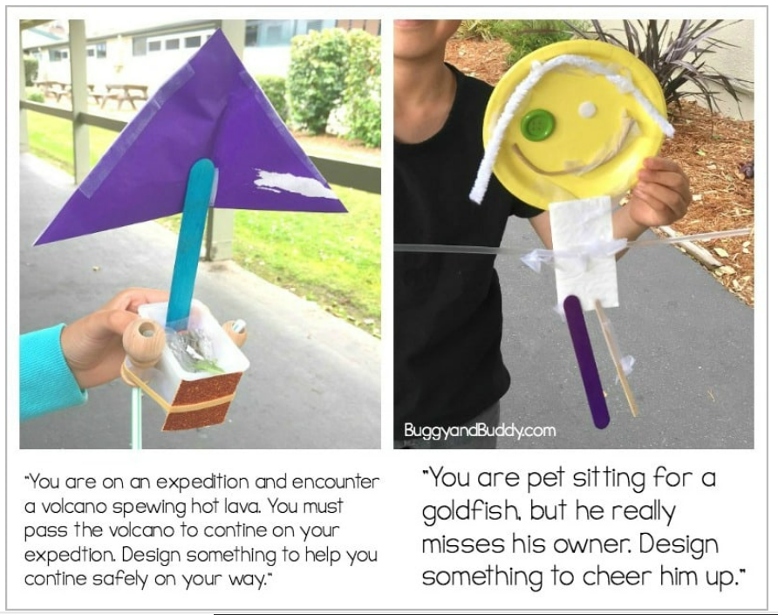

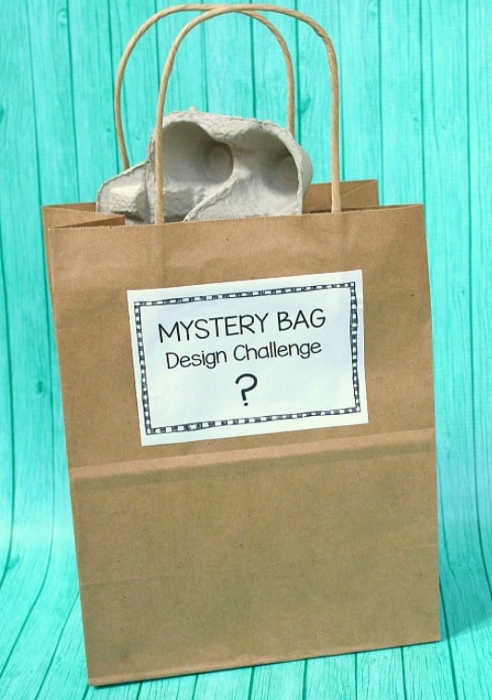

Place about 8-12 items into each bag. You’ll want to be sure the items are varied. Each bag should contain at least one larger item that can serve as a base for the design, and then an assortment of smaller items.

You can use any materials you have on hand- be creative! Save up recyclables for a few weeks: egg cartons, cardboard boxes, plastic containers, plastic lids, empty paper towel rolls etc. You can also use small sheets of paper that children would be able to cut up and use, Materials such as small paper plates, plastic cups, random craft materials like lollypop sticks, straws, buttons, elastic bands, pipe cleaners, string, wool etc.

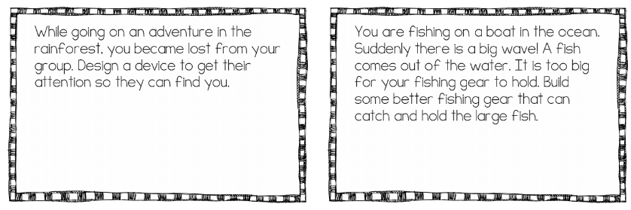
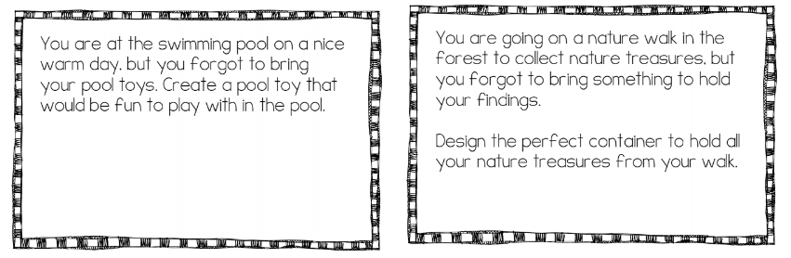
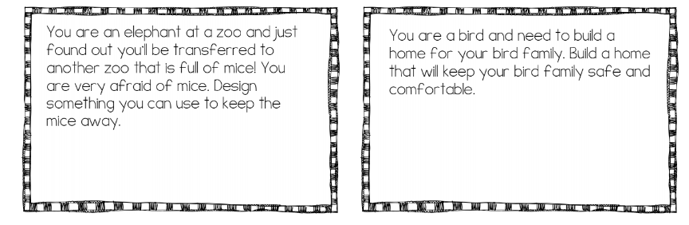
Mystery Bag Design Challenge Cards
