OWLS’ WEEKLY SUGGESTED HOME LEARNING – WB 1.6.20
Hello Owls! I hope you had a lovely half term week and enjoyed a break from school work. Let me know what you got up to!
Enjoy this week’s home learning and don’t forget that you can do some of your own activities instead if you wish.
Year 6, we are putting together some transition work each week and we’re working hard to add in a few Zoom sessions in the coming weeks too. Unfortunately, at this moment in time, we can’t have everyone back in school together but hopefully a virtual catch up will be the next best thing. We’re missing you all so much and we’re all so sad that this has happened. We feel lucky that we had Robinwood together though – even in freezing cold February!
How to get in touch… enquiries@saintoswalds.wigan.sch.uk FAO Mrs Higgens if you are Y5, or you can Tweet @saintoswalds or @Mrs_higgens. Year 6, you have all been contacted separately and can continue to email me directly as you will do when you move over to high school.
Speak to you soon!
Mrs Higgens and Mrs Smith xx
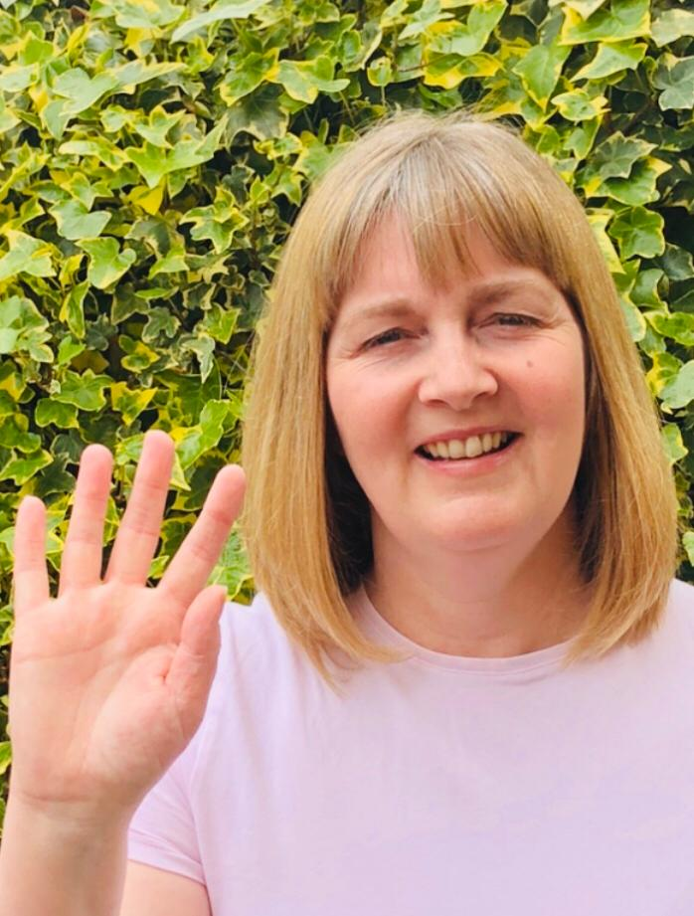
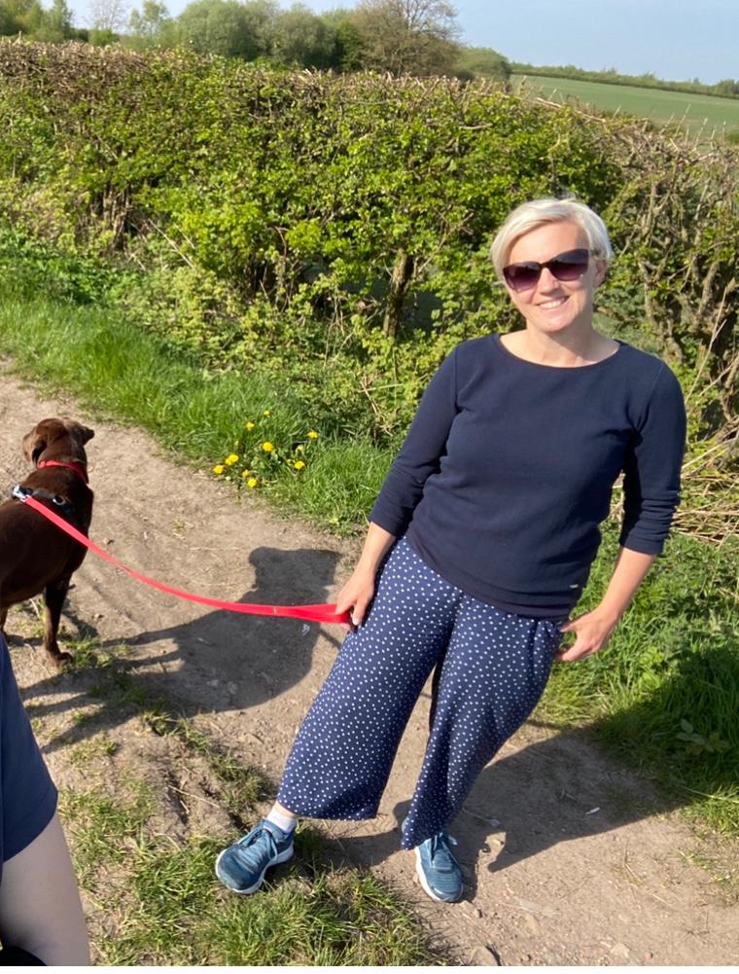

ENGLISH | MATHS
Comprehension  Attached you will find various examples of question stems based on reading VIPERS which will help you with this week’s reading tasks.  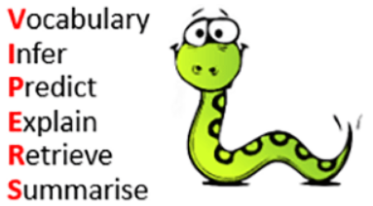  Task 1: Using the book you are reading, I would like you to come up with a question from each of the 6 reading focus areas (vocabulary, inference and so on).  Task 2: Watch the video clip and see if you can come up with another set of questions to ask someone in your house. https://www.literacyshed.com/marshmallows.html# Don’t forget to do the answers too so that you mark their work!  Writing/ Computing  This week’s task is one that every class will be joining in with and involves Summer poetry and Discovery Education!  We would like you to write a haiku about Summer 2020 and then get your parents to video you reading it aloud (landscape please). Just as with your other videoed home learning tasks, you can be as creative as you wish with backgrounds and props. I’ve seen fabulous video clips from you so I’m sure these will be just as good! Further information about Haikus is attached below along with parental consent to send the clips to Discovery Education.  If you would like to take part but don’t consent to the video being shared with Discovery, please just let us know when you send the clip.  Year 6 Transition  The Robin Hood MAT has the most fantastic transition resources and all of the links. The focus this week is on feelings about transition to high school.  Follow the link below and then scroll down to Y6/7 transition learning projects. Week beginning 1st June:  https://www.robinhoodmat.co.uk/Learning-projects/  We’d really love to have a look at all of the work completed but especially the letter which is Thursday’s task. Really try to give as much information about you as possible, and don’t forget to include the punctuation and paragraphs. Show off your brilliant writing skills. | Unfortunately we do not have access to the weekly White Rose planning home learning sheets anymore. The two best options now are to either work through the structured daily lessons on BBC Bitesize and the daily challenges (which are actually made in conjunction with White Rose). The other option is to pick and choose from Corbett Maths the areas which you feel you have gaps in learning. See below for links.  BBC Bite size Daily lessons:  https://www.bbc.co.uk/bitesize/dailylessons  Corbett Maths link:  https://corbettmathsprimary.com/content/  Ongoing Times Table Rockstars- try for 15 minutes a day  https://ttrockstars.com/.
R.E. | OTHER
The new theme which begins this week is based on Reconciliation.  I would like you to think about care and compassion. Think about the following questions and create a poster or booklet.  - What makes you feel better if you feel unwell?  - How do you care for others who may be sick?  - How can you show care and compassion for others who may have people in their family who have been poorly?  http://www.wednesdayword.org/ | Art and DT  We are continuing to look at the artist, William Morris. Please see below for information and your task.  PE – Have a go at a lesson a day starting with this one https://www.youtube.com/watch?v=IvySZYSZFNY This PE link is a series of fun You Tube videos produced by the Yorkshire Sport Foundation which gives the children some practical learning activities to do PE at home.

