OWLS’ WEEKLY SUGGESTED HOME LEARNING – WB 11.05.20
Hello Owls! I hope you have had a good weekend. I’ve enjoyed seeing your VE day celebrations on Twitter .Please keep sending your emails and keep sharing on Twitter so I can see what you’ve all been up to!
If I’m working at home, I’ll reply the same day, but if I’m in school, it might take a little longer. It’s enquiries@saintoswalds.wigan.sch.uk FAO Mrs Higgens if you are Y5, or you can Tweet @saintoswalds or @Mrs_higgens. Y6, you can now email me directly as we’re getting you a bit more prepared for how you will be working at high school. Enjoy this week’s work and I’ll speak to you soon!
Mrs Higgens and Mrs Smith xx
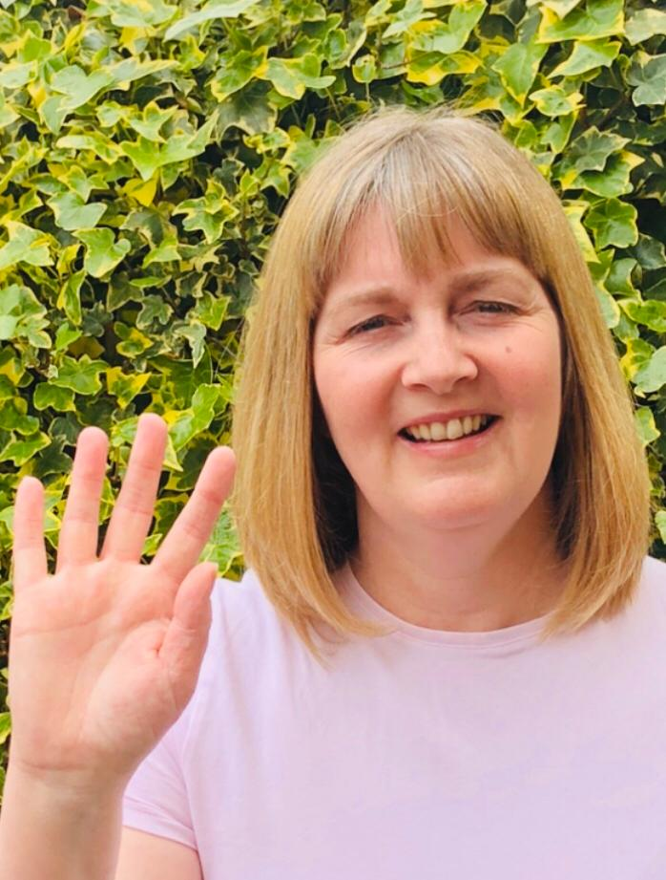
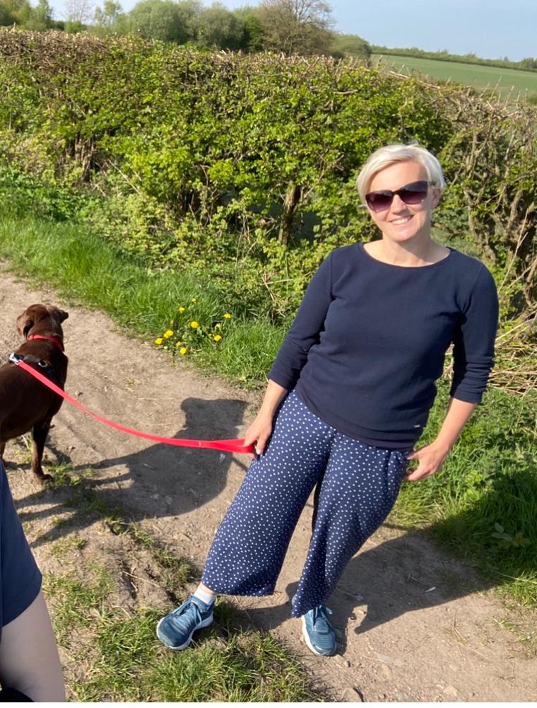

ENGLISH | MATHS
Comprehension  Keep up your reading for pleasure every day.  If you haven’t already, please subscribe to this site to access the home learning resources - all resources are free.  Task 1: Chocolate https://kids.classroomsecrets.co.uk/resource/year-5-reading-comprehension-chocolate-from-bean-to-bar/  Task 2: Women at War  https://kids.classroomsecrets.co.uk/resource/year-6-reading-comprehension-women-at-war/  Task 3: On Oak National Academy  Year 5- https://www.thenational.academy/online-classroom/year-5/english#subjects (lesson2)  Year 6-  https://www.thenational.academy/online-classroom/year-6/english#subjects (lesson 2)  Have you spotted that Harry Potter is being read aloud, chapter by chapter, by lots of the cast members?! Check it out here https://www.wizardingworld.com/collections/harry-potter-at-home I love it!  Spelling  I’ve attached a spelling menu so you can choose your own spelling tasks over the next couple of weeks. Continue using the Year 5/6 spelling sheet which was sent home on the last day, or by googling Y/6 statutory word list. You might also want to use the Y3/4 statutory word list sheet too.  Continue to use https://www.spellingshed.com/en-gb which has a free 30 days trial which has some great games and printable tasks.  Writing  On Discovery Education, please complete the following task linked to using commas to clarify meaning. https://central.espresso.co.uk/espresso/primary_uk/subject/module/video/item361723/grade2/module305326/collection361843/section361751/index.html | Times Table Rockstars- try for 15 minutes a day  https://ttrockstars.com/  Please click on the links to take you to home learning for Y5 and Y6 Summer Term week 2 – 4.5.20 (we are a week behind!).  Multiplication/Division/perimeter & challenge task Year 5  https://whiterosemaths.com/homelearning/year-5/  Fractions and challenge task Year 6 https://whiterosemaths.com/homelearning/year-6/  Remember, if this is a bit tricky, you can have a look at the work in Y4 or Y5 or you can continue working through your SATs books if you are Y6.  Corbett Maths also has some brilliant videos to help to explain some of the tricky areas and also some good activities to help you. The 5 a day section offers you some quick fire tasks.  https://corbettmathsprimary.com/
R.E. | OTHER
The theme continues to be Transformation which is linked to Pentecost.  Please see below for this week’s RE task. The diocese have provided new lessons especially for home learning.  Continue to pray the rosary throughout May. (see last week’s home learning for a guide to the rosary). Try to set a little bit of time aside each day to pray the rosary.  Please read this week’s Wednesday Word together with your family, using the link below.  http://www.wednesdayword.org/ | Computing  https://central.espresso.co.uk/espresso/coding/lessons.html#/coding/units  I would recommend starting at the 5A lesson but if this is too easy/difficult please go up or down the year groups.  Geography- European Countries  Please choose any country in the continent of Europe. You might want to do some research before deciding.  When you’ve chosen, please create an oral presentation no shorter than 1 minute but no longer than 3 minutes. You can start with notes and all of your research and then choose what you would like to say. Practise while perhaps timing yourself before presenting to someone who you live with, or maybe share over a video call if you are keeping in touch with someone who you can’t physically see at the moment. Props, backgrounds and music can be added in. Be as creative as you like!  Try to include:  - Capital city  - Major cities  - Climate  - Rivers/oceans/seas  - Is the country famous for anything in particular?  - Culture  PE – Please keep up with your walking / running / cycling and log your miles with school so that we can see how far as a school we can get! Good luck.

RELIGIOUS EDUCATION – YEAR 5/6 – PENTECOST

Read together and share: What should Connor say?
EXPLORE: The courage to be a witness

What should Connor say?
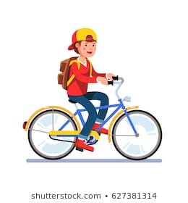
Connor was cycling home from school when he saw his elder sister, Kylie, with a group of young people. He knew some of them; they were tough and didn’t care what anyone said to them. They were from the local secondary school, where Connor would be going in September. Connor got off his bike and hid behind a parked car where no one could see him. He was fond of Kylie, even though she was always telling him he was stupid. He knew it was only teasing.

As he watched, he wondered why he had stopped. Was it curiosity? Was he spying or was he really concerned about Kylie? He wasn’t sure. Kylie was laughing. One of the girls offered her a cigarette which she took. Connor knew his parents would be cross if they found out. Kylie was only fourteen. He could see Kylie shaking her head and beginning to walk away, then another one of the group, a boy, held her arm and started arguing with her. Another girl pushed her, while another got hold of her bag. Kylie grabbed it back and started to run. The group let her go but shouted after her; “You’d better have the money tomorrow!”

Connor didn’t know what to do. There were too many in the group for him to tackle. Kylie was walking home now. Connor got home first. His Mother asked him if he had seen Kylie on the way. Before he could answer Kylie arrived home.

Choose Activities
- Together talk about different endings. Choose one of your endings to continue writing the story including feelings and beliefs which might affect the behaviour of the characters. Can you now add another paragraph that shows how you would have been if this was you? Is there anything you may have done differently? If so, why?
- Talk about the times you might have been in a situation when you witnessed something happen which was unusual, strange or even wrong and you knew you needed to tell someone. You were unsure for a number of reasons. Maybe you thought people would laugh at you, not believe you, or you might get into trouble. Write about a situation where you have needed courage to witness? What happened?

REVEAL: We are a witness to the Easter message
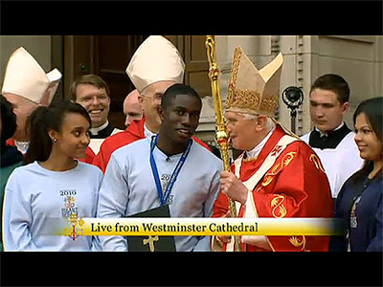
In 2010 Pope Benedict XVI made a special visit to our country. Whist he was here he met with lots of young people. Paschal Uche, read out a letter on behalf of all of the young people there. You can see his speech on You Tube.
Dear Holy Father, It is a privilege and a great pleasure to welcome you on behalf of young Catholics from England, Wales and Scotland. Your visit brings us together – it is like a family reunion – and we are very pleased to see you. My name is Paschal Uche and I am from St Francis’ Parish in East London. Gathered here today are two and a half thousand young people representing almost every parish in the country. Like many here I have been actively involved in the Church serving the elderly in Lourdes and going on retreat. I know that others help in Confirmation sessions, parish music groups, youth groups, and projects serving those who are disadvantaged. We are a truly living Church that offers great opportunities for young people to encounter the love of Christ and share it. Pope John Paul II said that our faith is a “noble and authentic adventure” and we really want other young people to experience this. It is our prayer that your visit inspires us to be “saints of the third millennium.” Holy Father we would like to ask you to bless for us a candle stand, which we hope will be a symbol for Catholic Youth Ministry. It has been thoughtfully designed for use in prayer, teaching and meditation. For many of us before today you were a face on the television or a picture in a Church but today we behold you face to face and on behalf of the Catholic youth of this great nation I would like to express my profound and heartfelt gratitude for your visit. May God Bless you.
- Whilst we are all at home keeping safe with our families there are lots of people who are witnesses to the Catholic faith. This means they are living just as Jesus taught us to do. Talk together about any witnesses you might know who are helping others at this time of lockdown. e.g. family member, parishioner, celebrity? Write a report on their work and what makes them a modern witness. How are their actions shaping lives? You will find lots of information from the television, online and news reports.
- How are you being a witness to the Catholic faith? How are you living as Jesus taught us? List some of the things you are doing at home to be like Paschal and help others. Write your own letter to your teachers in school to tell them how you are a witness of Jesus’ love.

Choose Activities
- Can you answer these questions?
What impressed you most in what Paschal Uche said?
Why do you think he was chosen to speak?
How do you think he felt speaking in Westminster Cathedral?
Do you think Paschal is a witness? What does he do to be a witness?

