OWLS’ WEEKLY SUGGESTED HOME LEARNING – WB 15.6.20
Hello Owls!
I hope you’ve had a good week. I’ve been for plenty of blustery walks and runs which I enjoyed but I didn’t have much use for my sunglasses! This week I will be working in school a lot more so it might take me a little longer to reply to tweets and emails but please don’t let this stop you from getting in touch.
Year 6, this Tuesday at 10:30 we will all be getting together for a fun Zoom quiz (details to follow). You won’t have to chat or share your answers aloud but there will be an opportunity to discuss any worries or questions that you might have if you want to. It’s just a chance to see everyone back in one place again which is exciting.
Enjoy your activities, and let me know if you get up to anything or just want to share something with me. Last week we had some children who had been strawberry picking, clothes designing, discovering more about our oceans, writing book reviews on Amazon, story writing, completing their own art work, making virtual surveys and I even got a photo of a pet tortoise! I love hearing about it all
How to get in touch… enquiries@saintoswalds.wigan.sch.uk or you can Tweet @saintoswalds or @Mrs_higgens.
Speak to you soon!
Mrs Higgens and Mrs Smith xx
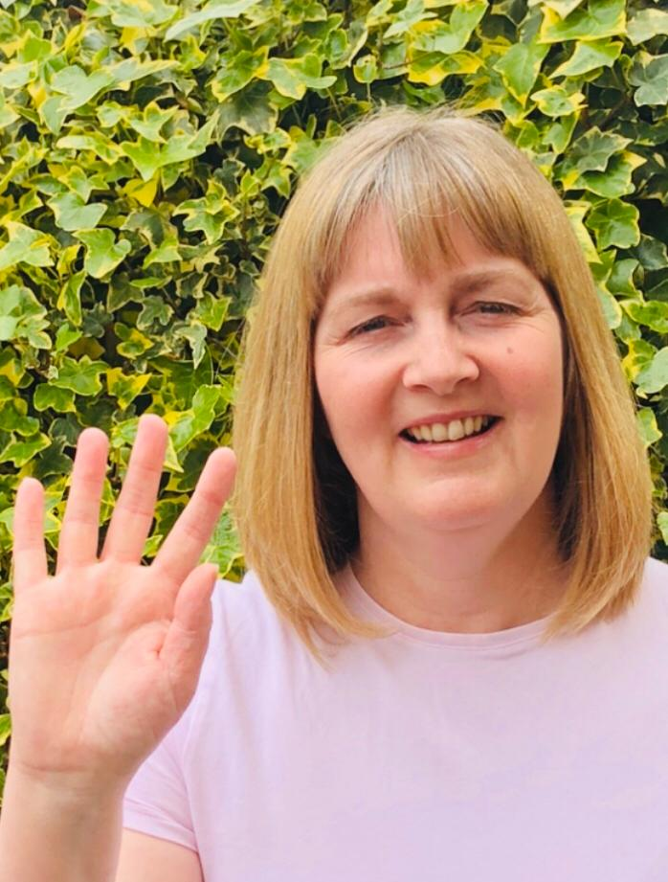
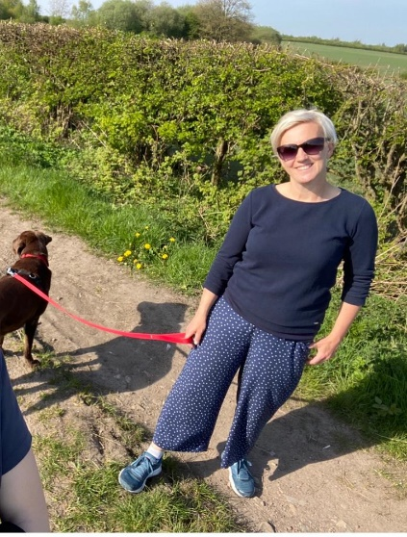
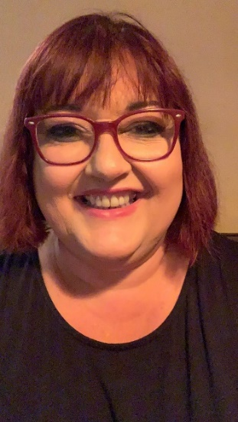

ENGLISH | MATHS

Year 6 Transition  We would like you to continue with the transition tasks on the Robinhood MAT website. The focus this week is about friendship and who turn to for support.  Follow the link below and then scroll down to Y6/7 transition learning projects. Week beginning 15th June  https://www.robinhoodmat.co.uk/Learning-projects/  Comprehension/Reading  1.Please read the story extract about circus performers and complete the comprehension https://cdn.oxfordowl.co.uk/2017/03/30/09/43/48/564/2749604_Reading_Comp_B.pdf  2. Visit Discovery Education using the following link. Choose an author from their book club videos and create a mini fact file. https://central.espresso.co.uk/espresso/modules/e2_book_club/index.html?source=subject-English-KS2-English-Resource%20types  Please try to read for at least 20 minutes a day just for pleasure.  Writing  1.Visit the Literacy Shed for this fantastic short film resource on Once in a Lifetime.  https://www.literacyshedplus.com/en-gb/resource/once-in-a-lifetime-ks2-activity-pack  2.Listen to this poem called Cat Rap. Make up your own rap using a different animal. Can you perform it too?  https://childrens.poetryarchive.org/poem/cat-rap/ | Please use the home learning packs from Hamilton at Home.  https://www.hamilton-trust.org.uk/blog/learning-home-packs/  Click on this link and scroll down to go to either Y5 or Y6.  We are up to week 7 but feel free to go back if you feel like you need to. These have some PowerPoints to help and also come with answer sheets.  The structured daily lessons on BBC Bitesize are still another good option, as is picking and choosing from Corbett Maths. See below for links.  BBC Bite size Daily lessons:  https://www.bbc.co.uk/bitesize/dailylessons  Corbett Maths link:  https://corbettmathsprimary.com/content/  Ongoing Times Table Rockstars- try for 15 minutes a day  https://ttrockstars.com/.  All times tables are now available for all children.  If you fancy some different online Maths games this site has plenty.  https://www.topmarks.co.uk/maths-games/7-11-years/problem-solving
R.E. | OTHER
The theme this week continues to be Reconciliation.  Please see below for some information about a special place called Lourdes. You may want to carry out some additional research and talk to the grown up who you live with about this. Design a poster for a school or parish trip to Lourdes and explain why it would be good to go, what the experience would be like and how it might shape your life.  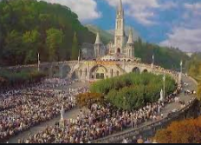 | Art and DT Lesson 4  We are continuing to look at the artist, William Morris who we would have been studying in school this term. Please see below this week’s collage task.  History  If we were in school, we would be carrying out a local history/British study on railways! I’d like you start this by creating a full page mind map of all you currently know or have heard about railways! This could be from our local area in Ashton/Wigan or it could be from books or films (Harry Potter for example). No fact or thought is wrong. I’d then like you to fill the spaces amongst the writing on your page with appropriate mini illustrations such as trains, bridges, smoke, people, signs, ticket collectors- anything you feel is relevant! Looking forward to seeing them!  PE Continue with lessons from ‘at home’ PE sessions here https://www.youtube.com/watch?v=NDZhgfrmogA This PE link is a series of fun You Tube videos produced by the Yorkshire Sport Foundation which gives the children some practical learning activities to do PE at home.  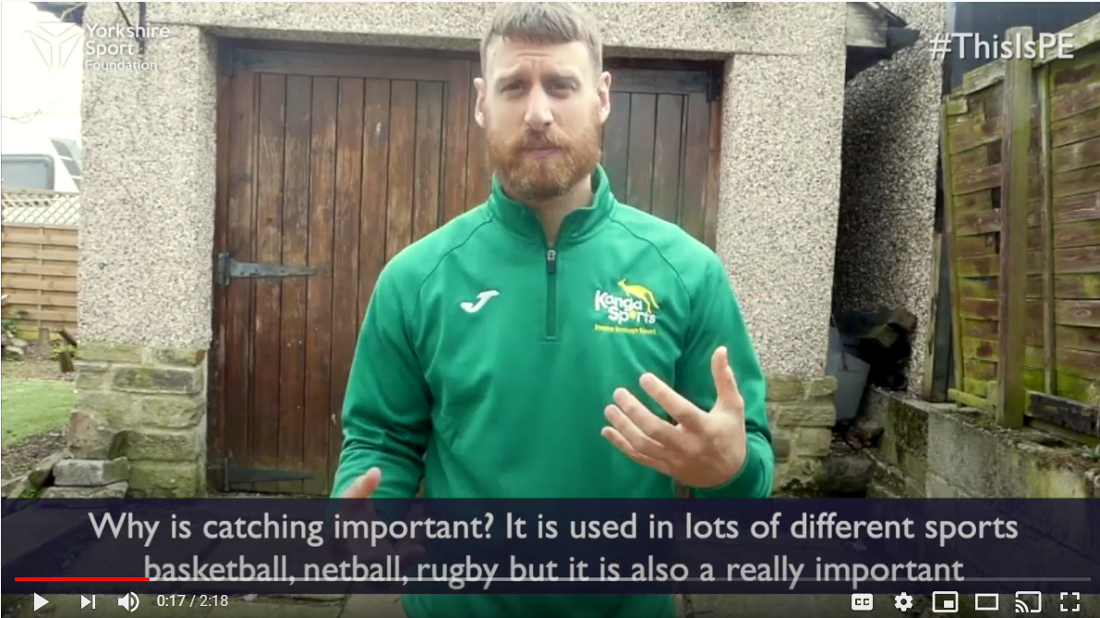  Crafty at home Challenges –  See the sheet below for some home-made fun! If you have any of your own, let me know and I could put them on next week’s learning for others to have a go at.

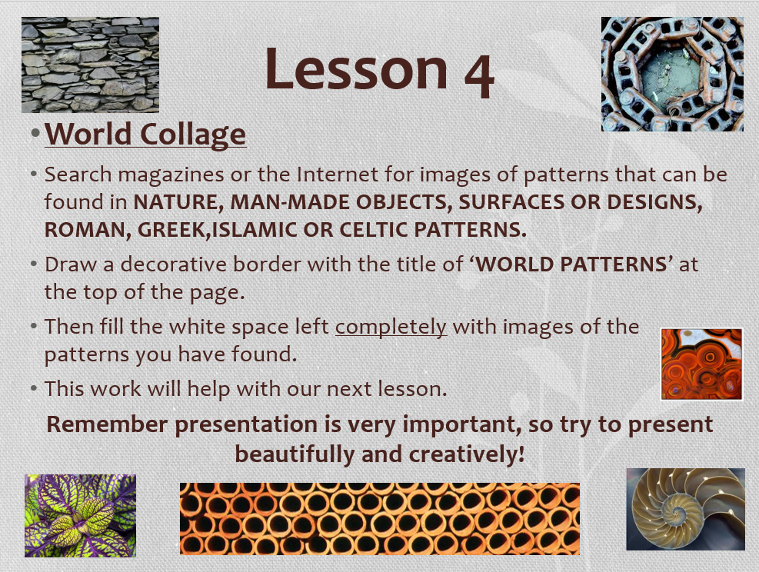

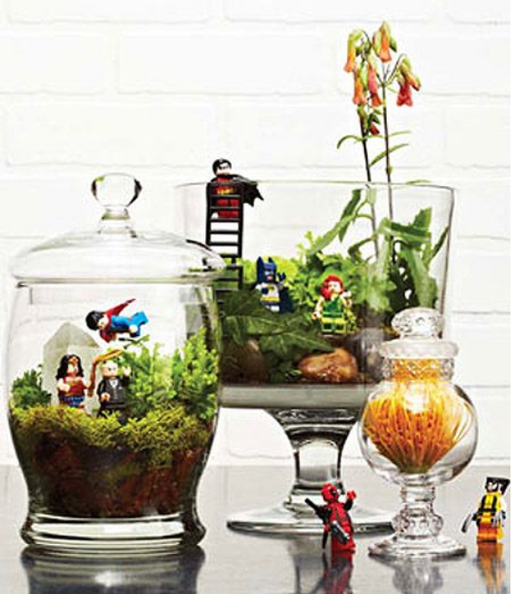
Crafty home ideas to try

- Create your own setting for Lego (or other character) fun.
Make sure you ask parents first before using their best bowls!

- Give these speakers a try and let me know how you get on!
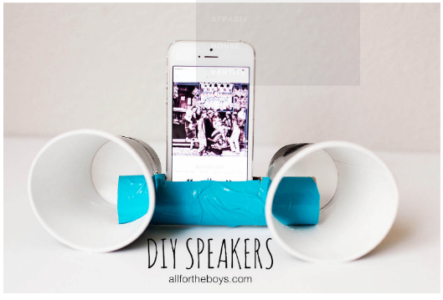
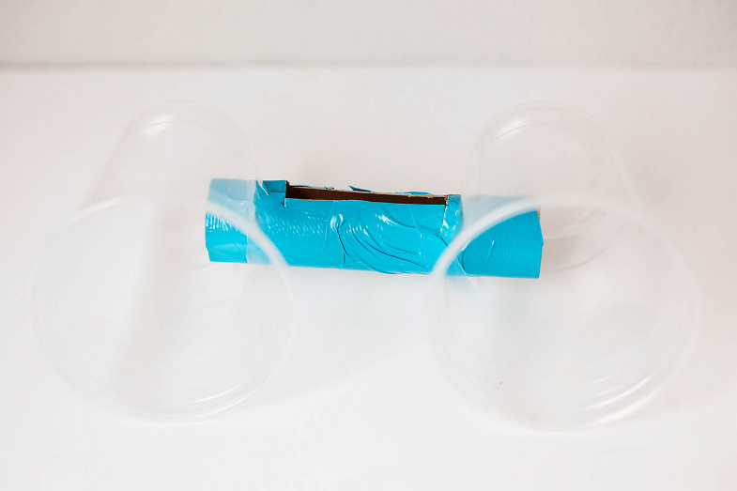

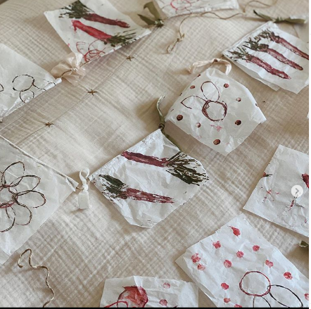
- Create bunting using string and ribbon and print using the end of toilet roll tubes. Sticks and leaves, petals, etc can be used as painting utensils. You could create a theme such as Summer or the weather. Be creative!

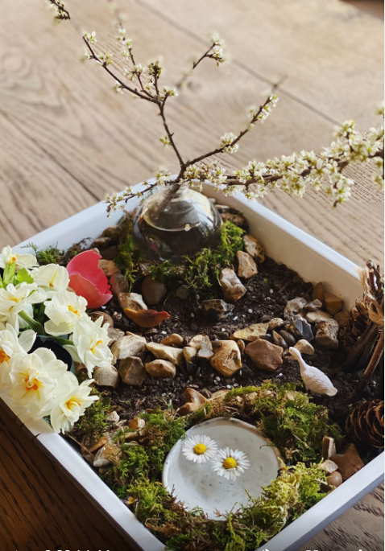 A Tupperware or baking tray garden. What can you find on your walk that you could use?

RE Task

Lourdes, a place of healing.

Lourdes is in the south of France. It is an important place of pilgrimage for sick people. It all began when a poor young girl called Bernadette Soubirous, had a vision of Our Lady (her story is in More Friends of Jesus).
Our Lady appeared to Bernadette 18 times, standing on a rock above a dirty old grotto (cave), where pigs used to shelter. At first people thought Bernadette was mad, but she persisted and did as Our Lady asked her. Often, she would pray the Rosary as she gazed at the figure. She did not know it was Our Lady at first. During the thirteenth time Our Lady appeared, she told Bernadette: “Go, tell the priests to come here in procession and build a chapel here.”
Another time, Our Lady told Bernadette to drink at the spring. There was no spring there, but Bernadette scrapped at the earth with her bare hands and, after a few tries, clear, clean water appeared. Later on, other people heard about it and a girl called Catherine, who had a paralysed arm, came and touched the rock and her arm was healed. After that, many people began to visit the grotto and eventually a number of churches were built to accommodate the pilgrims who came to pray.
Today 6 million people come to Lourdes every year from all over the world. Very many sick people come, some wanting a physical cure, but above all, a spiritual healing and to return and face life with an inner peace. There are five special signs at Lourdes:

- The water: many people who go to Lourdes bathe in special baths in the water from the spring.
- The rock of the grotto: pilgrims like to touch the rock of the grotto where Our Lady stood.
- Light: at night, there is a candlelight procession and all day there are candles burning in front of the grotto, reminding people of the light of Christ.
- The crowds are huge, coming from every race and nation, young and old, sick and healthy. Lourdes is a true experience of the Church, a gathering together of all the scattered children of God.
- The sick are given a special blessing every afternoon. It gives them comfort and their helpers also gain from the experience of being with the sick and serving them as Christ cared for the sick when he was on earth.

HCPT - The Pilgrimage Trust is an organisation which enables those who may need help, especially children and adults with disabilities, learning difficulties and social and emotional needs, to experience a pilgrimage to Lourdes. Every year they organise trips to Lourdes for over 7000 people.
SOME KEY QUESTIONS

- What do you think of the way Bernadette acted ?
- Why do you think people go to Lourdes?
- Would you like to go and why?
- What do you think you might do in Lourdes?
- Which of the five signs appeals to you most and why?

SOME SUGGESTED ACTIVITIES

- Research some information about Lourdes and design a poster for a school or parish trip to Lourdes and explain why it would be good to go, what the experience would be like and how it might shape your life.

