OWLS’ WEEKLY SUGGESTED HOME LEARNING – WB 18.05.20
Hello Owls! I hope you are all okay. I feel like I know what so many have you have been up to through your emails and Tweets. You definitely all seem to have a good balance of work, fun and exercise which sounds great to me. If you’ve still not managed to email or send me a Tweet, please try to this week. Remember, you don’t have to send your work, just a quick hello would be great.
If I’m working at home, I’ll reply the same day, but if I’m in school, it might take a little longer. It’s enquiries@saintoswalds.wigan.sch.uk FAO Mrs Higgens if you are Y5, or you can Tweet @saintoswalds or @Mrs_higgens.
Enjoy this week’s work and I’ll speak to you soon!
Mrs Higgens and Mrs Smith xx
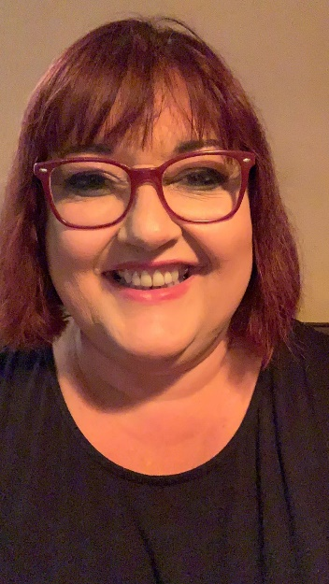
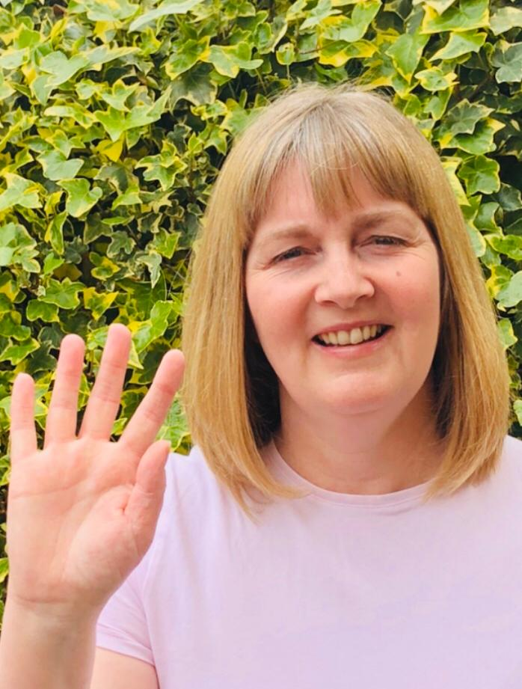
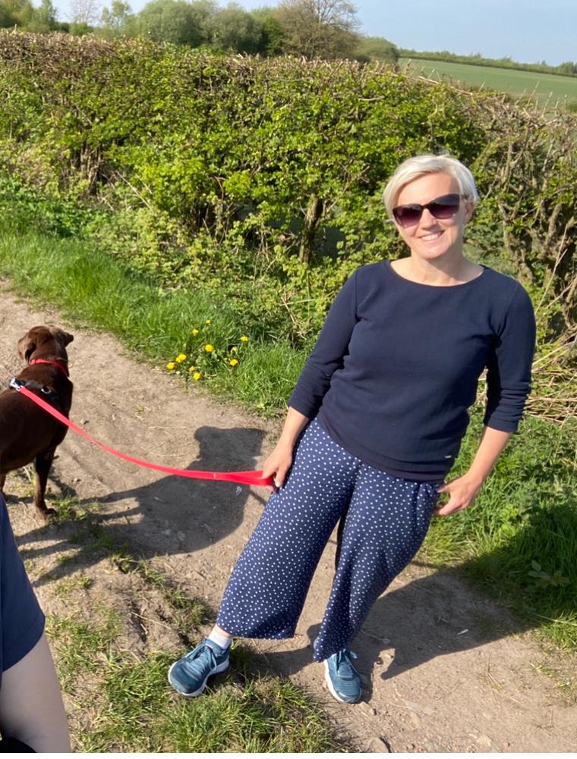

ENGLISH | MATHS
Comprehension  Keep up your reading for pleasure every day. Let me know what you are currently reading.  Task 1: Keeper by Mal Peet https://central.espresso.co.uk/espresso/modules/e2_comprehension_uks2/books/book_keeper.html#tab1  Task 2: On Classroom secrets- The circulatory System  https://kids.classroomsecrets.co.uk/resource/year-5-non-fiction-reading-comprehension-the-circulatory-system/  Spelling  Please continue with last week’s spelling menu tasks.  Writing  Y5 Lesson, 3, 4 and 5 over 3 days- Setting description https://www.thenational.academy/online-classroom/year-5/english#subjects  Y6 lesson 3, 4 and 5 over 3 days- Newspapers https://www.thenational.academy/online-classroom/year-6/english#subjects | Please click on the links to take you to videos for home learning for Y5 and Y6 Summer Term week 2 – 11.5.20 (we are a week behind).  Unfortunately we do not have access to the work sheets now, so instead, please choose corresponding worksheets from Corbett Maths by scrolling down the list in the link below. If you prefer, just go straight to Corbett Maths and choose the areas you feel you need to practise or haven’t covered yet.  Year 5:  https://whiterosemaths.com/homelearning/year-5/  Year 6: https://whiterosemaths.com/homelearning/year-6/  Corbett Maths link:  https://corbettmathsprimary.com/content/  Remember, if this is a bit tricky, you can have a look at the work in Y4 or Y5 or you can continue working through your SATs books if you are Y6.  Times Table Rockstars- try for 15 minutes a day  https://ttrockstars.com/.  Twitter has its eye on who’s been accessing the site- keep a look out for your name in the hall of fame!
R.E. | OTHER
The theme continues to be Transformation which is linked to Pentecost.  As you know, May is the month of Mary. I’d like you to create a simple poster about Mary – it can be on the computer or hand drawn and as big or as small as you want it to be. Please include some information about Mary and perhaps the rosary, and other information which you have found out through research. I would like you to also think about some art work which you could include in your poster.  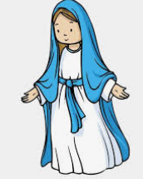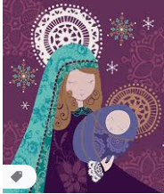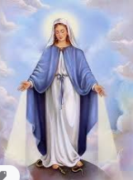  Here is a simple PowerPoint reminding you of the Hail Mary.  https://www.stoswaldswigan.co.uk/classes/fun-learning-games/religious-education  Please read this week’s Wednesday Word together with your family, using the link below.  http://www.wednesdayword.org/ | Art and DT  This week we are looking at the artist, William Morris. Please see below for information and your task.  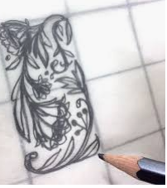  Geography: Make your World Bigger Quiz https://www.discoveryeducation.co.uk/make-your-world-bigger  This is basically a fun video quiz based on the world in which we live. There is a short video to watch and then a quiz after each one, and you can do a few a day or all in one go and it can be done as a family or on your own. Enjoy!  Visit the page and scroll down to see how to play.  PE – Please keep up with your walking / running / cycling and log your miles with school so that we can see how far as a school we can get! Good luck.

