OWLS’ WEEKLY SUGGESTED HOME LEARNING – WB 22.6.20
Hello Owls!
Another week has whizzed by and one which was filled with lovely emails, Tweets, seeing some of you in school, and even some Zooming with Year 6. I never fail to be amazed at your resilience and hard work during this time in which we have all had to get used to a brand new way of working. Your work that I see is of a great standard and the emails I receive are always so polite and interesting. I love hearing about your week and how you are spending your time, which does differ greatly for us all, due to each of our home situations. Keep doing your best and also keep up with those other activities which don’t involve school work or using a screen- these so important too. Take care, Mrs Higgens and Mrs Smith xx
How to get in touch… enquiries@saintoswalds.wigan.sch.uk or you can Tweet @saintoswalds or @Mrs_higgens.

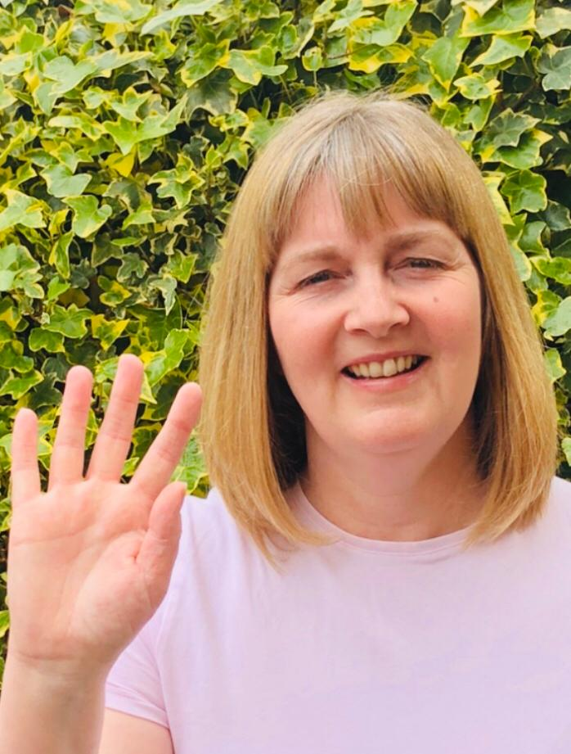
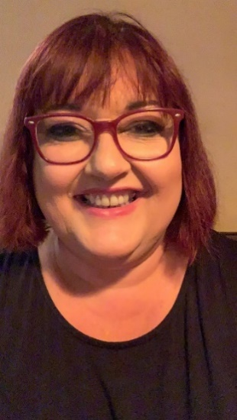
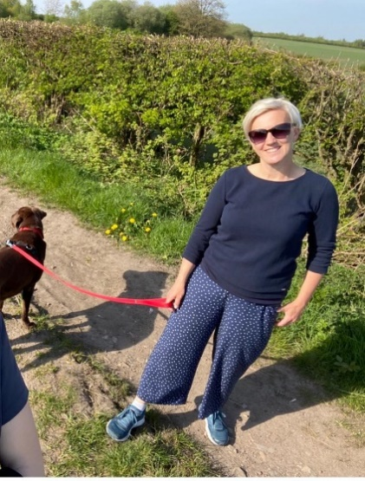

ENGLISH | MATHS
Year 6 Transition  We would like you to continue with the transition tasks on the Robinhood MAT website. The focus this week is about building independence ready for high school. Follow the link below and then scroll down to Y6/7 transition learning projects. Week beginning 22nd June  https://www.robinhoodmat.co.uk/Learning-projects/  Spelling  1.Complete this task on suffixes http://resources.collins.co.uk/KeenKite/samplepdfs/9780008161576.pdf  2. Complete an alphabetical list of cities from around the world. Where possible, include capital cities.  Comprehension/Reading  Click on the link to access the Literacy Shed’s comprehension pack. There are 5 to choose from- do them all or choose a couple to do this week. file:///C:/Users/d.higgens/Downloads/Stage%205%20Reading%20Packs%20-%20Stage%205%20Reading%20Pack%20a.pdf  Writing  Visit the Literacy Shed for this lovely short film about a challenge a group of meerkats face. Once you’ve clicked on the link, if you scroll down slightly there is an activity pack which can be completed throughout the week. https://www.literacyshedplus.com/en-gb/resource/catch-it-ks2-activity-pack  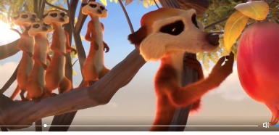 | Hamilton Maths Packs  Please use the home learning packs from Hamilton at Home.  https://www.hamilton-trust.org.uk/blog/learning-home-packs/  Click on this link and scroll down to go to either Y5 or Y6.  We are up to week 8 but feel free to go back if you feel like you need to. These have some PowerPoints to help and also come with answer sheets. The download includes a file for each day of work.  The structured daily lessons on BBC Bitesize are another good option https://www.bbc.co.uk/bitesize/dailylessons as is picking and choosing from Corbett Maths https://corbettmathsprimary.com/content/  Try a few Maths games on the link below…  https://www.topmarks.co.uk/maths-games/7-11-years/problem-solving  Ongoing Times Table Rockstars- try for 15 minutes a day  https://ttrockstars.com/.  All times tables are now available for all children.
R.E. | OTHER
Next Monday, on the 29th June, is the feast day of St Peter and St Paul. We traditionally would celebrate this day across the whole school so we would like to try and join across our homes in celebration instead.  It would be fantastic if you use the key and fish images (see attached) and create a mobile or a poster and add in key words that sum up what Jesus wants us to do e.g. love. You can use colours, paint or glitter- it’s up to you!  Fish are often symbolic with St Peter because he was a fisherman. Keys are symbolic too because in the Gospel of Matthew 16:13-19, it tells us that Jesus gave Peter the keys to the kingdom of heaven. St Paul was a great missionary of Christianity and the author of most of the Letters of the New Testament. What else can you find out about these two important people from the Early Church?  PLEASE SEND IN YOUR CREATIONS TO SHARE WITH US ON TWITTER OR VIA EMAIL. Below are a couple of starting ideas.  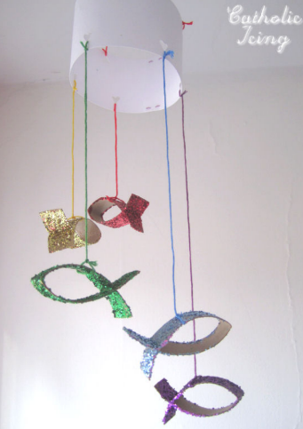  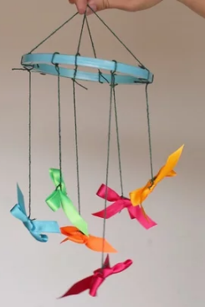 | Science  I know we looked at Space a few weeks ago but there’s still so much to learn and discover. This wonderful series on BBC I player with Professor Brian Cox is fantastic and your task is just to watch it and enjoy https://www.bbc.co.uk/iplayer/episodes/p07922lr/the-planets  Art and DT Lesson 5  Please see below for this week’s task and instructions. This week you’ll start to pull together some of the skills which you’ve been completing each week based on William Morris.  History  Last week, you made a start on your mindmaps for all things railways! This week, I’d like you to see what you can find out about Bryn or Garswood stations. How long has the station been there? Where could you get to in previous years and where can you get to now? When did the first railways appear in Britain? What can you find out about the old line which used to run behind St Edmund Arrowsmith and Byrchall High schools? Below is a link to start you off. Present your findings on a Powerpoint, leaflet or whichever creative way you choose.  https://www.funkidslive.com/learn/railways/discover-early-history-britains-railways-first-railway-railways-uk-take-off/#  PE This PE link is to lots of fun You Tube videos produced by the Yorkshire Sport Foundation which give some practical learning activities to do PE at home using things from around the home. We are up to lesson 15 https://www.youtube.com/watch?v=NDZhgfrmogA  At home challenge  Could you make a mini PE/exercise instruction video? Ask a parent to video you and you can send them over to me. It could be bike preparation and how to check your bike before going out, wearing a helmet, checking the tyres etc. If you are a gymnast, perhaps you could demonstrate some simple moves. If you go out for walk, tell us about the right type of foot wear and clothing and any recommended walks. It would be great to receive lots of these. I could even share them with the rest of the school, but they can also be kept private. Let me know when you email across.
