OWLS WEEKLY SUGGESTED HOME LEARNING – WB 27.4.20
Good morning Owls. School is very quiet without you all here and we are looking forward to when we can all be back together again. Until that time, I’m going to be setting you some activities to carry out each week.
As well as the school tasks, it’s also a great time to carry on getting involved with things around your home such as helping to wash up, helping to prepare meals, weighing ingredients for cooking, setting the table, pairing socks, changing your duvet cover or maybe a bit of polishing! Relaxing and taking time to do things you enjoy are also important.
I’d love to hear about anything that you’ve been up to. You can email your work to enquiries@saintoswalds.wigan.sch.uk FAO Mrs Higgens or you can Tweet @saintoswalds. See you soon!
Mrs Higgens and Mrs Smith xx
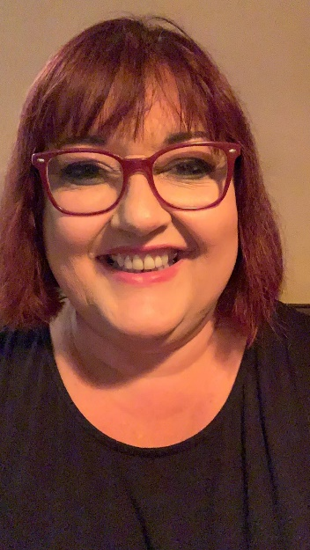
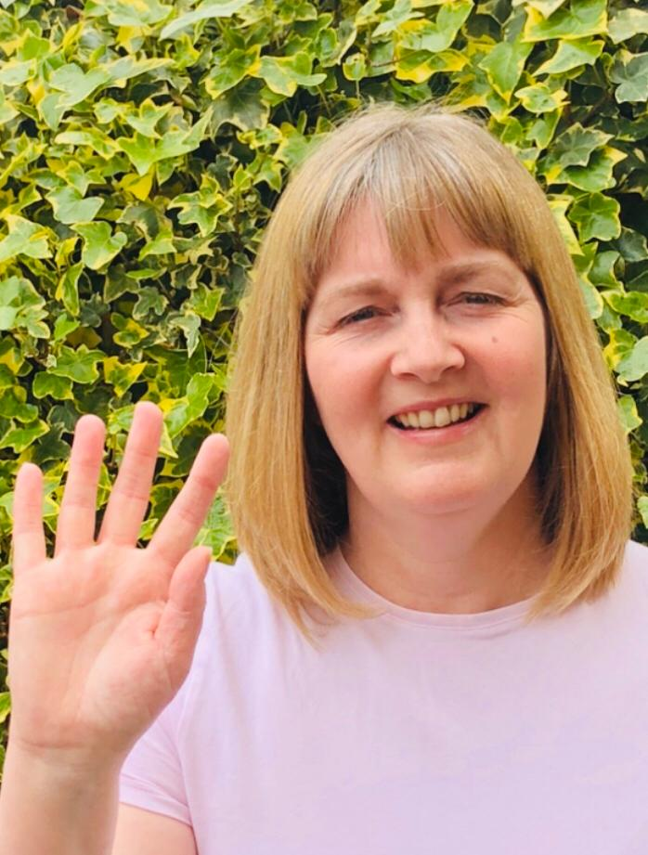
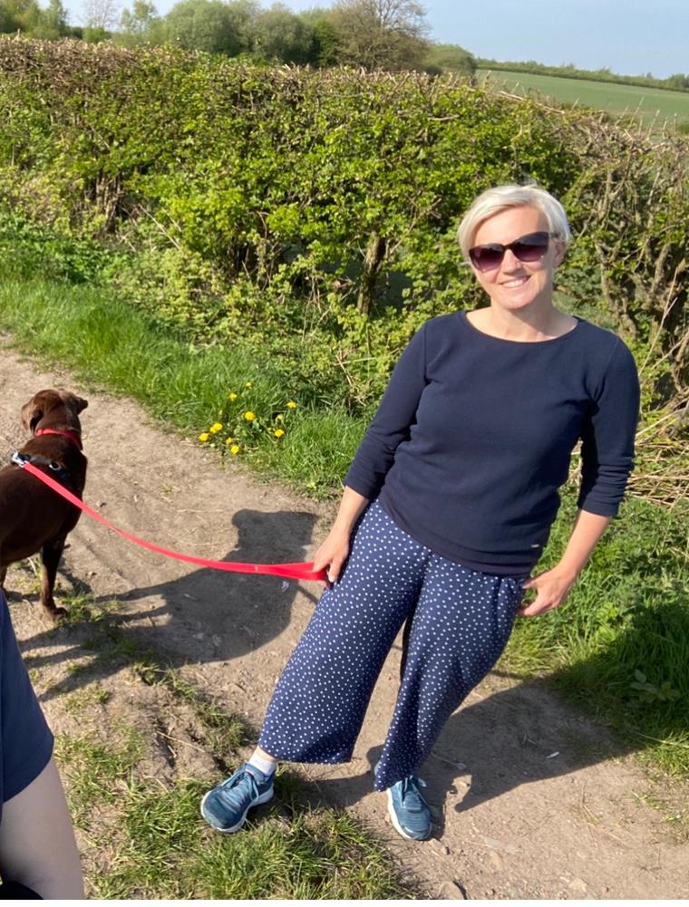

ENGLISH | MATHS
Comprehension  I’ve included two printable comprehension tasks and one to be done online. One is based on London https://www.vocabularyninja.co.uk/uploads/1/1/0/0/110032277/london_-_quick_comprehension.pdf  and the other is based on an unfortunate event with toothpaste https://cdn.oxfordowl.co.uk/2016/10/21/13/36/41/523/Bond_CEM_10_minute_test_EVR_9_10_Test_B.pdf  The link to the third comprehension can be found below on a new site, backed by the Government, called Oak National Academy. The children will be guided by a teacher through their activity.  Year 6 https://www.thenational.academy/year-6/english/newspaper-reading-comprehension-fact-retrieval-year-6-wk1-1/#  Year 5 https://www.thenational.academy/year-5/english/setting-description-reading-comprehension-fact-retrieval-year-5-wk1-1/#  Spelling  Spelling alphabetical order task  https://www.teachitprimary.co.uk/resources/y5/spelling-for-older-learners/writing-transcription/spelling-alphabetical-order/27320  Spot the mistake task  https://www.teachitprimary.co.uk/resources/y5/complex-punctuation/writing-transcription/spelling-punctuation-and-grammar-mistakes/23008  (Source:teachitprimary.co.uk).  The spot the mistake activity doesn’t have to be printed off- it can be just used on screen to discuss.  Writing  Our lives have a changed a lot in the last few weeks and we’ve all had to adapt in the way we usually go about our everyday life. I’d like you to write a diary entry about what changes you have noticed in your everyday life. What is good? What do you miss? What are you looking forward to when we are able to return to our everyday routines? You could do a draft version, and then edit and improve before writing/typing up and adding an illustration.  There’s a checklist below to help you. | Times Table Rockstars- try for 15 minutes a day  https://ttrockstars.com/  Please click on the links to take you to home learning for Y5 and Y6 Summer Term weeks 1 – 20.4.20.  Decimals and challenge task Year 5  https://whiterosemath s.com/homelearning/year-5/  Angles and challenge task Year 6 https://whiterosemaths.com/homelearning/year-6/  If the maths work is too challenging, please access the year group below. This will help to build confidence and the resources are really good quality.
R.E. | OTHER
The theme is Transformation which is linked to Pentecost.  Task 1  Wind, water and solar power are forms of energy used in everyday life. Research these forms of energy and any other you can think of. Positive and negatives of these energy types? How do they help? What do you feel about these different energy types? Why? Choose your own way of presenting your findings which could be a presentation which you record, a PowerPoint, a poster, art work etc.  Task 2  You have your own personal energy. How can you use this for the good of others at home, in school, in the community or wider world? Create a poster, cartoon strip, or booklet with lots of drawings and some explanations. | PE – Joe Wicks (Mrs Higgens tries to do this every day too!)  Science - Earth and the solar system  https://www.bbc.co.uk/bitesize/topics/zkbbkqt start researching by watching some of the clips and perhaps making some notes.  We will be using our research to make our own games next week.  Music  Please work through the fun tasks in the link below. https://www.stoswaldswigan.co.uk/classes/fun-learning-games/music. The final activity involves you creating a rhythm story. Please feel free to video this and email it over to enquiries@saintoswalds.wigan.sch.uk marked for Mrs Higgens.  Extra Challenge!  I’d love to make a slide show with a photograph taken by you (no parents allowed!). I would like this to be a photo of something in our world which makes you smile and feel happy. Some ideas might include a view that you have seen whilst out doing your daily exercise, a flower or tree, some art work or a drawing. Just email over one photograph please. Looking forward to seeing what you choose ☺

