OWLS’ WEEKLY SUGGESTED HOME LEARNING – WB 04.05.20
Welcome to Monday, Owls! I loved chatting with some of you on Twitter and getting your emails sent through to school last week. You’ve definitely kept me smiling . Please keep sending things through- it doesn’t have to just be your work, it can be anything you’d just like to share. If I’m working at home, I’ll reply the same day, but if I’m in school, it might take a little longer.
You can email your work to enquiries@saintoswalds.wigan.sch.uk FAO Mrs Higgens if you are Y5, or you can Tweet @saintoswalds or @Mrs_higgens. If you are Y6, you can email me directly as we’re getting you a bit more prepared for how you will be working at high school. See you soon!
Mrs Higgens and Mrs Smith xx
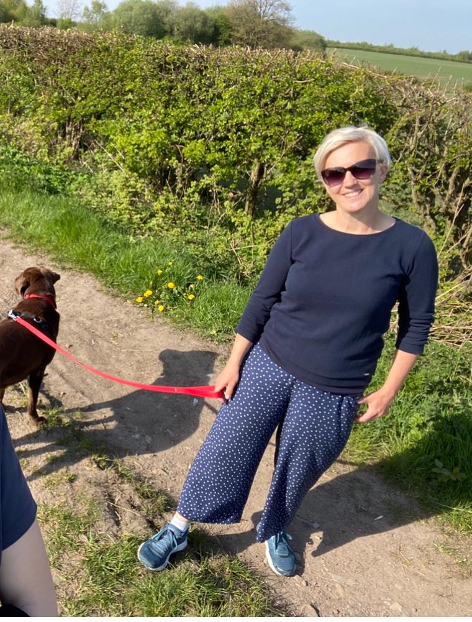

ENGLISH | MATHS
Comprehension  Please subscribe to this site to access the home learning documents - all resources are free.  Task 1: VE Day https://kids.classroomsecrets.co.uk/resource/year-5-victory-in-europe-reading-comprehension/  Task 2: HS2 debate  https://kids.classroomsecrets.co.uk/resource/year-6-reading-comprehension-the-hs2-debate/  Task 3: David Attenborough biography – Please see below. (The answers are underneath so don’t peek!)  Spelling  Using the Year 5/6 spelling sheet which was sent home on the last day, or by googling Y/6 statutory word list, create your own wordsearch and spelling web. Please see below for templates. https://www.spellingshed.com/en-gb has a free 30 days trial which has some great games and printable tasks.  Writing  On Discovery Education, please complete the following task linked to cohesion in paragraphs. https://central.espresso.co.uk/espresso/primary_uk/subject/module/video/item361717/grade2/module305324/collection361837/section361754/index.html  Keeping a journal throughout this time is also a good idea. I do mini journal each night and jot down 5 (short) key things about my day.  Don’t forget about epic.com which is a free online library. | Times Table Rockstars- try for 15 minutes a day  https://ttrockstars.com/  Please click on the links to take you to home learning for Y5 and Y6 Summer Term weeks 2 – 27.4.20 (we are a week behind!).  Decimals continued & challenge task Year 5  https://whiterosemaths.com/homelearning/year-5/  Angles continued and challenge task Year 6 https://whiterosemaths.com/homelearning/year-6/  If the maths work is too challenging, please access the year group below. This will help to build confidence and the resources are really good quality.  Remember, if this is a bit tricky, you can have a look at the work in Y4 or Y5 or you can continue working through your SATs books if you are Y6.  Corbett Maths also has some brilliant videos to help to explain some of the tricky areas and also some good activities to help you. The 5 a day section offers you some quick fire tasks.  https://corbettmathsprimary.com/
R.E. | OTHER
The theme continues to be Transformation which is linked to Pentecost.  Please see below for this week’s RE task. Don’t worry if you find any of the questions tricky, just try your best.  Father John has asked the parishioners to pray the rosary throughout May. Below is a guide to praying the rosary. What can you find out about praying the rosary? Try to set a little bit of time aside each day to pray the rosary.  Please read this week’s Wednesday Word together with your family, using the link below.  http://www.wednesdayword.org/ | PE – Keep working out with Joe Wicks. Please also keep up with your walking / running / cycling and log your miles at school so that we can see how far as a school we can get! Good luck.  Science - Earth and the solar system  Last week, you carried out research on the Earth and the Solar system. This week I would like you to use this knowledge to make your own game. It can be a game of your own choice but there a few ideas to help below:  - Top Trumps: https://www.tes.com/teaching-resource/blank-educational-top-trumps-template-6036598  - Snakes and Ladders with a space theme and perhaps a twist of solar system questions before someone is allowed to go up a snake (rocket?!).  - A simple board game where questions need to be answered in order to move spaces (I’m thinking a twist on a Monopoly). Could you devise a system to buy planets?  - Perhaps you could make some quiz cards and host your own Earth and solar system quiz night!  History 8th of May is VE Day  Please watch this video about VE day and then see below for a fantastic task sheet with lots of unique learning ideas.  https://www.bbc.co.uk/teach/class-clips-video/history-ks2-ve-day/z7xtmfr

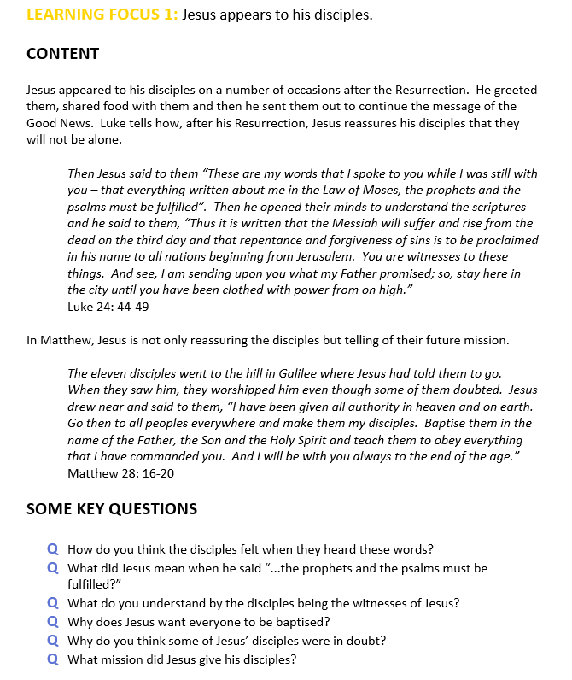

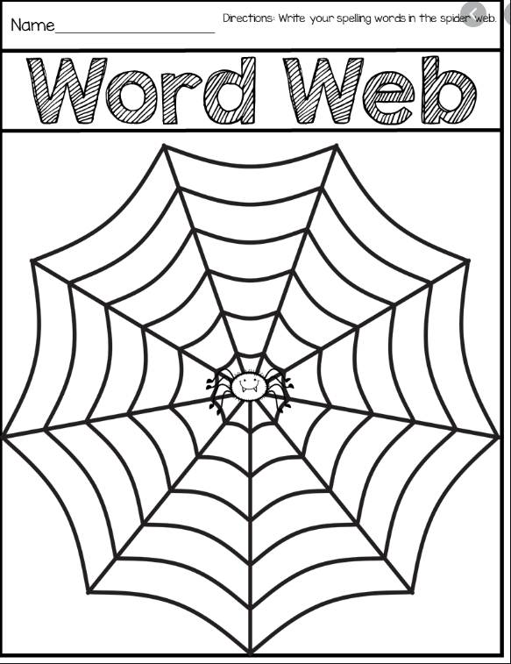

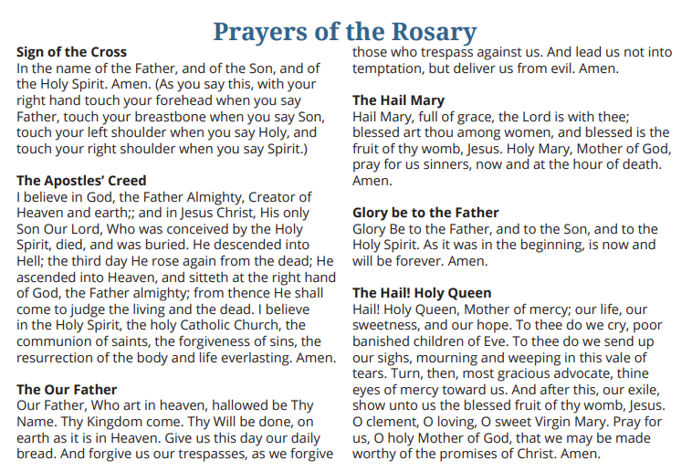
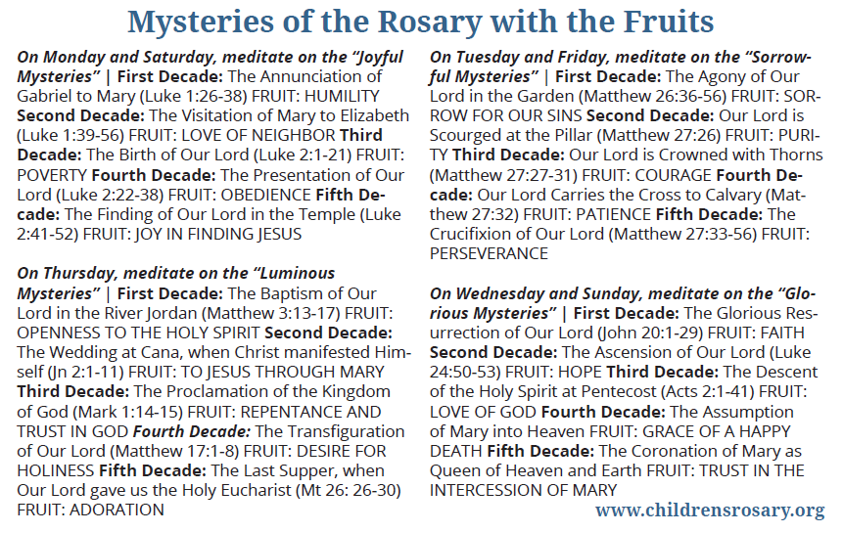

VE DAY
The project this week aims to provide opportunities for you to learn more about VE Day.
Choose one or more activity a day to explore. Be creative about how you present your work.
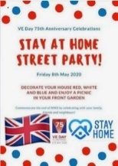  ‘Stay At Home’ Street Party  Read this article on Newsround and look closely at the photographs. How did people celebrate in 1945? Plan your own ‘stay at home’ street party.  What games could be played? What decorations would be put up? What food would be eaten? Who would be there? Is there anyone in your family who went to a VE Day party you could speak to?  For something more simple, you could design your own VE Day party invitation or create your own Union Jack flag bunting or make a Union Jack flag out of Lego! | Understanding World War Two/VE Day  On 8th May 1945, Britain celebrated the end of World War Two. To understand why VE Day was so important, you need to understand WW2. Visit these sites to help in your research:  Primary Homework Help - WW2  A Brief Overview of World War II – Video  BBC Teach - VE Day  What Is VE Day?  Can you create a timeline of important events leading up to  VE Day? | Wartime Recipes  With one rationed egg and a packet of powdered milk in the larder, World War II’s home cooks had to be creative. Find out what families were eating over 75 years ago.  Create some delicious meals using the recipe booklets below. You could serve them at your ‘Stay at Home Street Party!’  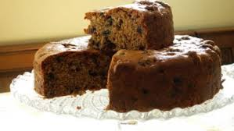  Wartime Recipe Booklet  Wartime Ration Recipes  WW2 Cake  Wartime Scones  Jam Tarts
Crack The Codes  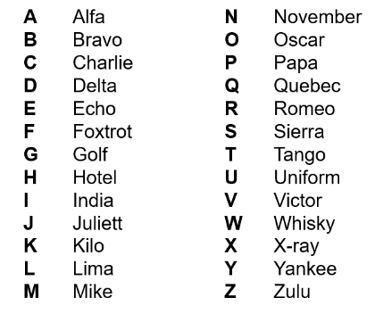  Phonetic Alphabet  The phonetic alphabet that was used in RAF ransmissions during the war. Learn to spell your name using the phonetic alphabet e.g.  Ted = Tango Echo Delta  Morse Code  Morse code is a communication system that represents the alphabet and numbers with a series of dots, dashes or a combination of both as shown here. Watch this video to find out more about Morse Code.  Can you write a secret coded message for your family to crack? | VE Day Songs  Try and learn the Horrible Histories VE Day song and perform it to your family.  Create your own motivational song. Listen to some of the following clips for inspiration. Click here to listen to some more traditional war time songs as well as the links below.  Wartime song lyrics  Run, rabbit, run!  Long way to Tipperary/ Pack up your troubles  We’ll meet again  The White Cliffs of Dover  Learn step-by-step how to Swing dance (The Lindy Hop) which originated in the late 1920s and early 1930s in Harlem, New York City. | 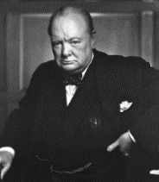  Winston Churchill  Who was Winston Churchill? Why do we remember him today? Produce a fact file/ poster displaying your information.  Create a mind map or list of facts about Winston Churchill.  What was his job?  Why was he so important during WW2?  What was one of his famous phrases?  Can you describe his characteristics?  Why he was important?  You can read more about Churchill using these links from Twinkl and Ducksters. You may present this information in any way you choose or use this template.  CHALLENGE: Can you learn Winston Churchill’s Victory speech and record yourself presenting it?
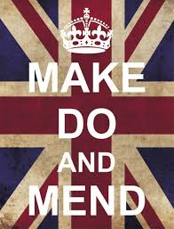  Make, Do and Mend  During WW2, there was a shortage of materials to make clothes. People were urged to "Make, do and mend".  Do you have any clothes or accessories that you could ‘upcycle’ into new clothing or something completely different to give it another purpose and a new lease of life? | Europe during the Second World War  Colour in the countries on the map (here) according to whether they were Allies, Axis, Axis controlled or Neutral.  You could print the map from Twinkl (code UKTWINKLHELPS) or create a list.  NatGeo Kids - WW2 History | Spitfire Science  Design and make your own Spitfire. You could make it out of paper, wood, recycled materials, etc. Test out your design. How far does it glide?  Does the material used for a paper plane affect the distance it travels? Try using newspaper, card, tinfoil, etc and carry out a test. Remember, only change ONE thing to make it a fair test.

