OWLS’ WEEKLY SUGGESTED HOME LEARNING – WB 8.6.20
Hello Owls!
I hope each of you are doing okay. This week has seen a big change in the weather but my garden is thankful for the rain and Maisy (my dog) is loving the cooler temperatures! I email with lots of you regularly but there’s still just a handful of you that I could love a little email from or a quick hello to let me know how you are.
Lots of you choose to use your own books and websites instead of the suggested work below and this is absolutely fine. Whatever you choose to do, I’d love to hear about it.
How to get in touch… enquiries@saintoswalds.wigan.sch.uk FAO Mrs Higgens if you are Y5, or you can Tweet @saintoswalds or @Mrs_higgens. Year 6, you have all been contacted separately and can continue to email me directly as you will do when you move over to high school.
Speak to you soon!
Mrs Higgens and Mrs Smith xx
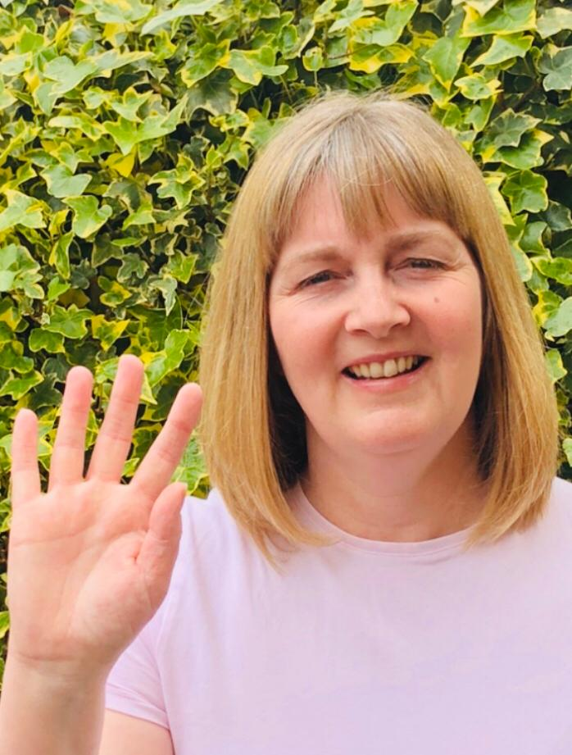
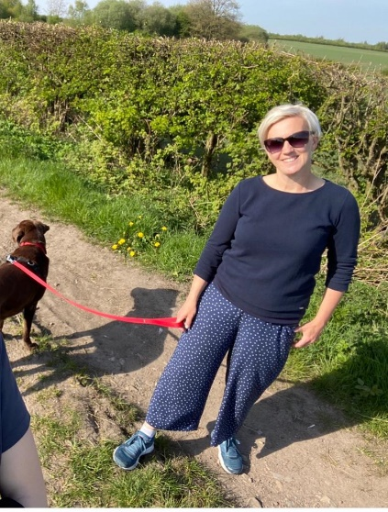
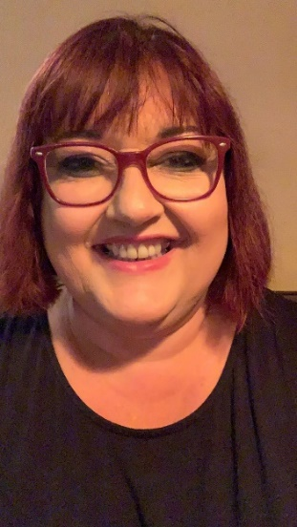

ENGLISH | MATHS

Year 6 Transition  We would like you to continue with the transition tasks on the Robinhood MAT website. The focus this week is about getting organised for secondary school.  Follow the link below and then scroll down to Y6/7 transition learning projects. Week beginning 8th June  https://www.robinhoodmat.co.uk/Learning-projects/  Comprehension and speech task  Please see the task sheet below based on famous speeches from people such as Barack Obama and Martin Luther King.  Writing  Change the lyrics of your favourite song into a short story. Or, write and perform your own song.  Perhaps there is a topic which you are passionate about which you could share with others through your song lyrics. | Since we can no longer download White Rose learning, the home learning packs from Hamilton at Home are another good choice. https://www.hamilton-trust.org.uk/blog/learning-home-packs/ Click on this link and scroll down to go to either Y5 or Y6. I would suggest beginning at Week 6 but feel free to go back if you feel like you need to. These have some PowerPoints to help and also come with answer sheets.  The structured daily lessons on BBC Bitesize are still another good option, as is picking and choosing from Corbett Maths. See below for links.  BBC Bite size Daily lessons:  https://www.bbc.co.uk/bitesize/dailylessons  Corbett Maths link:  https://corbettmathsprimary.com/content/  Ongoing Times Table Rockstars- try for 15 minutes a day  https://ttrockstars.com/.
R.E. | OTHER
The theme this week continues to be Reconciliation.  It is a Christian responsibility to care for the sick and needy. I would like you to create a prayer which might be specifically for someone you know who is sick, or for others who may have a family member who is sick.  If you would like to write additional prayers for those people who you feel may need one at the moment then this would be very thoughtful.  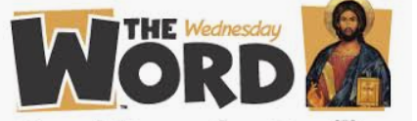  Please visit for this week’s http://www.wednesdayword.org/ | Art and DT Lesson 3  We are continuing to look at the artist, William Morris who we would have been studying in school this term. Please see below for information and your task.  PE Continue from lesson 6 with ‘at home’ PE sessions here https://www.youtube.com/watch?v=IvySZYSZFNY This PE link is a series of fun You Tube videos produced by the Yorkshire Sport Foundation which gives the children some practical learning activities to do PE at home.  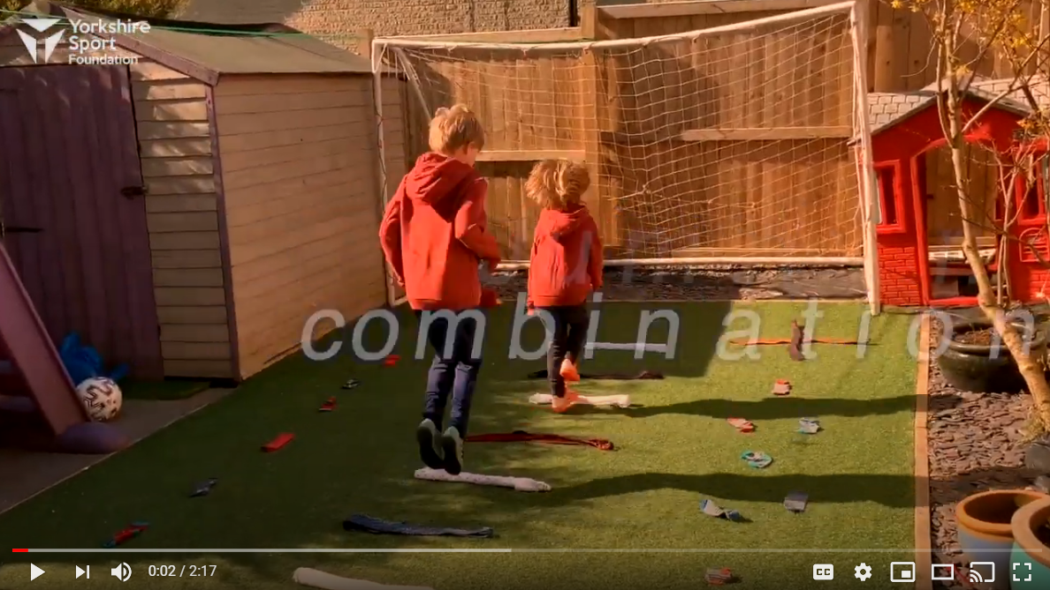  Wellbeing- Find some challenges to do from the Young Minds website. The resource is below.  https://youngminds.org.uk/resources/school-resources/wellbeing-activity-calendar-and-games/

English Task
IMPORTANT Parent or Carer – Read this page with your child and check that you are happy with what they have to do and any weblinks or use of internet.
1. Watch and think about a speech
• Watch this clip explaining about a famous speech:

https://www.bbc.co.uk/programmes/p00wwkvn
• Had you ever heard of the ‘I have a dream’ speech. Where did you hear about it?
• Now watch this second clip about the language in the speech. Make notes on Language Features about what you learn.
https://www.bbc.co.uk/programmes/p00wwq4t

2. Read other famous speeches
• Read Two Famous Speeches (see below)and answer the questions.
• Challenge yourself to read one of the speeches in the next set: Three Famous Speeches and to answer the questions on that speech as well.

3. Practise reading a speech out loud.
• Pick one of the speeches and practise reading it out loud. Practise until your words flow and you are able to speak really expressively.

Well done! Share read the speech that you have chosen to a grown-up. You can check your answers to the questions too at the back of this pack.

Try the Fun-Time Extra
• Watch and listen to some of the speeches. Are they as you expected?

- John F Kennedy – the section referenced begins at about 9.02
https://commons.wikimedia.org/w/index.php?title=File%3APresident_Kennedy%27s_Speech_at_Rice_University.ogv
- Barack Obama - https://www.c-span.org/video/?c4504854/barack-obama-victory-speech This is a longer section from Obama’s victory speech so listen from about 2.28 to about 3.39 for the section transcribed in the resources.
- Winston Churchill - https://winstonchurchill.org/resources/speeches/1940-the-finest-hour/we-shall-never-surrender/ This is a recording of the full speech, listen from around 10.42 onwards for the section transcribed in these resources.

