Outdoor Scavenger Hunt
We love an outdoor scavenger hunt at St Oswald’s!
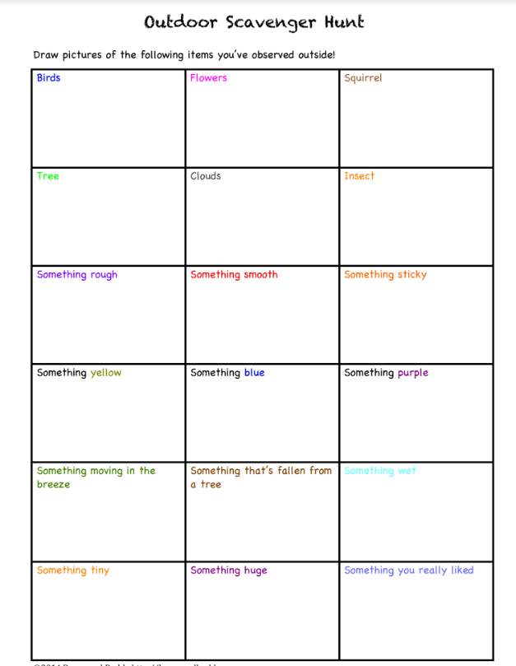
This template provided not only encourages all kinds of sensory discoveries, but it also provides room for children to sketch their findings!

