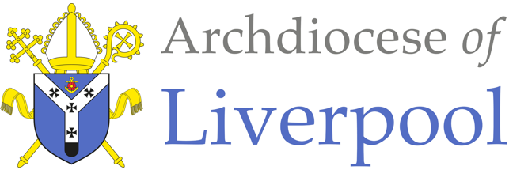
*Note to parents.
This work comes from the Come and See Religious Education programme which is taught in all Catholic schools in the Archdiocese of Liverpool. We have given a general guide to the learning opportunities that your child may have come across in school and have only suggested and selected a small amount of the programme. The activities aim to keep Religious Education practical and fun. They are in Year groups however, there is no harm in completing other year group work as this will help your child to remember and strengthen their learning. Please only choose the activities you and your child wish to complete. There are lots of suggestions to help you choose.
The first part of learning is called – EXPLORE. This shares your child’s everyday experiences and helps them to see how the Catholic faith is lived in their everyday lives. The second part, called – REVEAL shares bible stories that links to their everyday life.

RELIGIOUS EDUCATION - NURSERY & RECEPTION – PENTECOST

EXPLORE: Everyone has good news to tell.

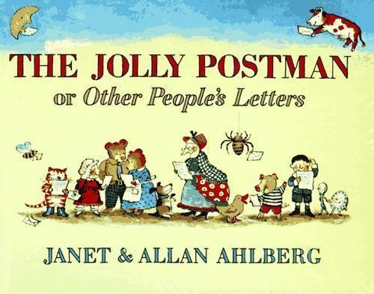
Read together and share: The Jolly Postman by Janet & Allan Ahlberg. – Full book available on You Tube
Choose Activities
- Tell each other a piece of good news and share with each other
- Find items of good news i.e. letters, cards, emails, photographs, certificates etc. which recall your or the children’s good news.
- Set up a good news board – children to bring in their own news e.g. a new baby.
- Write a good news letter or email or text message to a friend, teacher or family.

REVEAL: Pentecost: the celebration of the Good News of Jesus
- Share and read the bible story together

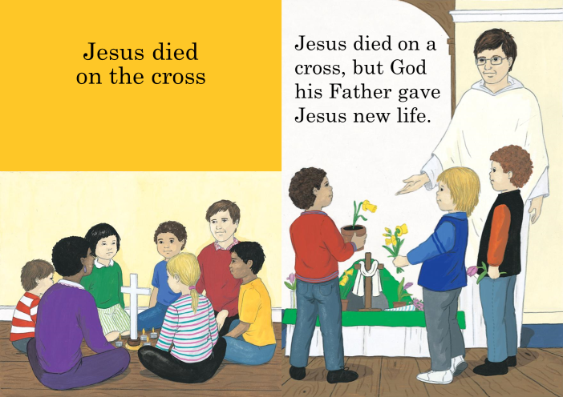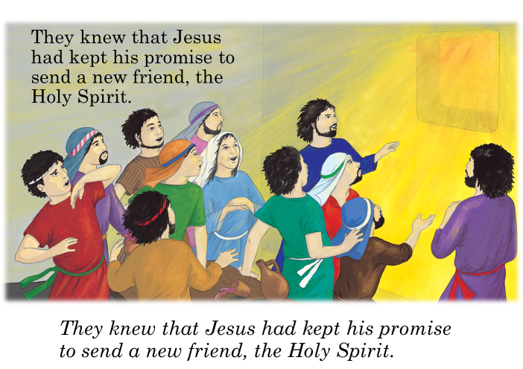

Choose Activities
- Read the bible story together. Jesus sent a new friend, the Holy Spirit. We cannot see the Holy Spirit, but we can feel it. It is like the wind. This is how the Holy Spirit can feel …
- Share a range of activities which explore the effects of the wind e.g.
  - Blow bubbles and watch them disappear. Talk about how you blow air into them and the air carries them away.
  - Fly a kite. Talk about how the wind lifts the kite and helps it to fly.
  - Watch and listen to a wind chime. Talk about how the wind enables music to be made.
- Make pin wheels and take them outside to see the effects of the wind. Talk about what you see happening to the windmills.

RELIGIOUS EDUCATION – YEAR 1 – PENTECOST

EXPLORE: Holidays as days to be happy

Look at together and share:
- Photographs of holidays or days out you may have had.
- Together talk about your school trips.
- Find pictures of holidays in magazines or on holiday websites. Talk about holiday experiences. This is a great way to wonder about the beauty of other places around the world.
- You may wish to share the BBC Barnaby Bear programme about how Barnaby goes on holiday. https://www.bbc.co.uk/bitesize/topics/z9grd2p/resources/1
- Our holidays and relaxing times are taken at home at the moment. Talk about what you have done at home that felt relaxing or fun, just like you are on holiday.

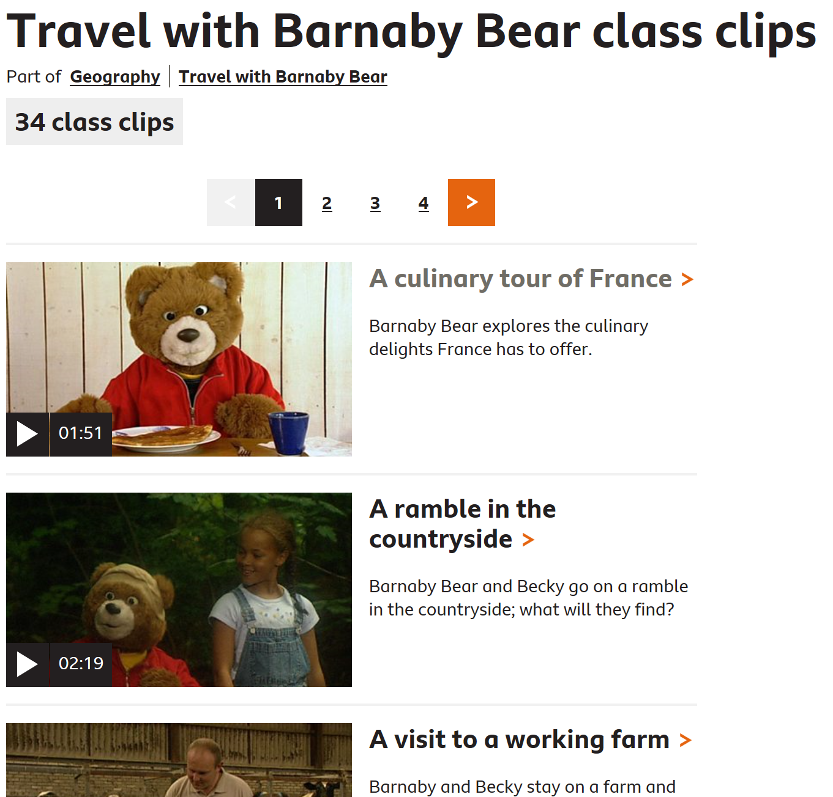

Choose Activities
- Cut out/draw things you would need to take with you for a holiday.
- Make a list of things you like to do in holiday time.
- Pack a suitcase for a bear to go on holiday.
- Play going on holiday or being on holiday somewhere in your house or in your garden.

REVEAL: Pentecost: a holy day, the feast of the Holy Spirit
- Share and read the bible story together
The word holiday comes from holyday. Some days of the year are ‘holy days’, these are special days in the Church’s year.
What is the Holy Spirit? The Holy Spirit is Jesus’ friend who is always with us to help and guide us. We can’t see the Holy Spirit, but we can explain the power of the Spirit with wind, air and fire images.

Pentecost Day (based on Acts 2:1-4)
In the second part of Luke’s story, the book of the Acts of the Apostles, we hear the story of Pentecost.
After Jesus had gone back to his Father, his friends stayed together with Mary, Jesus’ Mother.
Peter was there and James and John and all the others.
They missed Jesus very much.
They felt weary and lost.
They couldn’t get up and get on with their lives.
They didn’t know what to do.
They talked about their time with Jesus,
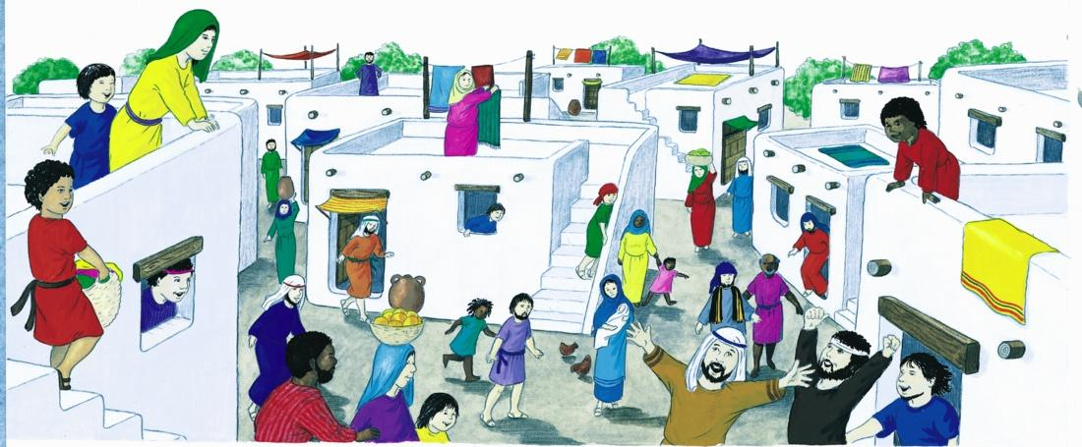
and wondered about his promise, ‘I will not leave you alone’.
Then on Pentecost day everything changed.
It was as if they had been made new, re-created.
They were different people.
They were filled with life, joy, peace and happiness.
They knew that Jesus had kept his promise to send the Holy Spirit, who would be with them always.
They wanted to share this happiness
and they got up straight away to go out to tell everyone.

Pentecost Day

Choose Activities
- Write in the bubbles what people are thinking and saying.
- Make decorations to celebrate Pentecost, the birthday of the Church e.g. paper chains, streamers, doves, flames, flags etc.
- In our churches we celebrate Pentecost, it is called the birthday of the church. Talk about how you might celebrate Pentecost at home. You may like to have a Pentecost party or play and pretend to have a Pentecost party.
- Make a birthday card for the Church.
RELIGIOUS EDUCATION – YEAR 2 – PENTECOST

EXPLORE: Passing on messages
The missing cat
‘Snowy, Snowy!’ called Lucy. “Mummy, I can’t find Snowy anywhere. She’s been out all night.” When Lucy came home from school, she asked, “Has Snowy come back?” “No, she hasn’t,” said Mum. “I’m beginning to get worried about her, cats often go off, but not for so long. What do you think we should do?” “Can we put a notice in the corner shop and tell the police?” suggested Lucy.
“Good idea,” said Mummy. “Ask Daddy to help you write out the notice and to phone the police.” Lucy and Daddy phoned the police and wrote out a description of Snowy for the shop notice board.
Next day, Lucy asked the other children at school if they had seen Snowy. The children took the message home and asked their parents about Snowy. Two days later, Lucy was having her breakfast and feeling sad because she missed Snowy so much, when she heard the hinge of the cat flap creak. She ran to the back door and there was a bedraggled Snowy, she didn’t look much like snow, she was so muddy. She made her way to her food bowl.
‘Where have you been, Snowy?” asked Lucy as she cuddled her. Snowy replied with a weak meow. “How lovely to have Snowy back!” said Mummy, “We’d better send a message to everyone to tell them to stop looking because Snowy has come home.”
Read and share together: The missing cat.

Choose Activities

- Answer these questions together or on your own
How did Lucy’s family pass on the message that Snowy was missing?
Who did they tell?
What else could they have done?
Why was it important to pass on the message that Snowy had returned?
- Imagine if Snowy was your cat and she had gone missing! Make a poster to say what she looked like so that people could find her.
- We are staying at home with our families to stay safe. How are we talking and sending messages to our friends and families?
Can you list all the ways we are sending messages?
What is your favourite way of passing on messages from home?
Why not message someone to tell them the story of Snowy the cat. You might like to read it to them. And don’t forget to give them a very special message from you too.

REVEAL: Spreading the message through the gift of the Holy Spirit at Pentecost
Jesus died on Good Friday and he rose again on Easter Sunday. Jesus’ friends were happy that Jesus was alive again, but Jesus told them he was going back to his Father in heaven. They felt sad about this, but Jesus told them he was going to send them a friend called, the Holy Spirit.
Jesus said, “The Holy Spirit will lead you and guide you. The Holy Spirit will help you to remember and understand all the things I have done and said to you. The Holy Spirit will teach you everything and help you to know how to live good lives.”

The Good News is that the Holy Spirit helps us share God’s love by the way we live our lives.
St. Paul wrote this bible reading to Christians living in Rome. We don’t always find it easy to be good or to do the right thing but, we can also ask the Holy Spirit to help us, so we can pass on the Good News by our kindness and goodness. We can think of people who are good and kind who show us the Good News of God’s love.
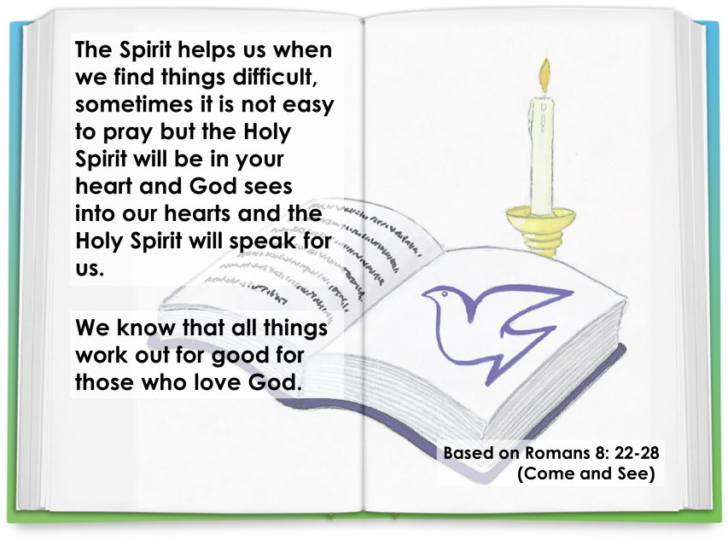

Choose Activities
- Talk together about how you think the Holy Spirit helping you? It may be helping you to be kind and helpful at home. You might be doing jobs around the home. You might be making posters of rainbows or helping neighbours with shopping.
- Make a list of all the things the Holy Spirit is helping you to do. You might want to take photographs and share them with your school or family.
- Talk together and share ideas about …If we all lived our lives by passing on Good News, being kind and good, what would the world be like? Can you make a drawing, collage or poster showing what this would look like?
- Say the following prayer to the Holy Spirit. You might want to pray this at home with your family or when you go to bed at night. You might want to share it with your family when you contact them. You could write out the prayer and decorate it.
Come Holy Spirit,
fill us with your joy,
fill us with your love,
fill us with your peace.
Help us to spread the Good News of God’s love to everyone.
Amen.
RELIGIOUS EDUCATION – YEAR 3 – PENTECOST

EXPLORE: The energy of fire and wind

Choose Activities
- Talk together about fire and wind.
- Fire - Explore the danger of fire and the safety measures we must take. Think of all the things that you can use fire for: starting a car, cooking, light, warmth, making things, metal work, glass, firing pottery, for purifying etc. Talk about the qualities of fire – it warms, melts, cooks, burns, change liquids and solid substances. Fire gives us light.
- Wind – if you have balloons use them to show wind power. Blow up the balloon and put the balloons down on the floor. What happens? How could you make them stay on the spot? Can you always control the balloon? Why not? Will it go where you want it to? What makes it move?
- Now for the fun part! Letting the air out of the balloon. Slowly at first and then quickly. Did you see anything happen? Did you hear anything? What made the noise? What made the movement?
- Think about wind and how we can use it in everyday life: drying things, windmills, wind farms and its use in nature: blowing away old leaves, distributing seeds etc.
- Show some BBC learning zone clips on wind power and fire e.g. making pottery. Notice how both wind and fire engage the senses: seeing, touching, hearing and smelling. Talk about how they do this.
- Make streamers, a kite, large pinwheel to blow in the wind.
- Make a flame collage, picture, building a model of a fire.

Read together and share:
- You Tube Non-Fiction -
Read aloud of Wind by Eric Edison- Story time with Ms. Caruso

REVEAL: The wonder and power of the Holy Spirit.

Jesus gave us the Holy Spirit when he went back to his Father in heaven. The Holy Spirit showered gifts upon the friends of Jesus, gifts which were different kinds of energy, gifts which gave them strength. They needed strength to go out and tell everyone about Jesus and share the Good News he gave us. The Holy Spirit has given special gifts to us all.

The gifts of the Holy Spirit help us in everyday life. There are seven gifts, which help people to lead good lives and make use of the gifts they have. These gifts should be used to help others.
Wisdom – be sensible and thoughtful.
Understanding – be loving to one another and take time to see what is happening.
Counsel – using wisdom and understanding to come to a good choice about something.
Fortitude – be brave and stand up for what you believe to be right and holy.
Knowledge – making right choices and good understanding. It takes practice to have true knowledge.
Piety – be respectful to God, for one another and for yourself.
Fear of the Lord - the awe and wonder of God. Be amazed by the love and goodness of God.
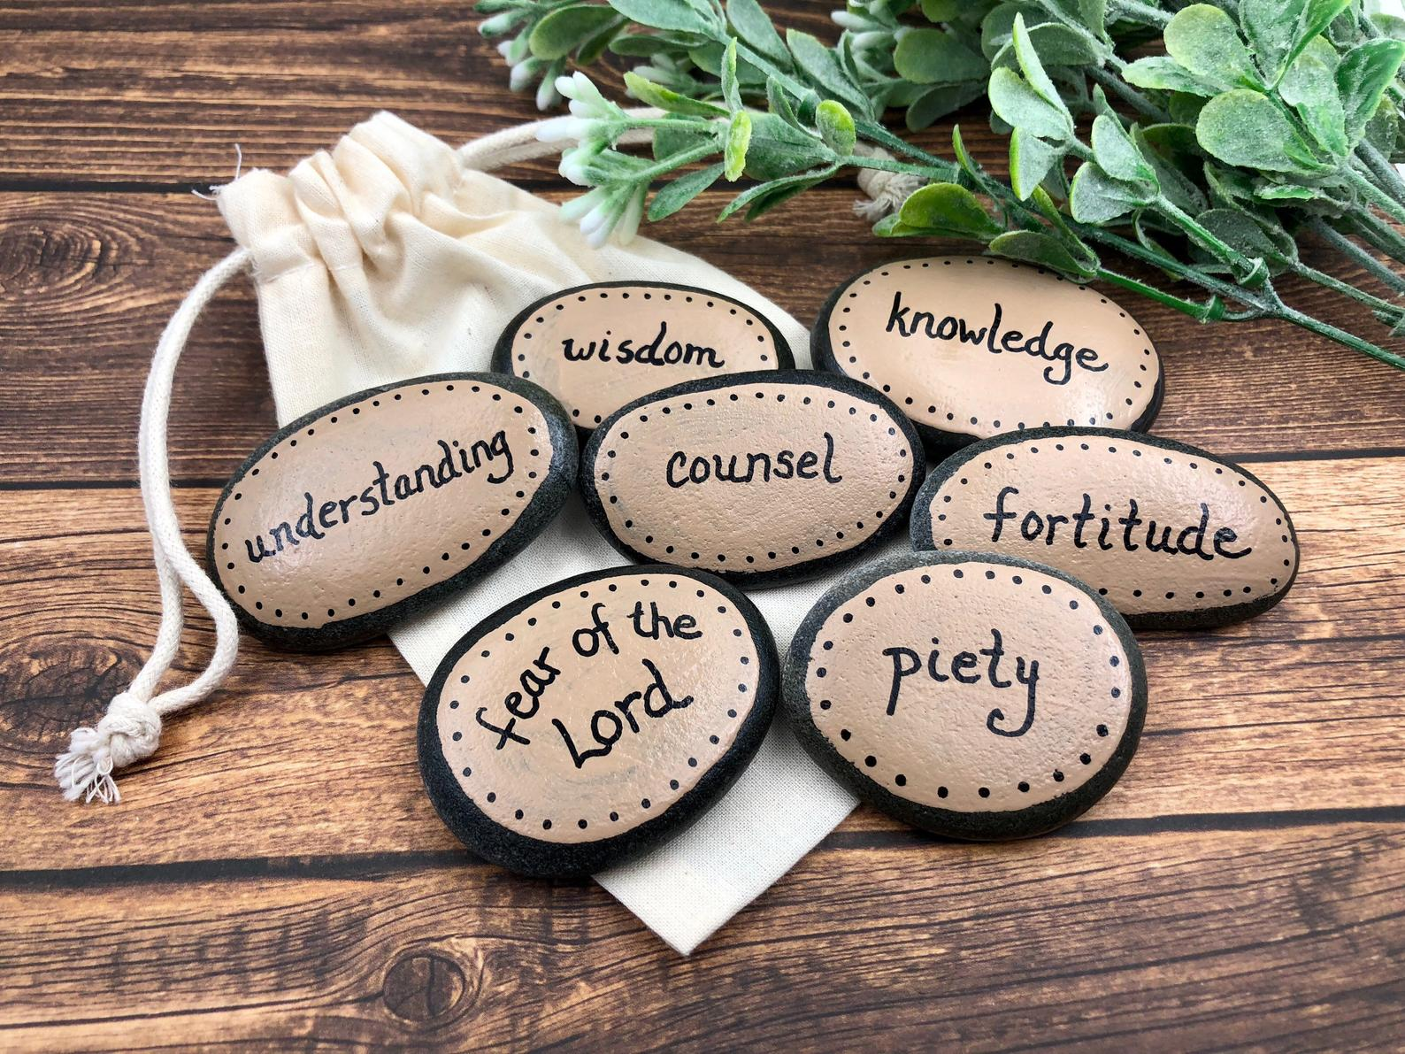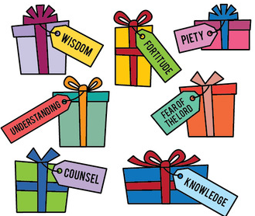
Some of the words are difficult to understand. Just think about one at a time. They all link together.

Choose Activities
- Talk together about which of the gifts of the Holy Spirit do you think is the most important to you? Why?
- How do the gifts of the Holy Spirit help us to help others?
- Where have you seen people using the gifts of the Holy Spirit? - at home, school and in the local community? There will be so many examples of these gifts as we are seeing lots of people helping those who are poorly, lonely, need shopping etc.
- Make a poster, collage, drawing or painting of the amazing ways the gifts of the Holy Spirit are being used around in our country and around the world.
- Decorate pebbles from your garden or cut out paper gift boxes to write the gifts of the Holy Spirit.
- Write a letter or email to say thank you to someone who is using their gifts of the Holy Spirit to help others.

RELIGIOUS EDUCATION – YEAR 4 – PENTECOST

Read together and share Cameron’s birthday present
EXPLORE: Good news brings life
Mum said that he was a bit late, but Cameron just muttered something, and went to his room. His Mum shouted up that if he got on and did his homework now, he would have time to play with his monster after tea. That made Cameron feel even worse. His Dad thought Cameron looked sick and thought he had better go to bed rather than play with his monster car. Cameron agreed. Next morning, he was still feeling rotten. He knew his parents had saved for his present and his Dad was as excited as Cameron with it. He knew he had been silly– not to mention disobedient. All day in school, he was quiet. His friends were sympathetic, but he felt lifeless.
Another day went on like that. He heard his Mum and Dad talking about him, wondering what was wrong with him. He looked unwell and he didn’t even want to play with his monster car. They wondered if they should take him to the doctor. His elder sister, Danielle, came into to his bedroom and asked him what was wrong. She asked him where his monster car was. At first, he said nothing was wrong, but his sister had a kind way of talking to him, and eventually he told her his sad story and how awful he had felt about it, especially because his parents had been so generous and he had let them down.

Cameron’s birthday present
Cameron had just had a birthday. His parents had given him what he really wanted, a remote-control stunt monster car. He was really thrilled and had spent the weekend learning how to use it and doing lots of stunt manoeuvres. He took it to bed with him and looked at it sitting on his windowsill, sparkling in the light from the street.
Monday morning arrived and his Mum reminded him that he had to leave his stunt monster car at home and not take it to school. Cameron nodded, hoping his Mum would not notice the large shape in his school bag. When he got to school, he told all his friends about his present. He knew he could not show them in school, so suggested that they walk home through the park so he could demonstrate his monster car manoeuvres. The other boys watched as Cameron made his stunt monster do incredible things and go really fast. Someone was watching this, an older boy called Gary. Slowly he got nearer, and no one noticed him until he ran over snatched the monster and ran off with it. Cameron felt sick. What could he do? It was no good running after Gary. He would never catch him. He and his friends all went off to their homes.

Next evening, after another miserable day, when he got home, he went straight up to his room and there to his surprise was his monster car sitting on his bed. He picked it up and hugged it. Tears of joy ran down his cheeks. He quickly brushed them away. He felt like a new person. He called his sister to tell her and ask her what had happened. Danielle smiled, and told him she knew Gary’s Mum and had been round to his house. Gary’s Mum gave her the monster car and told her she wondered where Gary had got it from and that it was useless to him as he didn’t have the radio to make it work. Gary was going to be in trouble when he got home.
Cameron was jumping up and down. He was so excited that his Mum came up to see what was wrong. She said she was glad to see him looking happy and alive again. He told her the story and said he was very sorry. She said she thought he was fortunate to have such a good sister and he had learnt an important lesson.

Choose Activities

- Talk about your thoughts about Cameron. Can you answer the following questions?
Why was Cameron upset about how his parents would feel?
How was Cameron rescued and how did it make him feel?
What lesson do you think he learnt?
What do you think happened in school next day?
How does good news change the way you feel and how you act?
- Collect some good news from your family, newspapers, from the television and write a front page of your own Good News newspaper. Write how and why it was good news and how it made them feel.
- Write your own story about either yourself or someone being sad and miserable and some good news that brought them happiness and made them feel alive.

REVEAL: The new life of the Easter message is spread through the power of the Holy Spirit

Share and read together the bible reading from Acts 4: 1-26, We cannot keep silent. The apostles are witnesses to Jesus being raised to new life by God. The Holy Spirit confirmed their faith in Jesus and gave them the courage they needed to speak out about the Good News of Jesus even when they were threatened.

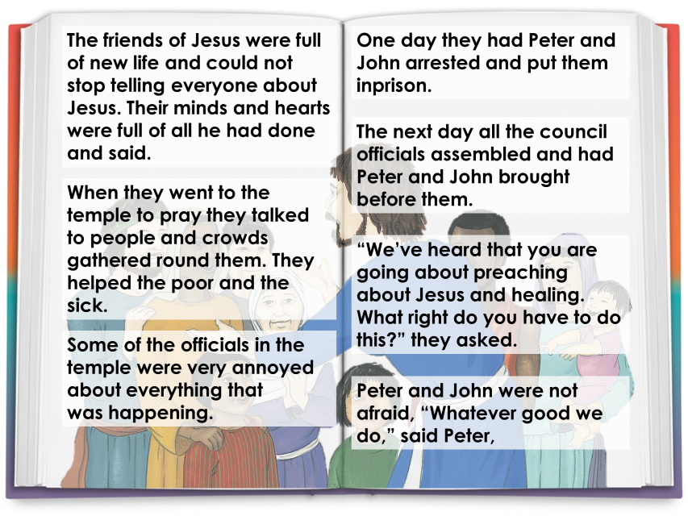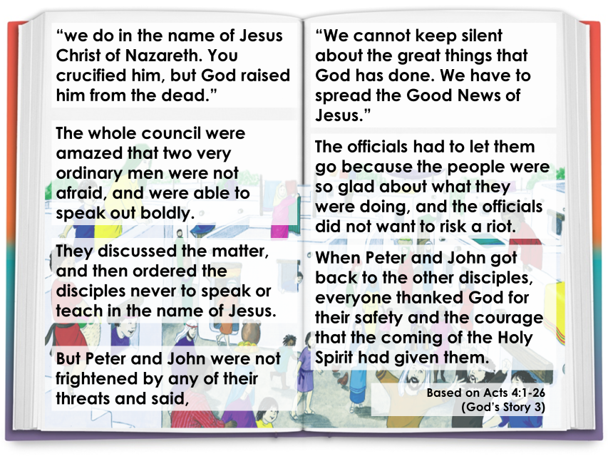
- Imagine you were a friend of Jesus who went out to tell everyone about his life and how he loved everyone. Write a speech you would give to people who have never met him or heard of him. What would you tell them about Jesus? Can you remember some of the things he did in his life to help and be kind to others? How did he show love to everyone? Think of the bible stories you have heard at school.

RELIGIOUS EDUCATION – YEAR 5 – PENTECOST
Choose Activities
- Can you answer these questions?
Why were the friends of Jesus full of new life?
Why do you think the officials were annoyed?
What happened to Peter and John?
How do you think Peter and John felt when they were arrested?
What did they say to the council?
How did Peter and John show their courage to the officials?
What would you have done? Why?

EXPLORE: Transforming energy

Fire is a traditional means of transformation into energy, producing heat and light. It can be used for cooking, melting, warming and burning liquids and solid substances. Solar panels can transform light from the fire of the sun into energy, to light and heat a house and to power batteries.

Wind can be transformed into energy; this has happened for hundreds of years. It was used to grind corn in windmills. How it works is that the sun heats our atmosphere unevenly, so some patches become warmer than others. These warm patches of air rise; other air blows in to replace them and that creates wind. The energy of the wind can be used in wind farms by building a tall tower, with a large propeller on the top. The wind blows the propeller round, which turns a generator to produce electricity.

Water can also be transformed into energy. Watermills used waterpower to grind corn into flour. Wind can transform waves at sea making them higher and these can be used to create energy. Water can be used to make hydroelectricity from rivers and streams in England and Wales and on a large scale in the Highlands of Scotland.

Sun All of the sources of energy above are dependent upon the transforming energy of the sun. Fire ultimately comes from the sun. The coal or wood used to produce fire has first of all been grown through the heat of the sun. The energy of sun, wind and water can be transformed and used as sources of renewable, clean and earth friendly energy. As humans we too have energy that can be transformed to good through using our minds, our time and our energy for the well-being of others.

Read together and share about energy.

Choose Activities
- Can you answer these questions?
What do you think would happen if there were no energy in the world?
Which source of energy do you think is best for world, why?
How can we as individuals save energy?
How can people use the energy of their minds for the good of others and why?
How can people use their own energy for the well-being of others and why should they?
Another word for transform is ‘change’. How can we use our energy to transform ourselves?
- What is renewable energy? Use CAFOD’s Kid Zone pages to find out how energy is being used across the world
- Can you make your own symbols for fire, wind, water and sun?

REVEAL: The fruits of the Holy Spirit

In Year 4 we learnt about the Gifts of the Holy Spirit. The first friends of Jesus used their new energy given through the Holy Spirit to spread the Good News of God’s love for everyone. The energy and transformation the Spirit makes are called the ‘Fruits of the Spirit’, because it is what grows in your heart through the power of the Holy Spirit.
- Share the bible reading together

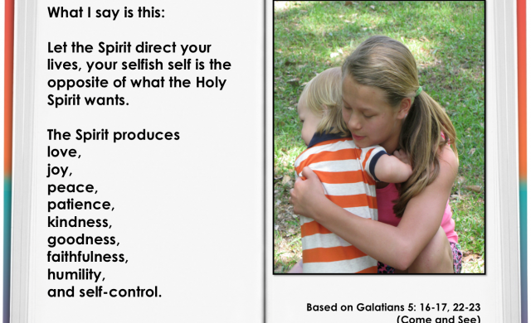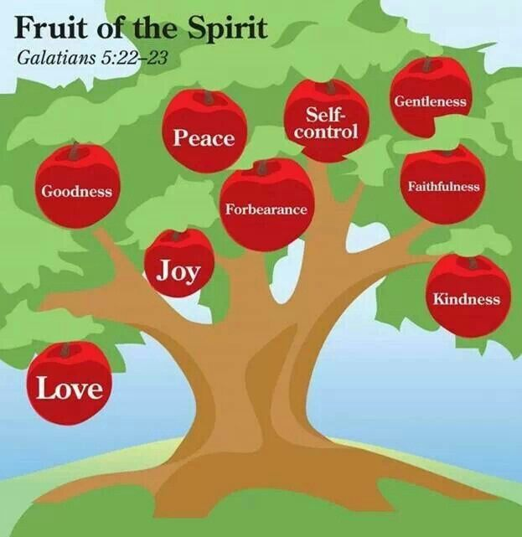

Choose Activities

- Describe which ‘Fruit of the Spirit’ you are and why? Explain how it transforms and gives you energy to use it to change and transform your world at home, in class and in school.
- Can you make a poster, drawing, collage of the fruits of the Spirit? Can you find out what each fruit means and how we can use them to help others.
- Can you collect news stories from your own area or on the news about how people are using the fruits of the Holy Spirit? For example,
My neighbour is using kindness to collect food for their family who cannot leave their house.

RELIGIOUS EDUCATION – YEAR 6 – PENTECOST

Read together and share: What should Connor say?
EXPLORE: The courage to be a witness

What should Connor say?
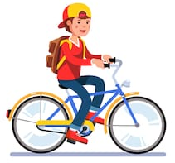
Connor was cycling home from school when he saw his elder sister, Kylie, with a group of young people. He knew some of them; they were tough and didn’t care what anyone said to them. They were from the local secondary school, where Connor would be going in September. Connor got off his bike and hid behind a parked car where no one could see him. He was fond of Kylie, even though she was always telling him he was stupid. He knew it was only teasing.

As he watched, he wondered why he had stopped. Was it curiosity? Was he spying or was he really concerned about Kylie? He wasn’t sure. Kylie was laughing. One of the girls offered her a cigarette which she took. Connor knew his parents would be cross if they found out. Kylie was only fourteen. He could see Kylie shaking her head and beginning to walk away, then another one of the group, a boy, held her arm and started arguing with her. Another girl pushed her, while another got hold of her bag. Kylie grabbed it back and started to run. The group let her go but shouted after her; “You’d better have the money tomorrow!”

Connor didn’t know what to do. There were too many in the group for him to tackle. Kylie was walking home now. Connor got home first. His Mother asked him if he had seen Kylie on the way. Before he could answer Kylie arrived home.

Choose Activities
- Together talk about different endings. Choose one of your endings to continue writing the story including feelings and beliefs which might affect the behaviour of the characters. Can you now add another paragraph that shows how you would have been if this was you? Is there anything you may have done differently? If so, why?
- Talk about the times you might have been in a situation when you witnessed something happen which was unusual, strange or even wrong and you knew you needed to tell someone. You were unsure for a number of reasons. Maybe you thought people would laugh at you, not believe you, or you might get into trouble. Write about a situation where you have needed courage to witness? What happened?

REVEAL: We are a witness to the Easter message
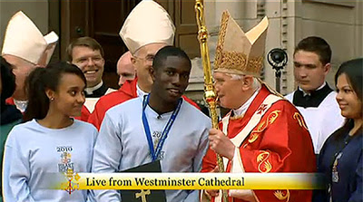
In 2010 Pope Benedict XVI made a special visit to our country. Whist he was here he met with lots of young people. Paschal Uche, read out a letter on behalf of all of the young people there. You can see his speech on You Tube.
Dear Holy Father, It is a privilege and a great pleasure to welcome you on behalf of young Catholics from England, Wales and Scotland. Your visit brings us together – it is like a family reunion – and we are very pleased to see you. My name is Paschal Uche and I am from St Francis’ Parish in East London. Gathered here today are two and a half thousand young people representing almost every parish in the country. Like many here I have been actively involved in the Church serving the elderly in Lourdes and going on retreat. I know that others help in Confirmation sessions, parish music groups, youth groups, and projects serving those who are disadvantaged. We are a truly living Church that offers great opportunities for young people to encounter the love of Christ and share it. Pope John Paul II said that our faith is a “noble and authentic adventure” and we really want other young people to experience this. It is our prayer that your visit inspires us to be “saints of the third millennium.” Holy Father we would like to ask you to bless for us a candle stand, which we hope will be a symbol for Catholic Youth Ministry. It has been thoughtfully designed for use in prayer, teaching and meditation. For many of us before today you were a face on the television or a picture in a Church but today we behold you face to face and on behalf of the Catholic youth of this great nation I would like to express my profound and heartfelt gratitude for your visit. May God Bless you.
- Whilst we are all at home keeping safe with our families there are lots of people who are witnesses to the Catholic faith. This means they are living just as Jesus taught us to do. Talk together about any witnesses you might know who are helping others at this time of lockdown. e.g. family member, parishioner, celebrity? Write a report on their work and what makes them a modern witness. How are their actions shaping lives? You will find lots of information from the television, online and news reports.
- How are you being a witness to the Catholic faith? How are you living as Jesus taught us? List some of the things you are doing at home to be like Paschal and help others. Write your own letter to your teachers in school to tell them how you are a witness of Jesus’ love.

Choose Activities
- Can you answer these questions?
What impressed you most in what Paschal Uche said?
Why do you think he was chosen to speak?
How do you think he felt speaking in Westminster Cathedral?
Do you think Paschal is a witness? What does he do to be a witness?

