**St Oswald’s Catholic Primary School**

**Love Jesus**

**Love Learning**

**Love Each Other**

**“We are a learning community promoting the Gospel values of mutual trust, care and respect”**

**RE Policy 2025-26**

**“We are a learning community promoting the Gospel values of mutual, trust, care and respect”**

As a school we ensure that all children and staff are treated fairly and equally. All children have equal rights to access all areas of the curriculum, regardless of race, gender and disability. Within this subject area, the SLT and all staff endeavour to provide the appropriate provision for this to occur. This policy follows guidelines and practices that are stated and outlined in St. Oswald’s Equality Scheme.

**At St Oswald’s, Religious Education is at the core of our core curriculum. It is delivered within our broad and balanced curriculum.**

Religious Education Intent: aims and objectives

Following guidance from the Archdiocese of Liverpool, the overall objective of our Religious Education curriculum is to equip our children with the knowledge, understanding and skills to live a catholic life by knowing and sharing in the love of Jesus and knowing that our mission ‘Love Jesus, Love Learning, Love Each Other’ underpins everything we do. We aim to develop our children’s faith commitment and spirituality, appropriate to their age and capacity, ensuring that they are religiously literate young people

In the life of faith of our Catholic School, religious education plays a central and vital part.  It is a rigorous academic discipline and as such is taught, developed and resourced with the same commitment as any other subject. The beliefs and values studied in Catholic Religious Education inspire and draw together every aspect of the life of our Catholic School.

We are committed to Catholic RE because all pupils have the right to receive an overall religious education. RE is for all and is a collaborative activity, which respects and promotes the child’s innate capacity for wonder, awe, reverence and imagination.

At St Oswald’s we intend to educate the whole person. At the heart of the school is a sense of purpose, which is to create a community that shares the values of love, respect, truth and reconciliation as shown through the example of Christ.

St Oswald’s Religious Education programme will: -

• Develop knowledge and understanding of God and Jesus and the central belief which Catholics hold

• Develop awareness and appreciation of Catholic beliefs and an understanding of its impact on personal and social behaviour.

• Encourage study, investigation and a rich language of religious experience- activities, stories, symbols, rituals, people and objects.

• Provide opportunity for celebration, prayer and reflection

• Develop appropriate skills and foster appropriate attitudes

• Include appropriate materials about other faiths

The Religious Education Programme

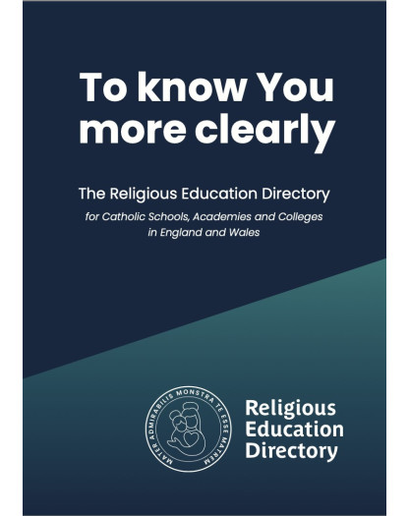To meet our aims and objectives we are working towards the full implementation of the model curriculum To Know You More Clearly – The Religious Education Directory. Currently we are using the in EYFS and Key Stage 1, whilst in Key Stage 2 we are continuing to use Come and See. As our Key Stage 2 classes are mixed age, we work on a 2 year cycle. Currently we are using both the RED model curriculum and *Come and See* as we move towards full implementation of the RED by September 2026.

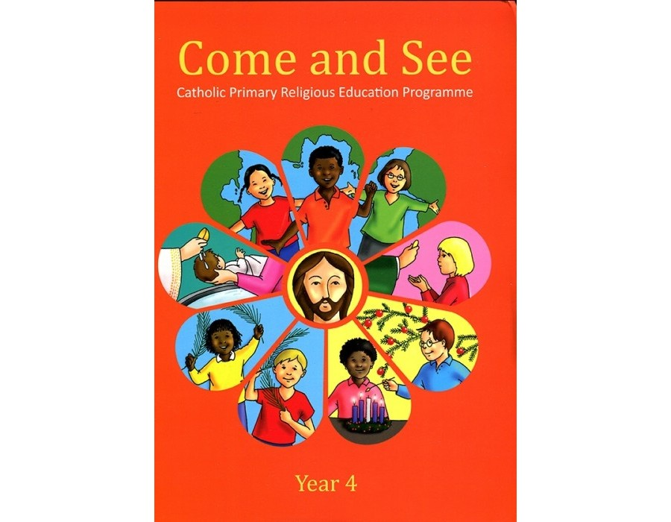

The Process In EYFS, KS1 and LKS2

To fulfil our aim and objectives we use the ‘To Know You More Clearly’ programme from the new Religious Education Directory prescribed by the Archdiocese of Liverpool. The aim of this programme is to draw pupils into a systematic study of the teachings of the Church. This is achieved through enabling all the children to explore the religious dimension of questions about life, dignity and purpose within the Catholic tradition. Links are made with universal experience, the pupils’ own experience and how this links to the Catholic Social Teaching Principles. Links are also made with experience of other faith traditions.

For all children the programme will raise questions and provide opportunities for reflecting on their own experience. It will help them explore the beliefs, values and way of life of the Catholic tradition and where appropriate, of other faith traditions.

***Overview of Content***

The programme of study for Religious Education in Catholic schools presented in ‘To Know You More Clearly’ has a framework with four structural elements:

**1. Knowledge Lenses**

**2. Ways of Knowing**

**3. Expected Outcomes**

**4. Curriculum Branches**

**Knowledge lenses** set out the object of study for pupils; they indicate what should be known by the end of each age-phase. They are referred to as lenses, since they are the areas that we are looking at and they divide the content of the programme of study into four systematic subsections for the study of Catholicism and two additional lenses for the study of religious and worldviews.

**The study of Catholic religion lenses are:**

|  |  |  |  |
| --- | --- | --- | --- |
| **Hear** | **Believe** | **Celebrate** | **Live** |
| **The study of other religious and worldview lenses are:** | | **Dialogue** | **Encounter** |

Ways of knowing set out the skills that pupils should be developing as they progress through their curriculum journey. Whenever we know something, we always know it in more than one way: we remember it, we critically assimilate it and we put it into practice. All three are ways of coming to know the things that are the object of our study. The Ways of Knowing are an evolution of the age-related standards in Religious Education.

The three Ways of Knowing are:

Understand

head – see- what will I see and hear to help me understand? Discern

heart – judge – how will I discover more? Respond

hands – act – What can I do now?

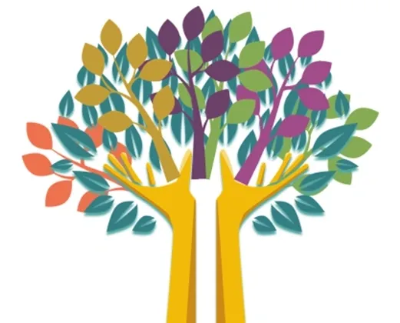

“Each branch has a core theme and invites pupils to learn about an aspect of Revelation, Scripture, life in Christ and life in the Church, and to discern what their learning means academically and experientially enabling them to judge, and act through a deeper knowledge of the Christian faith.”

To Know You More Clearly – RED 2023

|  |  |  |  |  |  |
| --- | --- | --- | --- | --- | --- |
| **Overview of content – EYFS and Key Stage 1** | | | | | |
| **Branches** | **EYFS** | | **Year 1** | **Year 2** | |
| Covenant and Creation | God created the world and said, ‘Indeed it is very good’ (Genesis 1:31). | The Creation story in Genesis 1:1-4, 24-26 as an ancient, prayerful, poetic reflection on God’s world | | | The story of Noah, focusing on God’s covenant (promise) with Noah and all living beings in the sign of the rainbow (Gen 9:7-17)  Psalm 139 in praise of God’s Creation of each of us and his love for us |
| Prophecy and Promise | Mary was going to have a baby. His name will be Jesus (Lk 1:26-31, 38).  Jesus was born in Bethlehem (Lk 2:4-7).  Shepherds hurried to see Mary and Joseph and baby Jesus (Lk 2:8-20)  The Annunciation (Lk 1:26-31, 38).  The Nativity (Lk 2: 4-7).  The Shepherds visit the manger (Lk 2:8-20) | The Annunciation (Lk 1: 26-38, focusing on 1:26-32, 38)  The Visitation (Lk 1:39-45)  The Birth of Jesus (Lk 2:4-8)  The Visit of the Shepherds (Lk 2:8-20) | | | The Annunciation of John the Baptist (Lk 1:5-20)  The Annunciation of Jesus (Lk 1:26-38)  The Visitation (Lk 1:39-50, 53)  The birth of John the Baptist (Lk 1:57-58)  Zechariah’s voice is restored  (The circumcision of John the Baptist) (Lk 1:59-66, 67,76)  The Birth of Jesus (Lk 2:1-8)  Including, for the season of Advent: Is 7:14, 9:1-2, 5-7  (Extracts from the book of Immanuel) |
| Galilee to Jerusalem | The Wise Men visit Jesus (Matt 2:1-12).  Jesus welcomes the little children (Mk 10:v16).  Jesus blesses the little children (story retold)  Feeding of 5000 (Jn 6:1-14) | The Presentation (Lk 2:22-38)  Finding in the temple and the hidden life (Lk 2:41-52)  Jesus announces his mission (Lk 4:16-22)  The call of the disciples (Lk 5:1-11)  Little children (Lk 18:15-17)  Zacchaeus (Lk 19:1-9 | | | The preaching of John the Baptist (Lk 3:2-6, 10-17)  Jesus is baptised (Lk 3:21-22)  The Temptation in the wilderness & Jesus begins to preach (Lk 4: 1-15)  Cure of a paralytic (Lk 5:17-26)  The choice of the twelve (Lk 6:12-16)  The calming of the storm (Lk 8:22-25)  Parable of the lost sheep (Lk 15:4-7)  For the Feast of the Epiphany  Matt 2:1-12: The visit of the Magi |
| Desert to Garden | A simplified version of key events of Holy Week especially Good Friday and Easter Sunday (to enable pupils to recognise key events).  The great commandment (Lk 10:25-28) | Jesus enters Jerusalem (Lk 19:28-38)  Jesus teaches in the temple (Lk 19:47-48)  The widow’s mite (Lk 21:1-6)  The last supper (Lk 22:7-23)  The Crucifixion and death of Jesus (Lk 23:33-46)  The angel’s message (Lk 24:1-8)  For Lent: Jesus is tempted in the desert for 40 days (Lk 4:1-13 | | | Jesus enters Jerusalem (Lk 19:28-38*)  The last supper (Lk 22:7-23*, 28-34)  The Crucifixion and death of Jesus (Lk 23:33-46*)  The angel’s message (Lk 24:1-8*)  Peter at the tomb (Lk 24:9-12) *Texts studied in Year One |
| To the ends of the Earth | Story of Pentecost (Simple Telling).  The early Christian community (Acts 2:42-47) | The road to Emmaus (Lk 24:13-35)  Promise of the Spirit and the Ascension (Acts 1:1-11)  Pentecost (Acts 2:1-4) | | | Jesus appears to the apostles and the Ascension (Lk 24:36-53)  Pentecost and Peter talks to the crowd (Acts 2:1-9, 12-13)  Conversion of Saul (Acts 9:1-19)  Fruits of the Holy Spirit (Gal 5:22-23) |
| Dialogue and Encounter | Friends of Jesus: Hear a simple life of St Peter and St Paul, friends of Jesus (linking to their feast day). | The road to Emmaus (Lk 24:13-35)  Promise of the Spirit and the Ascension (Acts 1:1-11)  Pentecost (Acts 2:1-4) | | | Jesus appears to the apostles and the Ascension (Lk 24:36-53)  Pentecost and Peter talks to the crowd (Acts 2:1-9, 12-13)  Conversion of Saul (Acts 9:1-19)  Fruits of the Holy Spirit (Gal 5:22-23) |

|  |  |  |
| --- | --- | --- |
| **Overview of content – Lower Key Stage 2** | | |
| **Branches** | **Year 3** | **Year 4** |
| Covenant and Creation | That in the first account of the Creation one day is ‘made holy’ (Gen 2:3).  The first account of the Creation,  Genesis 1:1-2:4.  Extracts from either Psalm 8 or 19 in praise of Creation. | The call of Abram (Gen 12:1-5)  The Abrahamic covenant (Gen 15:1-6)  Abraham and Sarah (Gen 18:1-15)  Abraham and Isaac (Gen 22:1-18)  (Optional)  The story of Joseph, focusing on the following key texts: Gen: 37:2-35, 41:1-42, 44:1-17, 33-34, 45:1-5, 16-20 |
| Prophecy and Promise | Messiah would be born of a virgin and would be called Immanuel (Is 7:14).  The Annunciation to Joseph (Matt 1:18-25).  Revisit Lk 1:26-38 | The miracle of the flour and the oil  (1 Kings 17:7-14)  Elijah’s encounter with God: the journey  1 Kings 19:4-8,  The meeting: 1 Kings 19:9-15  The preaching of John the Baptist (Matt 3:1-12 and Mk 1:1-8)  Isaiah 40:3 (contained within the gospel accounts)  The ancestry of Jesus (Matt 1:1-17) |
| Galilee to Jerusalem | Miracles, either: Cure of the centurion’s servant (Matthew 8:5-13) or  Cure of a paralytic (Matthew 9:1-8)  Parables, either: Parable of the Sower  (Matthew 13:4-9)  Parable of the Sower explained  (Matt 13:10-17) or Parable of the yeast (Matthew 13:33) or  Parable of the treasure and of the pearl  (Matthew 13:44-46)  For Epiphany: The visit of the Magi  (Matthew 2:1-12) | Peter’s mother-in-law and casting out devils (Matthew 8:14-17)  Cure of the woman with a haemorrhage.  The official’s daughter raised to life  (Matthew 9:18-26)  **Or**  Cure of two blind men and cure of a demoniac (Matthew 9:27-34)  The Baptist’s question (Matthew 11:1-15)  Jesus walks on the water and, with him, Peter (Matthew 14:22-33)  Peter’s profession of faith (Matthew 16:13-26) |
| Desert to Garden | The miracle of the loaves  (Matthew 14: 13-21).  The last supper (The institution of the Eucharist) (Matthew 26: 26-29) | The lost son (the prodigal) and the dutiful son (Lk 15:11-32)  The Judgement of the Nations (sheep and goats)  (Matthew 25:31-46)  The events of Holy Week from the gospel of Matthew Entry into Jerusalem  (Matthew 21:1-11),  Judas’ betrayal (Matthew 26:14),  The Passover and Peter’s denial foretold (Matthew 26:17-35)  Jesus prays (Matthew 26:36-46)  The betrayal and arrest of Jesus  (Matthew 26:47-56),  Peter’s denials (Matthew 26:69-75),  Pilate questions Jesus (Matthew 27:11-14),  The Crucifixion (Matthew 27:32-44),  The death of Jesus (Matthew 27:45-56) and the Burial of Jesus (Matthew 27:57-61) |
| To the ends of the Earth | Road to Emmaus (Lk 24:13-35)  The mission to the world (Matthew 28:16-20)  The group of apostles (Mary) (Acts 1:12-14)  Early Church (Acts 2:42-47)  Paul’s Letter to the Corinthians  (1 Cor 11:23-27) | The empty tomb (Jn 20:1-10)  The appearance on the shore of Tiberius  (Jn 21:1-19) |
| Dialogue and Encounter | Exodus 12:1-8,15-20, 13:3 •  Lk 22:14-23 | The road to Damascus (Acts 9:3-9, 17-19)  The first letter to the Corinthians  (1 Cor 13:1-7,13)  Teachers should choose additional texts about the mission of St Paul, for example:  Paul’s speech before the Council of the Areopagus (Acts 17:22-26, 28-29)  Galatians 1:11-24  2 Cor 11:22-23  Galatians 3:27-28 |

The Process In UKS 2

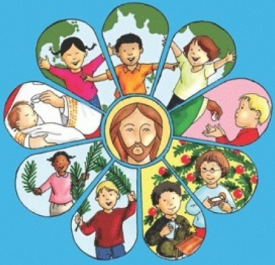Come and See has been developed through three key themes (Church, Sacrament and Christian Living), which are gradually explored, each time at greater depths.

The Church themes occur in each season time and each theme gradually builds on the understanding of the previous theme. To start the year, Come and See begins within the family because parents and carers are the first teachers of faith with regards to their children. After Christmas, children explore their local church and parish community. The year finishes with the story of the worldwide community; the universal Church because God is calling His people together throughout the world.

The Sacramental themes occur once in every season time and each theme gradually builds on the understanding of the previous theme. Following on from an understanding of belonging to a family, the theme of Baptism is introduced in KS1 to enable understanding of being initiated into the Church; while the theme of Confirmation is introduced in KS2, whereby the baptised are more perfectly bound to the Church. In Spring, after learning about the local Church, the Sacrament of Eucharist is explored as this is the Sacrament of Communion between Christ and Church. During Summer, the Sacrament of Reconciliation is focused upon, so that children have an opportunity to learn about the joy and challenge of relationships and God’s love and Mercy. At KS2, children learn about the Sacrament of the Anointing of the Sick which strengthens, forgives and unites the ailing person more closely to God.

The Christian Living themes occur in each season time and each theme gradually builds on the understanding of the previous theme. The Advent/Christmas theme considers the gifts of God’s love in Jesus. In Spring, Lent and Easter are explored as Jesus’ love for humankind knows no limit. In Summer, the study of the Ascension and Pentecost completes the Easter story and shows how the gift of the Holy Spirit strengthens the community and enables Christians to give witness to a life of joyful service.

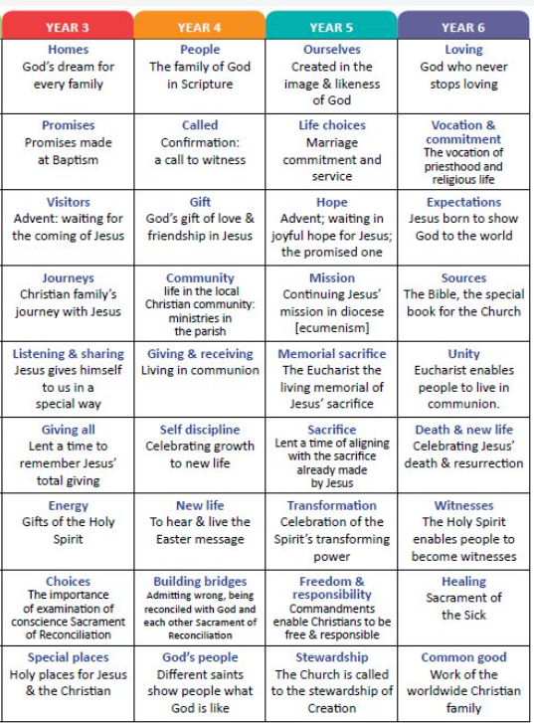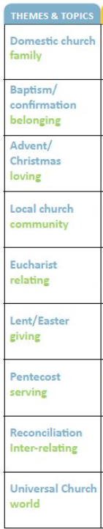

**Standard skills/driver words**

|  |  |
| --- | --- |
| The ‘skills’ words are a key aspect of the planning, delivery and assessment of Religious Education. The language of them must be clearly used. **Skills in RE** | |
| **Recognise** | **Talk about** |
| Labelling, naming, matching, sorting | |
| **Describe/Retell** | **Ask** |
| Retelling, sequencing, discussing, recalling, identifying | |
| **Give reasons** | **Make links** |
| Answer questions, describing, making links and connections, investigating, reflecting | |
| **Show understanding** | **Engage and respond** |
| Applying ideas, comparing, responding using examples, interpreting | |

|  |  |
| --- | --- |
| **Long Term Planning** | responsibility of the SLT. Each class has its own long term plan according to the programme of study for that particular year group.  Following RED and Come and See |
| **Medium Term Planning** | the content and focus of each theme  • links to the Catechism of the Catholic Church and Religious Education Curriculum Directory  • key concepts, skills and attitudes  • attainment targets  • Christian doctrine for the term  • The two/three themes and topics  • The start dates for each topic (each topic should be given equal time – each topic will take six/four weeks to complete)  EYFS and KS1 – Follow the planning provided by Liverpool Archdiocese Primary RE consultants |
| **Short Term Planning** | Short term planning is the responsibility of the class teacher. Planning is documented at the discretion of the teachers preferred template. Teachers should include the following in their planning:  • key words for the topic  • learning intentions for every lesson which includes a standard ‘skill’ word  • differentiation and activities |

Planning

Time allocation for RE

The Bishop’s requirement of 10 percent of curriculum teaching time is clearly indicated on the class timetables. This time does not include time for collective worships.

In Key Stage One and the Foundation Stage the time spent on RE each week is at least 2 hrs 30 mins.

In Key Stage Two the time spent on RE each week is at least 2 hr 30 mins.

UKS2 have longer sessions (up to 1hr at a time) due to the demand of the scripture and the need to look into things deeper.

Impact of Religious Education Assessment

Informal Assessment

* General observation of children engaged in general tasks and activities.
* Observation of contributions made to classroom displays.
* Review: end of task, activity, lesson, topic.
* Marking of more formal written work.
* At the start of every topic, classes complete a pre-learning mind map based on their new topic title and what the words mean to them. The is also an opportunity for children to recall previous units. At the end of the topic children review these by completing a post-learning mind-map as a whole class to show their new learning from the topic.
* Children underline the driver words in learning intentions.

Formal Assessment

* One topic each term is for formal assessment.
* Six children are identified from each year group usually 2 LA, 2 AA and 2 MA children. They become known as ‘benchmark children’. Their RE assessment tasks are tracked right from Reception through to Y6.

Self-Assessment

* Teachers communicate Learning Challenges to pupils in each lesson and these are broken down into success criteria.

Reporting and Recording

Recording provides evidence of achievement. It involves pupils in self-assessment and progress in dialogue with the teacher. It takes many forms:

• Notes from observations.

• Marking symbols in pupil’s books.

• Visual evidence- for example photographs. Voice notes, videos

• Year Group Assessment and Evidence Files.

There are four dimensions to reporting in Religious Education:

* Provides feedback to pupils on their achievement and progress.
* Informs teachers and colleagues of the achievement of individual pupils and the areas studied by a class and year group.
* Informs parents of the progress and achievement of their child.
* Informs parents, governors, parish and external agencies of the content and quality of Religious Education being provided and the achievements of the pupils.

At St Oswald’s parents are given the opportunity on three occasions during the school year to meet with their child’s class teacher to receive verbal reports on the progress of their child. Parents also receive a written interim report twice a year and an individual RE end of year report.

Monitoring, Evaluating and Reviewing

Aims and Purposes of Monitoring, Evaluation and Review

* To identify strengths and weaknesses in order to help us improve the quality of teaching and learning in our school for the benefit of our pupils.
* To make informed decisions from the basis of secure evidence and use this to develop corporate priorities.
* To raise expectations and standards across all areas.
* To assist in target setting.
* To celebrate achievement and successes and provide evidence to support judgements.
* To support staff development.
* To ensure that all staff have a clear picture of standards and areas for development within their own classes, teams, whole school and curriculum areas.

Key Principles

* Monitoring standards is central to maintaining and improving, it is at the heart of school planning as it leads to evaluation and review, which identifies the starting point for development.
* Monitoring leads to action.
* Monitoring provides a means of obtaining an accurate picture of various aspects of school life and practices that involve the staff and children.
* Confidentiality must be respected at all times.
* It must involve head teacher, staff and governors as appropriate.
* The system must be manageable in terms of time and information and have an agreed focus.

Sacramental Preparation

**We believe that it is essential that Home, School and Parish work very closely together in preparing each pupil for the Sacraments.**

St Oswald’s Catholic Primary School fully supports the parish in their preparation of the children for the Sacraments of Confirmation, Eucharist and Reconciliation. Parents are invited to attend an initial meeting during which the process of preparation and the commitment is outlined. Input from the parish priest, school and catechists is given. Our school RE Leader is part of the Sacramental Preparation team along with Deacon Paul Blinston (our school RE governor and parish deacon)

We follow the ‘With You Always’ Programme. This is a resource for parents and their children who are in Year 4. The resource encourages parents/carers and children to meet together with catechists, supported by the school to learn about the sacraments using the family catechesis method. Parents are the first and best teachers of their children in the ways of faith, as is made clear when the child is baptised.

Inclusion

As a school we ensure that all children and staff are treated fairly and equally. All children have equal rights to access all areas of the curriculum, regardless of race, gender and disability. Within this subject area, the SMT and all staff endeavour to provide the appropriate provision for this to occur. This policy follows the guidelines and practices that are stated and outlined in St. Oswald’s Equality Scheme.

Monitoring and Review

We are aware of the need to monitor the school’s Religious Education policy, and to review it regularly, so that we can take account of new initiatives and research, changes in the curriculum, developments in technology or changes to the physical environment of the school. We will therefore review this policy every year, or earlier if necessary. This policy was last updated in September 2024.

|  |  |
| --- | --- |
| **DISCUSSED AND AGREED BY RELEVANT STAFF** | **Sept 2024** |
| **DISCUSSED AND AGREED BY GOVERNING BODY** | **Sept 20234** |
| **MONITORING AND EVALUATION** | **Ongoing** |
| **REVIEW DATE(S)** | **Reviewed 13.12.19**  **Reviewed 21.09.20**  **Reviewed 14.09.21**  **Reviewed 12.09.22**  **Reviewed 15.09.23**  **Due to be reviewed September 2026** |

