ROBINS’ WEEKLY SUGGESTED HOME LEARNING – WB 1.6.20
Hello Robins, we hope that you are all safe and well. We hope that you have enjoyed finding out about Florence Nightingale.
Our focus this week is Plants and Growing Missing you all. Stay Safe!
Mrs Fox, Mrs Davies and Miss Lea xxx
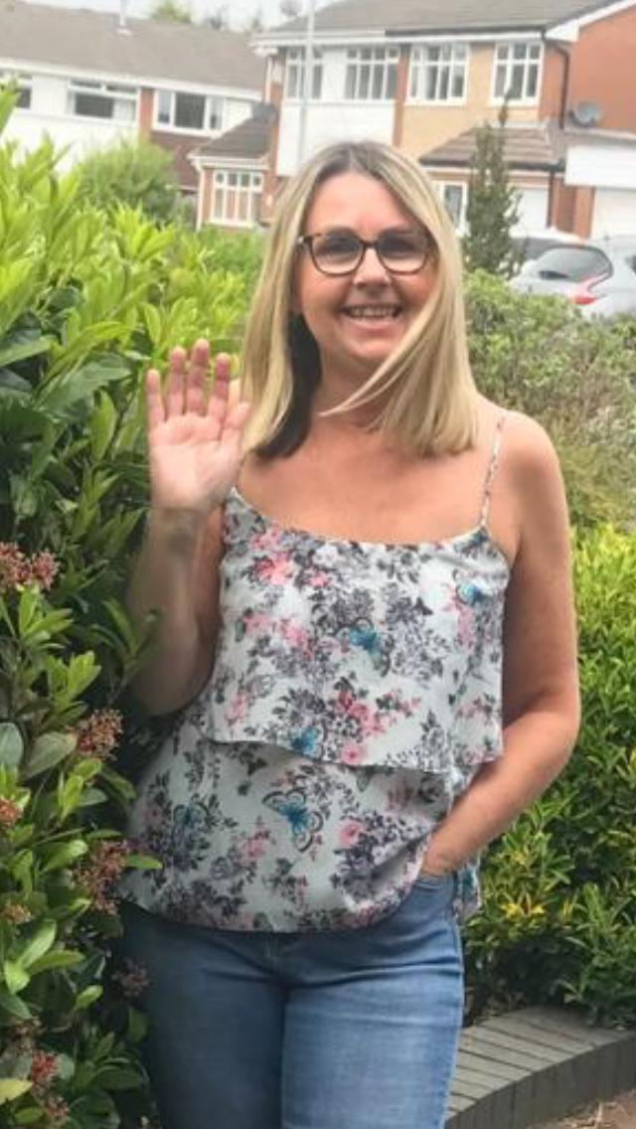
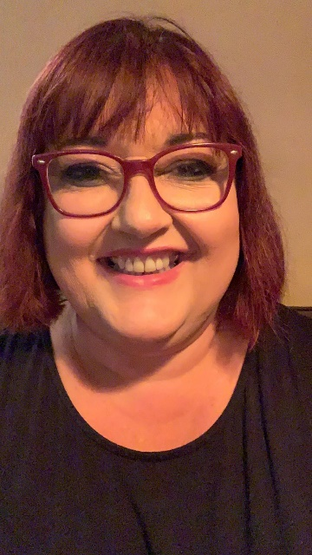
We’d love to see your work, so please Tweet @saintoswalds or send an email to enquiries@saintoswalds.wigan.sch.uk FAO Miss Lea.
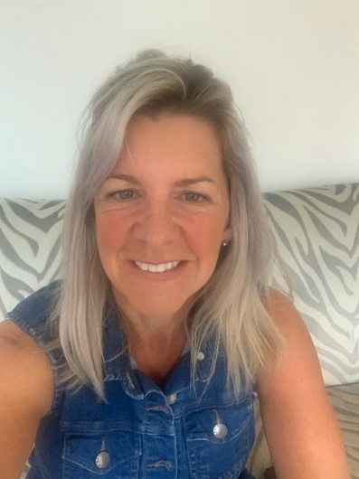
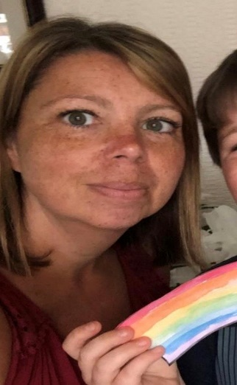

English | Maths
Reading – Read every day for pleasure for 15 minutes.  What has been your favourite book this week?  Please read/listen to the story ‘How to Grow a Dinosaur’ – the YouTube link will take you to the story.  https://www.youtube.com/watch?v=AtP9Ja9xMgQ  Writing –  Write a book review for the story ‘How to Grow a Dinosaur.’  Writing frame for a book review can be found online.  Our school has been asked to write Haiku poems about ‘Summer 2020’ by Discovery Espresso. The poems will be used as part of Espresso’s Newsbite films which will coincide with National Writing Day on 24th June. We would like you to prepare a Haiku poem (explanation and examples below) all about ‘Summer 2020.’  We would like our News Bites item to feature several children reading their poems directly to camera, and to include shots of the poems written on the page as well, so we will need parents to film the children, using iPhones (or similar!), holding the phone landscape not portrait. The children will need to be head and shoulders in shot like a news reporter and the poem on the page should be filmed separately (also landscape)  If you are interested in sending your child’s Haiku poem please complete the consent form below and email your video to our school email.  Reading comprehensions  Dinosaur reading comprehension - Hide and See – attached below  Dinosaur fact cards – read and match the facts to the dinosaur  Super Seeds  Year 1 - phonics – see below – alternative oa spelling  Oa phoneme spotter and sentence challenges  Year 2 – spelling – ‘tion at the end of words | Basic Skills:  Year 1 - Count forwards and backwards in 1’s, 2’s, 5’s, and 10s to and from 100  White Rose Videos – comparing length, height, mass  Year 2 – Recalling the 2’s, 5’s and 10’s times tables  White Rose Videos – Multiplication, sharing and grouping, odd and even  Turn up the heat - sheet attached – with all the hot weather we have been having – let’s measure the temperature (Year 2)  Measure how tall your plants are. Record these in a table.  CHALLENGE – create a block graph showing the measurements you have taken.  Fruit Shopping – work out how much the items cost and find the right coins to pay for your items  The Mystery of the Naughty Gnome in the Gnome Valley ( I have a gnome living in my garden I wonder if the clues lead to him?)
RE | Other
Our new Come and See topic is about ‘Being Sorry’  We start by recognising and describe the good and bad choices that we make in our daily lives.  Looking at the picture of the little boy and girl below – discuss the answers to the questions provided.  CHALLENGE – write speech bubbles to show what you think the children could be saying to each other.  Draw 2 circles and cut them out.  Draw a happy face on one circle and a sad face on the other.  On the back write/draw a list of times when you have felt happy and times when you have felt sad.  CHALLENGE – use these ideas write sentences about these times.  Cut out and sort or simply discuss where each of the picture cards would go – good choice or bad choice.  CHALLENGE – talk about how people feel when they make good and bad choices.  What should we do to make a bad choice right? | Science – plants and growing  We would like you to grow your own vegetables (see attached picture)  Using the tops of carrots, lettuce, The parts of your fruit and vegetables that you would usually throw away – have a go at growing them.  On the farm –draw the fruit and vegetables that you would grow on your farm.  Write about the conditions the fruit and vegetables would need to grow  Art – sketching  Sketch the plants/trees in your garden – look closely at the colour, lines, shape  Draw in black and white and in colour  Van Gogh drew sunflowers – Maybe you could use his art work as inspiration for your art work?  Have a go at drawing your own pictures of sunflowers in colour and black and white.  Van Gogh signed his name on his artwork – Can you spot it?  Don’t forget to write your name somewhere on your art work.  Computing - see Haiku poem guidance in the English section  Geography – Plants in your local area  Starting with your garden – what different types of plants/trees are growing?  As you go for your walk – what are the different plants/flowers/trees can you spot.  We have attached a ‘Plant Hunt’ sheet for you to take with you and tick off when you see them. Which flower do you see the most? Can you use tally marks, plot a pictograph to show the number of plants that you spotted?

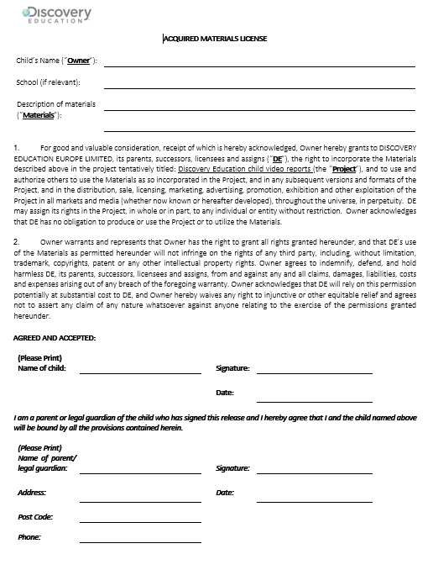

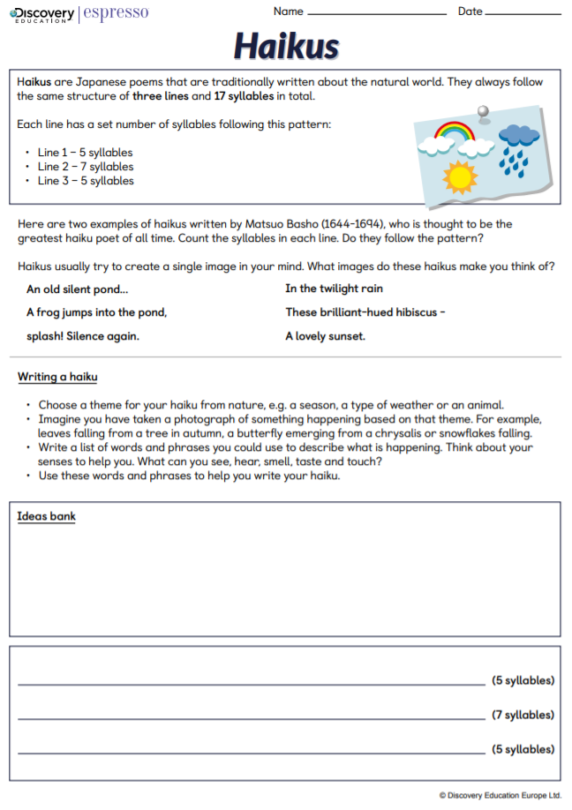
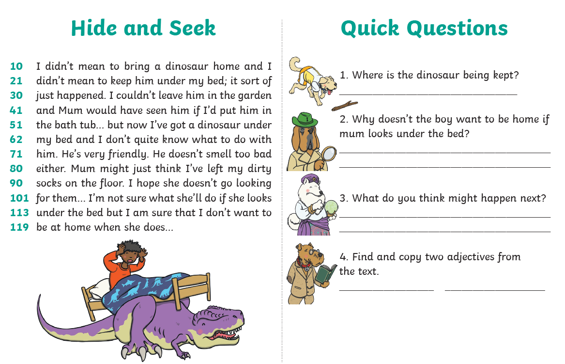
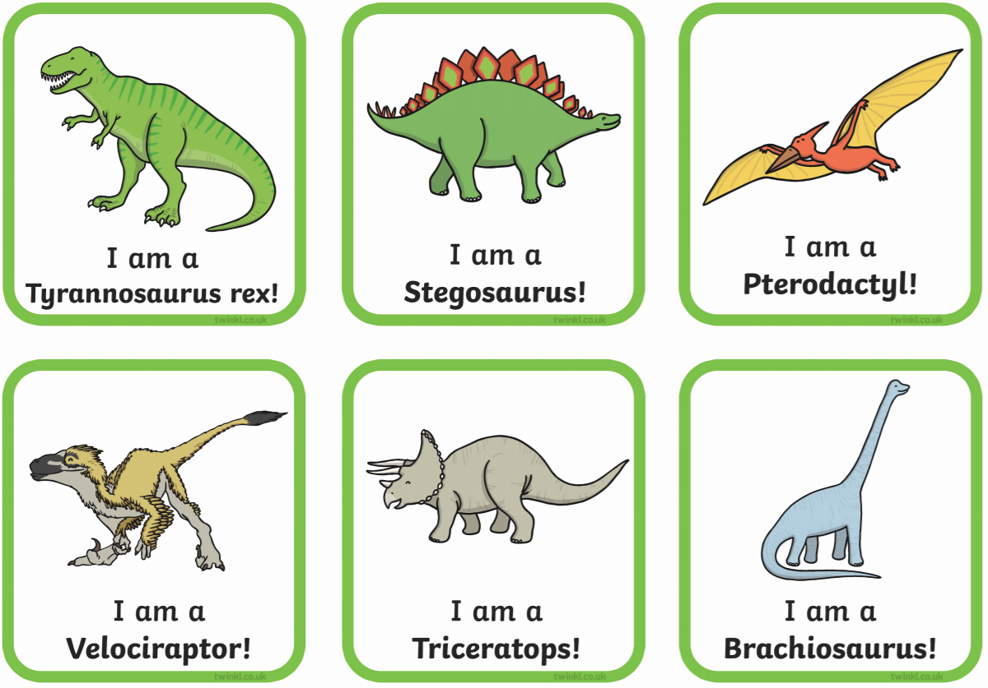
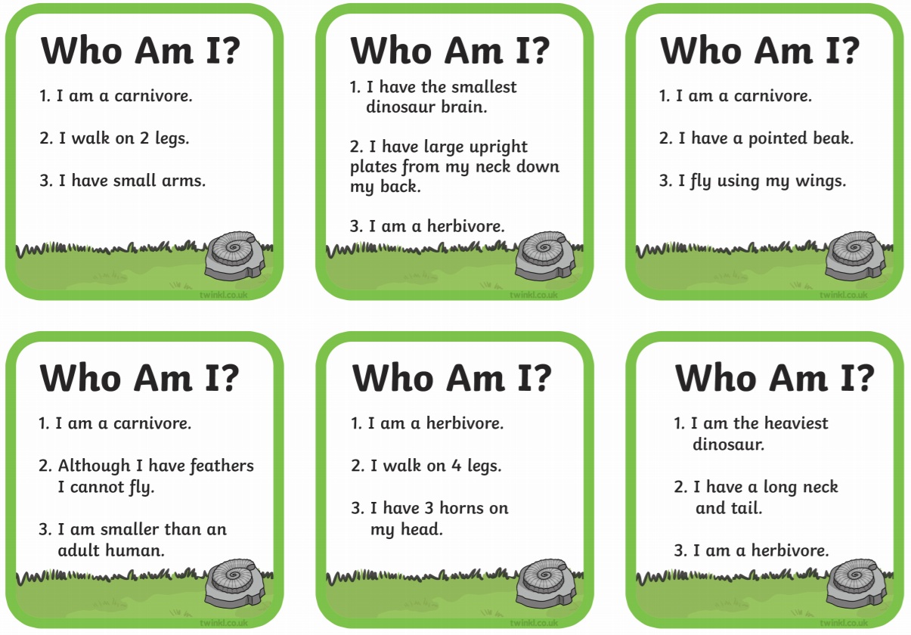

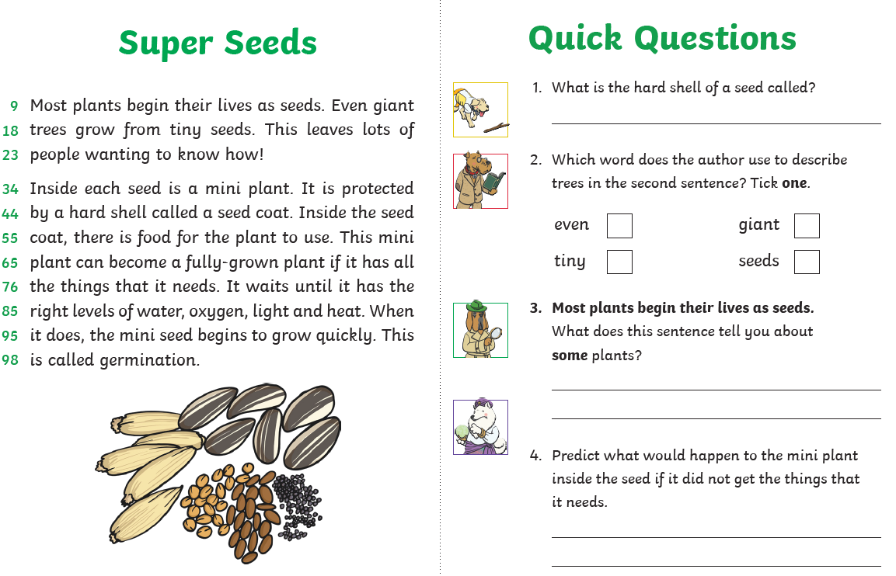

Year 1 – Alternative spelling of ‘oa’
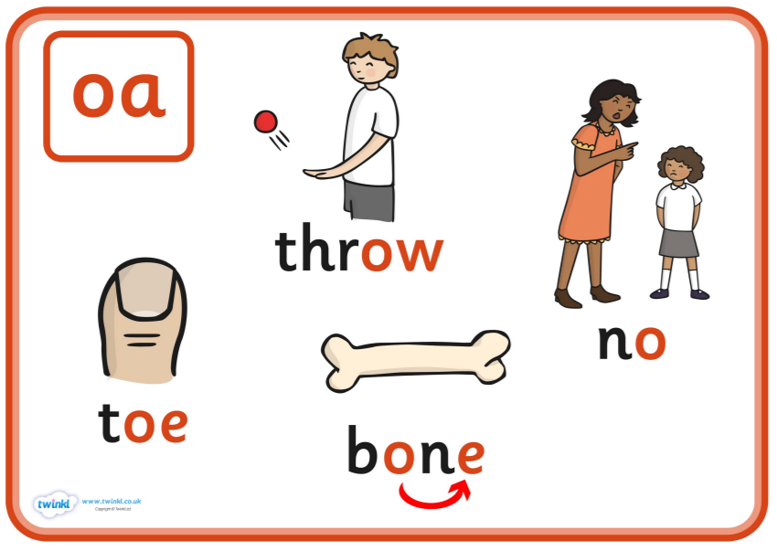
Phonics play – phase 2 and 5 Buried Treasure and Acorn Adventures
Phab Fonics – You tube –
Mr Thorne Does Phonics and Geraldine the Giraffe – oa, ow, o_e, oe , (you Tube)
Owen the Crow
Joan Toad
Cole the Mole
Alphablocks - oa – toad, o_e – home,

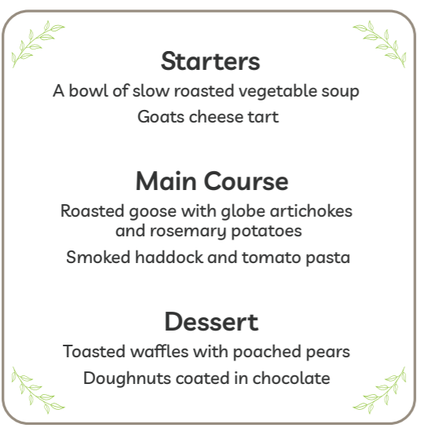
Year 1 – oa phoneme spotter

- How many oa words can you spot?

- Can you write silly sentences using different words that use the oa spelling?

- How many different oa/ow/o_e/oe words can you write in a sentence?

Year 2 – spelling –‘tion word ending
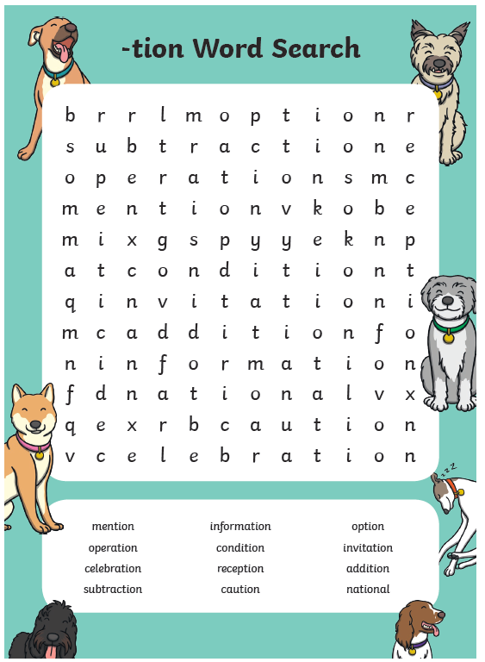
Use these words in sentences – statements, questions, commands and exclamations (see guidance from previous learning tasks of these different types of sentences)

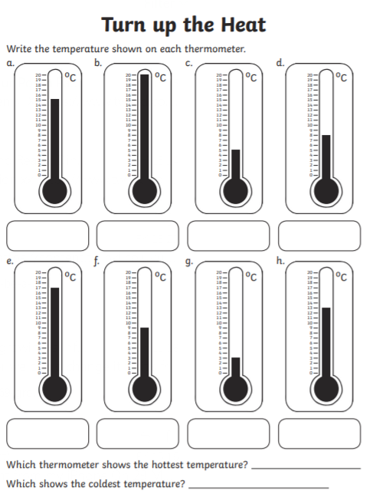
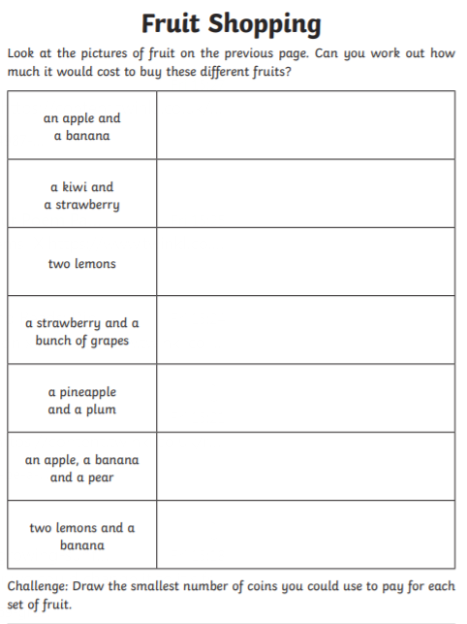

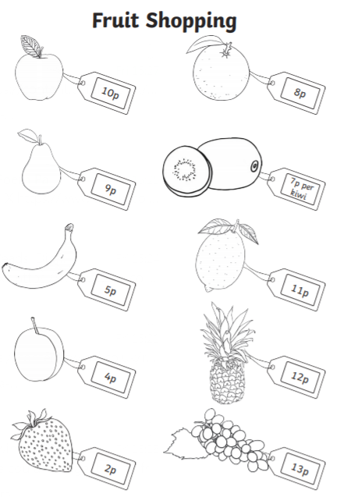

Which items could you just use silver coins to pay for them?

Which items could you just use copper coins to pay for them?

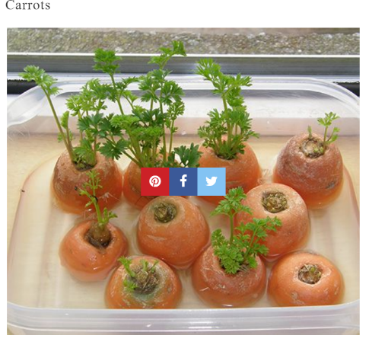
Science – Grow Your Own – here are just a few – google other fruit and vegetables that you could grow

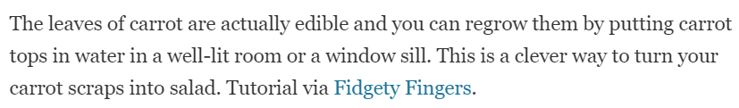
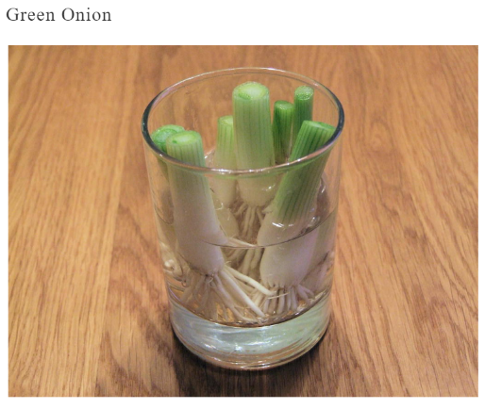

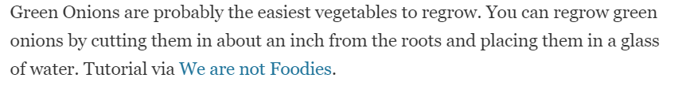

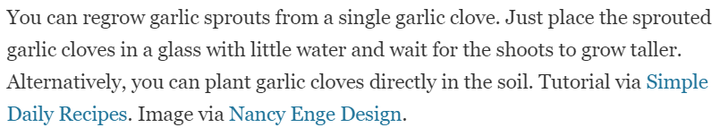
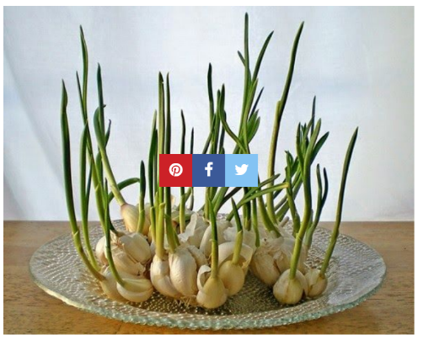

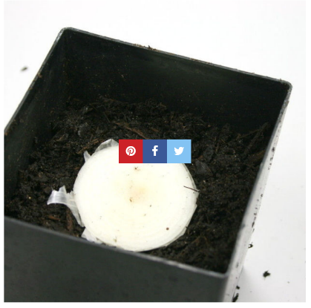

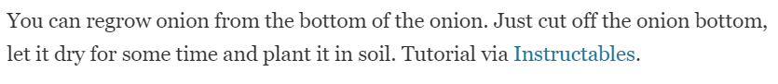

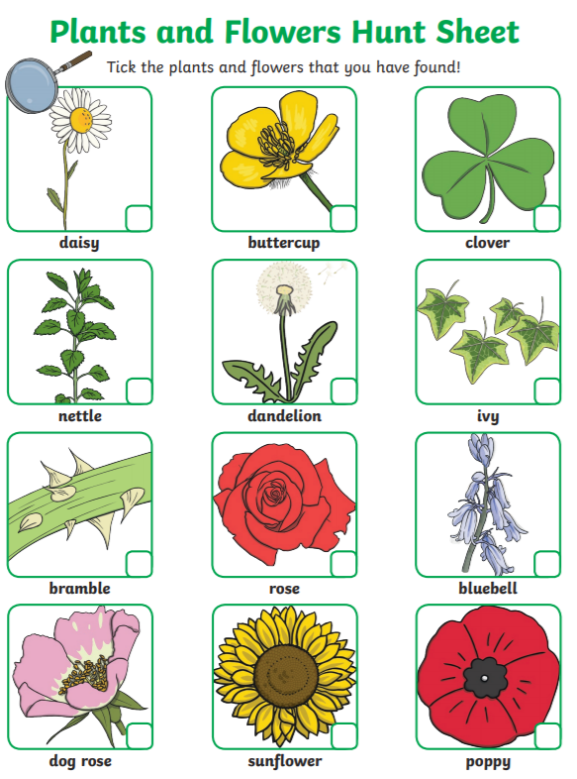

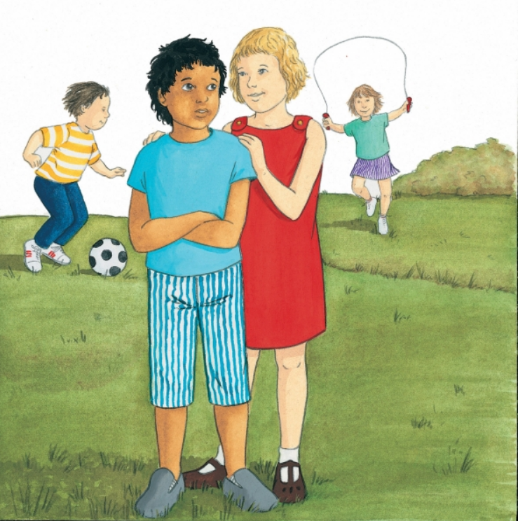
RE – Being Sorry

- What do you think has happened in the picture?
- How do you think the boy and the girl feel?
- How do you know?
- What choice has the girl made?
- What do you think happens next?
- When have you had to make choices like that?
- What helped you?
- What good choices have you made?
- How did you feel?
- What happens when you make a wrong choice?
- How do you feel, then? How can you try to make it right?

