ROBINS’ WEEKLY SUGGESTED HOME LEARNING – WB 11.5.20
Hello Robins, we hope that you are all well and you have enjoyed your VE day celebrations.
Our focus this week is Florence Nightingale. On May 12th it will be Florence Nightingale’s birthday. I wonder if you can find out how old Florence Nightingale would be. Missing you all. Stay Safe!
Mrs Fox, Mrs Davies and Miss Lea xxx
We’d love to see your work, so please Tweet @saintoswalds or send an email to enquiries@saintoswalds.wigan.sch.uk FAO Miss Lea.

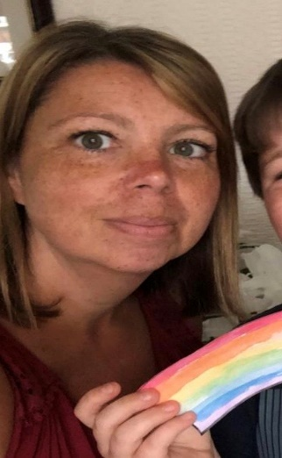

ENGLISH | MATHS
Reading – Read every day for pleasure for 15 minutes.  Have a go at Karate Kats for English Key Stage 1  Comprehension  Florence Nightingale –  1 star is for the Year 1’s (stars can be found In the bottom left hand corner)  3 stars for the Year 2’s  Florence Nightingale Poem  WRITING  Draw a picture of Florence Nightingale and write as many facts around her as you can remember.  Diary writing – A day in the life of Florence Nightingale  Prompt sheet below  Thank you cards for Doctors, nurses and carers  Birthday card for Florence Nightingale  Phonics – Year 1 – Alternative spelling of the ee sound  Watch the clips and play the games below  Challenge – how many different ee words can you write in a sentence?  How silly can you make your sentence?  Spelling – Year 2- Suffixes – er, ed, ing  We have attached a sheet to complete and a fortune teller to make  Challenge – write sentences using er, ed, ing, est words  - Statement sentence using a full stop  - Question sentence using a full stop  - Command sentence – being bossy e.g Stop running!  - Exclamation Sentence – these sentences must start with ‘how’ and ‘what’ | Basic Skills: Count forwards and backwards in 1’s, 2’s, 5’s, and 10s to and from 100  Supermovers is a great place to find active maths activities. https://www.bbc.co.uk/teach/supermovers/ks1-maths-collection/z6v4scw  Let me know which active maths clips you enjoy the most.  Y1: White Rose home learning – Summer Term – Week 3– 11.5.20 – Addition and Subtraction within 20  https://whiterosemaths.com/homelearning/year-1/  Y2: White Rose home learning – Summer Term – Week 3 – 11.5.20 – Addition and subtraction within 100  https://whiterosemaths.com/homelearning/year-2/  Have a go at the online games from the BBC.  Karate Kats website – maths games for Key Stage 1
RE
Pentecost Day  Recap Pentecost Day from previous week’s learning tasks and ask the key questions again.  Attached are the pictures linked to Pentecost Day – We would like you to put yourself in the position of the disciples – what would you be saying and thinking? Use the thought bubbles to record your ideas.  Make a dove – we have attached an image and template for you to make a concertina dove. | History  https://www.bbc.co.uk/bitesize/topics/zns9nrd/articles/znsct39  This clip will give you lots of information about Florence Nightingale  We have attached a grid and some sentences that we would like you to sort.  CHALLENGE – are there any other facts about modern and Victorian hospitals that you could add?  Florence Nightingale fact sheet – see below  Paper doll to make of Florence Nightingale - below  SCIENCE  Watch this You Tube clip about children and medicine  What is medicine?  https://www.youtube.com/watch?v=9OK6_OdWxTA  Read the information and answer the questions  Design a poster – Safety around medicines – See attachment  ART/DT  Using junk materials, make a lamp – like the one Florence Nightingale would have used.

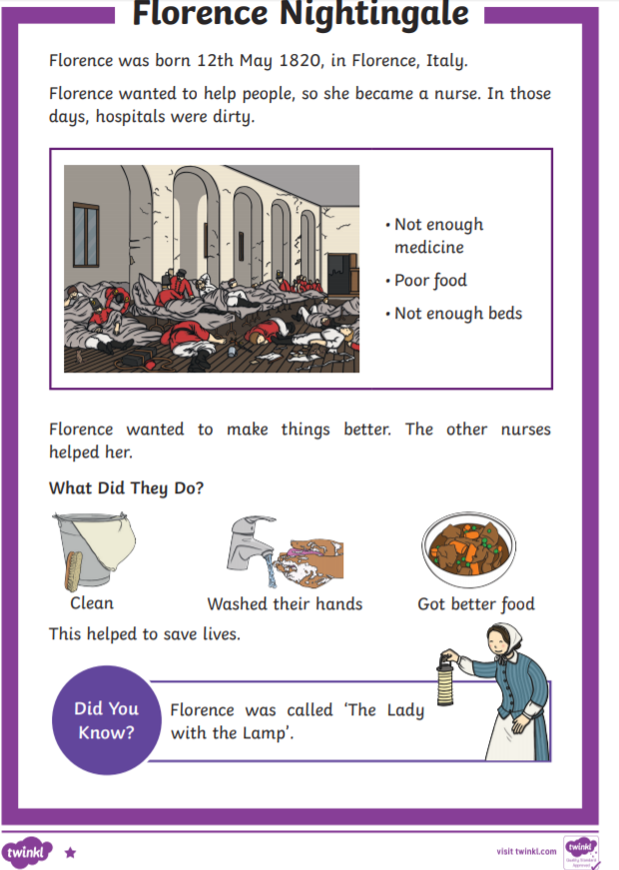
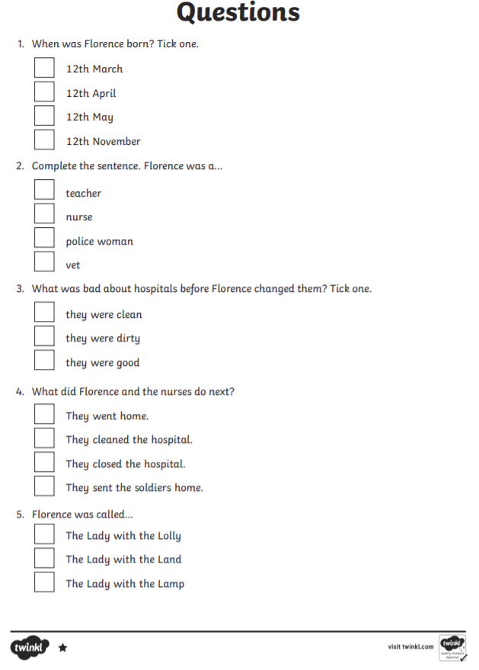
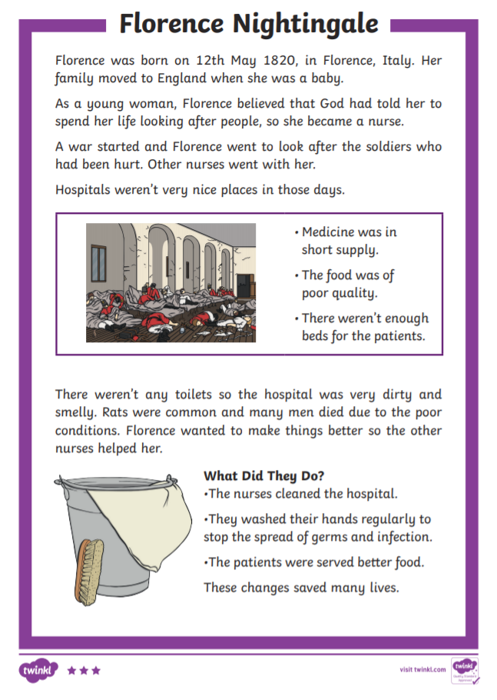
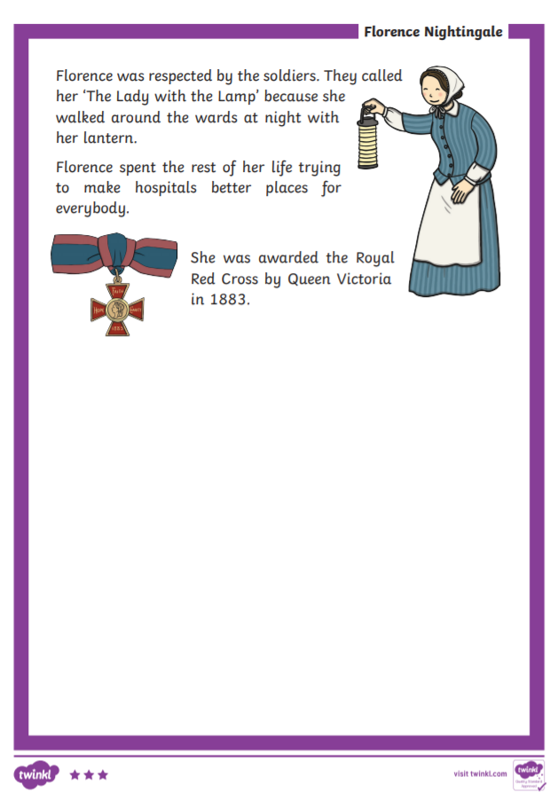
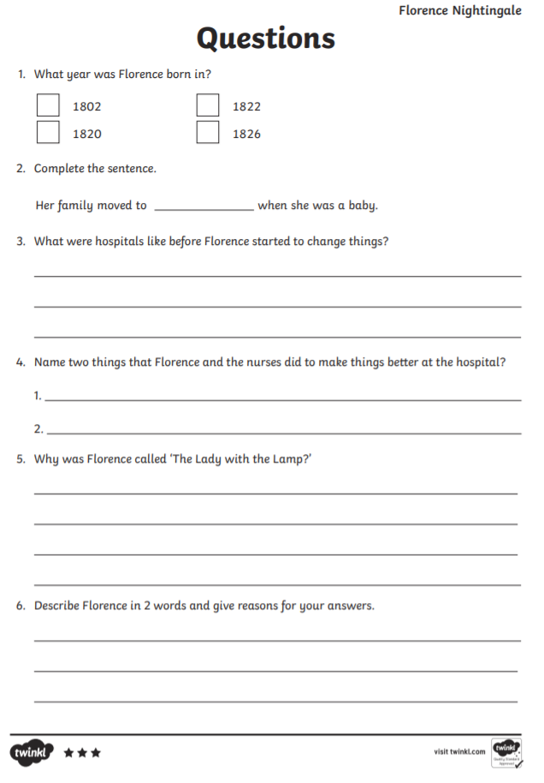
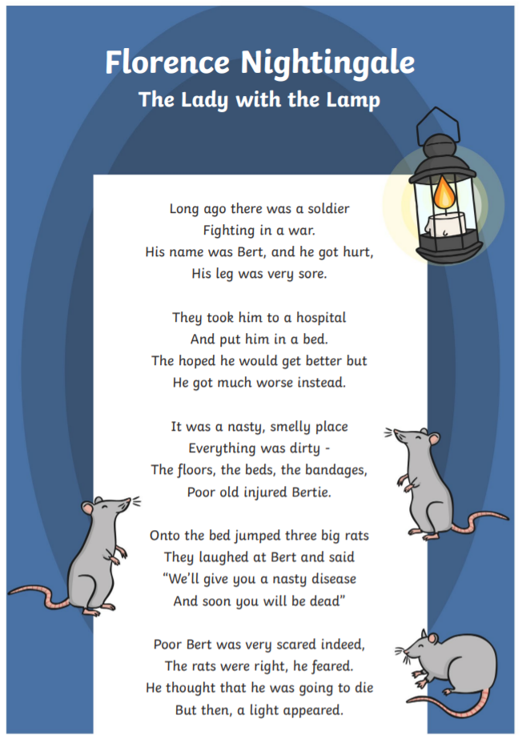
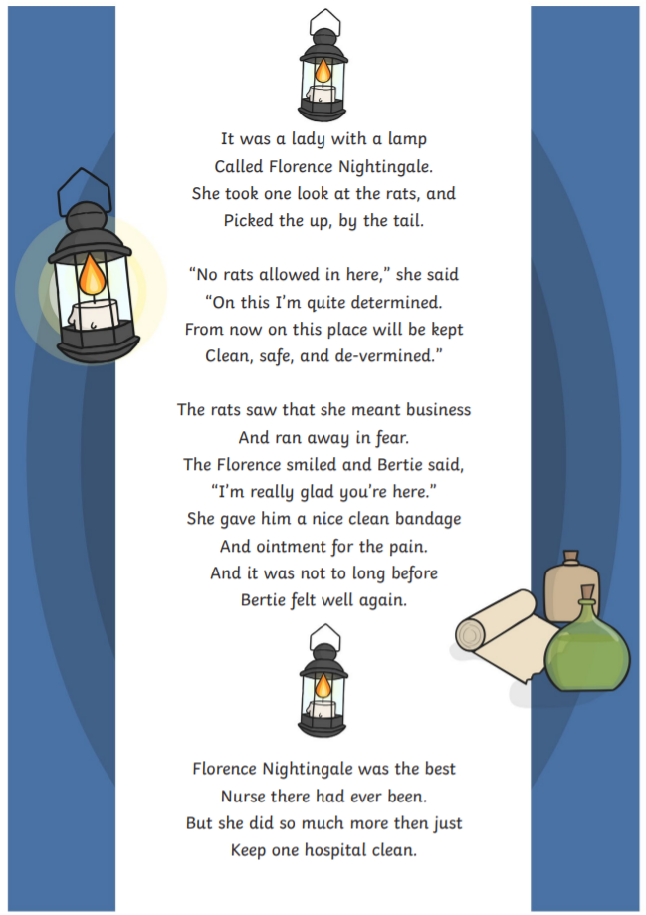
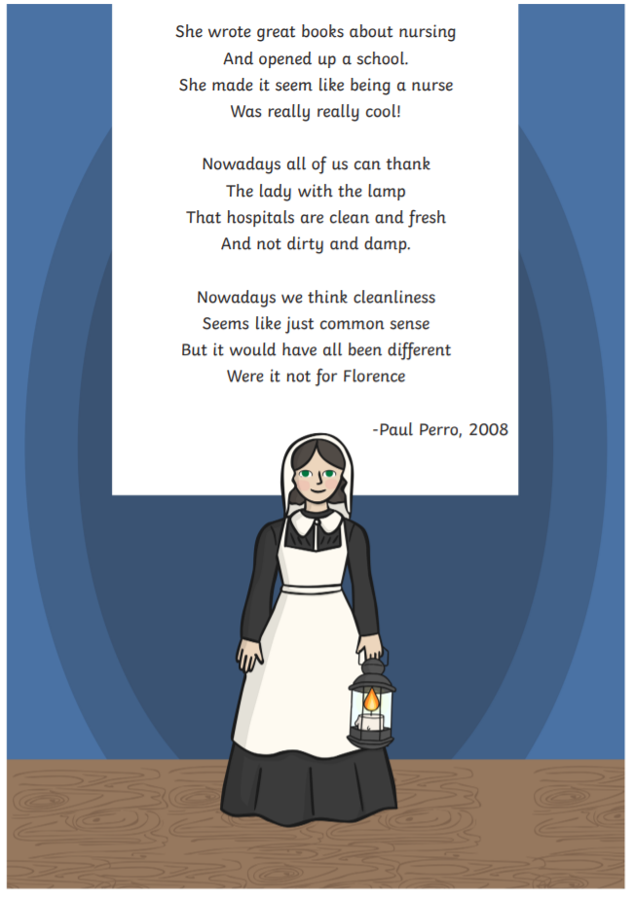
Florence Nightingale – The Lady with the Lamp Poem

- What was the name of the soldier in the poem?
___________________________________________________________

- Did the soldier get better? How do you know?
___________________________________________________________
______________________________________________________________________________________________________________________

- What was the hospital like?
_________________________________________________________________________________________________________________________________________________________________________________

- Why was Florence Nightingale known as the Lady with the Lamp?
_________________________________________________________________________________________________________________________________________________________________________________

- What do hospitals look like today because of Florence Nightingale?
_______________________________________________________________________________________________________________________________________________________________________________________________________________________________________________________________________________________________________
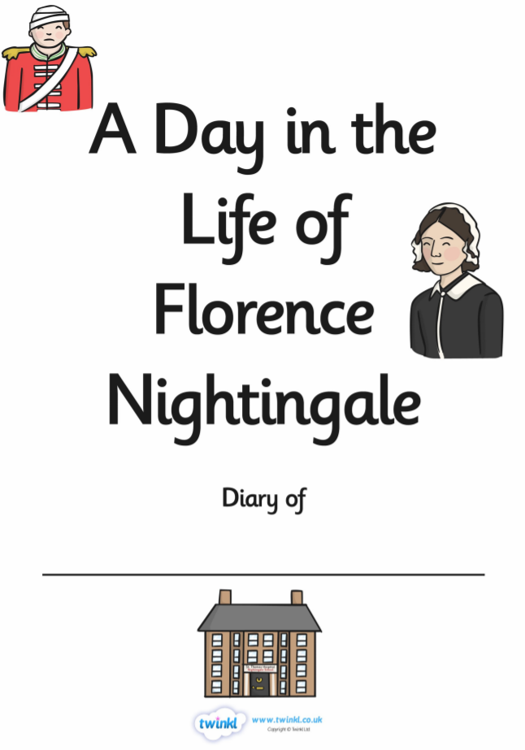
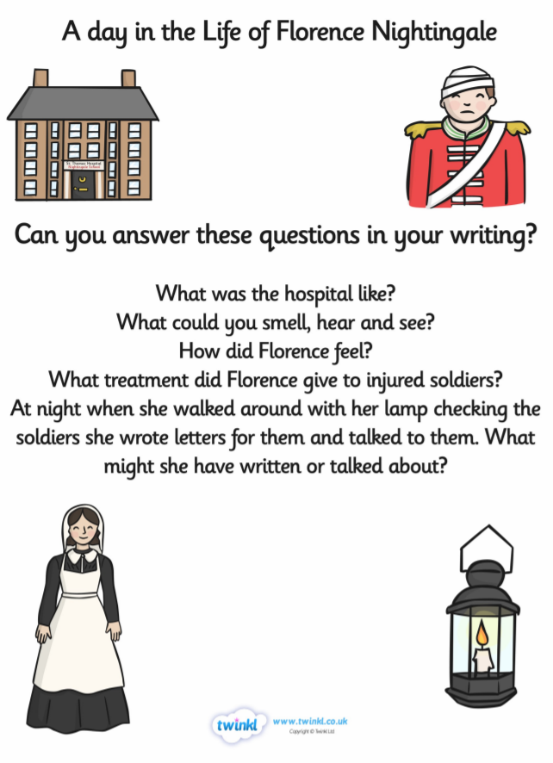
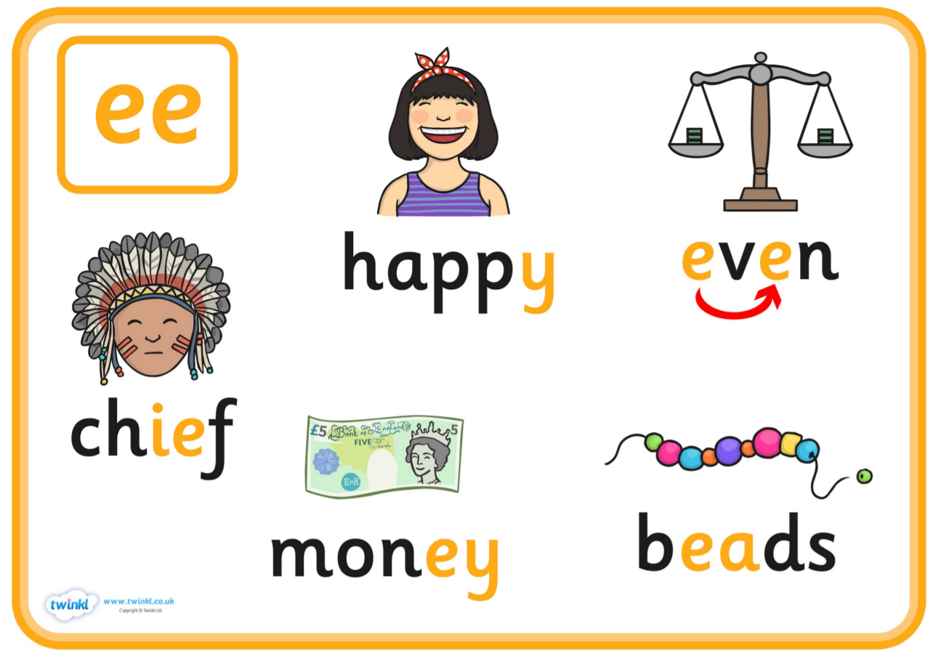
Year 1 – Alternative spelling of ‘ee’

Phonics play – phase 2 and 5 Buried Treasure and Acorn Adventures
Phab Fonics – You tube –
Lee the Bee
Pete and Steve
Dean the Seal
Mr Thorne Does Phonics and Geraldine the Giraffe – ee, ea, e_E (you Tube)
Alphablocks – ee

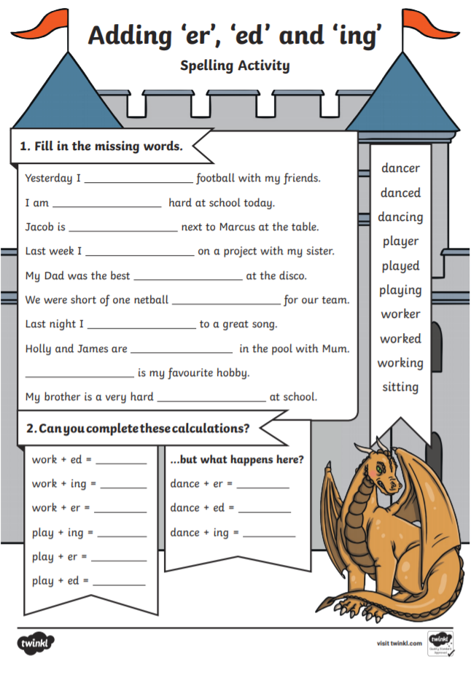
Year 2 – Suffixed – ed, er, ing
