ROBINS’ WEEKLY SUGGESTED HOME LEARNING – WB
Hi Robins, we hope that you and your families are safe and well. This week’s theme is Summer. We love summer it is our favourite season. We have added a rainbow that you can print and have as a keepsake of your time in Robins. We have also added the robin word art from our week on friendship. All of the words on the robin describe each and every member of our class. We are extremely proud of all of you and we have thoroughly enjoyed getting to know you and helping your brains to grow. Have an amazing summer, keep tweeting your pictures so we can see how you are getting on. Seeing your faces and finding out what you are doing makes our day.
Missing you all. Stay Safe!
Lots of love Mrs Fox, Mrs Davies and Miss Lea xxx
We’d love to see your work, so please Tweet @saintoswalds or send an email to enquiries@saintoswalds.wigan.sch.uk FAO Miss Lea
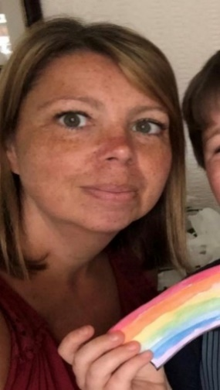

English | Maths
Reading for pleasure – 15mins per day  DISCOVERY EDUCATION also have a link to videos and games linked to traditional tales.  In the search box type ‘Summer’  Reading Comprehension (see attached sheets)  - Questions about Summer  - Read and Follow  - Read and Colour  Writing Tasks  - Write a recount of an enjoyable time spent in the summer – it could be a summer holiday that you have been on.  - Write a postcard and send it to school – Are you going on a day trip? Write a postcard and send it to school telling us all about it  - Write a summer senses poem (attached example)  Phonics – Split Digraphs  Split digraphs reading comprehension  - Colour the words that have the split digraphs  A_e, e_e, i_e, o_e, u_e  Split digraph real and nonsense word colouring mosaic  Spelling  Suffixes – Match the suffixes to the words  Past and present tense sheet  Compound words | Basic Skills  Y1 – Quick recall of doubling and halving facts within 20  Top Marks Website has games to play linked to doubling and halving  Y2 – Rapid recall of 2’s, 3’s, 5’s, 10’s time tables – play TTrockstars and Top Marks to develop quick recall.  White Rose and BBC Bitesize  Year 1 –  Year 2 –  Time games online  Top Marks and Everyschool.co.uk  Attached sheets linked to summer.
R.E. | Other Subjects
We have come to the end of our topic on Neighbours.  We have attached a prayer for you and your family to say together. Maybe you could light a candle and play some quiet reflective music as you say it together.  Colour the candle outline and stick/write the prayer on to it. On the back of the candle you could write about how you can be a good neighbour to others.  This could be used as a bookmark when you are reading.  You could use the prayer as a bedtime prayer before you go to sleep. | Sun Safety – organise your summer beach bag with the things that will keep you safe in the sun.  Make a sun safe poster informing people how they can keep safe in the sun  Geography – Think about a place in the world you would most like to go on holiday – Create a poster of the things that you might see in this place or write an information book about the place thinking about the landmarks, weather, food, things to do etc.  History – seaside holidays in the past  History of seaside holidays  Seaside holidays – Past and present holidays  Art – design and make your own sunglasses – the funkier the better  Science – Rainbow science experiment –  instructions attached – please send us a picture of the rainbow that you make.
