ROBINS’ WEEKLY SUGGESTED HOME LEARNING – WB 18.5.20
Hello Robins, we hope that you are all safe and well. We hope that you have enjoyed finding out about Florence Nightingale.
Our focus this week is Imagination. We love day dreaming and going to a world in our own imagination. Where do your day dreams take you? Missing you all. Stay Safe!
Mrs Fox, Mrs Davies and Miss Lea xxx
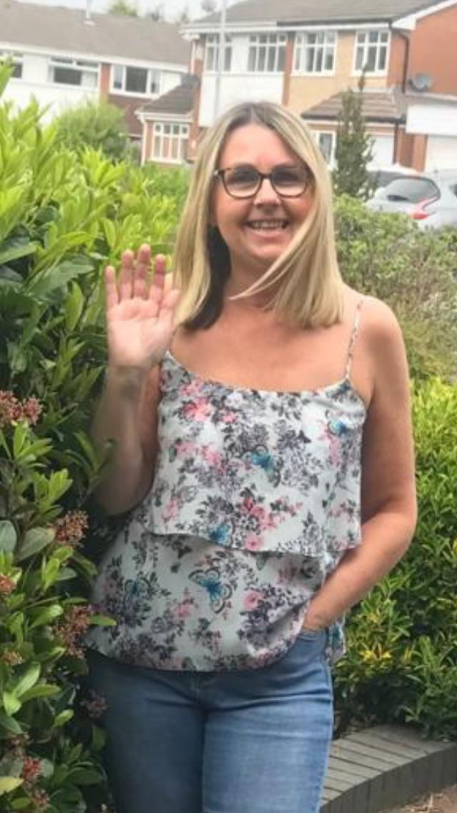
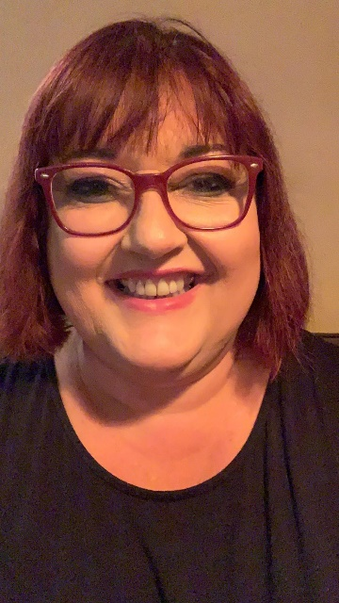
We’d love to see your work, so please Tweet @saintoswalds or send an email to enquiries@saintoswalds.wigan.sch.uk FAO Miss Lea.
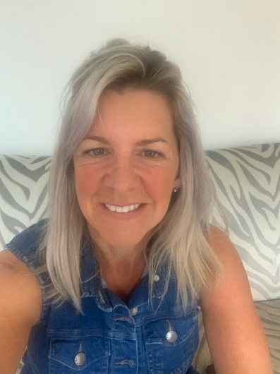
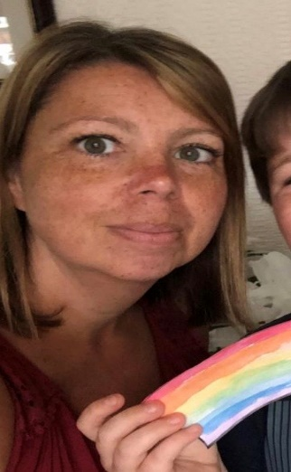

ENGLISH | MATHS
Reading – Read every day for pleasure for 15 minutes.  What has been your favourite book this week?  Please read/listen to the story ‘Whatever Next!’  https://www.youtube.com/watch?v=Nn73STXrPP0  There are lots of stories written by Jill Murphy e.g. Peace At Last, The Large Family and The Worst Witch Series. Have you got any of these stories at home?  If not then you will find them on YouTube for you to listen to.  https://www.youtube.com/watch?v=9U9y35kWBvM  (Peace At Last)  Comprehension  Jill Murphy is the author of the story ‘Whatever Next!’ We have attached information about her and some questions for you to answer.  Shooting from the Stars  Read and Colour - planets  Writing – use your imagination  Answer mum’s question from the end of the text ‘Whatever next?’ - Write your own adventure for Baby Bear. Add illustrations to show what is happening in the story. ( see the story writing prompt poster attached)  Write a letter from Baby Bear to his mum about his time on the moon.  Year 1 phonics – alternative spelling for ‘igh’  See attached websites  Can you write a list of words using the different spellings of ‘igh’  Can you write silly sentences using the different ‘igh’ spellings?  Spelling – Year 2- Suffixes – ful, less, ly  We have attached a sheet to complete  Challenge – write sentences using words containing ‘ful, ‘less, ‘ly  - Statement sentence using a full stop  - Question sentence using a full stop  - Command sentence – being bossy e.g Stop running!  - Exclamation sentence – these sentences must start with ‘how’ and ‘what’ | Basic Skills:  Year 1 - Count forwards and backwards in 1’s, 2’s, 5’s, and 10s to and from 100  Year 2 – Recalling the 2’s, 5’s and 10’s times tables  https://www.splashlearn.com/counting-games  This website has lots of different games for year 1 and 2.  Y1: White Rose home learning – Summer Term – Week 5– 18.5.20 – Measures – length, height and weight clips  https://whiterosemaths.com/homelearning/year-1/  Y2: White Rose home learning – Summer Term – Week 5 – 18.5.20 – Multiplication clips this week  https://whiterosemaths.com/homelearning/year-2/  Year 1 you have a Solar System Code Breaker task to secure your addition and subtraction skills  Year 2- Mixed Operations - colour by numbers  CHALLENGE – draw your own space themed picture and create your own colour by numbers using the 2’s, 5’s, 10’s and 3 times tables.  Baking – Measures is an important part of our maths learning and I know a lot of us Robins are baking at home. Linked to this week’s text we have included a recipe for star biscuits.  Enjoy making them! (and eating them)
RE
Talk about the picture attached  Ask the following key questions:  - Who is in the picture?  - What do you think the people in the picture are celebrating?  - What does a birthday celebrate?  - Why is Pentecost a holy day?  Plan a ‘get together’ for you and your family when we can all meet and be together again.  - Who is going to be at your celebration?  - Where will you hold your celebration?  - What will you do at your celebration?  - What will you eat and drink?  - What news will you share with each other? | Science – Learn the names of the different planets.  There is a YouTube song to help you remember the order.  https://www.youtube.com/watch?v=noiwY7kQ5NQ  https://www.youtube.com/watch?v=ZHAqT4hXnMw  Write a fact file about one or all of the planets in our Solar System.  Use your imagination to design your own planet – sheet attached  DT – using junk materials make your own rocket  ART – Use your imagination to draw a picture and write about where your rocket would take you  History – during our history lessons this year we have looked at Neil Armstrong – the first man on the moon. Recall with your family the facts that you learned.  What date was the first moon landing?  Who was the second person on the moon?  What were the first words spoken by Neil Armstrong?  What was the name of the spaceship that took them to the moon?  Who were the astronauts that landed on the moon with Neil Armstrong? What were their roles?  How many people have landed on the moon since?  Geography  Where in the world would you visit in your rocket?  Find 10 facts about the country you would visit.  Which continent is your place on?  What is the capital city of your country?  How many people live there?  How many miles away from Ashton is it?  What does the flag look like?  What language do they speak?  Can you learn some words from that language?  What animals live there?

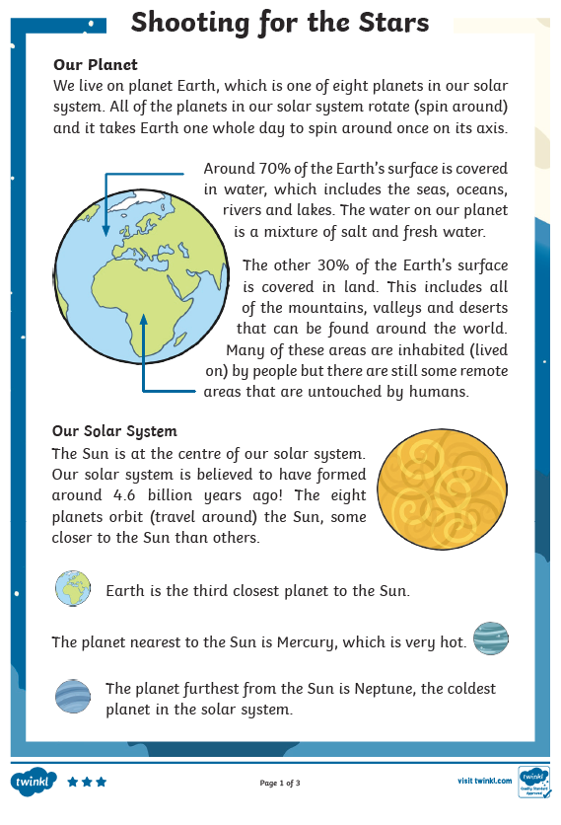
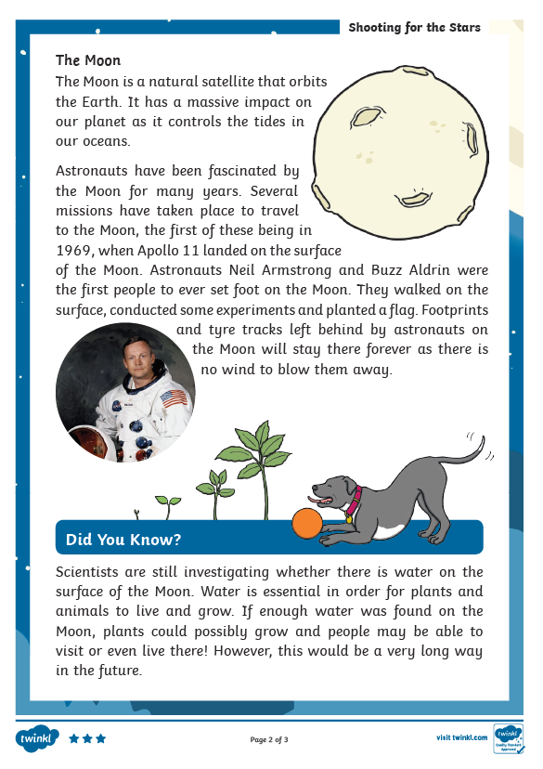
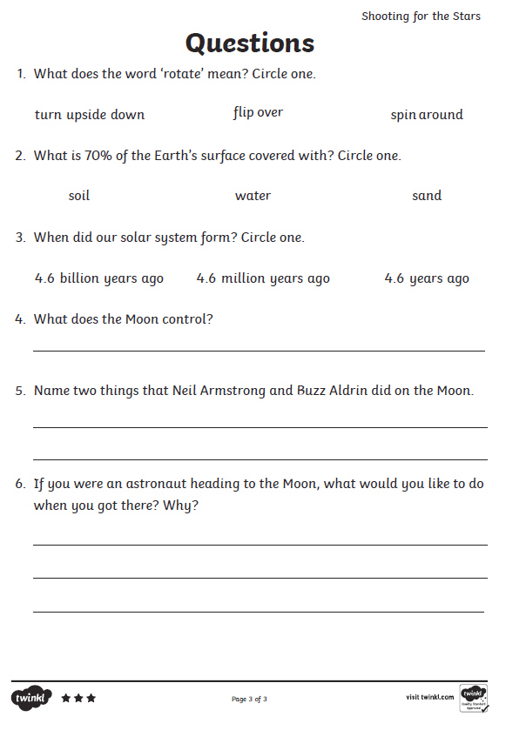
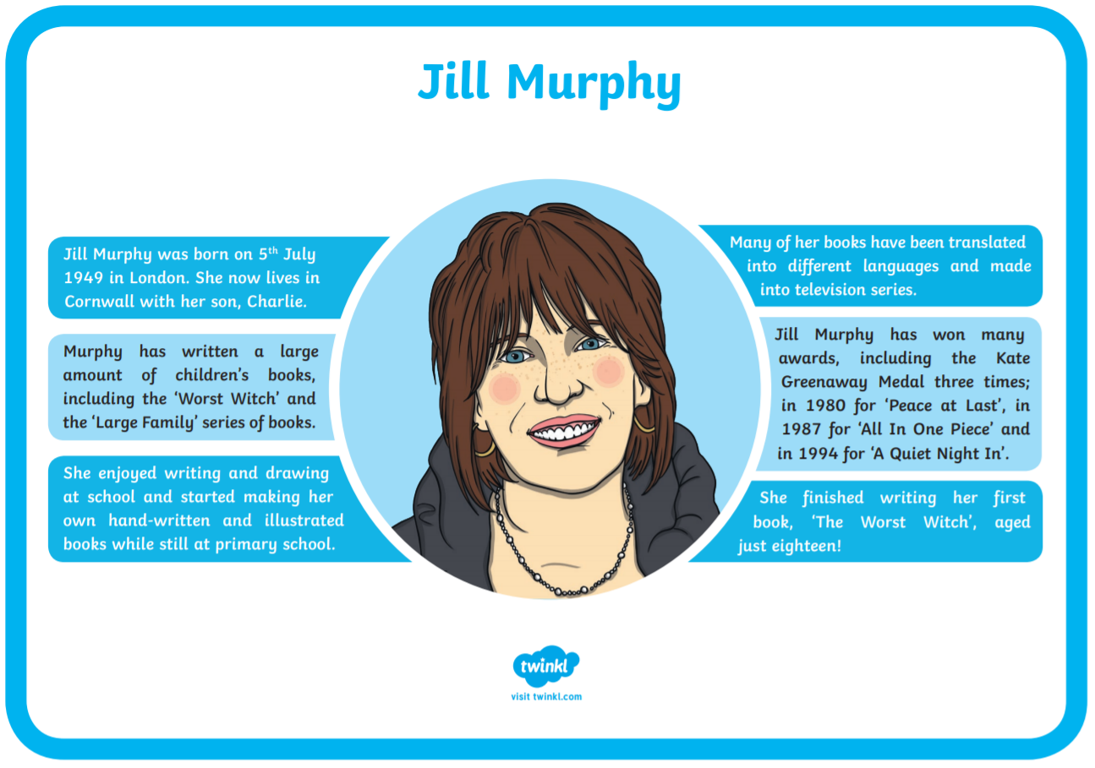
When was Jill Murphy born? How old is she?
_____________________________________________________________________
How many children does Jill Murphy have?
_____________________________________________________________________
What did she enjoy doing at school?
_____________________________________________________________________
How do you know that her books are popular?
_____________________________________________________________________
List the books that won the Kate Greenaway Medal
_____________________________________________________________________
_____________________________________________________________________
_____________________________________________________________________
Have a look for these books on you tube and see which one is your favourite.
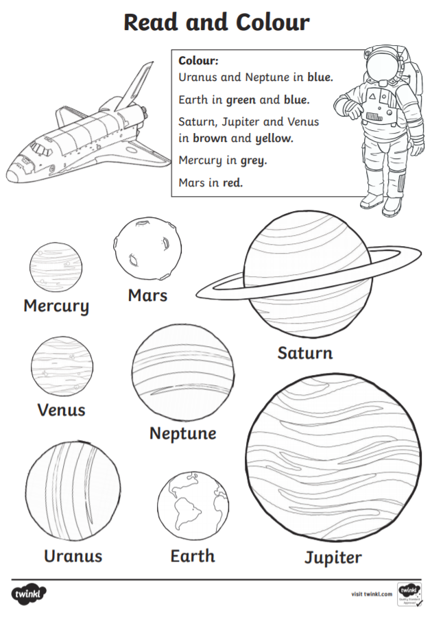
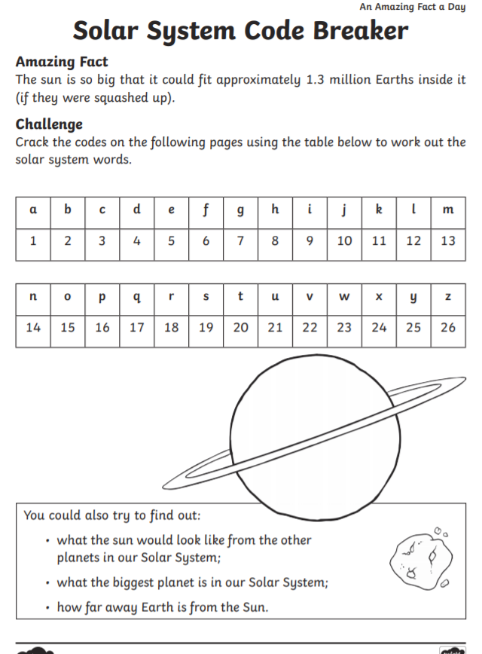
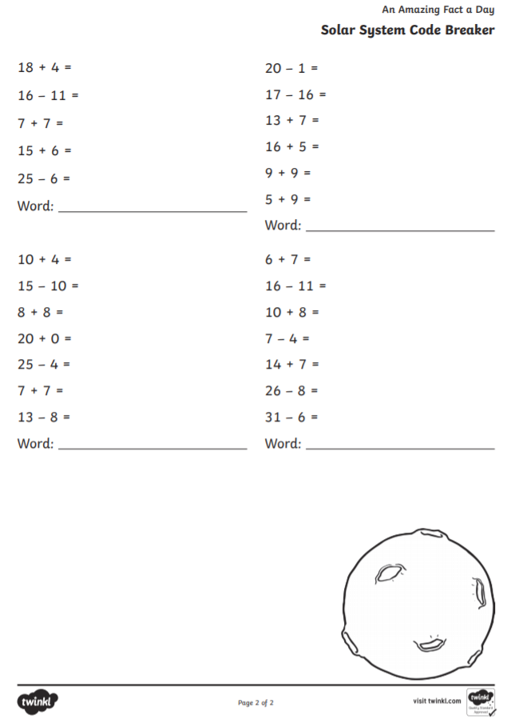
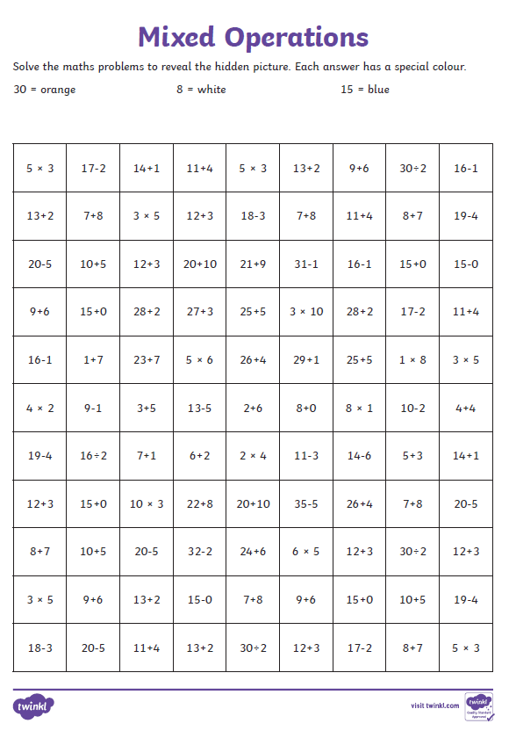
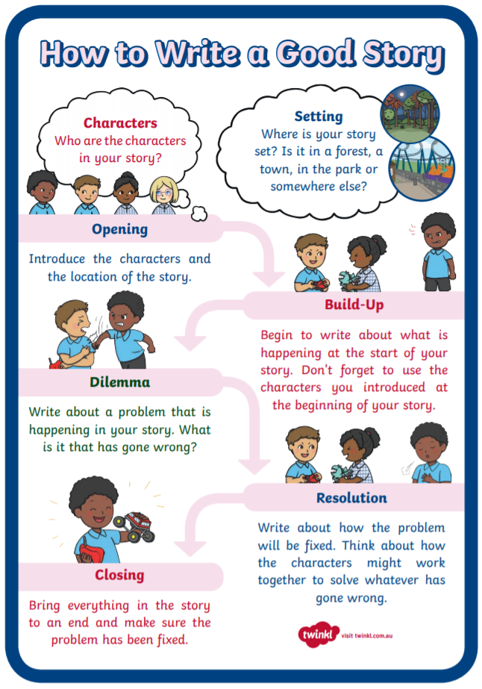
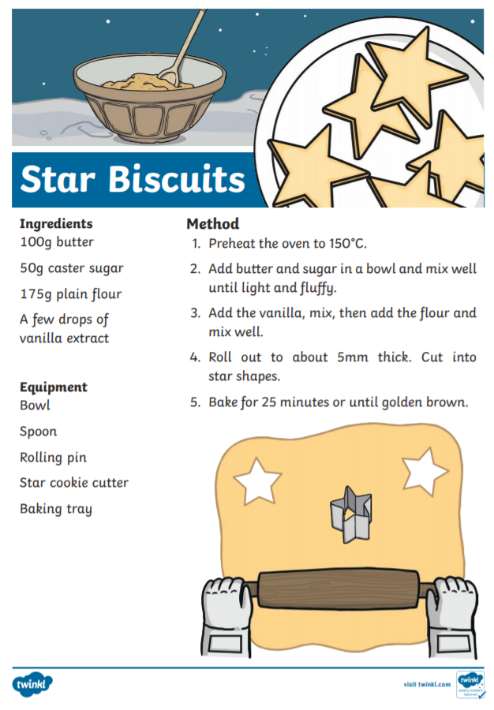
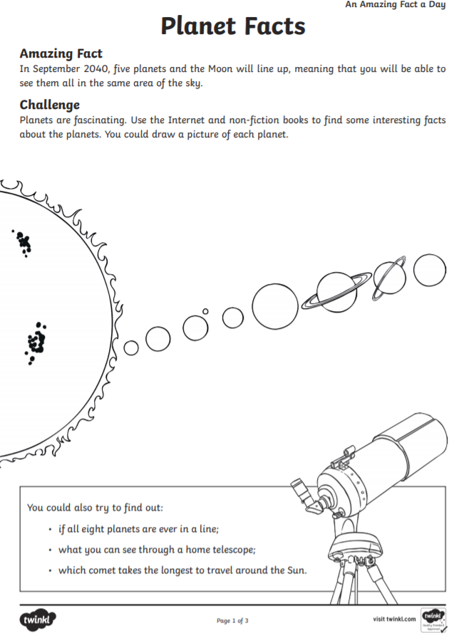
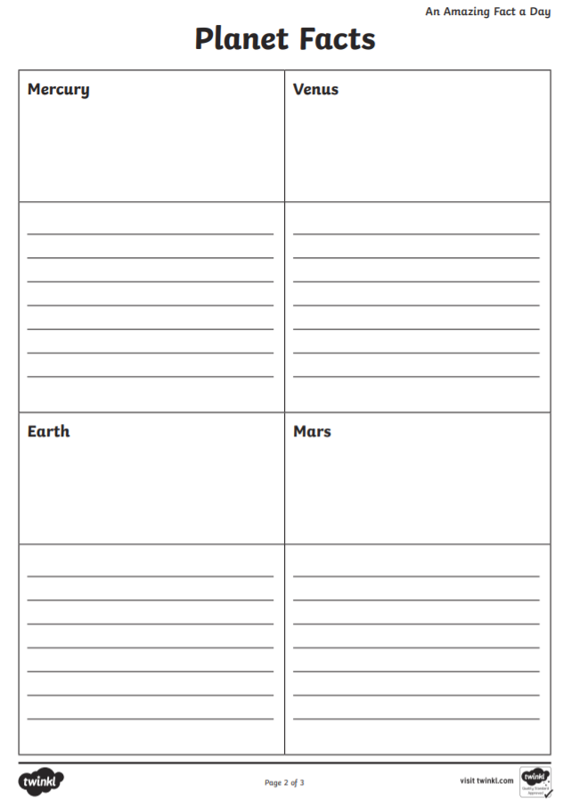
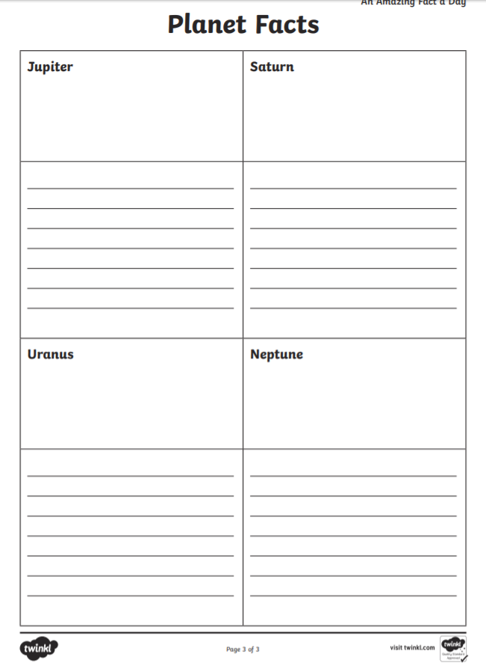
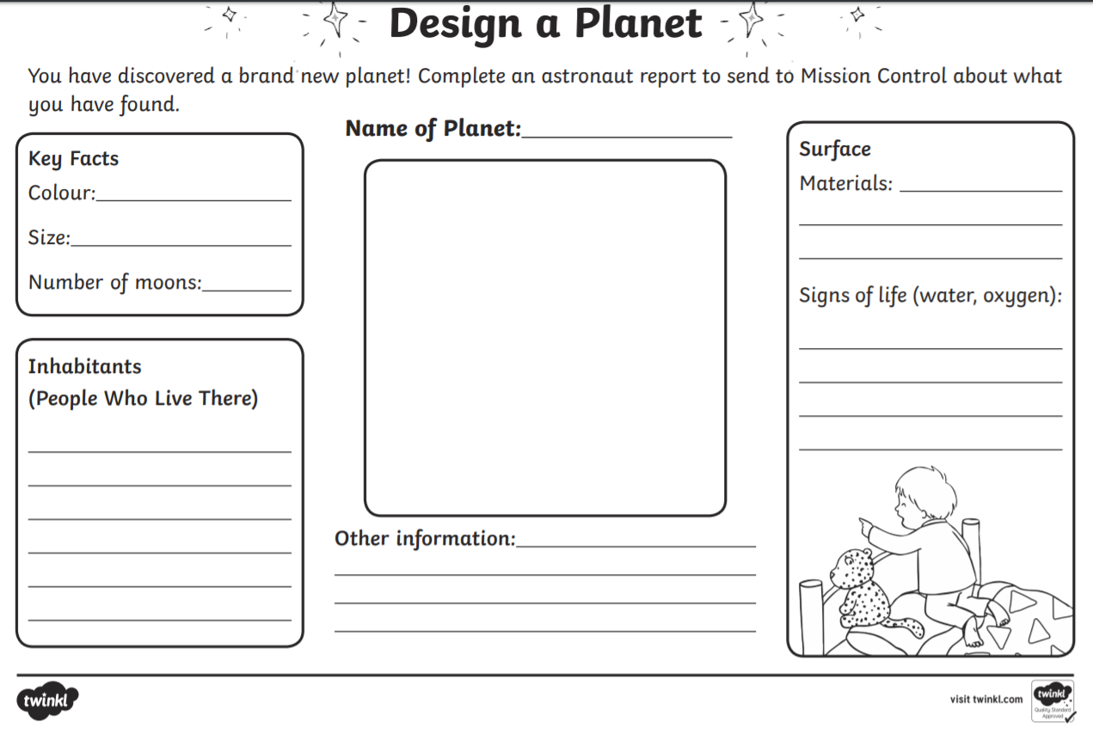
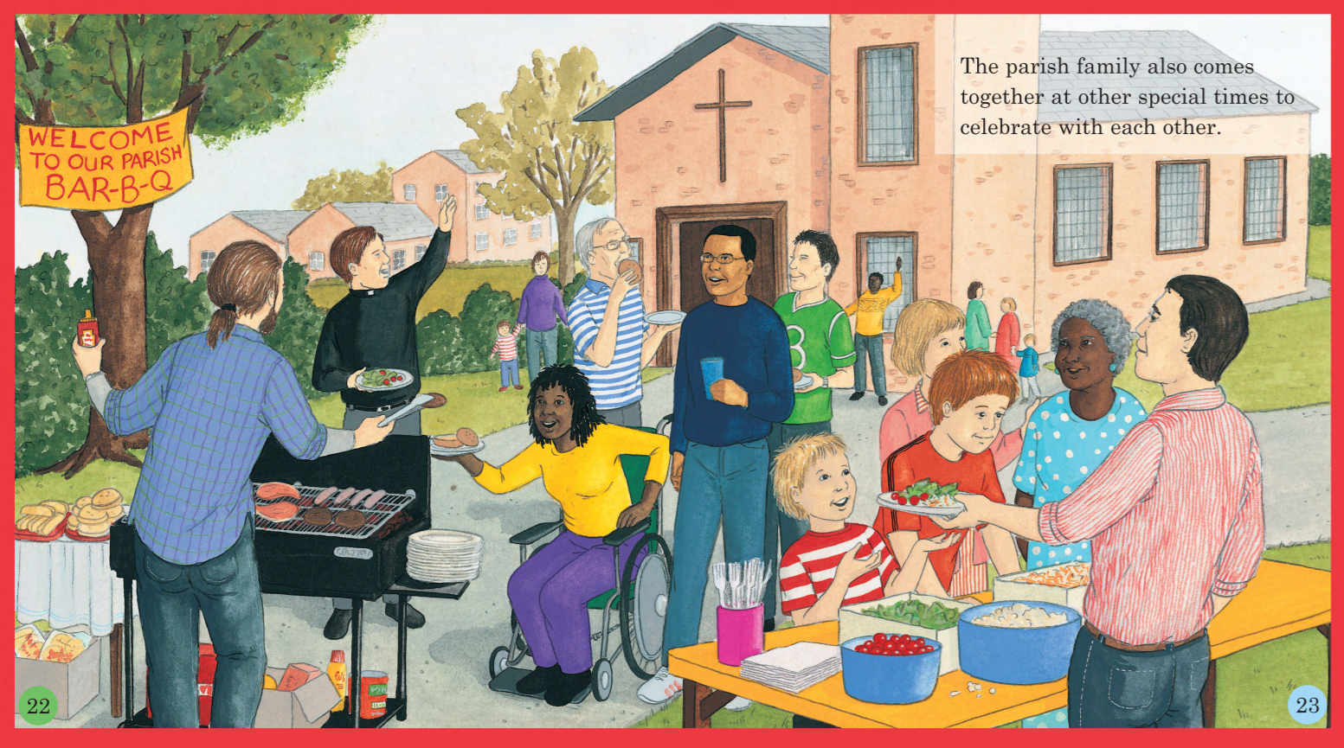
Year 1 – Alternative spelling of ‘igh’
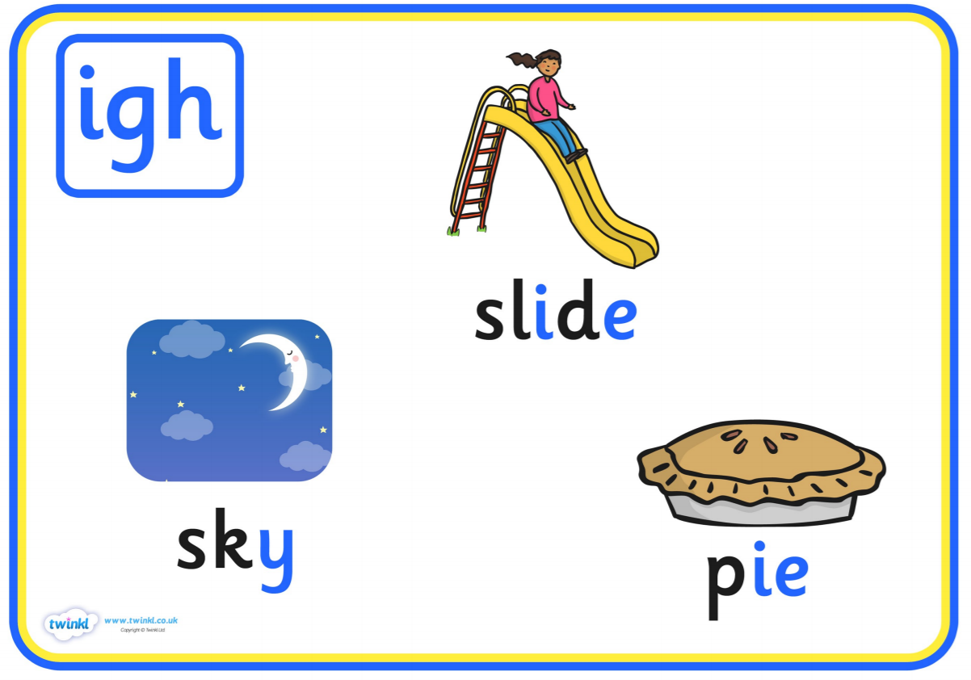

Phonics play – phase 2 and 5 Buried Treasure and Acorn Adventures
Phab Fonics – You tube –
Mike the Pike
Mr McKie’s Pie
Nicola Nightingale
Mr Thorne Does Phonics and Geraldine the Giraffe – igh, ie, i_e, y, I, (you Tube)
Alphablocks – igh, tightrope, i_e – mine

