ROBINS’ WEEKLY SUGGESTED HOME LEARNING – WB 27.4.20
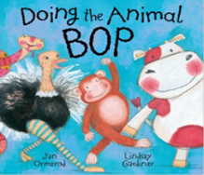
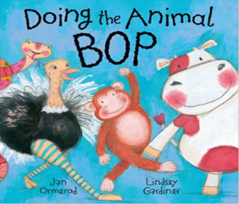
Hello Robins, we have really missed seeing your smiling faces, hearing you laugh and helping your brains to grow. Mrs Fox, Mrs Davies and I have put our heads together and created some fun and exciting challenges for you to complete with your grown-ups. Our focus this week is – DANCING. On Wednesday it is international Dance Day. Share the story ‘Doing the Animal Bop’ using the following you tube link: https://www.youtube.com/watch?v=t-JrAArqEEs
Watch the funny clip of animals dancing: https://www.youtube.com/watch?v=TQwmME2SI9E
We’d love to see your work, so please Tweet @saintoswalds or send an email to enquiries@saintoswalds.wigan.sch.uk FAO Miss Lea. Enjoy and remember to stay safe!
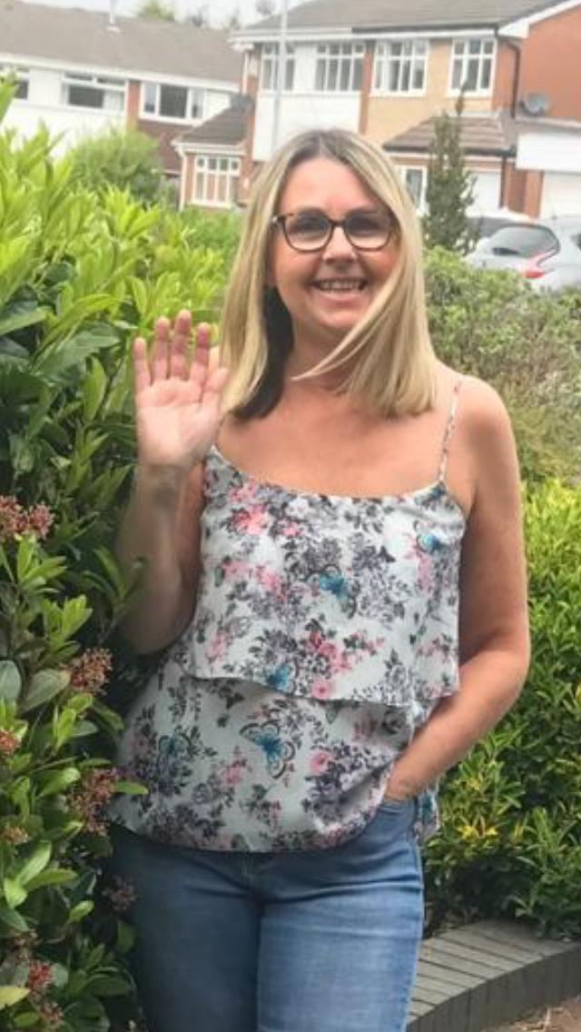
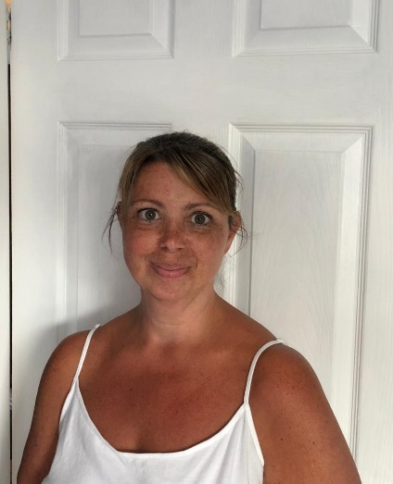
Miss Lea, Mrs Fox and Mrs Davies XXX

ENGLISH | MATHS
Reading – Read every day for pleasure for 15 minutes.  Can you read books about animals? Is your text fiction or non-fiction?  Share the story ‘Doing the Animal Bop.’ (you tube)  Can you find stories similar to ‘Doing the Animal Bop?  HINT – Giraffes can’t dance.  Comprehension – we have attached 3 reading comprehensions all linked to animals from the story below:  - How to Be a Lion 2. Elephant 3. Penguins  Writing – We would like you to think about your favourite animal. Research and write some interesting facts about your animal. Can you find facts that we would not know?  We have attached the year 1 and 2 writing skills to help you.  Spellings – Using the animals from the text create a list of rhyming words (they can be silly, nonsense words to – they just need to rhyme)  Snake - take, cow - how, hen - pen, duck - cluck  Using your rhyming words create rhyming couplets. We have attached some that we have thought of to start you off. Have fun! The crazier the better. | Basic Skills: Count forwards and backwards in 1’s, 2’s, 5’s, and 10s to and from 100  Play the caterpillar ordering game on the following website https://www.topmarks.co.uk/ordering-and-sequencing/caterpillar-ordering  Y1: White Rose home learning – Summer Term – Week 1 – 20.4.20  https://whiterosemaths.com/homelearning/year-1/  The focus is doubling, halving, grouping and sharing.  Y2: White Rose home learning – Summer Term – Week 1 – 20.4.20  https://whiterosemaths.com/homelearning/year-2/  If your child finds any of the tasks too challenging, go to the previous year group or look back at the Week 1 and Week 2 tasks above the Summer Term ones. It’s important that your child builds their confidence.  Below is a little mystery to solve about a feather.
RE
Our theme is: Holidays and Holydays  Explore: Talk to each other about holidays you have been on and holidays you would like to go together.  Reveal: Before Jesus left his friends, he promised to send them a helper, the Holy Spirit. The holy day, Ascension Thursday, celebrates Jesus’ return to his Father.  It is difficult at this age for children to understand the abstract concept of the Holy Spirit. The image of a dove and elements such as air, wind and fire are used to help explain the power of the Holy Spirit.  We have attached a passage from the Bible to share with the children and a stain glass window dove for them to colour. | Science: Listen to the song about herbivores, carnivores and omnivores.  https://www.youtube.com/watch?v=3yrikH2QEFA  Play the online game sorting the animals according to what they eat.  https://switchzoo.com/games/pleasedofeedtheanimals.htm  Draw a poster teaching younger children about what animals eat.  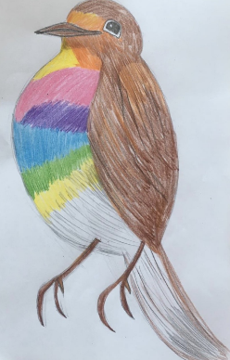  Art  We would like you to draw a robin – but not with a red breast with a rainbow coloured breast.  Mrs Davies has drawn one to help you when you are drawing your own.  Send in your photographs of the robins you have drawn.  PE – Dance / Music  We would like you to create your own animal dance.  Share your funky moves with us.  What can you find around your house to add sounds to your animal dance?  Computing  Please type in an email what you have been getting up to and send it to our school email address with the subject being FAO Miss Lea.  Use your tablets/phones to take your own photographs and email them to us.

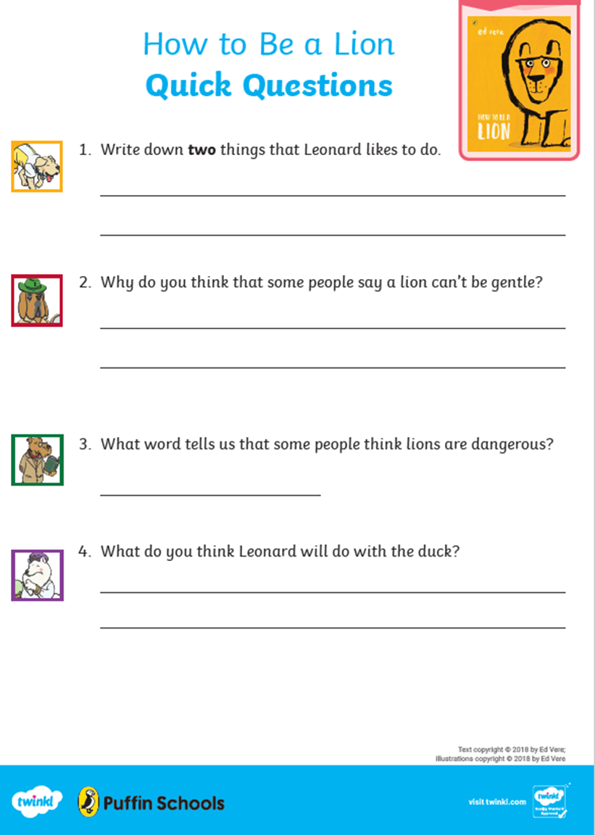

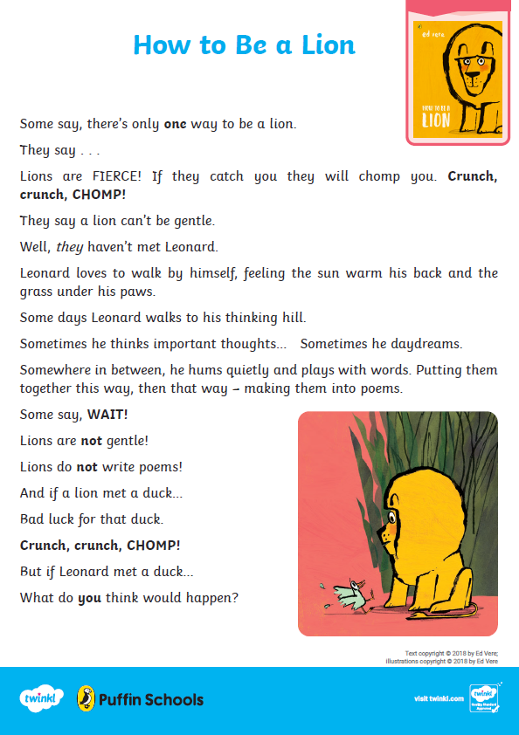

As you are reading/singing this poem add your own actions (please ask a grown up to film you acting out the poem and email it to us)

What kind of text is ‘Elephant?’ HINT – read the sentence above!
_________________________________________________________________
Find and copy one word that describes the elephant’s feet.
_________________________________________________________________

Have you enjoyed reading/singing the poem?
What part of the poem have you enjoyed and why?
___________________________________________________________________________________________________________________________________________________________________________

What other words could use instead of ‘stomp, stomp, stomp’ in the second verse?
___________________________________________________________________________________________________________________________________________________________________________

Write and perform your own animal poem – use one of the animals from the story ‘Doing the Animal Bop’ to inspire you.
Type your poem into an email or film you saying your poem and send it to us

