SEAGULLS’ WEEKLY SUGGESTED HOME LEARNING – WB 27.4.20
Hello Seagulls! We hope you’re all well and staying home, other than your own form of exercise a day! We had a quick look into our classroom today and it’s very quiet, too quiet, believe it or not! We would love to see pictures of what you have been up to on Twitter or sent to the school’s email address, enquiries@saintoswalds.wigan.sch.uk FAO Mr Goulding and Mrs Barton! We look forward to hearing from you soon, especially by email, as described in one of the tasks below. Enjoy having this time with your families!
Parents/Carers- any questions- please feel free to email school and we will get back to you. Take Care.
#StaySafeStayHomeSaveLives
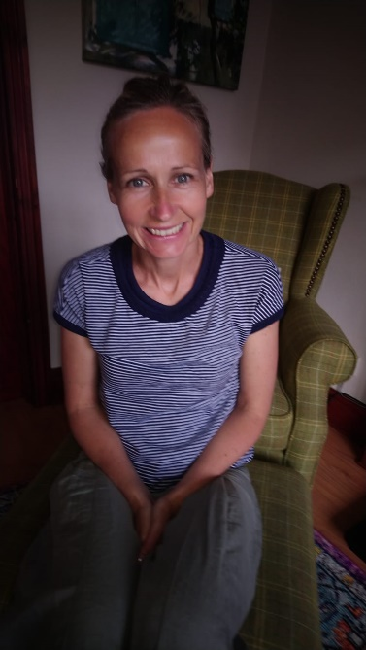
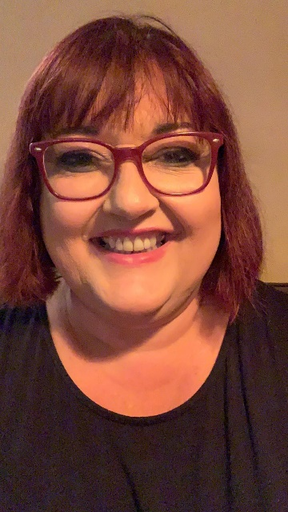
Mr Goulding, Mrs Barton, Mrs Brearton, Mr Little and Mr Ode XXXXX
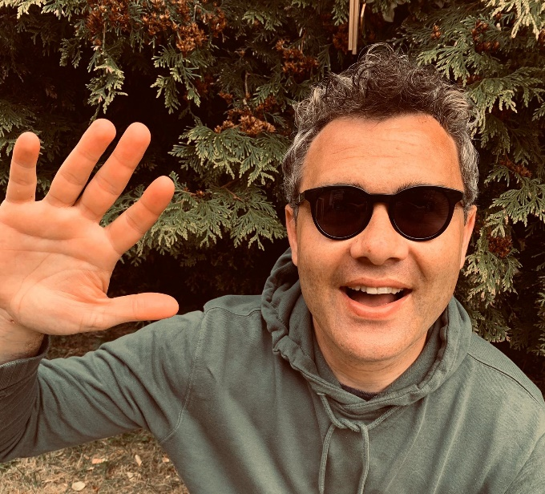

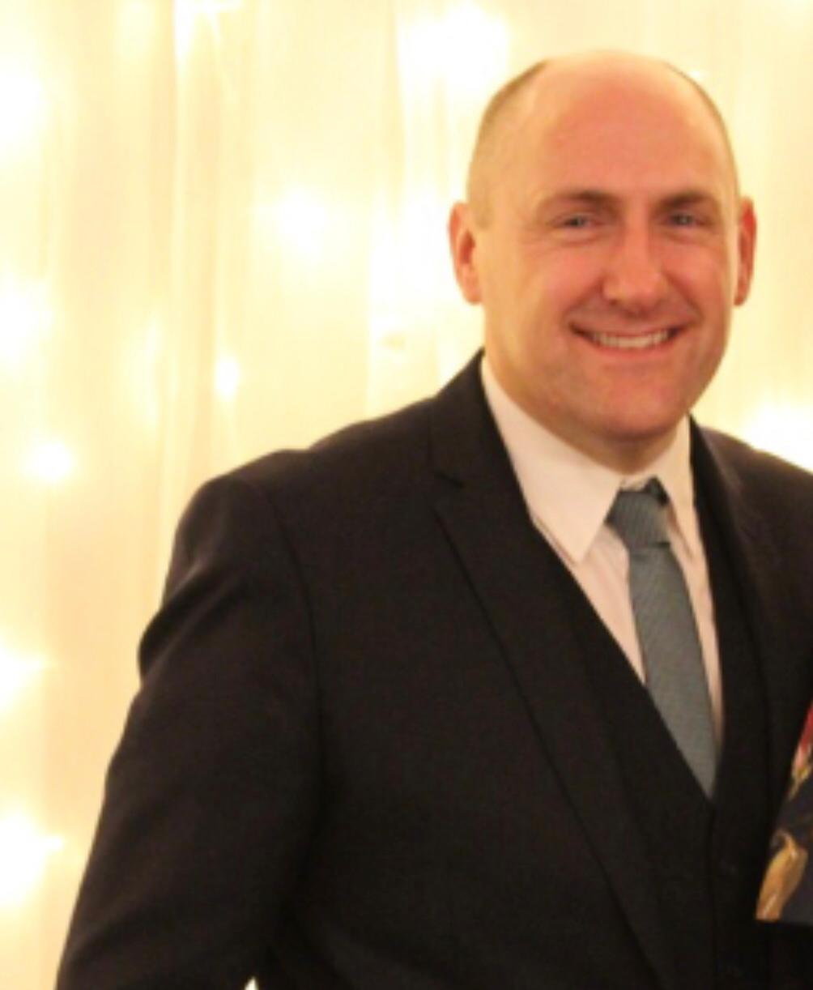
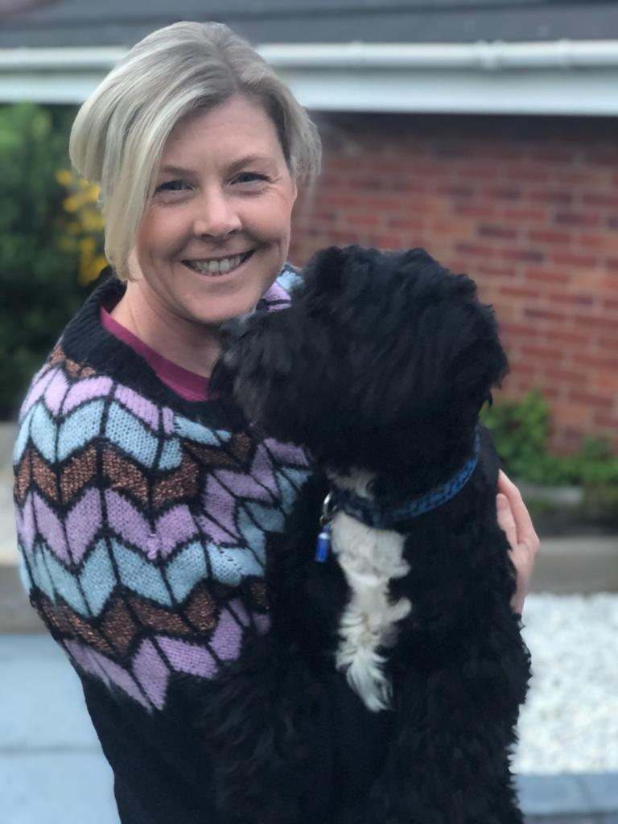

ENGLISH | MATHS
Reading – Read every day for pleasure for 30 minutes.  Comprehension tasks –  Fiction: To Be a Cat by Matt Haig  https://www.bbc.co.uk/bitesize/articles/zn8bgwx  Non-Fiction: Who’s the Best Footballer on the Planet? (see below)  Poetry: A Trillion Tropical Leaves (see below)  Writing – Email- Please write an email to our school email address- enquiries@.saintoswalds.wigan.sch.uk for the attention of Mr Goulding/Mrs Barton. Tell us what you’ve been up to, the ‘pros and cons’ of not being able to come to school, what you’re looking forward to doing when we return to school etc. Remember your punctuation and spelling!  Spellings – Words with the spelling pattern ‘ough’  though, although, dough, doughnut, through, cough, trough, rough  Extra – a good game to practise spellings online http://www.ictgames.com/mobilePage/spookySpellings/index.html | 6 times table – Instant recall – use this website if available https://www.topmarks.co.uk/maths-games/hit-the-button ;  White Rose Home Learning – Year 5 – Summer Term – Week 1 – 20.4.20 - Decimals up to 2 decimal places  https://whiterosemaths.com/homelearning/year-5/  There is also Week 1 and Week 2 work above which can help if your child is finding the work too challenging. Also your child could access the previous year’s work in order to build their confidence up. Anything is useful.
R.E. | OTHER
The theme is: Transformation and is linked to Pentecost.  Research a form of energy: wind, water, solar power for example. What are the pros and cons? What do you feel about it? How does it help? Create a poster / powerpoint / film report to share your findings.  How can you use your energy for the well-being of others – at home, in school, in the community? Draw images and write captions. | Science – The Solar System  https://www.bbc.co.uk/bitesize/articles/zhk2mfr  Activity 3 is a sheet that can be printed or you can just write out the sentences.  As an extra challenge, why not do some research, then go star-gazing with an adult to see if you can spot any of the planets of the solar system in the night sky (often they can be seen with the naked eye).  Geography – Tokyo – Mr Goulding’s favourite city in the whole world! With the 2020 Olympics now rescheduled to take part in 2021, research the natural and man-made features of this incredible city. Create a poster to advertise to tourists, when we’re able to travel again, about the city’s features and attractions.  https://www.kids-world-travel-guide.com/japan-facts.html  https://www.natgeokids.com/uk/discover/geography/countries/facts-about-japan/

